**EXPERIENCED MEDICAL REPRESENTATIVE**

**PHARMACY FACULTY, UNIVERSITY OF MEDICINE AND PHARMACY HO CHI MINH CITY**

**EDUCATION:**

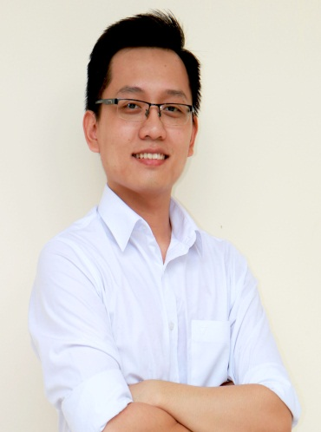

MINH TRI NGUYEN

**Date of birth: 27/04/1994**

**Gender: Male**

**Nationality: Viet Nam**

**Address: 21, 17th street, Binh Tri Dong B Ward, Binh Tan District, HCM city**

**Mobile phone : 0969487237**

**Email address:**

[**ds.tringuyen94@gmail.com**](mailto:ds.tringuyen94@gmail.com)

**Skills:**

* **Fluent English**
* **Good MS-office skills**
* **Strong communication and presentation skills**
* **Leading and team working**
* **Decision making and problem solving**

**Hobbies:**

* **Sports: soccer, tennis, …**
* **Music: singing, playing guitar, …**
* **Travelling**
* **Reading books: about business, sales, branding, leading**

2012 – 2017: Pharmacy Faculty, University of Medicine and Pharmacy

2009 – 2012: High school for the Gifted - National University

**POSTS AT HIGHSCHOOL AND UNIVERSITY:**

2012 – 2015: D2012 Monitor

2013 – 2014: Chairman of “Van nghe xung kich” club – Univesity of Medicine and Pharmacy

2009 – 2012: Secretary of A2 class – High school for the Gifted

**RELATED EXPERIENCES**

**Medical Representative**

*Servier Viet Nam* | August, 2017 – June, 2018

* Manage and build good relationships with doctors and relevant people
* Receive sales target and create strategic plan to meet or exceed the target, based on the Marketing campaign
* Keep updating new information about the products for doctors
* Get feedback about the company’s products and services
* Complete other tasks and projects, such as: English project, MC for the National Meeting, …

**Sales Team Leader**

*Awake your power project* | July, 2013 – August, 2013

* Gather the team, choose the product, find good suppliers
* Set sales target and strategic plans
* Execute and manage the team to exceed the target

**CAREER TARGETS**

2018 – 2022: Become one of the best Medical Representatives

2022 – 2027: Become a Team Leader/ Area Manager