**CURRICULUM VITAE**

**INFORMATION**

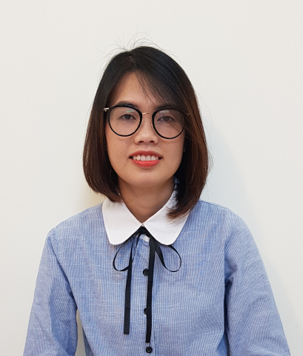Name: Dam Thi Ha

Gender: Female

Marital status: Single

Nationality: Vietnamese

Email: [hadamthi@gmail.com](mailto:hadamthi@gmail.com)

Tel: Mobile – 0909.731.699

Address: 26 Nguyen Thuong Hien, Go Vap, HCM.

**CAREER OBJECTIVES**

* **Short term:** completing my tasks well, building good relationship with my both colleagues, partners and customers, improving soft skills and ability of foreign languages.
* **Long term:** Through experience and training offered by the company, I look forward to growing and being promoted in a higher position that I can dedicate my best ability and have more responsibility for the product’s successfulness.

**EDUCATION**

**9/2014 – 12/2017**: Ho Chi Minh University of Medicine and Pharmacy

Bachelor of Pharmacy.

**9/2008 – 11/2012**: Ho Chi Minh University of Technology

Bachelor of Biotechnology, GPA 3.14/4.

**CERTIFICATE**

* Completion course of Use antibiotic reasonable in the treatment of sore throat by HCM University of Medicine and Pharmacy.
* Completion course of First aid skills by HCM University of Medicine and Pharmacy.
* Certificate of English level B.
* Certificate of computer science level B.

**EXPERIENCE**

### 7/2018 - 4/2019: Product manager in An Khang Pharmacy.

### Achievements: Update and manage all product information on the online channel of An Khang pharmacy system, build the optimal information system for users…

### 3/2018 - 6/2018: Sales Hospital in Zuellig Pharma, work at some hospital: Cho Ray, Binh Dan, An Binh, District 10, Trung Vuong, Rang Ham Mat Trung Uong.

### Achievements: achieve 100%, help in gaining market share on key strategic products, ensure my work closely with the Integrated Brand Teams (Marketing, Medical, KAM, Regulatory Affairs) and provide them regularly with field/competitor information and insights.

### 9/2017: I have been through training sessions at Binh Dan Hospital and Boston VietNam Pharmaceutical joint stock company.

Achievements: understanding of the operation of a hospital, a department; observing the working methods of Pharmacist at the hospitals and Pharmaceutical company.

### 7/2017 – 9/2017: I spent two months as a consultant pharmacist at Hong Diep Pharmacy.

* **4/2012 – 6/2012**: I was training two months at the laboratory of The Trieu An hospital.

**SKILLS**

* Good teamwork skill and ability to work under pressure.
* Well-organized time management skill and proven problem salving skills.
* Ability to work on multiple tasks and meet tight deadlines.
* Good computer skills: MS. Word, Excel, Power Point, Internet.
* Language: English: fluent
* Responsible, careful, active and flexible in work.
* Honest, friendly and ready to learn new things.
* Hobbies: Traveling, reading book.