**CURRICULUM VITAE**

**INFORMATION**

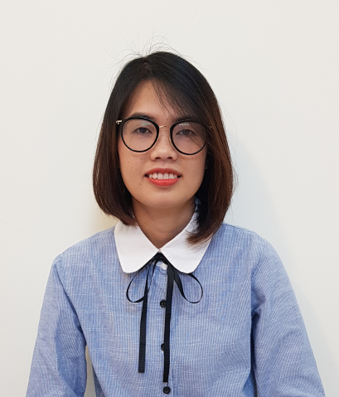Name: Dam Thi Ha

Gender: Female

Date of birth: 19/11/1990

Marital status: Single

Nationality: Vietnamese

Email: [hadamthi@gmail.com](mailto:hadamthi@gmail.com)

Tel: Mobile – 0909.731.699

Address: 26 Nguyen Thuong Hien, Go Vap, HCM.

**CAREER OBJECTIVES**

Applying experience in communication and sale skills, understanding the psychology and customer needs to become a professional staff, bring more value to customers.

**EDUCATION**

**9/2014 – 12/2017**: Ho Chi Minh University of Medicine and Pharmacy

Bachelor of Pharmacy.

**9/2008 – 11/2012**: Ho Chi Minh University of Technology

Bachelor of Biotechnology, GPA 3.14/4.

**CERTIFICATE**

Completion course of Use antibiotic reasonable in the treatment of sore throat by HCM University of Medicine and Pharmacy.

Completion course of First aid skills by HCM University of Medicine and Pharmacy.

Certificate of English level B.

Certificate of computer science level B.

**EXPERIENCE**

### 9/2017: I have been through training sessions at Binh Dan Hospital and Boston VietNam Pharmaceutical joint stock company.

### 7/2017 – 9/2017: I spent two months as a consultant pharmacist at Hong Diep Pharmacy.

**4/2012 – 6/2012**: I was training two months at the laboratory of The Trieu An hospital.

**SKILLS**

Good teamwork skill and ability to work under pressure.

Well-organized time management skill and proven problem salving skills.

Ability to work on multiple tasks and meet tight deadlines.

Good computer skills: MS. Word, Excel, Power Point, Internet.

Language: English: fluent

Responsible, careful, active and flexible in work.

Honest, friendly and ready to learn new things.

**REFERENCER**

PGS. TS. Truong Ngoc Tuyen

Lecturers of HCM University of Medicine and Pharmacy

Email: [truongtuyen2001@yahoo.com](mailto:truongtuyen2001@yahoo.com)

PGS. TS. Vo Phung Nguyen

Lecturers of HCM University of Medicine and Pharmacy

Email: [vophungnguyen@gmail.com](mailto:vophungnguyen@gmail.com)