# OBJECTIVE

## Short-term objective

Join and stick with a professional working environment to:

* Develop skills: communication, teamwork, management, negotiation,…
* Accumulated experience to become a professional Medical Communication Specialist and contribute to the long-term development of company.

## Long-term objective

* 2-4 years: become the manager of Medical Communication Specialist group
* 5-10 years: start-ups

# EDUCATION

## CAN THO UNIVERSITY OF MEDICINE AND PHARMACY

9/2013 - 7/2018

## MAJOR: PHARMACIST

GPA: 3.15/4.00 (7.82/10)

# EXPERIENCE

## COFFEE SHOP

7/2016 - 9/2016

## PART-TIME IN THE COFFEE SHOP

* The waiter in the coffee shop

Achievements and skills gained:

* Improve communication skill.
* Catch the satisfaction of the customer
* Know the value of money

# ACTIVITIES

## PLAY SOCCER & SHUTTLECOCK KICKING

2013 - PRESENT

* Easy to make friends who have the same favorite and become intimate
* Improve the health and teamwork
* Achievement: Consolation prize in 2017

## VOLUNTEER ACTIVITIES IN SCHOOL

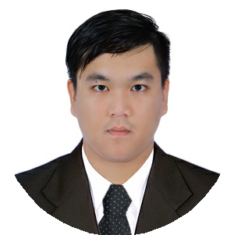

**Nguyen Duy Khang**

Medical Communication Specialists

Tra Vinh, Viet Nam

[ndkhang0895@gmail.com](mailto:ndkhang0895@gmail.com)

(+84) 169 405 0021

2013 - PRESENT

* Donate to help the difficult people
* Join the Tra Vinh Student Association
* Organize the Big game of the Pharmacy's faculty

## PROGRAM TALK ABOUT THE JOBS OF THE PHARMACIST

9/2017 - PRESENT

## MEMBER OF BE PHARMACIST GROUP

* Organize monthly events to meet with Can Tho University of Medicine and Pharmacy alumni
* Share and learn how to search for the jobs of a pharmacist
* Improve communication skill and become more confidence

# SKILL

**Communication** - Easy to make friends

* + Interact and maintain conversation well
  + Improve presentation skill

**Teamwork** - Mutual respect

* + Work independently
  + Construction spirit

**Management** The leader of a soccer team and a clinical pharmacy subgroup

* + Arrange training time of team
  + Divide the work and deadline of group Clinical Pharmacy
  + Raise the spirit for friends

**Studying** - Make study plan

* + Group study
  + Concentrate on main subject

**Language** English

* + Ability to read and communicate well
  + Read Specialized English materials

# CERTIFICATIONS & AWARDS

2013-2018 Scholarship in 5th, 8th, 9th semester

2017 Informatics certificate: Basic level (Microsoft Office)

# INTERESTS

Soccer, Shuttlecock kicking

Comedy

Shark tank Vietnam