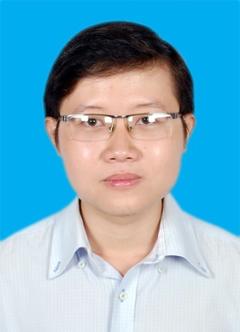**TRẦN HỮU HOÀNG CHƯƠNG**

Date of Birth: 28/08/1994

Contact address: B6.12, Fuji Residence, District 9, HCMC

E-mail: [huuhoangchuong1994@gmail.com](mailto:huuhoangchuong1994@gmail.com)

Phone number: 01294026425

Place of birth: ThuaThien Hue, Viet Nam

**EDUCATION**

*Aug, 2013 – July, 2018* **University of Medicine and Pharmacy, HCMC campus**

 M*ajor in Pharmacy*

GPA 6.52/10

**WORKING EXPERIENCE**

*Sept, 2014 – July, 2015* **Circle K Vietnam**

Customer Service:

- Sorting, sanitary goods in stores

- Forwarding, transferring, cargo inspection between stores under its systems as necessary

- Sales transaction in accordance with regulations

*Jan, 2015 – Sept,2015* **Abbott Nutrition Vietnam**

Promotion boy (PB):

- Introducing the product to the customer

- Ensuring sales

- Forwarding the products for supervisor of company

**SOCIAL ATIVITY**

*Dec, 2014 – Jan, 2015* **Vietnam Student Union -HCM City**

Spring campain Volunteer:

- Earning money

- Caring & building home for homeless elders

**SKILLS**

* Fluent written and spoken English and Vietnamese
* Logical thinking to handle the problem
* Sale skill: experienced in persuading customers trust products
* Computer skills : MS Word, Excel, Power Point

**CARRER GOALS**

* Taking profits for our company
* Contributing good ideas to build our company
* Improving soft skills & having the opportunity to promote
* Obtaining practical knowledge in the field of pharmacy

**HOBBIES**

* Reading fiction, novel & detective story
* Listening to music
* Traveling to new cities
* Discovering the culture & natural landscape.