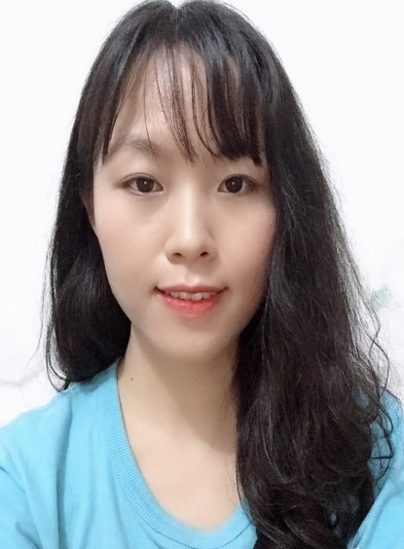

|  |  |
| --- | --- |
| Nguyen Bao Ngoc July 29, 1992  No. 4, Lane 19 Alley 120 Dinh Cong, Phuong Liet, Thanh Xuan, Hanoi  0866919901  [nguyenbaongochup@gmail.com](mailto:nguyenbaongochup@gmail.com) PERSONALITY  * Enthusiastic, hardworking.  TOOL SKILLSCOMPUTER▶ WORD: Good ▶ EXCEL: Good  ▶ POWER POINT: Good ENGLISH ▶ LISTENTING: Average – Good  ▶ SPEAKING: Average – Good  ▶ READING: Good  ▶ WRITING: Good COMMITMENT I commit that the information provided above is accurate and complete about me as well as my work process.  I am committed to being disciplined by dismissal if there is any information that is not true. | CAPACITY PROFILE  **Position: Medical Representative** EDUCATION ▶  **HANOI UNIVERSITY OF PHARMACY**   * Major: Pharmaceutical industry – Graduation classification: Good.  PERSONAL SKILLS, EXPERIENCE, CAPACITY ▶ **COMMUNICATION SKILLS:**  **-** I have been working as salesperson in various industries including footwear, cosmetics, drugs, so that I am able to convince customers to buy my products.  ▶ **TEAM WORK SKILLS:**   * Having participated in team activities at the school, which helped me learn the ability to listen, be more positive, be more confident, be responsible to myself and for my assigned works   ▶ **COMPUTER SKILLS:**   * Fluency in Microsoft Office: obtained by joining team works in classes and also preparing my essays. * I am able to process texts, prepare reports clearly, prepare power point files in an attractive and easy-to-understand manner, well process figures and data in excel. * My fluency in computer use is obtained through training at school and self-study.   ▶ **PROFICIENCY IN ENGLISH**   * My English skills are average and good.   ▶ **OTHERS:**   * Able to arrange time and works in priority order.     ▶ **WORKING EXPERIENCE:**   * I have been taking the following positions:   + Nhat Minh Pharmaceutical Company (late 2015-2016): working as a storekeeper – temporarily taking this position for an employee to take maternity leave  + Viet My Company (at Ngoc Khanh Drug Market): working a salesperson  + In addition, I have worked at a number of retail pharmacies like Quoc Anh pharmacy at Ngoc Khanh drug market   OUTSTANDING SKILLS **PROFESSIONAL SKILLS:**  - Be knowledgeable about drug names, categories and segments in the market; be able to instruct the drug usage.  - I am also quite good in functional foods: about their uses and ingredients, and supplements.  **SOFT SKILLS:**  - Thanks to my personal sales experience, I have ability to convince customers to buy my products  - I also have ability to convince suppliers to get cheap prices, find quality sources at reasonable prices PERSONAL DEVELOPMENT OBJECTIVE/PLAN **WITHIN 1 YEAR:**   * I wish to get opportunity to work in a dynamic environment, thereby developing myself and enhance my working capacity so that I can make some contributions to the company’s development.   **FROM 1 – 3 YEARS**   * I hope to work for your company for a long-term, become an excellent employee, actively contributing to the company’s development. And I also try my best to study new expertise as well as enhance my capacity in foreign language and computer skills.   **ABOVE 3 YEARS:**   * I hope that I will become a key expert of your company.  EXTRA-CURRICULAR ACTIVITIES **ACTIVITY 1:**  I used to join some collective activities such as humanitarian blood donation, voluntary public cleanup activities REFERENCES **Mr. Nguyen Tuan Anh**   * Position: Chief engineer - Dsteel-Vina Korea Company Limited * Contact No.: 0946569369- mail :tuananh08x5@gmail.com   *Hanoi, January 13, 2019*    **CANDIDATE**  **NGUYEN BAO NGOC** |