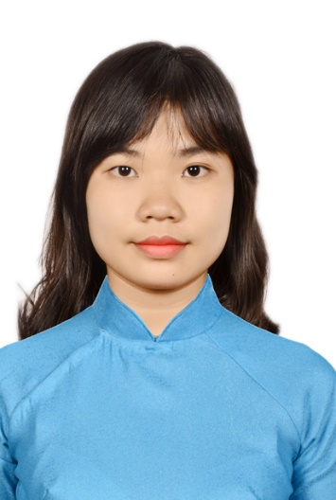

CURRICULUM VITAE

Position applied:

|  |  |  |
| --- | --- | --- |
| **PERSONAL**  **INFORMATION** | **Full name:** | NGUYEN MY TIEN |
| **Date of birth:** | 27/08/1995 |
| **Place of birth:** | Tien Giang Province |
| **Class:** | B39, Faculty of Pharmacy, Can Tho University of Medicine and Pharmacy. |
| **Contact address:** | Ly Phuc Man Street, Binh Thuan Ward, District 7, Ho Chi Minh City. |
| **Contact number:** | +84 35 8950 710 |
| **Email address:** | [**nguyenmytien1313@gmail.com**](mailto:nguyenmytien1313@gmail.com) |
| **Marial status:** | Single |
| **EDUCATION** | * 2013 – 2018: Student at Faculty of Pharmacy, Can Tho University of Medicine and Pharmacy. * Average accumulated score 9 semesters 7.50 out of 10. | |
| **CAREER OBJECTIVES** | * Work in a professional, dynamic environment * Expand social relationships and improve important working skills: teamwork, presentation, leadership… * Become a good Medical Representative in the future | |
| **PERSONAL**  **QUALITIES** | **Strengths**   * Communication skills * Integrity and high sense of responsibility * Diligence and sustainability under high pressure | |
| **HOBBIES** | * Playing sport * Reading books * Traveling | |
| **ACTIVITIES** | * 2013 - 2017: Participating in other extracurricular activities at university and outside: Social Club, Pharmacy English Club. * Teaching street children and orphans. * Participating in various charity work: “Blood Donation”. * Taking part in volunteer work named “Green Summer Campaign” in 2014 and 2015. * Working part time job as a waitress at food store and clothing store. * Experiencing at Pharmacy as a pharmacist. | |
| **SKILLS** | **Computer Skill**   * MOS Certifications: MS Word, MS Excel, MS Power Point, SPSS. * Internet, Email   **Language Skill**   * Able to comprehend English documents * Able to communicate and present in English * IELTs certificate score 6.0   **Communication Skill**   * Developed from extracurricular activities and group working | |