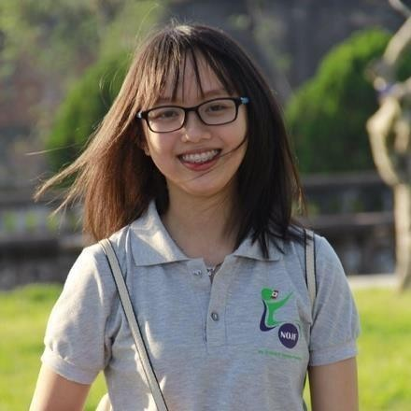Address:466/36 Le Van Sy, Ward 14, Dist 3, HCMC Phone[: 0164 320 3369 Email: giaotran911@gmail.com](mailto:giaotran911@gmail.com)

TRAN NGUYEN QUYNH GIAO

|  |  |
| --- | --- |
| **OBJECTIVE** | * Acquiring knowledge and experience in sale field * Become sale manager in 5 years |
| **EDUCATION** | - **2012 – 2017**: Hue university of medicine and pharmacy- Major in pharmacy.  Degree classification: Very Good |
| **EXPERIENCE** | * **2/2018- today**: Medical representative at Sunstar Joint Stock company. Be responsible for prescription products in several hospitals in HCM    + Approach the customers and making good relationship with all appointed customers   + Set up and manage customer’s profile, develop potential customers |
| **SKILLS & STRENGTHS** | * An outgoing and persuasive manner * High responsibility and target-driven * Be able to withstand highpressure * Be good at English skills (Ielts 6.5) * Microsoft Office: good at Word, Exel, Power Point |
| **ACTIVITIES** | * **2015:** Taking part in “Clinical pharmacy club” in Hue university of medicine and pharmacy as a vice-president. * **2016**:ParticipatinginNOJFoundationasaninterpreterforhelping cerebral palsy children in Hue city. * **2016**: Dedicating as a communication coordinator atthe Vietabroader study-abroad conference. |
| **HONORS - AWARDS:** | * **2012 – 2017**: Top 10% of the students over 5 – year course * **2014**: Winning Scholarships for best students inuniversity.   - **2017**: Doing a thesis named “*Study on the acute andchronic toxicity of resistant starch on rat*” instructed by Assoc. Prof Tran Huu Dung  - **Certificate**: 2012 – 2017: End of the year awards for best  students(signedbyProfessorCaoNgocThanh,MD,PhD, Rector of Hue University of Medicine and Pharmacy). |