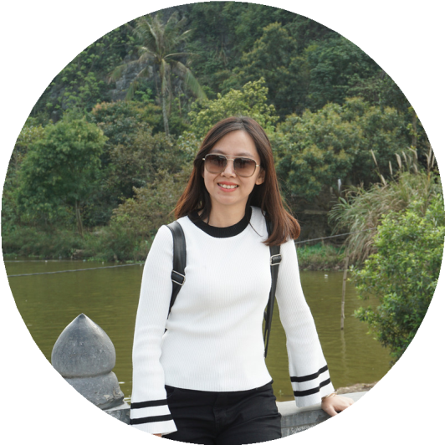

**ABOUT ME**

I possess aggressive thinking and good negotiating skills. My communication skills and positive attitude makes me an effective communicator with everyone; enthusiasm, integrity, good mind-set, hard-working and confident.

In more 5 years, I want to become a Regional Sales Manager.

### EXPERIENCE

### KTG Appliances – Sales Manager (MT channel – Home Appliances)/July 2018 – Now

### Manage, supervise, train and motivate the Sales Representative (with 21 SR)

### Check and follow-up SR activities to maintain a schedule of calls, spend time working on fields and double visit with SR

### Report and Suport CEO to achieves objectieve of Sales Department and build strong SR Team.

### Making and training the presentation of Skill, Product knowledgement… Make the training plan for each SR.

### Make the guildline merchandizing and SR job description, make the survey based on the Company’s request.

### Team achieved 111% on July and 96% on August-2018.

### IPSEN Pharma Viet Nam - Medical Representative/July 2017 – June 2018

* Develop & maintains good customer relationship, develop new customer & detailing product.
* Solve problems on field. Collect customer database/information for use as sales leads. Collect the feedbacks from customer and buil-up marketing plan for each customer.
* Support my manager to lead our team. Speak for Group Discussion.
* A member of Project Team to organize some activities and events.
* Understanding and update the status of directly competitive.
* Achieved 119% sales performance in Q3'2017; 114% sales performance in Q4'2017 and 137% sales performance in Q1'2018.

### TEDIS Representative – Team leader & Medical Representative/Aug 2015 – Jun 2017

* Build customer relationship & detailing product. Build up marketing plan for each customer.
* Build strong team and lead the MR team to achieve objective.
* Ensure the sales targets implementation in territory; be responsible in these channels: Beauty store (Nuty, Beauty Hub, Epomi, …)/ Pharmacy Chain – Pharmacy and Retailer.
* Understanding and update the status of directly competitive.
* Achieved 160% in 2016; 130% in Q1&Q2’2017; increase 30 % in the number of customer for each year.

**GSK Exclusive Team –** Medical Representative/Apr 2013 – Aug 2015

* Build customer relationship & detailing product. Support area sale manager to lead our team. Certificate “Best Sales Rep” in 2014.
* Speak for Group Discussion.

### Management skills.

### Soft skill and office skills: Word, Excel, Powerpoint.

### CONTACT

### 🕿 0907 24 79 71

### 🖃 tiffanytranthuytrang@gmail.com

### 🏠 9/26 Pham Van Hai, Tan Binh District

### EDUCATION

### Ho Chi Minh University of Medicine & Pharmacy

### Major: Pharmacy

### ACTIVITIES

### A member of project team to organize some activities and events at IPSEN & Church.

### HONOR & AWARD

### 2014 – Good sales Rep in GSK Exclusive.

### 2016 – Best Effort Sale Rep in Tedis

### 2017 – Best Sales Reps in HCM

### SKILLS

### Handle objection & negotiation skills.

### Excellence communication.

### CERTIFICATION

### Certificate of Achievement "Effective Communication Skills" from Dale Carnegie - School of Business - with highest performance

### Certificate of complete "Negotiation & Handle Objection Skills" from Robenny - School of Business.

### REFERENCE

### MR. Trần Trung Hậu (Manager)

### Mobile: 0908 171 564

**TRẦN**

**THÙY TRANG**