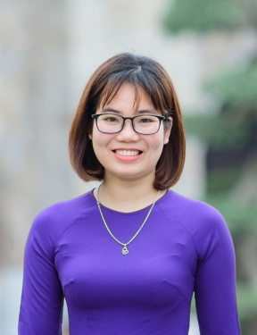 CURRICULUM VITAE

DO THI HOAN

Medical Representative

# Profile

* **Date of birth**: August 5th, 1994
* **Phone number**: 03667888594
* **Email**: [dohoandkh@gmail.com](mailto:dohoandkh@gmail.com)
* **Address**: Ho Dac Di street, Nam Dong Ward, Dong Da District, Ha Noi



# Objective

* Becoming a good Medical Representative with the greatest efficiency.
* Working in professional and self-motivated environment.
* Improving myself about specialized knowledge and skills

# Education

## Hanoi University of Pharmacy [ 2012 - 2017 ]

* Major: Clinical Pharmacology
* GPA: **3.42**/4



# Work experience

* March 2017 : Telesale in Big Success Media Company.
* From 2012 to 2017: Private Tutor Math, Physics Chemistry for students of secondary school, high school and university exam**.**
* From July/2017 up to Oct/2018 : Medical Representative in AstraZeneca.
* Take responsibility for some fields: Bach Mai Hospital,108 Hospital, E hospital,…
* Ensure target in areas ( 104%)
* improve skills in negotiation, communication, presentation.

# 

# Activities

# A part of Association of Thanh Hoa countrymen (Aug 2012- Jun 2013)

# Member of I4U club ( Aug 2012- Jan 2013)

# February 2016- May 2016, member of VEEC English Club.



**Skills**

**Information and Technology**

* **Word**
* **Excel**
* **Power Point**

**Communication**

**English**

* **Listening**
* **Speaking**
* **Reading**

**Time Management**

**Searching skills**



# Personal characteristics

* Honesty, always keep an open mind and be optimistic, willingness to learn new things.
* Adaptable to new situations.
* Hard-working, careful, sociable with other people.
* Having an enthusiastic attitude with work, a high sense of responsibility.