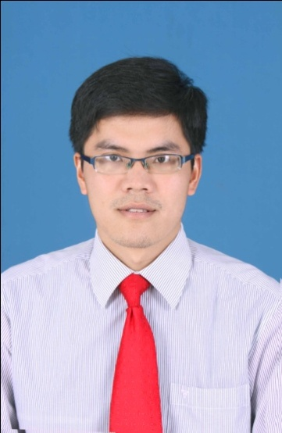**CURRICULUM VITAE**

1. Full name: Vu Trung Duc
2. Date of birth: October 31, 1990
3. Height: 1m75 . Weight: 70 kg
4. Gender : Male
5. Marital status : Single
6. Address : 629 Giai Phong street, Hai Ba Trung district, Ha Noi.
7. Tel : 0389 937 661
8. Email : [vutrungductq3110@gmail.com](mailto:vutrungductq3110@gmail.com)
9. ID: 070872959
10. Day of degree: February 10,2010

EDUCATION

September 2008 – June 2013

Ha Noi University of Pharmacy

SKILLS

**English** : *(Mark 1 to 5 for competence, where 5 is the highest)*

|  |  |  |  |
| --- | --- | --- | --- |
| Listening | Speaking | Reading | Writing |
| 3 | 2 | 3 | 2 |

**Independent studying and researching skills :** Collected information from many sources: library, research books and internet to enrich my knowledge.

**Communication and presentation skills :** Realized the importance of communication skills and acquired experience about effective communication methods.

**Team work** : Good at working with a team.

**Computer** : Good at Windows XP, Windows 7 about Word, Power Point.  
 Had knowledge of Mail, Internet

CHARACTER DESCRIPTIONS

* **Enthusiastic, open minded, optimistic, social and have a good sense of humor.**
* **Have ability of l**earning new things very quickly.
* Have special interests in working under a challenging environment.
* Good at organizing my time and be a punctual person.

WORK EXPERIENCE

|  |  |  |  |  |
| --- | --- | --- | --- | --- |
| **Company** | **Position**  **(product)** | **Time** | **Territoy** | **Achivement** |
|  | QA Staff | 7/2013-11/2015 | Factory in Me Linh Industrial Zone | Rank “High” in annual review |
|  | Medical Representative  (Cardiology Intervention Team) | 11/2015- 4/2016 | Hanoi Medical University Hospital,  Thai Nguyen Central Hospital, Viet Tiep Hospital | Over 100% target |
|  | Medical Representative  (CD Team) | 4/2016-12/2018 | Hung Viet Hospital,  Tam Anh Hospital  Thien Duc Hospital  Van Dinh, Gia Lam and Hoai Duc District General Hospital | Over 110% target |
|  | Product Specialist  (Oncology team) | 1/2018- now | Hanoi Medical University Hospital,  National Lung Hospital, Phu Tho and Ninh Binh Province General Hospital, | Over 100% target |

DESIRED WORK

* Active and professional working environment
* Plenty of chances to improve skills and social knowledge
* Lots of opportunities for promotion

DESIRED POSITION

* Position: Medical representative, marketing
* Salary: negotiable
* Place: working in Hanoi but might go to other province for further performance

INTERESTS

|  |  |
| --- | --- |
|  | * Collecting world coins, Viet Nam banknotes and stamps * Reading books and newspaper, listening music. * Traveling and talking with my friends.   I certify that the facts contained in this CV are true and complete to the best of my knowledge, and understand that if proved falsified, these statements shall be grounds for dismissal. For further information and reference, I would be very pleased to be contacted at telephone. |

Reference: Human-resources Department