**APPLYING FOR POSITION MR IN THANH HOA .**

**CURRICULUM VITAE**

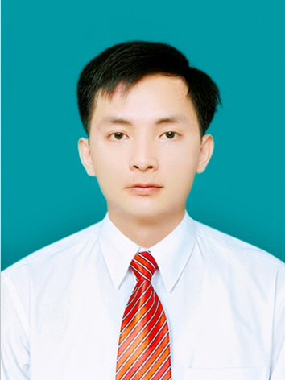**Personal Information**

**Full name** TRUONG VAN TRONG

**Date of birth** 19th August 1989

**Marriage status** Married

**Nationality**  Vietnamese

**Address**  Loc Son Commune,Hau Loc District, Thanh Hoa Province.

**Hand-phone**: 0978.297.626

**E-mail**: [*Mrtruong1908@gmail.com*](mailto:Mrtruong1908@gmail.com)

**Desired work**

* Working in a active and professional environment.
* Becoming a Medical representative in Thanh Hoa province.

**Education**

* 9/2007-6/2012: Thai Binh medical university.
* GPA: 6,88.
* 9/2004-5/2007: Hau Loc II High School, Hau Loc District,Thanh Hoa province.

**Extra Activities**

* Joining in the enthusiastic hearts Club established by Student Union in the activities of love
* Cutting rice to help people avoid flood at Tu Tan Commune, Vu Thu District, Thai Binh Province in 2008.
* Being a volunteer helping student in the Entrance Exam in school year 2010 and 2011.

**Working Experience - Achievement**

* **5/2008-9/2011:**
* Being a tutor to help students prepare well for the entrance exam to University at grade of 10, 11 and12.
* Joining in the direct goods selling at Herbalife Vietnam Company.
* **08/2012- 7/2013:** Being a Medical Representative OTC at Phuc Hung Traditional Pharmaceutical Company Ltd.
* Implementing the programs of Business Department, Marketing Department.
* Creating a close relation among drugstores in the area, solving problems arisen the between agents and customers.
* Achieving the sales targets, coverage of new items, and the proportion of goods category assigned by the company.
* Making the contribution to the thing that Thanh Hoa is the only province having the growth rate of 2% in 2012 ( according to the information of General Director in the Year End Meeting 2012)
* **7/2013-8/2014 :**Being a Medical Representative ETC at Binh Minh Pharmaceutical company .
* **10/2014-present:** Being a Medical Representative at Novo Nordisk company cover 4 provinces: Thanh Hoa-Ninh Binh-Nam Đinh-Thai Binh
* Management and development of internal and external medicine hospitals using the company's insulin
* Expand the district-level hospitals using company’s insulin
* In charge of contracting, introduce new products to be used for patients with health insurance card.
* Take care of the doctor, provide product information that the hospital won the contract, take care doctors during the workshop.
* Plan, segment customers, ensure the development of the area commensurate with the growth of the company.

**Skills**

* Pharmacy: Training, learning and research in-depth knowledge of specialized Pharmacy: Clinical Pharmacy, Pharmacology, Pharmaceutical Economics ....
* Language : English Certificate B.
* Computer skill : Microsoft Word, Excel, PowerPoint,Proshow producer.
* Good independent work and teamwork skill.
* Good communication skill.

**Ability**

* Work independently and team work.
* Working in high pressure environment.
* Patient in listening and understanding others.
* Hard- working, honest and responsible.

**Hobbies**

* Traveling,listening to music,sports.

I confirm that the information above I have given is correct and I will bear the full responsibility for them.