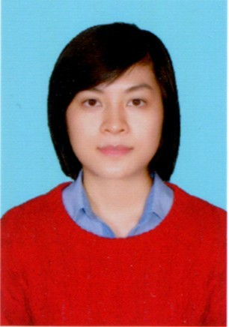

**PERSONAL SKILLS**

* **Office:** Word, Excel, Power point
* **English**: listening, speaking, reading
* **Teamwork**: good
* Creative, dynamic, diligent, trustworthy, flexibility, problem solving abilities, good communication and creativity
* Working with high pressure capability, can travel province or abroad

**PROFILE**

**DINH THI MY DUNG**

Address: Truong Vinh Ky, D.Tan Phu, HCMC

Birthday: 14/11/1991

Mobile phone: 0355075356

Email: dungdinh91@gmail.com

**OBJECTIVE**

I deeply want to work in a professional working environment and have a good opportunity to work independently or as part of a dynamic team where I could make a significant contribution while developing my skills yet further.

**EDUCATION**

* **University of Medicine and Pharmacy, HCMC 2014 - 2017**

Major: Pharmacist

* **Da Lat University Sept 2009 – May 2013**

Major: Bio-technology

**WORK EXPERIENCE**

* **Hoa Thien Phu Pharma cord July 2018**

Marketing dept (Product Specialist) product knowledge training for sales staff

* **Boston pharmaceutical Oct 2017**

Trainee : Study about manufacturing process and operate system.

* **Suchiang Pharmaceutical July 2013 – Sept 2014**

Manager Assistance and Medical Representative

Understanding of DAV Regualatory policies

* **Dalat Universiy** **2011 – 2013**

Trainee in laboratory’s university about biology, microbiology and biochemical.