Socialist Republic Of Vietnam

Independent Freedom Happy

Job application

    To: Mr. (Ms) Director of Pharmaceutical Joint Stock Company

       Human Resources Department / Division

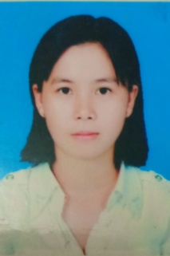Through information on the website I know your company is in need of recruitment tablets with a pharmacy channel placement position

      I realized that I had the qualifications and qualifications suitable for the position of the pharmacist, so I wrote this application to join the dynamic and professional lifting staff of your company

My name is: Nguyen Tran Phuong Thao

Born: October 20, 1984

Address: Phuoc Tu Hamlet, Thanh Phu Commune, Ben Luc District, Long An Province

Phone: 0979738654

I would like to summarize the learning process and my work as follows:  
- October 2010 to October 2014: Studied in pharmacy, Ho Chi Minh City University of pharmacy

     - March 2015: Working at Van An Long An Clinic

        - June 2015 submitted to submit pharmaceutical presentation at GLomed Pharmaceutical Joint Stock Company

        - October 2015 to date working at UNITED INTERNATIINALPHARMA

       In addition, I can use the office computer fluently, English to communicate well, work honestly and carefully

If recruited into a dynamic and professional staff of our company, I would like to promise to accept every single rule, regulations of our company, try our best to complete the assigned work, constantly learning to develop working skills.

    I hereby certify that the foregoing is true, if any, I accept full responsibility before the law

I sincerely thank you.

Long An, October 18, 2019

                                                          Single glass

Nguyễn Trần Phương Thảo