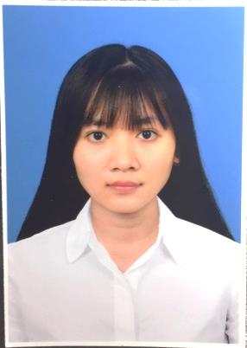**CURRICULUM VITAE**

**NGUYEN KIM XUAN**

Ninh Kieu district, Can Tho city

Phone Number: 0777 757 926

**CAREER OBJECTIVE:** to become a good medical representative.

**EDUCATION:**

+ I have graduated from Vo Truong Toan university with good grade in pharmacy.

+ Language: level B of English in Vo Truong Toan university.

+ Ability to use the office computer.

**PERSONAL:**

Full name: NGUYEN KIM XUAN

Gender: female

Date of Birth: June 1st, 1995

ID Number: 334888289

Date and place of issue: June, 4th 2012 by Tra Vinh police

Nationality: Viet Nam Religion: No

Marriage status: Single

Health: Good

**WORK HISTORY**

2017 worked in Phale coffee

2018 worked in Huynh Mai pharmacy.

September 2019 – March 2020 worked in Trung Son pharma.

**FAMILY RELATIONS:**

|  |  |  |  |  |
| --- | --- | --- | --- | --- |
| **Full name** | **Year of Birth** | **Relation** | **Occupation** | **Residence** |
| Nguyen Van Thanh | 1971 | Father | Business | Cau Ke District, Tra Vinh Province |
| Tran Kim Thuy | 1970 | Mother | Business | Cau Ke District, Tra Vinh Province |

**PERSONAL STATEMENT:**

I am a warm, sincere person who is eager to learn and willing to work hard.

**REFERENCE:** available upon request

The above information is answered for the truthfulness of my declaration and I will be responsible for any in correction.

**Writer**

Nguyen Kim Xuan