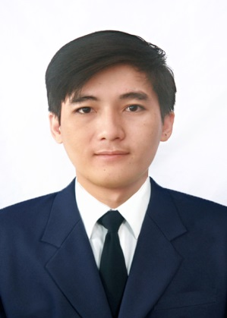**CURRICULUM VITAE**

**VO HOANG QUAN**

We should not give up, we should not deal with difficulties that defeat us *– A. P. J. Abdul Kalam*

1. **PERSONAL DETAILS**

|  |  |  |
| --- | --- | --- |
| Date of Birth |  | 15 April 1993 |
| Address |  | An Phu District, An Giang Province |
| Cellphone |  | 0907 097 427 |
| Email |  | [Vhquanag@gmaill.com](mailto:Vhquanag@gmaill.com) |
| Marital status |  | Single |

1. **CAREER OBJECTIVE**

|  |  |
| --- | --- |
| Short term goal | Improve my skills and expend my knowledge by working in professional organization and challenging. |
| Long term goal | Pursue my career path in the pharmaceutical.  Contribute to the company’s growthand recognized. |

1. **WORKING EXPERIENCES**

|  |  |  |
| --- | --- | --- |
| QA Department, Hisamitsu Viet Nam Pharmaceutical Co., Ltd. | 11.2017 – 05.2020  Position: Sub leader.  Deviation, Change Control: Risk management, CAPA, leader of group registration inspection, Report KPI, check and issue SOP, batch record, test record, Appraisal records. | |
| Animal husbandry Long Bình Co,.Ltd  Staff sell | 2016 – 2017  Manage warehouse, import and export drugs at the warehouse.  Selling drugs OTC, ETC, medical equipment and supplies. |

1. **EDUCATION BACKGROUND**

|  |  |
| --- | --- |
| **Bachelor of Pharmacy**  2011 - 2016 | Vo Truong Toan University, Faculty of Medicine,  Can Tho City  Result: Good |

1. **ADDITIONALS SKILLS**

|  |  |
| --- | --- |
| Language | English: level B (Read – Write) |
| Software | Microsoft Office: Prepare documents and reports by WinWordand Power Point effectively. Well in using Visual Basic Excel for manage work. |
| Other expertise | Time management, Work under high pressure, team work, communication skill. |

1. **SOCIAL ACTIVITIES**

|  |  |
| --- | --- |
| **Member of Charity Group**  THIEN DUYEN Charity, Can Tho City | 2015 –2017  Working together with volunteers to collect clothes and food for poor people.  Taking care of children atorphanages |
| **Member of Ho Chi Minh Communist Youth Union at University** | 2012 – 2016  Working together with other members and students to organize, arrange and prepare for university activities. |

1. **PERSONAL PROFILE**

* Like study and working in manufacturing, calm, patient, I would like to work and join to social activities to get actual experiences and learn how to co-operate with others and work together for best result for company..
* Currently looking to join an organization that reward hard work, more conditions to study and offers good opportunities for career development.