

Liferay Quickstart Guide

Rich Sezov
Liferay Quickstart Guide
Richard L. Sezov, Jr.
Copyright © 2008 by Liferay, Inc.

This work is offered under the Creative Commons Attribution-Share Alike Unported license.

You are free:
- to share—to copy, distribute, and transmit the work
- to remix—to adapt the work
Under the following conditions:
- Attribution. You must attribute the work in the manner specified by the author or licensor (but not in any way that suggests that they endorse you or your use of the work).
- Share Alike. If you alter, transform, or build upon this work, you may distribute the resulting work only under the same, similar or a compatible license.
The full version of this license appears in the appendix of this book, or you may view it online here:
http://creativecommons.org/licenses/by-sa/3.0

Table of Contents
1. Introduction and Installation 5
Liferay Installation 5
2. Initial Administration 9
3. Building Your Intranet 15
Content Management 15
Creating an Administrative Page 17
Polls Portlets 19
Blogs and Blogs Aggregation 21
Breadcrumbs and Message Boards 23
News and RSS Feeds 25
Projects and Wikis 26
Organization Pages 29
Themes 30
4. Installing Your Intranet on a Real Server 33

Introduction and Installation
Welcome to the Liferay Quickstart Guide! This document is intended to get you up and running with Liferay as quickly as possible. To do this, we will walk through the steps of implementing Liferay for a corporate Intranet, one of many applications for which Liferay Portal is used. If this is your implementation, you will be able to directly apply the concepts here to your Intranet. If not, you will still be able to use these techniques to build your site, as we will be implementing many of Liferay's built-in features, and you will be able to see how they work firsthand.
And so, without further ado (this is a Quickstart Guide after all), let's get started.

Liferay Installation
A prerequisite for installing Liferay is to have the JDK (Java Development Kit) installed first. If you're running Linux or a Mac on your machine, the JDK is generally provided by the vendor of your operating system, either on a CD or in a downloadable software repository.
If you're running Windows, it's a little more complicated. Go to http://java.sun.com and download the latest version of the JDK. It is likely labeled “Java SE” in the Popular Downloads section. When you install it, don't install it in the default location. Instead, install it to a folder near the root folder on your machine, such as C:\Java. Use the subfolder name that it gives you (i.e., jdk1.6.0_06) so that the full path looks something like C:\Java\jdk1.6.0_06. When the installer for the JRE comes up, change the path for that too so that it is inside C:\Java.
When you are finished, go to your Control Panel and click the System icon. Go to Advanced, and click the Environment Variables button. Add a system variable (not a user variable) called JAVA_HOME, and point it to the directory to which you installed the JDK (i.e., C:\Java\jdk1.6.0_06). Click OK, and then edit the Path variable, which you'll find in the list of system variables. At the beginning of the variable, add a section which reads %JAVA_HOME%\bin and put a semicolon (;) after it. Click OK until you come out of all the dialog boxes, and then open a Command Prompt window. Type java –version and press Enter. If you get a message telling you the version of Java, you’ve correctly configured the JDK. If not, check your JAVA_HOME variable to see if you have it pointing to the location of your JDK install correctly, and make sure your syntax is correct in your Path variable.
Liferay Portal is provided as one of several convenient application server bundles. This is by far the fastest and easiest way to install Liferay, so we will use it. You can grab the recommended bundle at Liferay's download page: http://www.liferay.com/web/guest/downloads/portal. The link will be right there at the top of the page; click it and download the bundle to a convenient location on the machine upon which you want to build your site.
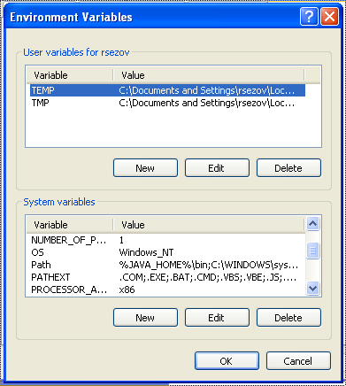Illustration 1: Setting the environment variables on Windows.
The recommended bundle uses the lightweight Tomcat servlet container as an application server to host Liferay. To install it, simply unzip it. It will create a folder and a folder structure underneath that folder. It doesn't modify configuration files, change registry settings, or anything like that. Uninstalling Liferay is as simple as deleting this folder.
Once you've unzipped Liferay, you can run it immediately. It uses an embedded database to achieve this so you can get up and running quickly; however, the default embedded database is populated with Liferay's web site. We're going to create our own web site, so let's start with an empty database.
Navigate to the folder to which you installed Liferay. Inside this folder should be a folder called bin; open this folder. Inside you will find several files. Move lportal.properties and lportal.log out of this folder, or delete them.
Now you are ready to start Liferay! If you are on Windows, double-click on the startup.bat file that's in this folder. If you are on Linux or Mac, launch the startup.sh file. Liferay will start and will create a new, blank database automatically. If you are running Windows, the Windows Firewall may pop up. Make sure you unblock Liferay, or you won't be able to connect to it via your browser once it starts, which makes this whole exercise a moot point.
To see your new portal, open up a browser and type the following URL into the address box:
http://localhost:8080
You will see Liferay's default home page:
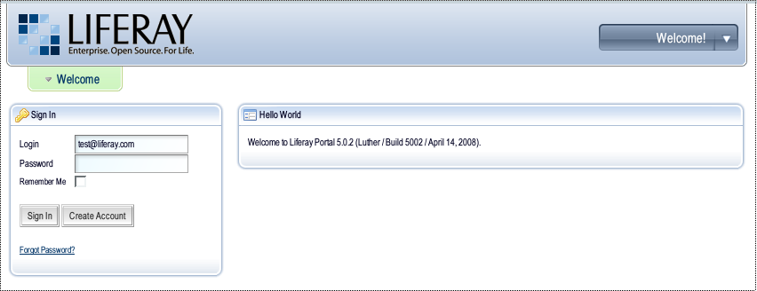Illustration 2: Liferay's default home page.
Congratulations! You have just installed Liferay Portal!

Initial Administration
Now that you have Liferay Portal running, you can begin setting up your Intranet. On the left side of your screen is the Sign In portlet. Log in with the following credentials:
Login: test@liferay.com
Password: test
The first time you log in, you will be presented with the Terms of Use page. Scroll down to the bottom of your screen and click the I Agree button. The Terms of Use screen can be disabled or customized later if you wish. Once you click the button, you will be presented with the administrative user's personal home page.
This page is accessible only to the Administrator, because that account has the Power User role. You will proceed first to customize this page in order to create an account for yourself and make yourself an Administrator.
All of the square boxes on the page are known as portlets. Portlets are web applications that can be added to a page to provide functionality. Since Liferay is a portal server, all of the functionality it provides has been implemented as portlets. The portlets that are on the administrator's page by default are good for exploring some of Liferay's functionality, but they are not very useful to administer Liferay. So we will remove these portlets and add administrative portlets to the page instead.
Click the red X icon in the top right corner of each portlet window until you have cleared the page completely. Then move your mouse cursor up to the Dock, which is in the top right of your browser window, displaying the message “Welcome Test Test!” When your mouse touches it, it will expand to show more links. Click the one labeled Layout Template. Choose the 2 Columns 70/30 layout and click Save.
Next, go back up to the Dock and click Add Application. A categorized list of applications (implemented as portlets) will appear. Click on the Admin category to expand it. You will see a list of portlets that can be added to the page. Drag the Enterprise Admin portlet off of the list and onto the left column of your page and drop it there.
Next, drag the Admin portlet into the right hand (smaller) column and drop it there. Finally, open the Community category and drag and drop the Communities portlet into the left column underneath the Enterprise Admin portlet.
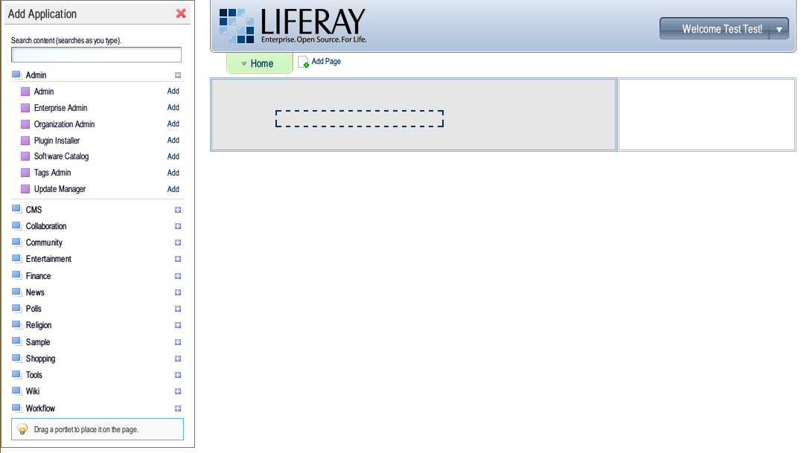Illustration 3: Dragging and dropping the Enterprise Admin portlet onto your page.
These are all the portlets you will need to do your initial administration of your new Liferay Portal server. Close the Add Application window by clicking on the red X in the top right corner. You should now have a screen that looks like this:
You are now ready to begin creating your portal!
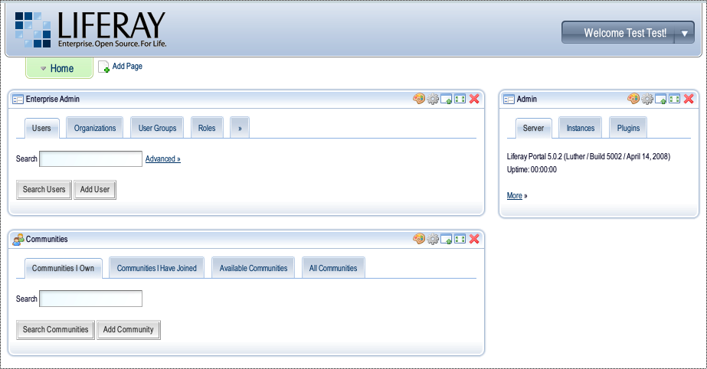Illustration 4: Completed page of administrative portlets.
Let's create the organization whose portal this is. For the purposes of this document, we'll call it My Company. Click the Organizations tab in the Enterprise Admin portlet, and then click the Add Organization button.
Give your organization a name of My Company and choose a country and region for the company. Click Save.
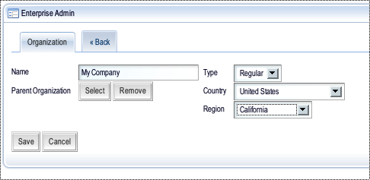Illustration 5: Creating My Company.
You will see that the form has now been expanded to allow you to add all kinds of information about the company, including email addresses, mailing addresses, web sites, and more. For now, we won't enter anything else, but you can always come back and add more data about your company here.
Click the Back tab to go back to the list of organizations. You will now see the My Company organization in the list. On the right side of the screen is a button labeled Actions. Click this button and then click the Add User link from the list that appears.
A new form will appear allowing you to enter new user information. Use this form to create an account for yourself in the portal. At a minimum, you will need to give yourself a screen name, an email address, a first name, and a last name. Click Save. As before, the form will reappear with more fields, allowing you to enter a lot more data about yourself, including a picture to use for your avatar. If you have a picture handy, go ahead and add it.
Most importantly, if you were running Liferay on a server which also was host to a mail server, you would have received a password from the system in your inbox. Since it is likely that you don't have a mail server on the same machine upon which you've installed Liferay, you will have to change your password so you can log in.
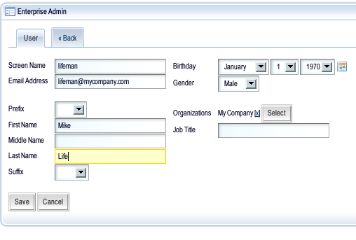Illustration 6: Adding a new user.
Click the Password tab and put the password you want to use in the two fields, and then click Save.
The next thing we want to do is give your account the same administrative rights that the default administrator account has. Once we've done that, we can change the password on the default administrator account so that it is not at the default setting and log out. When we log back in, we'll log in with your account and build the portal using your user ID.
Click the Back tab and then click the Roles tab. Click the Actions button next to the Administrator role and click Assign Members. You will see a list of people who are currently in the role (just the default administrator, as that is the only account in the system). Click the Available tab. Your name will be in the list. Check it and click the Update Associations button. Congratulations! You are now a portal administrator.
Now we need to change the default administrator's password. Go up to the Dock and click the My Account link. You will see the same user form you filled out earlier. Click the Password tab and change the password to something other than the default. Once you have done that, you can go ahead and log out of the portal.
Log back in using your new account. Remember, your login is your email address, and the password is whatever you set. You will again need to agree to the terms of use, and then you will be brought to your custom home page. You are the only person who can access this page. This time, leave it alone; you probably will want to remove some of the portlets on this page, but you may also want to keep want some of them (such as the Calendar). You can decide that later.
Instead, click the Add Page link in the top navigation. Name your page Admin and press Enter. The new page will be created. Click on the link and you will see your new, blank Admin page. As before, use the Layout Template link in the Dock to choose the 2 Columns 70/30 layout, and add the Enterprise Admin, Communities, and Admin portlets to the page.
You have a few more administrative tasks to do before we can start building your Intranet. First, we need to make your account a member of the Guest community. The Guest community ships with Liferay as the home page of your portal. You will need to be a member of the community for its links to show up in the Dock when you are logged in. On the Communities portlet, click the All Communities tab. Click the Actions button next to the Guest community and click Join.
Now we want to make it so that all newly registered users automatically become members of the Guest community. To do this, we need to go back to the Enterprise Admin portlet. Click the Return to full page link in the top right corner of the Communities portlet and then click the arrow tab in the Enterprise Admin portlet. Next, click the Settings tab. On this page, we can change some global settings for your portal. Change the Name to mycompany.com and change the Mail Domain to mycompany.com. Change the Time Zone to your time zone, and then click the Save button.
Next, click the Default User Associations tab. In the field on the top (default community names), put Guest and then click the Save button. Now when you register anyone new (or if they register themselves), they will automatically become members of the Guest community. This allows them to view both the public and private pages of the community, and gives them default permissions in the community to do such things as post to message boards, add documents to a document library, etc. You can always customize these permissions later.
You are now ready to begin building your Intranet.

Building Your Intranet
The remainder of this document will walk you through creating pages in Liferay and loading them with content. We will see a lot of the built-in features of Liferay. Because Liferay is a portal server, you can add new features to it yourself by downloading or purchasing third party portlets—or by developing some portlets yourself.

Content Management
Go up to the Dock and scroll to My Places -> Guest and click Public Pages. This the home page of your portal, and it's pretty spartan at this point. So let's jazz it up.
Go up to the Dock and click Layout Template. Pick 2 Columns 70/30 and click Save. Now drag the Sign In portlet over to the column on the right. Remove the Hello World portlet. Go up to the Dock and click Add Application. From the CMS category, drag a Journal Content portlet to the left column and drop it there. Click the Add Article icon which appears in the portlet. You will see a content management window appear. This is part of Liferay's Content Management system, and it allows you to create static content for your web pages.
We're going to put just a title at the top of the page. Give the article the name Welcome and type the word Welcome! into the rich text editor. Highlight the text you typed and choose XX-Large from the Size drop down. Click the Text Color icon which is right next to it and choose a color you like. Finally, click the Bold icon and click the Save and Approve button at the bottom of the page.
You'll be back to your home page, but this time it will be displaying the Journal article you created in a portlet window. You can add as many Journal Content portlets as you like to populate your page with content. Go ahead and use the Dock to add three more Journal Content portlets to your page: two underneath your welcome message and one in the right hand column underneath the Sign In portlet.
You can add whatever content you like to the two portlets in the column on the left: you'd generally want to put news announcements here; things you'd want everyone to see when they come to your corporate home page. Put a Café Menu in the portlet on the right, so your visitors can see what your cafeteria is serving this week. If you don't have real content, have fun making it up!
When you're finished, you should have a page that looks something like this:
Now we want to add a page for community and collaboration. Click the Add Page link at the top of the page. Give the page the name Community. Go up to the Dock, click Layout Template, and select the 3 Column layout.
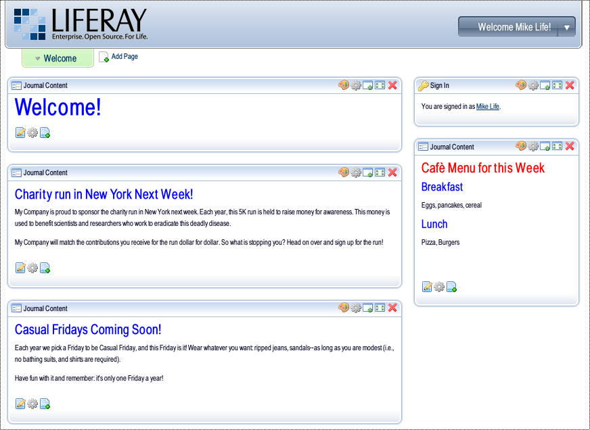Illustration 7: Home page after adding some content.
We will be making this page the central focus of global collaboration for your Intranet. Later, you can actually create organizations for the various groups within your company to have their own collaboration spaces, but this will be a shared area where everyone can go.
Go up to the Dock and click Add Application. From the CMS category, add the Navigation portlet to the left column. From the Collaboration category, add the Recent Bloggers portlet to the left column under the Navigation portlet.
In the middle column, add a Journal Content portlet from the CMS category and the Communities portlet from the Community category.
In the right column, add a Polls Display portlet from the Polls category and the Page Comments portlet from the Community category. Close the Add Application window. Add an article explaining what this page is for to the Journal Content portlet you added to the middle column.

Creating an Administrative Page
Notice that several of the portlets have no content in them? These portlets require content to be created in other areas of the portal before any content will show up. Let's take the simplest one first and fill it with content. To do this, we will create a special administrative private page in your Intranet.
Go up to the Dock, navigate to My Places -> My Community -> Private Pages. Click on the Admin page you created earlier. In the Communities portlet, click the All Communities tab. Click the Actions button and select Manage Pages. You should see the following screen:
You can see on the left a hierarchy of pages that you have been creating. So far, you have a flat list of pages, but you can nest them as deeply as you want. Keep in mind if you do this that most of Liferay's themes only provide navigation for the top level, so you will have to put a Navigation or Breadcrumb portlet on these pages in order to enable users to get to them. We have already done this on the Community page you have created, because we will be adding a nested page under the Community page.
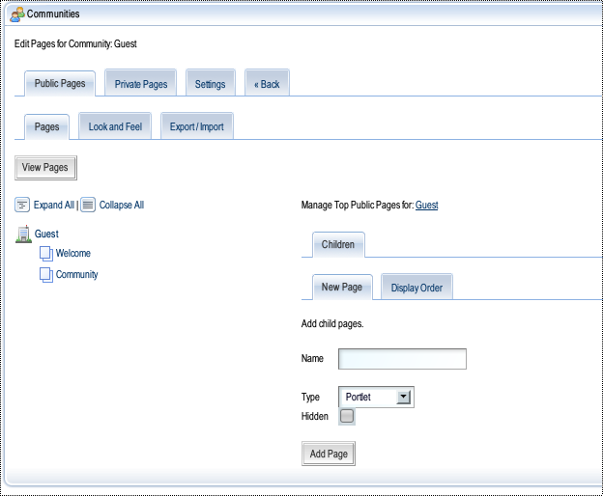Illustration 8: Liferay's Manage Pages interface.
Across the top you have tabs for Public Pages, Private Pages, and Settings. Settings affect the pages for the whole community. You can set virtual hosts, enable Google Analytics on your pages, and a whole host of other things. We won't go into that here, but feel free to explore the interface yourself.
So far, we have been creating public pages. This time, we are going to create an administrative private page. A public page is viewable by everyone, even those who are not logged in to your portal. A private page is viewable only by members of the community. By creating a private page in the Guest community, we are ensuring that only people who are logged in to the portal can view it, because we earlier made everyone who is registered in the portal a member of the Guest community by default. For this reason, making the administrative page a private page will only protect it from people who are not logged in to the portal—hardly a good security measure. So after we create the page, we will place custom security restrictions on it so that only the people we specify may view the page.
Click the Private Pages tab. You will see that there are no pages in the hierarchy on the left, because there are no private pages yet. On the right side of the screen, give the page the name Admin and click the Add Page button. Now you have a page in the tree on the left. Click on your new page, and then click the Page tab on the right side of the screen. Click the Permissions button at the bottom. You will see Liferay Portal's permissions screen. Click the Community Roles tab, and then click the Available tab. You should see the following:
Select Community Administrator and Community Owner by clicking the check boxes to the left of their names and then click Update Permissions.
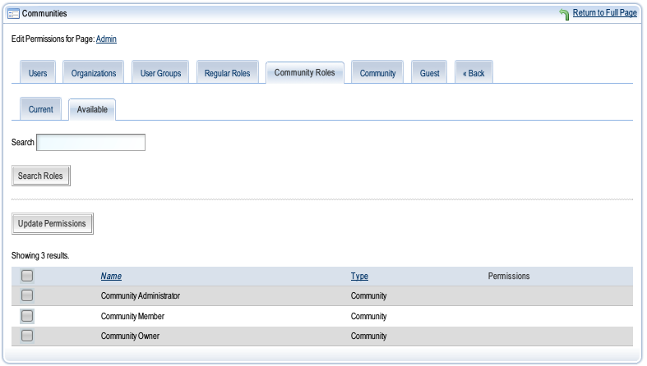Illustration 9: Liferay's permissions interface.
You will now set the permissions for the first role you selected. Select the View permission and click the arrow to move it over to the left. By doing this, you are saying that users with the Community Administrator Role can View this page. Click the Next button.
You will then be able to set the permissions for the Community Owner role. Select all the permissions and move them to the left. Then click the Finished button.
Are we done yet? No, not yet. Why? Because, though we have granted administrators access to the page, we have not yet taken away access from the rest of the community. So click the Community tab.
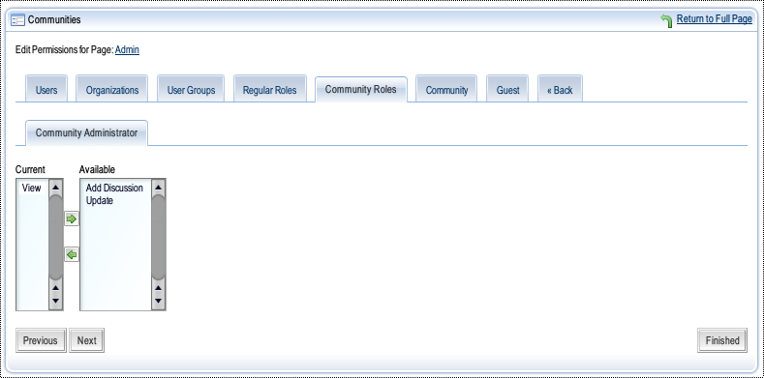Illustration 10: Setting permissions on a role.
By default, the community can add discussion (if you've added the Page Comments portlet to a page) or view any page in the community. We're going to take these permissions away. Move the Add Discussion and View permissions to the right (Available) column and click Save. Now click the Back tab.

Polls Portlets
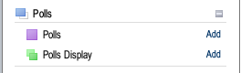Illustration 11: Polls portlets
Let's put some portlets on this page now. Click the View Pages button in the top left corner. You will presented with a now-familiar blank portal page. Go up to the Dock and click Add Application. From the Polls category, add the Polls portlet. Notice that the Polls portlet has a purple icon and the Polls Display portlet has a green icon. This is telling you that the Polls portlet is a non-instanceable portlet and the Polls Display portlet is an instanceable portlet.
This means that the Polls portlet can be added to a community once, and it holds one set of data. In this case, you will be adding poll questions with multiple choice answers. The set of questions belongs to the community as a whole. So if you add the Polls portlet to another page in the community, the same set of questions will be displayed. The Polls Display portlet, however, is different. It can be added many times to pages in the community, and each instance of the portlet can hold a different poll question. So you use the Polls portlet to create questions and the Polls Display portlet to display them and allow users to answer them.
If you were to add the Polls portlet to another community, that community would get its own set of questions that is different from the ones in the Guest community. But each instance of that portlet has the same set of data within that community. That is what makes it non-instanceable.
Once you have added the Polls portlet to the page, close the Add Application window. You have one button in a default Polls portlet: Add Question. Go ahead and click it. You will see a form which allows you to add a question and the multiple choice answers. You can even add choices beyond the default two by clicking the Add Choice button. Have fun. Make up a question. When you're finished, you should have something which looks like the following:
Click Save. You have now added a Poll question on the administrative page. This makes it so that only administrators can create poll questions. You are now ready to display this question on the Community page, where you added the Polls Display portlet.
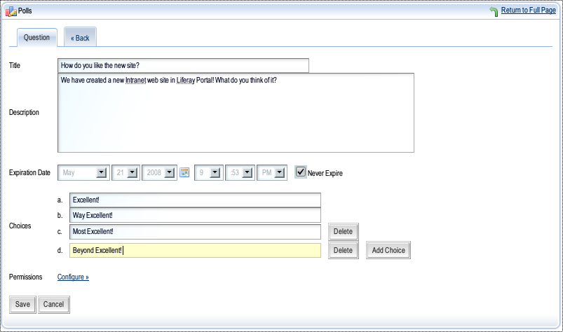Illustration 12: The Polls portlet.
Go up to the Dock and go to My Places -> Guest -> Public Pages. Click the link to the Community page you created. In the Polls Display portlet—which you added to the column on the right—click the Configuration icon. It looks like a gear. You will get a simple drop down selection box which allows you to choose a question from the Polls portlet to be displayed in the Polls Display portlet. Choose your question and click Save. Then click the Return to Full Page link.
You will now see that your poll question is being displayed in the Polls Display portlet. This allows your users to vote on the question, and it keeps track of all the votes. Once a user has voted, it does not allow that user to vote again.
You should now have a page that looks something like this:

Blogs and Blogs Aggregation
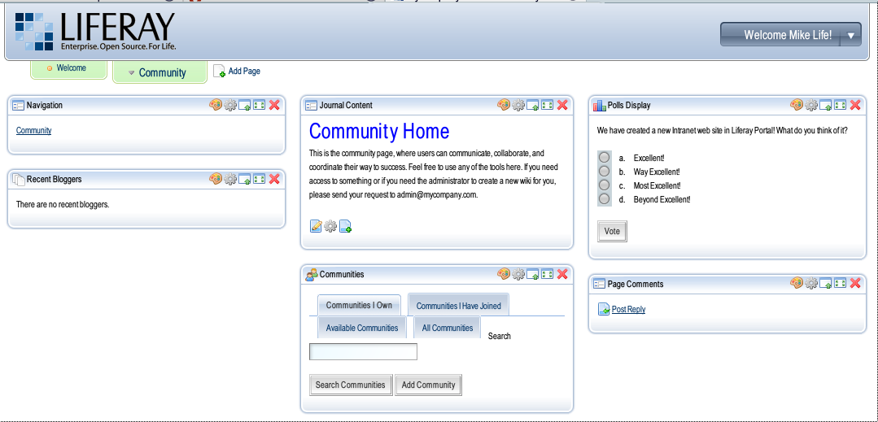Illustration 13: Community page with your poll question displayed.
Notice that there is also nothing in the Recent Bloggers portlet. That is because you have no users who are bloggers yet. Since you are the only user in the system, if you create a blog for yourself on your personal public page, it can show up in the Recent Bloggers portlet.
Go up to the Dock and select My Places -> My Community -> Private Pages. Click on your Admin page you created earlier. Click the Users tab in the Enterprise Admin portlet. Click the Actions button next to your user name and select the Manage Pages link. You will be brought to the Manage Pages screen you used earlier to create pages in the Guest community, but this time you are looking at your own, personal public pages. And as you can see from the hierarchy on the left, you have no pages. So go ahead and create a page called Home. Click the View Pages button.
You will see that you now have a blank page. Go up to the Dock and click Add Application. From the Collaboration category, add the Blogs portlet to the right column on your page and close the Add Application window.
When there are no blog entries in the Blogs portlet, it contains only one button: Add Blog Entry. Click this button and add a blog entry. You will see that it uses the same WYSIWYG editor that the Journal portlets use. You can use this to add text and images to your blog entries. When you are finished with your blog entry, click Save.
If you wish, you can add other portlets to the left hand column or change the layout to a one column layout to make the page look a bit better. In any case, you should have a blogs portlet that looks something like this:
Now use the Dock to navigate back to the Guest community, where your Intranet pages are. To do this, select My Places -> Guest -> Public Pages. Then click the Community link. You will now see that you have a blog entry listed in the Recent Bloggers portlet. People can click the link to go directly to your blog and view the entries. By default, the Recent Bloggers portlet will show every blog in the portal. You can use the Configuration icon to modify it so it displays only blogs from users of a particular organization. For now, we will leave it alone.
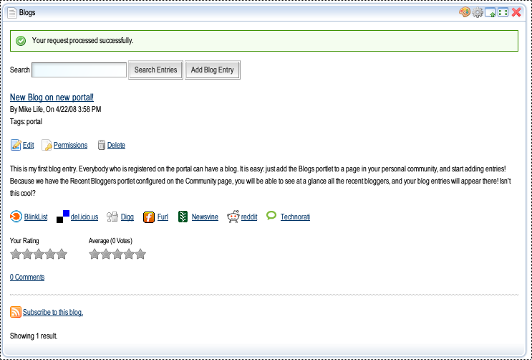Illustration 14: The Liferay Blogs portlet with a single blog entry.
We have designed this page so that as users begin using the portal, creating blog entries, and commenting on the page, the portlets will grow down toward the bottom of the page as the content within them changes. This is generally a good practice, as you want to make sure that all of the content types available to your users are above what is called the fold of the page. You don't want to hide any content at the bottom, because users might miss it entirely. If, however, your users can see that “Recent Bloggers” or “Page Comments” continue down the page, they may decide that they want to scroll down to view that content, since it is obvious that it is there. This is a good page design.
At this point, you should have a Community page that looks something like this:

Breadcrumbs and Message Boards
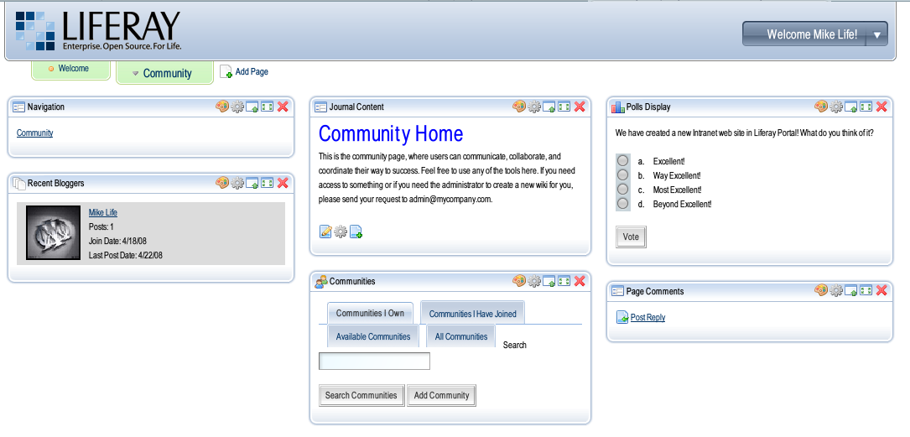Illustration 15: Continuing with the Community page.
Let's now give your users an area where they can discuss particular topics of interest to them. Go up to the Dock and click Manage Pages. Click the Children tab. You are going to create a child page under the Community page called simply, Forums. So name the page Forums and click the Add Page button. You will see that there is now an arrow next to the Community page in the hierarchy on the left. This indicates that there is at least one other page underneath Community. Click the arrow, and the hierarchy will expand.
Click the Return to Full Page link in the top right corner of the portlet window. Notice that the Navigation portlet now has a link to your newly created Forums page, and that there is no link to that page in the navigation that runs across the top of the screen. Most Liferay themes don't have drop-down menus that can display the full page hierarchy, so you need to provide your own navigation to them by using a Navigation or a Breadcrumb portlet. Of course, you can always build your own theme which includes this functionality if you need it. We will look at themes a little later in this document.
Click on the Forums link in the Navigation portlet, and you will be taken to your new, blank Forums page. Go up to the Dock, click Layout Template, choose the 1 Column layout, and click Save. Go back up to the Dock and click Add Application. Open the CMS category and click the Add button next to the Breadcrumb portlet. Open the Collaboration category and click the Add link next to the Message Boards portlet. Close the Add Application window.
You can see that the Breadcrumb portlet shows you a trail of the locations to which you have navigated in the page hierarchy. The first thing we will do is remove the portlet borders from this portlet so that it looks more natural on the page.
Click the Look and Feel icon in the top right corner of the Breadcrumb portlet window. It looks like a painter's palette. A window will pop up allowing you to change all kinds of look and feel settings for this portlet. All we want to do is remove the borders, so uncheck the Show Borders check box and click Save. Close the window by clicking on the red X in the upper right corner. Now use your browser's Refresh button to refresh the page. The portlet box is now gone! Users who are not administrators will not see the configuration links above the portlet; for all intents and purposes, the portlet content is now embedded in the page.
Now let's configure the message boards. You have probably seen message boards all over the Internet, and these are really no different. Click the Add Category button to add a discussion category. A good one to start with is General Discussion. Once you've added the name and description, click Save.
Liferay's message boards allow users to subscribe to message topics. If they do this, they will receive an email whenever somebody replies to a topic to which they are subscribed. These emails by default come from “Joe Bloggs” who has the email address test@liferay.com. This is probably not what you want.
Click the Configuration icon (looks like a gear) in the top right corner of the portlet window. Set the name and email address to something that's appropriate, such as
Name: Portal Admin
Address: admin@mycompany.com
Click Save. As you can see, you can customize the messages on other tabs of this screen. We won't be doing this here, but feel free to explore this section later. You can also customize the user “ranks,” which are whimsical labels placed on users who post certain amounts of messages to the boards. The default ranks go from Youngling (zero to 24 posts) all the way up to Yoda (1000 or more posts). You can modify the rank names and the post amounts to anything you want.
There are other settings, but we're not going to change any other settings right now. Click the Return to Full Page link to get back to the forums. If you wish, you can create more message categories. When finished, go into the General Discussion category we created earlier. Notice that you can add both subcategories and threads. You can nest categories as deep as you like. For now, we're just going to post a thread to the boards. Click the Post New Thread button.
You will see a form that allows you to post a message to the message board. There is an editor which has a syntax similar to those you'd find on other message boards. Go ahead and post a message. When you are finished writing your message, click Save.
You should now see your message. It should look something like this:

News and RSS Feeds
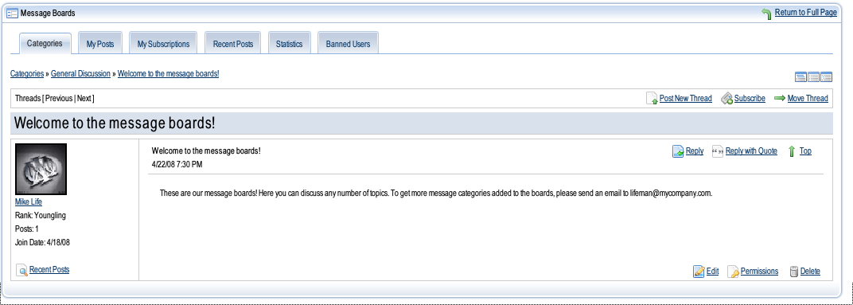Illustration 16: Message boards post.
What Intranet would be complete without industry news feeds collecting news about all of your competitors from all over the Internet? Let's create that page next.
Go up to the Dock and click Manage Pages. We're going to create a top-level page, so click the Guest link at the top of the hierarchy on the left. Give your new page the name News and click the Add Page button. Click the Return to Full Page link and then click the link to your new page in the top level navigation. Using the Dock, click Layout Template and pick the 2 Columns 50/50 layout.
Go back up to the Dock and select Add Application. From the News category, add the News portlet to the left column and the RSS Portlet to the right column. Notice that both of these portlets are instanceable portlets. This means you can add as many of them as you like to any page and can configure each instance to hold different data.
When the portlets appear, you can see that they already have news in them. They are configured by default to connect to certain feeds. Of course, you can completely customize this.
In the News portlet, click the Preferences icon, which looks like a pencil and paper. Here you can select from multiple categories of news feeds to display in the portlet. By default, Society -> International Relations and Top Stories -> Top Stories are selected. We're looking for some specific news links, so let's make some assumptions.
Your business does some outsourcing, so you are interested in news on outsourcing. Click Business: general, and then select Outsourcing News. Click Save and then click Back. Because of your industry, you compete with several companies. Click Companies, and then check off some companies and click Save and then click Back.
You get the idea. We could select more news feeds from more categories, and you can certainly do that later if you want. For now, click the Return to Full Page link. You will see that news articles from all the categories you selected are now being displayed.
The RSS portlet is a bit more free-form. It allows you to add any feed you can find on the Internet to your portal. Is there a feed you like? If so, go find it and copy the URL to your clipboard. If not, here's a handy feed for you to use:
http://www.liferay.com/web/guest/home/journal/rss/14/news
Click the Configuration icon (looks like a gear). You can see that three feeds are already configured in the portlet. If you like them, you can leave them there. If not, you can click the Remove icon next to the feed to remove it. In either case, you will need to click the Add Feed icon to add another feed to the list. Paste your feed into the URL field, and optionally give it a title. Select the number of entries you want to display and click Save.
You should now have a page that looks something like this:

Projects and Wikis
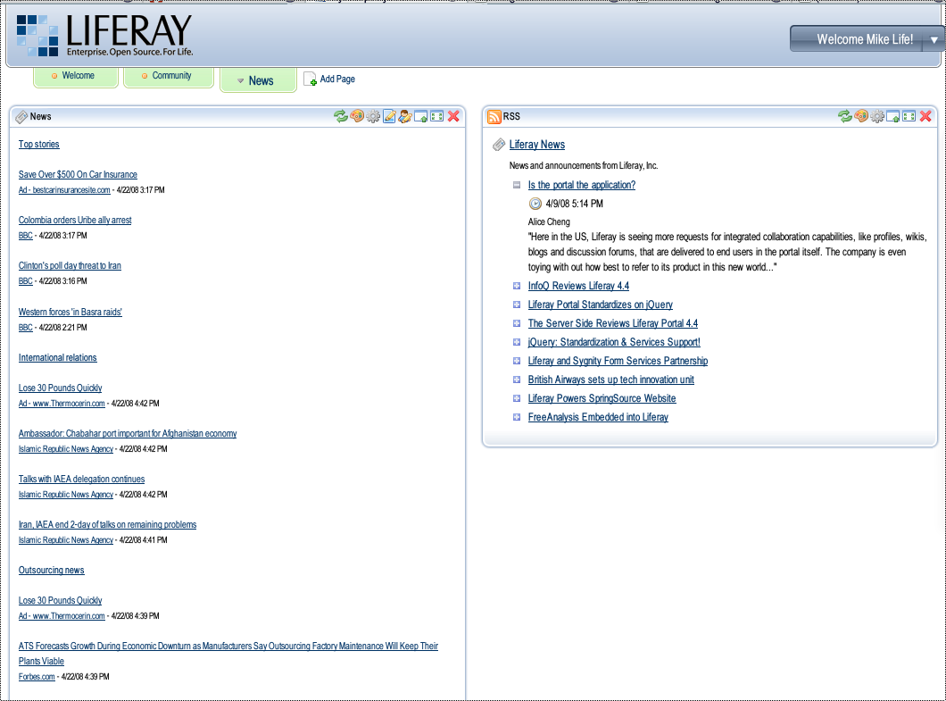Illustration 17: Your news feeds.
Every Intranet should have a collaboration area where users can go to work on their documents and share data pertaining to them. Many portals use online Document Libraries and discussion forums for these, and Liferay has this functionality as well. But probably the most ideal tool for this sort of thing is a Wiki. So let's set up a Projects page for users to collaborate on their projects.
Click the Add Page link in your top level navigation and give the page the name Projects. Click on your new page. Go to the Dock and pick Layout Template. Choose the 1 Column layout and click Save. Now go to the Dock again and click on Add Application. Add the Wiki portlet from the Wiki category.
Liferay's wiki is a full-fledged, powerful wiki application that supports every wiki feature you could want:
- Flexible Wiki syntax (Creole format)
- Images from the Internet or attached to the page
- Multiple wikis in the same community
- History
- Attachments of files
- Print Preview
- Page moving (without breaking existing links to the page)
- Diff of page versions
- Email subscriptions to changes
- Table of Contents
- Optimistic Locking (notification that somebody else is editing the same page)
- Child pages
- Tag based navigation
And yes, there is more. We won't have time to explore many of these features here, but suffice it to say that Liferay's wiki will be sufficient to the task (and likely will exceed the number of features necessary) for managing your company's wiki.
Let's edit the main page first and add some introductory text. There's a link that says “This page is empty. Edit to add some text.” Go ahead and click that link.
You are brought to a page which allows you to enter text, either in Wiki syntax or via the WYSIWYG HTML editor you've used previously. Let's use the Wiki editor.
Entering text into a Wiki is done via wiki syntax. Liferay's wiki uses the Creole syntax, which is a common wiki syntax that has been designed to be a standard for wikis going forward. Because many wiki markup engines have in the past had slightly different syntax, this is an effort to standardize them. There is a cheat sheet for the syntax to the right of the wiki editor.
Enter some text into the editor. Here's some example text:
== Projects ==

Welcome to the projects page! Here you can get an overview of the projects being worked on internally and optionally gain access to contribute to them. Ask your project manager for further details.
When you are finished, click the Save button. You will notice that your text has now been formatted properly via the wiki syntax. There is also a link below the page stating there are 0 attachments. Let's add an attachment to the article by clicking that link.
You will be brought to another page which holds meta data about the page. One of the tabs on that page is labeled Attachments. Click the Add Attachments button and attach a document from your machine to the page. Use the multiple file uploader (requires Flash) or the classic uploader to upload a document.
Before we leave this section of the page, click on the General tab. Notice that you can provide RSS feeds to your Wiki content from here. This allows you to publish wiki content to other areas of your portal or to other web sites. There is also a permissions link here which allows you to permission this wiki page just like any other asset in the portal.
The History tab will let you see all the revisions of the page, compare between those revisions, and even revert to a previous revision of the page if you wish to.
There's more to explore here, but for now, click the back icon next to the title of the page (FrontPage). You'll be taken back to the front page of the wiki, and now it will be saying there's one attachment.
There's a small icon at the top right corner. If you roll your mouse over it, a label pops up: Manage Wikis. Go ahead and click it. This is where you can create various wikis for various projects. Right now, there is only one, labeled Main. This is fine and can serve as an introduction to the page or as a “roll up” wiki that a project manager might use to summarize the status of many projects. You have already added a page to this wiki.
Let's create a new wiki for another project. Click the Add Wiki button. Give your project a cool name, like Project Idioglossia. Click Save. Now you will see that there are two wikis: the main one and one for your new project. You can add as many as you want. Notice the Actions button next to the wikis. You can use this button to permission the wikis by user group, organization, community, or role so that only the project team working on that particular project can update that wiki. As you did before, you can go in and examine the permissions that are there by default to determine whether they are appropriate. For now, click the Back tab.
Now you can see that Project Idioglossia has a link up at the top of the portlet window along with the main wiki. To get to that wiki, simply click on the link and begin adding pages and attachments.
We have one more thing to do to this page. Since there's only one portlet on this page, and it takes up the whole page, don't you think it would look better if we removed the portlet window borders? Click the Look and Feel icon (the painter's palette), uncheck Show Borders and click Save. Close the window and refresh the page. You should now have a page that looks something like this:

Organization Pages
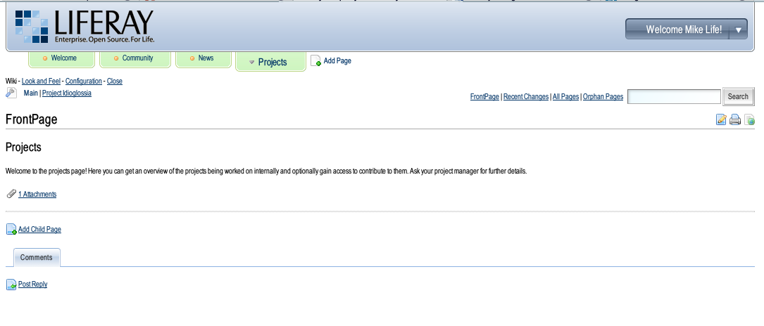Illustration 18: The project page with the wiki portlet.
Your portal does not have to be built solely in the Guest community. There will be times when certain organizations within your company need their own space. In this case, you can allow them to create pages for their own use.
Every company has a marketing organization in order to spread the word about the company's products so they can be sold. So let's create a marketing organization for My Company and allow them to create their own pages.
Go back to your personal community via the Dock: My Places -> My Community -> Private Pages. Go to your Admin page. Click the Organizations tab. Click the Actions button next to My Company and then click Add Suborganization. Call it My Company Marketing and give it a country / region, and then click Save.
Because you created the organization, you automatically become its owner. However, you're not in marketing, you're a portal administrator. So you need to create and permission a marketing user who will administer the marketing organization. Click the Actions button next to My Company Marketing and click Add User (if the user already existed in the portal, you could have clicked Assign Members). Add a user. Make up his or her name if you want to. When finished, click Save. As before, change the password so you can log in as this user. Click the Return to Full Page link in the top right of the portlet window.
Now we want to make our marketing user an administrator of the marketing organization. Click the Organizations tab again and click the Actions button next to My Company Marketing. Select Assign User Roles. Click the Organization Owner role. You will see that you are in this role, because you created the organization. Click the Available tab, and you should see your new user in the list. Check off the user's name and click the Update Associations button. The user you created is now an owner of the marketing organization in the portal, with the ability to create users, pages, add portlets, and manage permissions on resources in the organization. Click the Return to Full Page link.
The marketing organization can now have their own completely separate web site in the portal. The interface for creating it is exactly the same as what you have been using to create the site in the Guest community. In the Dock, you now have access to the marketing organization's pages in My Places. There are no pages in there yet, but we can create one.
Click the Organizations tab in the Enterprise Admin portlet. Click the Actions button next to the My Company Marketing organization and then click Manage Pages. You can add both public pages which everyone can see (even Guests) or private pages that only members of the My Company Marketing organization can see. Since we created this organization because the marketing people wanted their own space, that probably means they want private pages. So we'll create a home page for them there and then send the user you just created an email telling her that she can now begin creating pages.
Click the Private Pages tab. You will be at the new page interface automatically. Give the page the name Home and click Add Page. Click the View Pages link in the top left corner to go to the page. Go up to the Dock, click Add Application, and from the CMS category, add a Journal Content portlet to the page. Add an article called Marketing Home and put some introductory text into it. When finished, click Save and Approve.
As you can see, you can build portals for your entire organizational hierarchy in Liferay. You can also create communities which cut across organizational hierarchies to provide services that anyone can access. And for those who want a private section of the site to do their work, you can create that too.
You can go and send that email now. Your marketing person probably wants to get started.

Themes
Building out your intranet has been pretty easy, hasn't it? But there's one glaring omission in what we've been building: all the pages look the same, and they have the Liferay logo sitting in the top left corner. You probably want the My Company logo up there, and maybe a whole different look and feel.
Developers can create new themes for Liferay that completely change the way it looks. With a good theme, it can be hard to tell that your site is even running Liferay. For now, though, you don't have to wait for a developer to create your theme: you can grab one of the ones from Liferay's repository on the Internet.
Go up to the Dock, and select My Places -> My Community -> Private Pages. Click on the Admin page. Go back to the Dock and click Add Application. From the Admin category, add the Plugin Installer to the page under the Communities portlet in the left column. This portlet allows you to download and install new portlets and themes from Liferay's internet repository. In addition to that, you can add other repositories that you create internally or others create.
Click the Theme Plugins tab. Browse the themes and when you find one you like, click on it. You can see a screen shot of it and if you click the screen shot, you can see a larger version. To install the theme, simply click the Install button: the theme will be automatically downloaded and installed.
You can apply themes to whole communities, individual pages, and everything in between. Before you apply a theme to the Guest community, you may want to try it on your personal community first to make sure that it looks like what you want. Go up to the Dock and click Manage Pages. Click the Look and Feel tab. You should see the theme or themes you installed in the list. Choose it and the page will automatically refresh with the new theme.
Look to the left, where the page hierarchy is. You can see that the Admin page is selected. You have just applied the theme to the Admin page in your personal community. If you were to navigate to the Home page, it would still have the old theme. To apply the theme to the whole community, click the community name at the top of the hierarchy—which in this case is your name. Click the Look and Feel tab again, and select the theme. Now it is applied to every page in your community.
Now we've taken care of the look and feel, but what about that pesky Liferay logo? We want to replace it with the logo of our company. This can be done in several places.
If you want to replace it for the entire portal, click the arrow tab in the Enterprise Admin portlet. Click the Settings tab. You can see now where the Liferay logo is set. Click the Change link underneath it. Click the Browse button and find the logo you want to use on your machine. Click OK and then click Save. The logo will change to your company logo across the portal.
If you want to replace the logo just for a particular community or organization, you can do that too. Click the Return to Full Page link and then click the All Communities tab in the Communities portlet. Click the Actions button next to the Guest community and then click Manage Pages. Click the Settings tab and then click the Logo tab. You can browse for a logo that will be displayed just for this community.
Go ahead and change the theme for the Guest community to one of the themes that you downloaded. You can do this by accessing the Manage Pages interface through the Communities portlet. If you're already there, click the Back tab from the logo page. Click the name of the community (Guest) which is at the top of the hierarchy. Then click the Look and Feel tab and select your theme. To see your new Intranet page with the theme applied, access it via the Dock: My Places -> Guest -> Public Pages.
You may want to customize the titles of your portlets now (which you can do by clicking on them), or remove the portlet windows altogether. Modify the page as you see fit. When you are finished, you should have something that looks like this:
You are done!
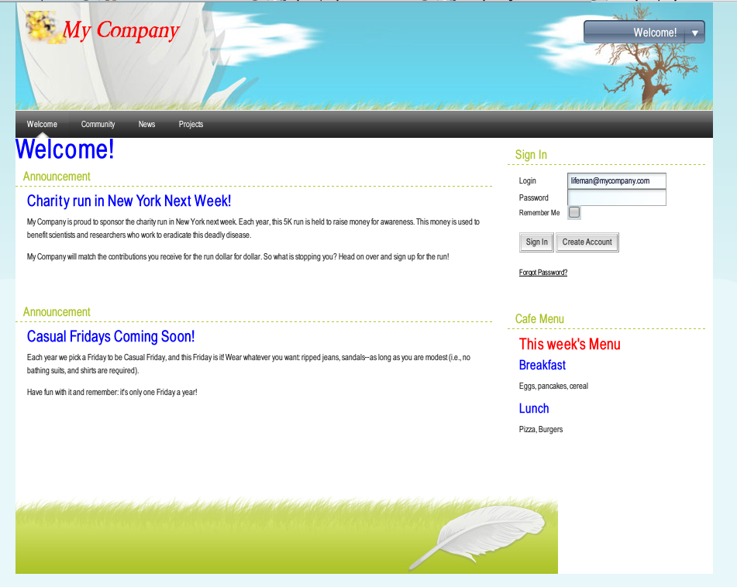Illustration 19: The final home page of your Intranet. This theme is called Dreamy.
We hope you have enjoyed creating an Intranet from scratch using Liferay!

