

Portal Developer's Guide

This Document Is A Draft, and May Have Inaccuracies.

Richard L. Sezov, Jr.
Liferay Developer's Guide
Richard L. Sezov, Jr.
Copyright © 2009 by Liferay, Inc.
Put ISBN Number Here if this is a published work

Contributors:
Put contributor names here

Table of Contents
This Document Is A Draft, and May Have Inaccuracies. 1
1. Introduction 5
Heading 2 6
Heading 3 6
Heading 4 6
Fonts 6
Images 7
2. Chapters 9
Tables 9
PDFs 10

Introduction
This is a first chapter page. There is some test text on it so that you can see that when the page breaks, it breaks into a left and right page set, with page numbers listed properly. This makes it so that when the book is published, the page numbers are on the proper side of the page.
This is a first chapter page. There is some test text on it so that you can see that when the page breaks, it breaks into a left and right page set, with page numbers listed properly. This makes it so that when the book is published, the page numbers are on the proper side of the page.
This is a first chapter page. There is some test text on it so that you can see that when the page breaks, it breaks into a left and right page set, with page numbers listed properly. This makes it so that when the book is published, the page numbers are on the proper side of the page.
This is a first chapter page. There is some test text on it so that you can see that when the page breaks, it breaks into a left and right page set, with page numbers listed properly. This makes it so that when the book is published, the page numbers are on the proper side of the page.
This is a first chapter page. There is some test text on it so that you can see that when the page breaks, it breaks into a left and right page set, with page numbers listed properly. This makes it so that when the book is published, the page numbers are on the proper side of the page.
This is a first chapter page. There is some test text on it so that you can see that when the page breaks, it breaks into a left and right page set, with page numbers listed properly. This makes it so that when the book is published, the page numbers are on the proper side of the page.
This is a first chapter page. There is some test text on it so that you can see that when the page breaks, it breaks into a left and right page set, with page numbers listed properly. This makes it so that when the book is published, the page numbers are on the proper side of the page.
Notice that at the top of the page the header automatically picks up the name of the chapter without you having to do anything. Pretty cool, eh? This will happen as long as you use Heading 1 for your chapter titles. It will format the page automatically. At the bottom of the page, whatever you've got in your Heading 2 will appear. This tells readers what section of the chapter they are on, which is also helpful.
I figured out how to do this when I was first creating the template, but haven't done it since, so I don't remember how I did it. For this reason, don't mess with the headers and footers, except to take the Draft text out of them when you're done with your document. Otherwise, it could take a while to re-enable this feature.

Heading 2
The text above is in the Heading 2 style. Always use the style to create headings. They are done in a hierarchy, so if you need a subheading, you would then use Heading 3 (see below). They are also properly spaced, so you won't ever have to press Enter twice to space things out.

Heading 3
The text above is Heading 3. As you can see, it is slightly smaller than Heading 2, denoting its position in the hierarchy.

Heading 4
The text above is Heading 4. As you can see, it's even smaller than Heading 2, plus it's indented.

Heading 5
The text above is Heading 5. It's even smaller and further indented. Though there are further headings defined in the template, we don't use them and they may not be styled properly. You hopefully shouldn't need to go beyond Heading 5.
Note also that the headings determine what shows up in the Table of Contents. If you change the text in these headings and then scroll up to the Table of Contents, you can update it by right-clicking on it and selecting Update Index/Table. The Table of Contents will then update so that it reflects what is in your headings. So we can generate a Table of Contents automatically very easily by making sure we use the heading styles above for all of the chapters. Heading 5 does not appear in the Table of Contents.

Fonts
Here's a list of the fonts in this document:
Body Text: Gentium Book Basic
Headings: Delicious
Code: Liberation Mono
There should be no other fonts used in this document other than these. This also gives us some freedom to more easily change the fonts in the future, if for some reason we want to change the book design.

Images
Images can be inserted via Insert → Picture → From File. Select the image and then click OK, and the image will be resized so it fits and inserted where the cursor is. We then have a particular style for the images which right now is done manually, because I haven't figured out how to do this automatically.
Right click on the image and select Caption. Type the caption and click OK (I do have a style for the caption). Next, click somewhere in the text to deselect the image. Next, click on the image. You'll see that the image is selected without the caption frame. Right click on it and select Picture. Select the Borders tab. Select the .50 pt line width and Set All Four Borders (the second box from the left) under Line Arrangement. Then click OK. You should get a result like below:
So basically, what we're after for all images is a small border around the image itself, with the caption outside the border. The caption should automatically number each illustration as it's added to the document.
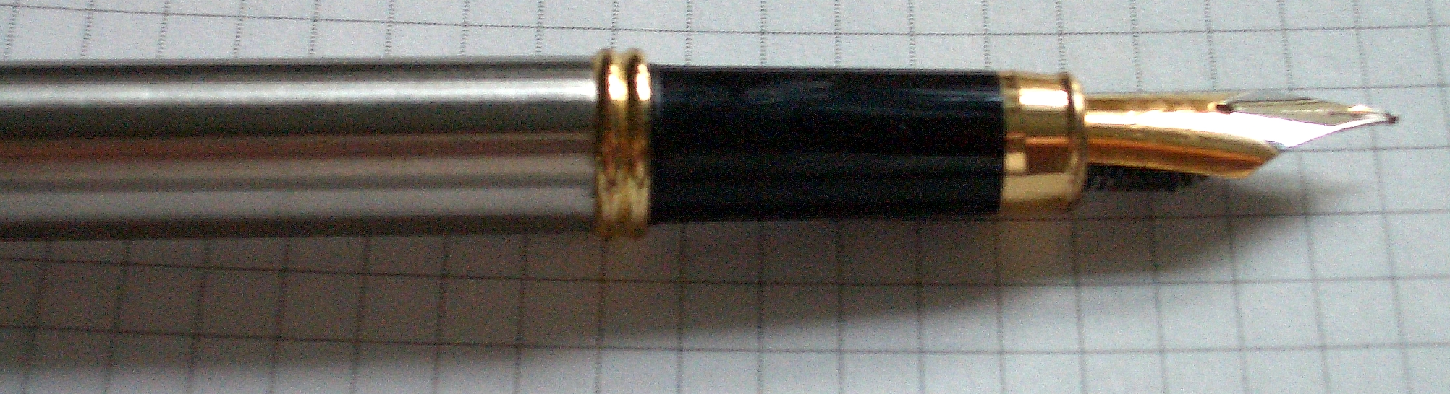Illustration 1: This is a fountain pen from China. I use these all the time.
I am the only one I know who does this.
If you need to move the image around, make sure you select the frame that the image is in (with the caption) and not the image within the frame.

Chapters
When you need to create a new chapter, click Insert → Manual Break, and then select Page Break. Also select the Page Style. A new chapter should always start on a Right Page style.
Once the break occurs, go up and select the Heading 1 style and type your chapter name. It should get numbered automatically. When you hit Enter, you'll break down here, to the middle of the page. You can then just start typing your text and using the headings like you did before. If you update the Table of Contents, you'll see that your new chapter will appear.
All of this is done to make the writing process as easy as possible. All the design decisions are pretty much taken care of in order to free you to concentrate on the content. You won't have to worry so much about properly formatting things, because all of that is done for you if you use the styles. If you don't use the styles, the document will become a mess, and I (Rich Sezov) will be very unhappy. :-)

Tables
Okay, let's talk about tables. You can create a table via Table → Insert → Table... and then specifying the number of rows and columns you need. This will create something ugly, that looks like this:
Ugly Table Column 1 | Ugly Table Column 2
Some text | Some more text
Nobody wants a table that looks like this. So we've created a style for tables as well. Here it is:

File | Purpose
dock.vm | Implements the Liferay Dock
init-custom.vm | Allows you to add your own custom Velocity variables
init.vm | In conjunction with VelocityVariables.java in Liferay, sets many Velocity variables that correspond to Liferay Java objects.
navigation.vm | Implements the page navigation within the theme
portal_normal.vm | The overall template for all pages the theme implements. This file includes the other files.
portal_pop_up.vm | The overall template for any portlets which implement pop-up windows.
portlet.vm | The template for portlet windows within the theme.
Once you create your table and stick your data in it, you can format it this way by placing the cursor in the table and selecting Table → Autoformat and then selecting the Liferaybook table style.

PDFs
When generating the PDF for this book, you will want to set some options that are not the default. Select File → Export as PDF. If you are producing a PDF for the web site, leave the JPEG compression alone. If you are producing a PDF for print, select Lossless Compression. After this, make sure the Export Automatically Inserted Blank Pages check box is checked. This ensures that your Right Pages stay as Right Pages, and that your page numbering in the PDF matches what's in the Table of Contents and Index.

