

Working Smarter with
Liferay Social Office

Richard L. Sezov, Jr.
Stephen Kostas
Michelle Hoshi
Working Smarter with Liferay Social Office
Richard L. Sezov, Jr., Stephen Kostas, Michelle Hoshi
Copyright © 2010 by Liferay, Inc.

This work is offered under the Creative Commons Attribution-Share Alike Unported license.

You are free:
- to share—to copy, distribute, and transmit the work
- to remix—to adapt the work
Under the following conditions:
- Attribution. You must attribute the work in the manner specified by the author or licensor (but not in any way that suggests that they endorse you or your use of the work).
- Share Alike. If you alter, transform, or build upon this work, you may distribute the resulting work only under the same, similar or a compatible license.
The full version of this license may be viewed here:
http://creativecommons.org/licenses/by-sa/3.0

Table of Contents
1. Introduction 11
What can you do with Social Office? 11
How is Social Office Different from Liferay Portal? 12
Social Office Concepts 13
Users 13
Applications 14
Sites 14
Navigating Social Office 15
Summary 16
2. Getting Started 17
Installing the software on your platform 17
Using the Windows Installer 18
Using the Cross-Platform Zip File 19
Installing Social Office for Production Use 20
Database Setup 20
Social Office Home 21
The portal-ext.properties File 21
DB2 22
Derby 22
Hypersonic 22
Ingres 23
MySQL 23
Oracle 23
PostgreSQL 23
SQL Server 23
Sybase 23
Signing In 24
Sign In Options 24
OpenID 24
Create An Account 25
Forgot Password 25
Navigating Social Office 25
Home 25
Sites 26
Contacts 27
Announcements 27
Activities 27
Tasks 28
Today's Events 28
Weather 28
Profile 28
Activities 29
Mail 29
My Sites 30
The Control Panel 30
Navigating the Control Panel 30
Using the Control Panel 31
Summary 32
3. Sites 33
Adding a Site 33
Browsing Sites 33
Managing Permissions for Sites 34
Site Roles 34
Site Applications 34
Calendar 34
Importing and Exporting Calendars 36
Documents 36
Editing a File 38
Blogs 40
Forums 42
Permissions 43
Adding Categories and Mailing Lists 43
Using the Forums 44
Forums Administrative Functions 46
Wikis 47
Navigating in the Wiki application 48
Getting Started with the Social Office Wiki 48
Adding and Editing Wiki Pages 49
Page Details 50
Members 51
Other Site Options 52
Adding/Removing Applications 52
Layouts 52
Announcements 53
Chat 55
Summary 55
4. Control Panel 57
Navigating the Control Panel 57
Social Office Architecture 58
Users 58
Roles 58
Sites 58
User Groups 58
Using the Control Panel 59
Adding Users 59
User Management 60
Roles 61
Defining Permissions on a Role 62
User Groups 63
User Groups and Page Templates 64
Global Server Settings 68
Password Policies 69
Settings 69
General 70
Authentication: General Settings 70
Authentication: LDAP 71
Global Values 71
Single Sign-On 76
Authentication: Central Authentication Service (CAS) 77
Authentication: NTLM 78
Authentication: OpenID 78
Authentication: OpenSSO 79
Authentication: SiteMinder 79
Default User Associations 79
Reserved Credentials 80
Mail Host Names 80
Email Notifications 80
Identification 80
Miscellaneous: Display Settings 80
Monitoring 81
Server Administration 81
Resources 81
Log Levels 81
System Properties 81
Portal Properties 82
Shutdown 82
OpenOffice 82
Summary 82

Preface
Liferay Social Office is Liferay's brand new social collaboration product for the enterprise. We are excited to bring both the product and this book to you, in the hope that you'll be able to use each to enable your teams to work together more efficiently.
Some time ago, we at Liferay were brainstorming some common use cases which Liferay Portal does a good job solving. One of these is team-based collaboration. Many of our customers have used Liferay Portal both inside their enterprises and outside on the Internet to provide a better way of sharing documents and data with the people with whom they work every day. Liferay Portal provides a very flexible solution which allows you to do that. But it can also do much, much more. Because Liferay Portal has that flexibility, the path from the initial install to a robust web site that could be used for collaboration was not always straightforward to the new user. Business users wanted a product they could install and use right away.
This was not the only reason for the new product. Internally, we realized that we needed a product like this ourselves, and that we already had all the features in place to make it possible. We just needed to assemble them together in a way that most optimally supported the scenario of social collaboration, and we wanted to make getting set up as easy as possible for new users.
In this way, Social Office was born. We created the product to provide a simple, out of the box solution for team collaboration. Using Liferay Portal as a base, Social Office provides you with a fantastic array of features that you don't have to spend a lot of time configuring. In fact, you can have a full production environment set up in less time than it takes to brew a pot of coffee.
Though it sounds like this is a brand new product, it's in many ways an older, proven solution as well. Since it uses Liferay Portal as a base, it inherits all the benefits of a mature, stable solution which has been in the marketplace for some time. In addition to this, we've had an early adopter program, and the product is already in production use with multiple customers. It has even received industry recognition: it's in the Gartner magic quadrant for social software, and has been mentioned as the only open source, Java-based solution for collaboration in a comparison review of products in this space.
Since our early adopter program was so successful, we're excited to finally release the product to the general public. Customers who have already started using it have been exceptionally pleased with the results, and you gain the benefit from our collaboration with those early adopters. In fact, this is one of the great things about open source: we've received extensive feedback on the product, including bug fixes and feature requests. Our customers have told us whether things are intuitive or not, and we've incorporated that feedback right back into the product.
This book is for those who are setting up and administering an installation of Liferay Social Office. From installing Social Office to introducing you to its entire feature set, you'll see all of the things Social Office can do to help your team. We hope you'll use it as a tool to get Social Office up, running, and integrated into your enterprise.
Conventions
Sections are broken up into multiple levels of headings, and these are designed to make it easy to find information.
Source code and configuration file directives are presented like this.
If source code goes multi-line, the lines will be \
separated by a backslash character like this.
Italics are used to represent links or buttons to be clicked on in a user interface and to indicate a label or a name of a Java class.
 Tip: This is a tip. Tips are used to indicate a suggestion or a piece of information that affects whatever is being talked about in the surrounding text. They are always accompanied by this gray box and the icon to the left.

Bold is used to describe field labels and portlets.
Page headers denote the chapters, and footers denote the particular section within the chapter.
Publisher Notes
It's our hope that this book is valuable to you, and that it's an indispensable resource as you begin to administer a Social Office server. If you need any assistance beyond what's covered in this book, Liferay, Inc. offers training, consulting, and support services to fill any need that you might have. Please see http://www.liferay.com/services for further information about the services we can provide.
As always, we welcome any feedback. If there is any way you think we could make this book better, please feel free to mention it on our forums. You can also use any of the email addresses on our Contact Us page (http://www.liferay.com/contact_us). We are here to serve you, our users and customers, and to help make your experience using Social Office the best it can be.
Author Notes
Special thanks are due to my co-authors, Stephen Kostas and Michelle Hoshi, who turned around their chapter assignments in record time while the product was changing under them. I also cannot underestimate the help of Ryan Parks in quickly answering our calls for help and in giving us further explanation of various features. And I must also make special mention of Stephen Wilburn, who copy edited this document. I thought the text was pretty clean, but he slogged through our hastily written prose with an attention to detail that made it look like monkeys had typed this thing. If you find this book to be readable, it's because of him.
As always, we hope this book is useful to you as you begin your journey with Liferay Social Office!

Rich Sezov
June, 2010

Introduction
“Help!”
This has been the cry of information workers everywhere who have tried to manage complex projects through email and shared folders. You've probably had a similar experience: you're collaborating on a document with a team of people and are emailing it back and forth. Person A creates the initial document and Person B replies with some edits. Person C replies with additional edits at the same time Person A replies with the corrections from Person B. Person D takes this and rewrites a whole section of the document while Person B and C respond to Person A's update. Pretty soon, it becomes very difficult to determine which document is the latest document.
The same scenario plays itself out when working in shared folders. Person A creates a document and puts it in a network share. Person B edits the document and saves it under a different file name. Person C edits it and re-saves the original. Person A tries to reconcile the two, while Person D opens Person B's document and saves yet another version. Before you know it, you have the same problem you had with email: you can't tell which document is the latest document. Additionally, you have a worse problem: you don't have a clear history of how the document got to where it is in the first place.
“Help!”
Liferay Social Office is a collaboration tool that is designed to answer that call for help by meeting the needs of teams who work together on projects. It is an easy-to-install web application that facilitates collaboration for large and small businesses alike. With Liferay Social Office, you'll have the system and your workgroups up and running in no time, with all the tools necessary for them to work more efficiently and more easily than before.

What can you do with Social Office?
Social Office gives you the social collaboration features you need to do virtual teamwork. You can coordinate calendars and schedules, write shared blog entries, work together on documents, discuss issues in forums, document everything in a wiki, and more. The underlying theme is that all discussion and collaboration is kept with the asset. What does this mean? It means that the asset, whether that be a document, a thread, a blog entry, or a wiki article is the star around which all of the discussion and collaboration orbits.
Trying to collaborate on assets through email or server shares works up to a certain point—but then it fails because it's a backwards way of doing the work. The asset in that scenario becomes secondary, and the “wrapper”—email or the share—becomes the primary target of the work. So instead of concentrating on the asset which the team is trying to produce, the focus turns to the wrapper. In the case of a shared folder, you might manually rename documents according to a numbering scheme so everyone can tell which is the latest—that is, until someone forgets to do so, or until someone accidentally overwrites the latest document. In the case of email, users try to navigate huge threads while passing an asset back and forth—until someone forgets to “reply all” or until someone starts a new thread (and maybe forgets to put the whole list on the thread). Working in the mediums of shared folders or email puts the focus on working with the wrapper, not the asset. And so what happens is the asset gets lost because they're forced to focus on the wrapper instead of the asset. With Social Office, you will be free to concentrate on their assets—the system gets out of your way so that it's a simple matter for your team to work together.

How is Social Office Different from Liferay Portal?
Social Office benefits from its core, which is based on Liferay Portal. Users of both will find a comfortable, familiar interface, because many of the applications in Social Office come from Liferay Portal. However, while the core software is similar, the two are tooled for different purposes.
Liferay Portal is a full featured web portal, containing an industry-leading suite of built-in applications and tools. It's highly customizable and businesses use it to run major web sites all over the world. We've optimized Liferay Portal for creating state-of-the art, robust web sites that serve millions of users every day.
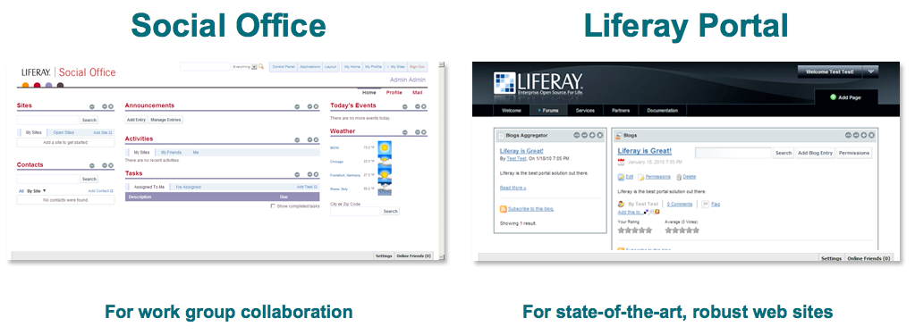Illustration 1: The difference between Liferay Portal and Social Office
Social Office has a more focused purpose. We've designed it for work groups needing to collaborate on documents and data in the office. The included tools and defaults were carefully chosen to provide users working within a group the ability to easily communicate, collaborate, and coordinate their tasks. Additional applications were added to the product to support these goals.
If you're creating a public web site and need the full features of an unparalleled, industry-leading engine to power that site, Liferay Portal is the ideal solution for you. If, however, you're creating a site that's designed to help people within specific groups communicate and accomplish tasks on a corporate Intranet, Social Office will help you accomplish that with minimal set up and administration.

Social Office Concepts
Liferay Social Office is designed around the concept of users and their work. For this reason, everything in Social Office is centered around keeping you up to date on the activities of your teammates. This works not only within individual teams, but also across all the teams of which you're a member. To do this, Liferay Social Office gives each user his or her own personal space, and each team has its own site where its work is stored. Using the power of Liferay's social API, users' activities are tracked and reported to the rest of the team.
For example, if a user on Team A shares a document, that activity is displayed not only in Team A's activities, but also in each team member's activities. This provides the ability for the rest of the team to know what work is being done as soon as possible, and then they can respond by making their own contributions.
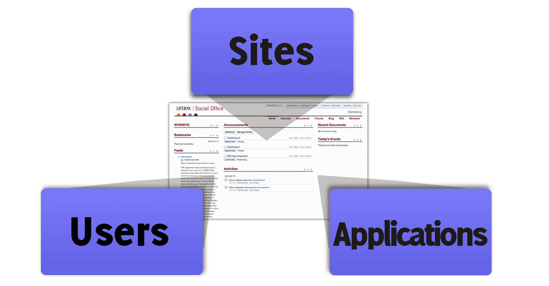Illustration 2: The three components which make Social Office work
There are really only three concepts which Liferay Social Office uses to accomplish all of this: Users, Applications, and Sites. Let's take a closer look at each to see how you can use Social Office to help your teams work better.

Users
Users are at the core of Social Office. In order to interact with and use Social Office, you must have a user account. Users can register themselves or the system can be set up so that your account is created by an administrator. Administrators have full control over the entire site, can create and delete other users and sites, and can take care of the initial configuration. Administrators can also create additional users with administrative capabilities.
Power Users are advanced users who can create Sites, but have no access to the Control Panel, and therefore cannot create users or set permissions. Power users take care of the day-to-day operations of their Sites.
Other users are the regular members of your team who use the system to get their day-to-day work done. They can view the Sites they to which they have membership and they can interact with files and documents on those Sites.

Applications
Users make use of applications every day in Social Office to get their work done. Each page on every site in Social Office is only as useful as the applications installed on it. The available applications range from utilities for online information such as weather forecasts or RSS feeds, to blog and wiki tools, and more.
By default, each user has a number of applications installed on his or her home page. Users have full control over their personal pages: they can add or remove applications from their pages and adjust the settings for available applications. This ability can be modified or removed altogether by administrators.
When a new site is created, it's pre-populated with pages and applications on those pages. In many cases, each application gets a page of its own; in other cases, applications are aggregated together on a single page to provide a unified place where users can see all the new information that their teammates have posted.
Owners of sites are free to add or remove applications from pages on their sites. Regular users will not have the ability to do so. In this way, site owners can maintain the most optimal working environments for their users.

Sites
Sites are the structure that holds everything else in Social Office together. Every page contained in Social Office is part of a Site—including users' personal pages, which are just personal Sites. Sites are, at first glance, a collection of pages with specific functions, but they are also the basis of a sort of user “community.” Users can be members of certain Sites either by assignment or by invitation, and once they are members they can use the full capabilities of the Site, as well as receive notification of various activities.
Sites ultimately become the key to good collaboration in Social Office, because each Site contains its own Calendar and set of events, as well as its own Document Library, Wiki, Blog, and Announcements. These tools enable members of a Site to communicate effectively with each other. Personal Sites help individual users as they log in to see an aggregated list of activities. This list comes from the activities of all the teams with whom they are collaborating. This way, users can see at a glance everything that's happening with their work, and they can respond very easily to anything that needs attention across all of the Sites of which they are members.
Here's an example of how it all comes together:
Ryan, Jim, and Michael are all members of the Sales Site. Ryan schedules a meeting for the whole Sales team about a new product launch and puts it on the Calendar. When Jim and Michael log in, they both receive a notification of the meeting. Jim can't make the meeting, but he's been maintaining the Sales Wiki for new products, so he asks Michael to update it for him after the meeting.
Michael updates the Wiki with the new information after the meeting, and Ryan posts a summary of what happened in the meeting in the Sales Blog. When Jim logs in the next day, he'll receive a notification of the new Blog post with the information he missed, as well as a notification about the updated Wiki. Additionally, he can easily access those pages to catch up on what he missed. This works because Social Office automatically keeps everyone up to date on the activities of the teams they work with every day.

Navigating Social Office
Liferay Social Office has two primary areas of navigation: the global navigation area and the Site navigation area. These are detailed in two toolbars at the top of the screen. The global navigation also includes a persistent search option as well as the ability to click on the company logo in the top left corner to return to the logged-in user's home page.
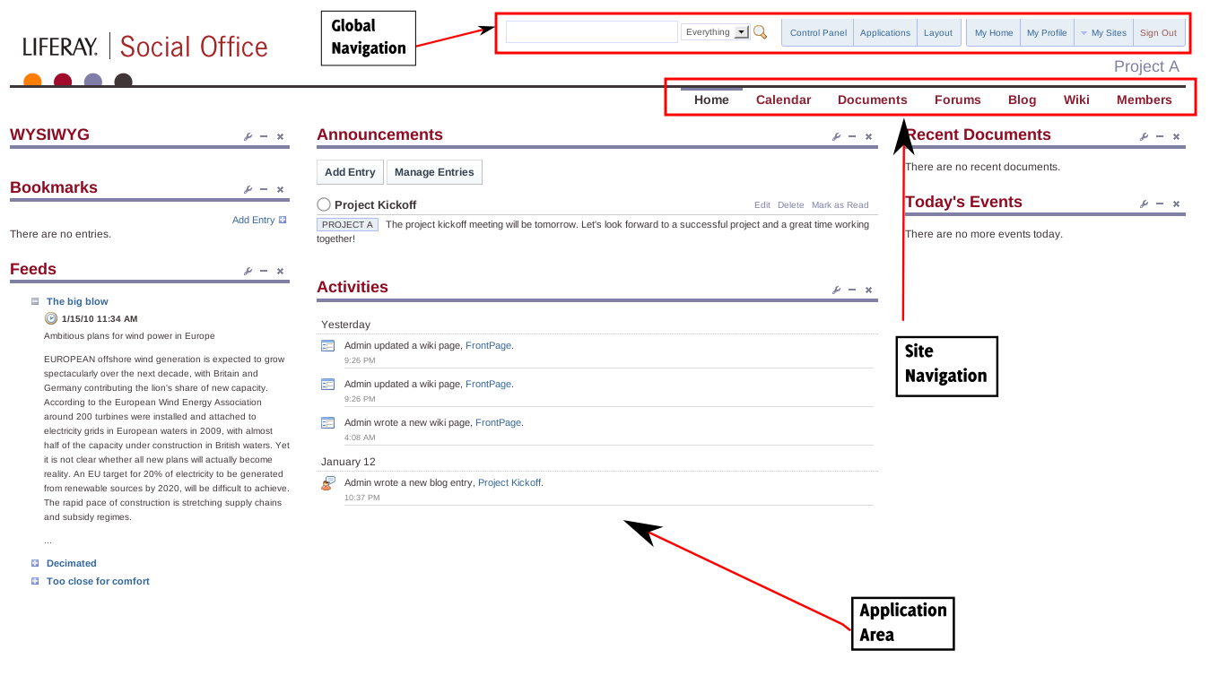Illustration 3: The Social Office interface
Beneath the global navigation is the site navigation. Beneath this is the application area, where one or more applications can reside. Users will primarily use the application area in their day-to-day work.
Social Office dynamically shows or hides links in the navigation based on the permissions of the logged-in user. For example, administrators will see links to the Control Panel, Applications, and the Layout templates, while regular users will not.

Summary
As you can see, Liferay Social Office provides you with an unbeatable, web-based solution for team collaboration. It allows your team to work unhindered, getting out of their way so that they can put their focus on their work instead of worrying about how the system works. And it gives you peace of mind in knowing that all assets are in one place and protected by a system that supports proper document versioning so that you can see the full progression of how your assets got to their final form. We've worked hard to make Social Office a pleasure to work with, and we think you'll agree that it helps your teams work better.

Getting Started
Liferay Social Office is designed to be quick and easy to set up and get running for your enterprise. We've endeavored to make the set up process as simple and straightforward as possible. Whether you're installing Liferay Social Office on your own machine for testing purposes or installing it for production use, set up time is measured in minutes, not hours.
This chapter will describe the procedure for installing Liferay Social Office and connecting it to an enterprise database so that it can be used in production environments. While this should be sufficient for everyone who uses Social Office, note that since Social Office is based on Liferay Portal technology, its performance can be optimized in similar ways as Liferay Portal. If you decide that you need an advanced configuration of Social Office (such as a cluster), please see the Liferay Portal Administrator's Guide, specifically Chapter 6: Enterprise Configuration for more information.
Once Social Office is installed, you'll want to become familiar with the user interface. For this reason, we'll go over some of the first steps you'll take as a Social Office administrator.. Before you know it, you'll be up and running—ready to streamline your work and facilitating collaboration between team members!

Installing the software on your platform
The initial release of Social Office is available as a bundle from Liferay. You should have received either a cross-platform .zip file or a Windows executable file. In either case, you'll find that installing Social Office is simple and straightforward.

Using the Windows Installer
Simply double-click on the installer you have received and the installation will begin. A standard installer will appear and ask you where you want to install the software. The default is C:\Liferay, but you can change this to whatever path you wish. Once the installer is finished, Social Office is immediately available—there's no need to reboot. After the installation, you'll find a new group in your Windows Start Menu for Social Office. To start Social Office, simply click on Start. That's it! To stop Social Office, click on Stop. (see illustration 5). Note that this particular default install is useful only for demo and evaluation purposes: it uses an embedded database which is great for getting up and running quickly. If you want to configure Social Office for production use, please see the section below on connecting it to an enterprise database.
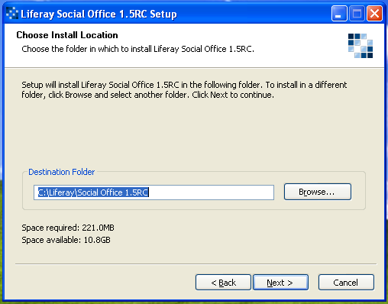Illustration 4: The Social Office Windows installer
Because Social Office is a browser-based application, it starts up as a web server process on your machine. For this reason, you'll see a window pop up and display some messages before your browser launches to view Social Office. This is normal and to be expected. Please do not close this box! When it has finished starting, your browser will launch automatically so that you can log into Social Office.
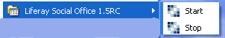Illustration 5: Starting and Stopping Social Office

Using the Cross-Platform Zip File
If you're running an operating system other than Windows, you can use the cross-platform .zip file to install Social Office. The one prerequisite is that Java is installed properly. Install Java and make sure that your JAVA_HOME environment variable is pointing to the location of your JDK. Once this is done, simply extract the .zip file to the location of your choice, and then Social Office can be launched via scripts from the command line.
The same caveats apply to the .zip distribution as apply to the Windows installer: the default install is useful only for demo and evaluation purposes because it uses an embedded database. While this database is great for getting up and running quickly, it doesn't perform well in production environments where many users access the system. For this reason, when you're ready to configure Social Office for production use, please see the section below on connecting it to an enterprise database.
To start Social Office, launch the script that's found in the [Social Office Folder]/tomcat-[version]/bin folder, where [Social Office Folder] is the top level folder extracted from the .zip file.
You can use the following command on Linux / Mac / Unix to start Social Office:
./startup.sh
Social Office will then launch.
Similarly, to stop Social Office use this command:
./shutdown.sh
Windows systems also have the same start and stop scripts, found in the same folder. To start Social Office on Windows, use this command:
startup
And to stop it, use this command:
shutdown
If you're on Linux, Unix, or Mac, you can see the Tomcat console by issuing the following command:
tail -f ../logs/catalina.out
Once Social Office has completed its startup, it will automatically launch a web browser so you can see the home page. If this doesn't happen, launch your web browser and then go to the following address: http://localhost:8080. The default Social Office login page will appear in your web browser. Now you're ready to explore the various features of Social Office!

Installing Social Office for Production Use
Eventually, you'll want to install Social Office onto a production server. Unlike Liferay Portal, which can be downloaded both as a standalone .war file or as a bundle, Social Office has been simplified by distributing it as a bundle with an application server. This greatly simplifies the setup and configuration for Social Office, as there's significantly fewer steps to get a bundle up and running.
Unzip the bundle or install it to the location from which you're going to run it using the instructions above. For example, you might use D:\apps in Windows or /opt in Linux or UNIX variants. As we mentioned before, the default bundle installation of Social Office uses an embedded database. While this works great for rapid evaluation or development, it has several drawbacks:
- Only one user can access it at a time since the data is stored on a file on disk and HSQL locks it when doing changes.
- The data is stored inside the bundle and might be lost on redeployment.
- This configuration doesn't scale well and will perform poorly once multiple users access the system.
For these reasons, you don't want to run Social Office against the embedded database. Fortunately, Social Office has great support for most production-ready databases, and it's easy to configure Social Office to use them. The exact instructions will depend on the database, but here's a summary:
- Create the database in your DBMS of choice (see the section below labeled Database Setup for further information).
- Create a portal-ext.properties file in the Social Office Home folder which points to the database and mail session.
- Start Social Office. Social Office will create the tables automatically and start.
As you can see, this is a simple, three step process. Using MySQL as an example, we'll go over the exact settings in portal-ext.properties below.

Database Setup
First things first, let's get that database set up. Using your database vendor's tools, create your database and grant a user ID full access to it. You'll eventually configure Social Office to connect to the database using this user ID. Once this is completed, the first time Social Office starts it'll create the indexes and tables automatically.

Social Office Home
In Social Office, there's a folder named Home. This folder is the top level folder that was extracted from the .zip file or the location you installed Social Office via the installer.
Social Office Home is primarily used for storing special configuration files, like portal-ext.properties. Please take a moment to find this folder on your system. We'll be creating a configuration file there.

The portal-ext.properties File
Liferay Social Office, like Liferay Portal, makes use of a configuration file to store its settings. These properties files differ from the configuration files of most other products in that changing the default configuration file is discouraged. In fact, the file that contains all of the defaults is stored inside of a .jar file, making it more difficult to customize. Why is Social Office set up this way? Because Liferay's products use the concept of overriding the defaults in a separate file rather than going in and customizing the default configuration file. You only change the settings you want to customize in your own configuration file, and then the configuration file for your software remains uncluttered and contains only the settings you need. This makes it far easier to determine whether a particular setting has been customized— and it makes the settings more portable across different installations of Liferay Portal and Liferay Social Office.
The default configuration file is named portal.properties, and the default version resides inside the core of Social Office. To override the settings in this file we use another, similarly named file called portal-ext.properties. This file is stored in your Social Office Home folder. By default, the file doesn't exist at all, so you'll need to create it to get Social Office connected to your database.
So let's get started pointing your Social Office bundle to your database. Create a file called portal-ext.properties in your Social Office Home folder. Since this file overrides default properties that come with Social Office, you're going to override the default configuration which points Social Office to the embedded HSQL database. Using the built in connection pool, you can easily connect Social Office to most popular database servers. The template for MySQL is provided as an example below.
#
# MySQL
#
jdbc.default.driverClassName=com.mysql.jdbc.Driver
jdbc.default.url=jdbc:mysql://localhost/lportal?useUnicode=true&characterEn- coding=UTF-8&useFastDateParsing=false
jdbc.default.username=mommy
jdbc.default.password=daddy
In the configuration above, we're assuming the user name is mommy and the password is daddy. Obviously, you would instead use the user ID and password you configured earlier in your database. You would also point the JDBC URL to your database server, unless you're running the database on the same machine as Social Office.
For email there's a similar procedure using the built-in mail session. The mail session is a resource which enables communication between Social Office and your mail server. Please note: configuring the mail session properly is very important! Since several of Social Office's applications rely heavily email notifications, the ability to communicate with your mail server is essential. To configure the mail session, please add the following directives to your portal-ext.properties file (substituting your mail server information):
mail.session.mail.pop3.host=localhost
mail.session.mail.pop3.password=
mail.session.mail.pop3.port=110
mail.session.mail.pop3.user=
mail.session.mail.smtp.auth=false
mail.session.mail.smtp.host=localhost
mail.session.mail.smtp.password=
mail.session.mail.smtp.port=25
mail.session.mail.smtp.user=
mail.session.mail.store.protocol=pop3
mail.session.mail.transport.protocol=smtp
Save the file. You're all done! The next time you start Social Office, it'll connect to your database server and create the tables it needs to function.
We used MySQL above, just as an example, but of course Social Office supports most common databases. Below we've provided the templates for all of the supported databases. Use the template that corresponds to the one you're using.

DB2
jdbc.default.driverClassName=com.ibm.db2.jcc.DB2Driver
jdbc.default.url=jdbc:db2://localhost:50000/lportal:deferPrepares=false;fullyMaterializeInputStreams=true;fullyMaterializeLobData=true;progresssiveLocators=2;progressiveStreaming=2;
jdbc.default.username=db2admin
jdbc.default.password=lportal

Derby
Derby is an embedded database and is not recommended for production environments.
jdbc.default.driverClassName=org.apache.derby.jdbc.EmbeddedDriver
jdbc.default.url=jdbc:derby:lportal
jdbc.default.username=
jdbc.default.password=

Hypersonic
Hypersonic is an embedded database and is not recommended for production environments.
jdbc.default.driverClassName=org.hsqldb.jdbcDriver
jdbc.default.url=jdbc:hsqldb:${liferay.home}/data/hsql/lportal
jdbc.default.username=sa
jdbc.default.password=

Ingres
jdbc.default.driverClassName=com.ingres.jdbc.IngresDriver
jdbc.default.url=jdbc:ingres://localhost:II7/lportal
jdbc.default.username=
jdbc.default.password=

MySQL
jdbc.default.driverClassName=com.mysql.jdbc.Driver
jdbc.default.url=jdbc:mysql://localhost/lportal?useUnicode=true&characterEncoding=UTF-8&useFastDateParsing=false
jdbc.default.username=
jdbc.default.password=

Oracle
jdbc.default.driverClassName=oracle.jdbc.driver.OracleDriver
jdbc.default.url=jdbc:oracle:thin:@localhost:1521:xe
jdbc.default.username=lportal
jdbc.default.password=lportal

PostgreSQL
jdbc.default.driverClassName=org.postgresql.Driver
jdbc.default.url=jdbc:postgresql://localhost:5432/lportal
jdbc.default.username=sa
jdbc.default.password=

SQL Server
jdbc.default.driverClassName=net.sourceforge.jtds.jdbc.Driver
jdbc.default.url=jdbc:jtds:sqlserver://localhost/lportal
jdbc.default.username=sa
jdbc.default.password=

Sybase
jdbc.default.driverClassName=net.sourceforge.jtds.jdbc.Driver
jdbc.default.url=jdbc:jtds:sybase://localhost:5000/lportal
jdbc.default.username=sa
jdbc.default.password=
As you can see, Social Office supports a number of the leading databases in the industry today.
Social Office will take about a minute to launch while it creates the tables.. Once this is completed, a new browser window automatically opens and you'rre presented with the Sign In screen.

Signing In
When prompted, sign in using the default user id and password.
Screen Name: admin
Password: admin
Go ahead and sign in using these credentials. If this is the first time you're logging in, you'll be prompted to choose a password reminder. Once you've chosen a question and filled out the answer, click Save.

Sign In Options
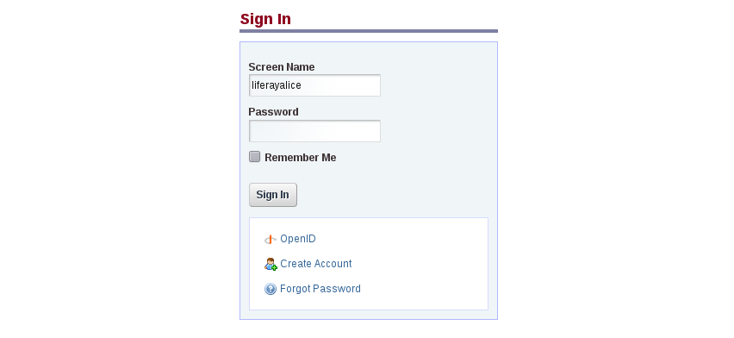Illustration 1: Sign In Portlet

The Sign In screen has a three options at the bottom of it. These are options you've probably seen on other web sites.

OpenID
OpenID is a new single sign-on standard which is implemented by multiple vendors. The idea is that multiple vendors can implement the standard, and then users can register for an ID with the vendor they trust. The credential issued by that vendor can be used by all the web sites that support OpenID. Some high profile OpenID vendors are AOL (http://openid.aol.com/screenname), LiveDoor (http://profile.livedoor.com/username), and LiveJournal (http://username.livejournal.com). Please see the OpenID site (http://www.openid.net) for a more complete list.
The obvious benefit of OpenID for the user is that he or she no longer has to register for a new account on every site in which he or she wants to participate. Users can register on one site (the OpenID provider's site) and then use those credentials to authenticate to anyOpenID-supported web site. Many web site owners struggle to build communities because end users are reluctant to register for so many different accounts. Supporting OpenID makes it easier for site owners to build their communities because the barriers to participating (i.e., the effort it takes to register for and keep track of many accounts) are removed. All of the account information is kept with the OpenID provider, making it much easier to manage this information and keep it up to date.
The OpenID link is the first of three links available directly under the Sign In button. Social Office's integration with OpenID allows users to log in using their OpenID identifier from their preferred OpenID provider instead of having to create a brand new login for Social Office.

Create An Account
The second link is for account creation. If a new user wants to log in and doesn't already have login credentials, he or she would use this link.. Note that administrators can disable this function, thus requiring administrators to create all accounts.

Forgot Password
The last is the Forgot Password link. This one does pretty much what it says: if a user has login credentials but can't remember his or her password, the user clicks this link to submit his or her user name and password reminder and a new password is sent to their email address on file. This is just one of the many email notifications that Social Office sends to users, and is one of the reasons that setting up the mail server properly is so important.

Navigating Social Office
Upon first logging in to Social Office, you'll notice that you're directed to your Home Page. Under your name at the top of the page you'll see three options, Home, Profile, and Mail.

Home
This is the user's home page. This is where users are directed each time they log in to Social Office. It's here that users can find relevant information on what's going on each day as well as track announcements, activities, and tasks.
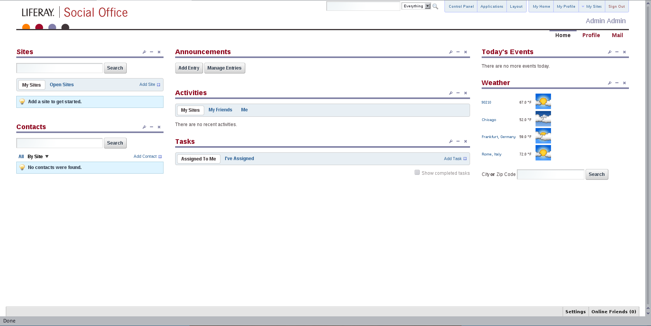Illustration 2: Personal Home Page of the Admin user

The left column contains the Sites portlet as well as the Contacts portlet. The center column contains three aggregation portlets: Announcements, Activities, and Tasks. The right column shows Today's Events and Weather. You can remove each of these applications from your home page by clicking the x in the upper right hand corner of the application. To add an application back (or add a new application) simply click the Applications tab at the top of the page. This is located between Control Panel and Layout. You can also move the applications to different locations on the page by selecting the title of the application and dragging and dropping them onto a column of the page.
You can also change the layout of the page if you don't like the default three-column layout. To do this, click the Layout button at the top of the page. Don't worry, we'll give you full details on layouts in the next chapter.
That's the overall view of a user's personal home page. Let's dive deeper and take a look at the functions of each application on this page.

Sites
In Social Office, Sites are collections of Users who have a common interest. Each site is pre-populated with collaboration pages allowing you to quickly start collaborating with others. You can create a site for any project or department that requires collaboration between users. For example, a company could create a site specifically for the marketing team, research team, or HR department. To drill down even further, the marketing team could create sites for projects A, B, and C. The great thing about Social Office is that as soon as a site is no longer needed (say project A has been successfully launched) that site can easily be deleted and a new site created for the next project.
This portlet is an aggregation of all of the sites to which a user belongs. Initially, you will want to click Add Site. If you know a site has already been added, you can click Open Sites to see a list of sites that are available for you to join. To go back to our example, If a user creates content in the site for project A, and is then re-assigned to project B, the user simply leaves the project A site and joins the project B site. All the content that this user created for project A will remain in the project A site—and the user will now have access to everything in project B. This allows him or her to immediately start learning and contributing to the team.

Contacts
Here you'll find a list of all of your contacts within Social Office. Contacts are people you added to your network within Social Office. To add a contact, simply click the Add Contact button at the top right corner of the portlet.

Announcements
The Announcements portlet lists all the announcements that are relevant to you. An announcement is any message that a user wishes to share with others in Social Office. Anyone can create an announcement. When creating an announcement, you choose the scope, display, and expiration dates. The scope is used to define who within social office receives the announcement. This can be everyone, All Site Owners, or all users within a specific site. As an example, this is great for project managers who wish to share a message with every user within a specific site or for Admins who have an important announcement for all users within Social Office.

Activities
The Activities portlet aggregates all the recent activities that are relevant to you. An activity is any change or update that a user made while logged into Social Office. For example, if the admin of the marketing site creates a wiki on how to interact with advertisers and you're part of the Marketing site, then an activity is displayed indicating that an event took place. In this application, activities are scoped in three ways: by sites you belong to, by the activities of your friends within Social Office, and by your own activities. The advantage of this is that users can quickly see what's happened since they last logged in to Social Office.

Tasks
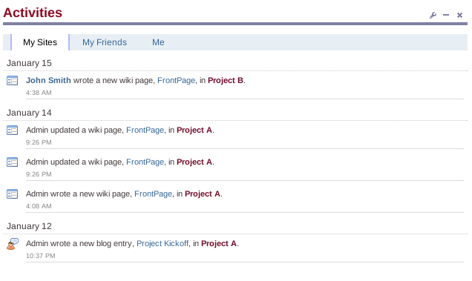Illustration 3: Activities Feed
Tasks are assignments that are in various stages of completion. They can be assigned to specific people within Social Office. The Tasks portlet allows you to view all of the tasks that others assigned to you, as well as all the tasks that you assigned to others.

Today's Events
Today's Events will give you a quick overview of all of the public events for each site that you belong to. These events are pulled from the calendars of those sites. See the Calendar section in the Sites chapter to learn about creating new events.

Weather
This lists the weather for cities that you choose. By default it lists 90210, Chicago, Frankfurt, and Rome. To change the default cities, simply click the Configuration button and select Preferences. To search for a city, type the desired city name or zip code into the search box at the bottom of the portlet. Doing this will open up a new window that displays the current weather for the city or zip code you're searching.

Profile
Clicking Profile will take you to your profile page. Your profile page is basically a resume that lets other users in Social Office know your contact information as well as different projects that you have worked on. To edit this click Edit Profile and Edit Projects in the lower left hand corner under your picture.
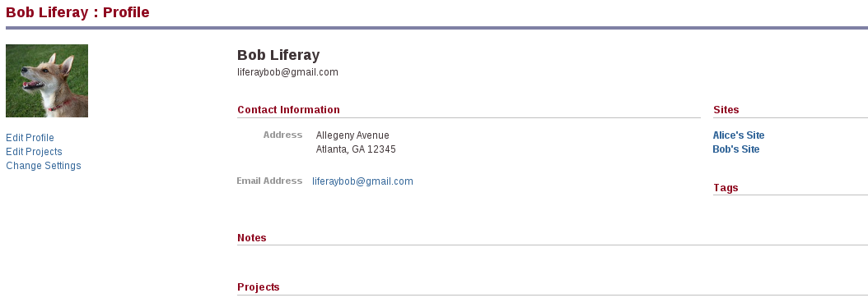Illustration 4: Profile

Activities
This is the same as the Activities portlet on your home page. It aggregates all of the recent activities for your sites, your friends, and you. The benefit of having an activities feed on your profile page is that when other users in Social Office navigate to your profile page, they can see what you and your friends have been up to recently.

Mail
Social Office offers a mail client. This is great because it means you have the convenience of not having to log in to another server or use another application to check and send your email. Currently, Social Office can integrate with any mail server that uses the IMAP protocol, as well as Google's GMail service.
In order to check and receive email in Social Office you'll need to configure the mail portlet settings. This is where you'll configure your email accounts. To start click Add Mail Account. Next choose Gmail Account or Custom Mail Account and follow the directions. After you have successfully added an email account, when navigating to the mail page, you'll be presented with the option to Check Your Email or Configure Email Accounts.
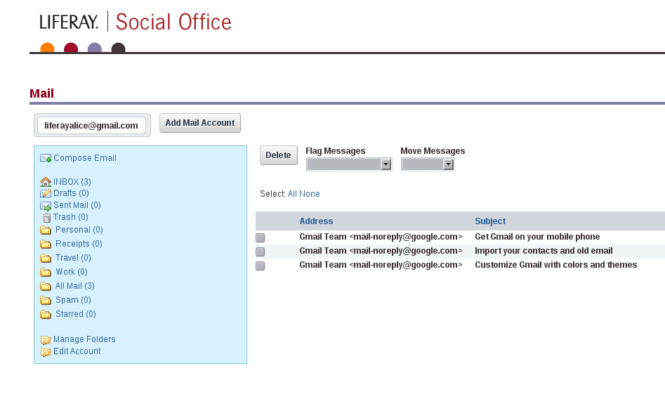Illustration 5: Default view of Social Office's email client.

Social Office also provides a global navigation area at the top right of the screen. This is one way to navigate away from your personal page to other areas of Social Office.

My Sites
This shows you a list of all of the Sites which you're currently a member of. Should you click on one of the sites you'll be redirected to the home page for that particular site. This is a quick way to navigate to any site of which you're a member.

The Control Panel
The Control Panel takes you to the administrative functions of Social Office. Only Administrators will have access to the Control Panel.

Navigating the Control Panel
The Control Panel is very easy to navigate. On the left side is a list of headings with functions underneath them. The headings are in alphabetical order, but the functions are in a logical order.
User Name: The first section is always the logged in user's personal space. Here, you can change your account information.
Portal: The Portal section allows portal administrators to set up and maintain the portal. This is where you can add and edit users, roles, and configure the settings of the portal.
Server: The Server section contains administrative functions for configuring portal instances and more.
All of the functions that you'll need to maintain social office can be found in the control panel.
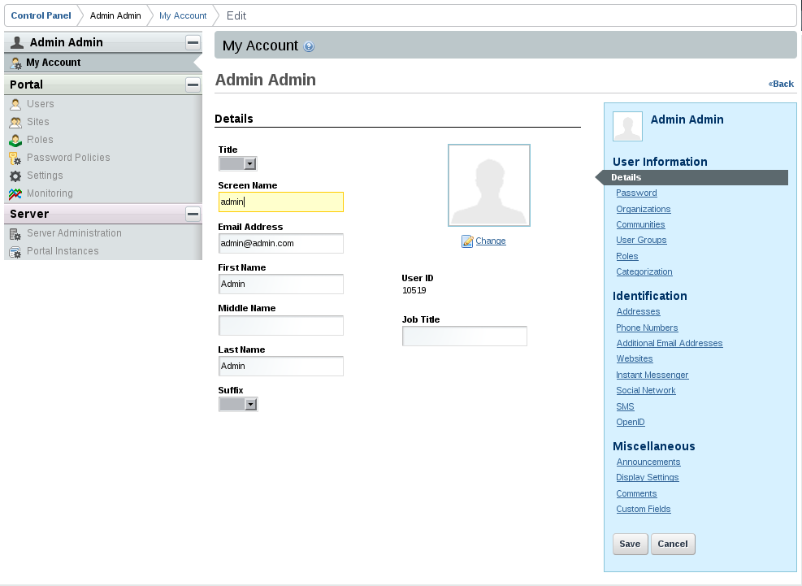Illustration 6: Control Panel

Using the Control Panel
The Portal section of the Control Panel is used for most administrative tasks. This is where you'll find the interface for the creation and maintenance of
- Users: These are individuals in Social Office who are representative of actual people. They are assigned a screen name and a password in order to login to Social Office.
- Roles: Roles are groupings of users that share a particular function within Social Office according to a particular scope. In Social Office there are two scopes that roles can take. The first is a site role. This is a role that has permissions that are applicable only within the site that it's assigned to, such as the Marketing Site. The second is a regular role. The permissions associated with this role are effective throughout social office and not just within one particular site.
Additionally, it allows you to configure many server settings, including:
- Password Policies: If you (as an admin) have certain password requirements, a password policy is where you would enforce this. Some examples of password policy settings are allowing a user to change his own password, preventing reuse of old passwords, enabling password expiration after a specified time, and enabling account lockout after a certain number of failed logins. These are just some of the settings that can be set and managed with a password policy.
- Authentication options, including Single Sign-On and LDAP integration. Social Office currently supports several single sign-on solutions including, LDAP, CAS, NTLM, OpenID, Open SSO, and SiteMinder. Social Office also supports any LDAP directory including but not limited to Apache Directory, Fedora Directory, Microsoft Active Directory, Novell eDirectory and OpenLDAP.
- Default User Associations: There are two types of default user associations in Social Office: sites and roles. If you want every newly created user associated with a particular site you would list the name of that site under Sites. If you want every newly created user associated with a particular role you would list the name of that role under Roles.
- Reserved Screen names: Allows Social Office admins to set aside certain screen names that they don't want users to use. This is beneficial if you want to restrict users from creating screen names that contain bad words for example.
- Mail Host Names: You have already configured one mail host for sending notifications. You can optionally specify other mail hosts for sending mail in case the main one you configured becomes unavailable.
- Email Notifications: There are two types of email notifications that you can configure. Account Created Notification will alert a user that an account was created in Social Office using their email address. You can customize the message that's sent to the newly created user. The Password Changed Notification lets a Social Office user know when their password is changed and what it's changed to. Just as with the Account Created Notification, you can customize the message that's sent to the user.
You'll use the Portal section of the Control Panel to create your structure, implement security, and administer your users. Please see Chapter 4 for an exhaustive view of the Control Panel.

Summary
Liferay Social Office provides an easy to install platform that gets you up and running very quickly. It requires minimal configuration, and in fact needs only a connection to a database and a mail server to become fully operational. Once you have it installed, it presents to the user a very clear and consistent interface which is intuitive. Using this interface, you can navigate to any area in Social Office you need to set up the Sites and enable your users to get their work done.

Sites
Sites are the core of Social Office—they are both the organization of people and the collection of pages that hold the tools for team collaboration. Sites are the structure Social Office uses to bring together the various groups within your organization and enable them to work together.
In this chapter we'll discuss the basics of creating and configuring Sites, and take a look at the pieces that hold a Site together. We'll also take a look at each application and how they all fit together to break down the barriers between team members and enable them to work together.

Adding a Site
Any user with sufficient permissions can add a Site via the Sites application or the Control Panel. From the Sites application, a user simply needs to click on Add a Site and set the name and permissions for the Site. From the Control Panel, a user would go to Sites on the left side and then click Add a Site. Each Site is not only a collection of pages, but also a community of which users can become members.

Browsing Sites
Each user by default should be equipped with a Sites application on his or her home page with which he or she can navigate to the various Sites in Social Office. From other pages in Social Office, users can navigate via the My Sites link in the global navigation at the top right corner of the screen.
Each Site is composed of several pages which are accessible by tabs. The home page for each Site is a hub containing applications which aggregate data from the primary applications on the Site. The other pages contain one application each—Calendar, Blog, Wiki, Forums, Documents, and Members. We'll go over these later in the chapter.

Managing Permissions for Sites
Sites can be Open or Private. Anyone can view the content of an Open Site and anyone can join. For Private Sites, nonmembers cannot access the Site directly and must be invited to become a member.
The person who creates a Site is the Owner of the Site. That person has full control over permissions, applications settings, and layout throughout the Site. Social Office Administrators also have this ability (For more information on Administrators and other user roles, see Chapter 4: The Control Panel).
In addition to the overarching Site permissions, individual applications and entities within those applications have configurable permissions. For example, the Blogs application could be setup so that anyone can create an entry, so that only members can create a blog entry, or so that only specific users can create an entry. On top of that, individual entries within the blog could also be set so that anyone can view or comment on them, or so that only members of the Site can view or comment, even if the blog itself is public.

Site Roles
In order to maintain a proper Site, certain users are assigned as administrators. The Control Panel chapter covers the creation and assignment of User Roles. In general, you'll create the roles in the Control Panel and set the abilities of that role within the specific applications in the Site.

Site Applications
In your initial Social Office Setup, each Site will contain six core applications on separate pages, accessible via the top tab navigation: Calendar, Documents, Forums, Blogs, Wiki, and Members. Most of these applications also work with the smaller applications which are displayed on the Site's home page. More details on these interactions are discussed below.

Calendar
Social Office's Calendar application is a complete calendaring solution. You can schedule any number of events of different types, receive alarms via email or text message, import and export your calendar, and much more. Additionally, you can import and export the calendar to the popular iCalendar format for use in other applications.
On the home page for a Site, there is by default an application called Today's Events. This application will display any events currently scheduled on that Site's Calendar to occur on the current date. The events are displayed based on the event's permissions—so a guest user viewing the page will only see public events, and only the creator of the event will see private events.
On the Calendar page, the default view is to see the entire month of events, but you can change that to show a week or a day at a time. Arrows will appear to the left and right of the current span of time that you're viewing—you can use these to view the next day, week, or month as needed.
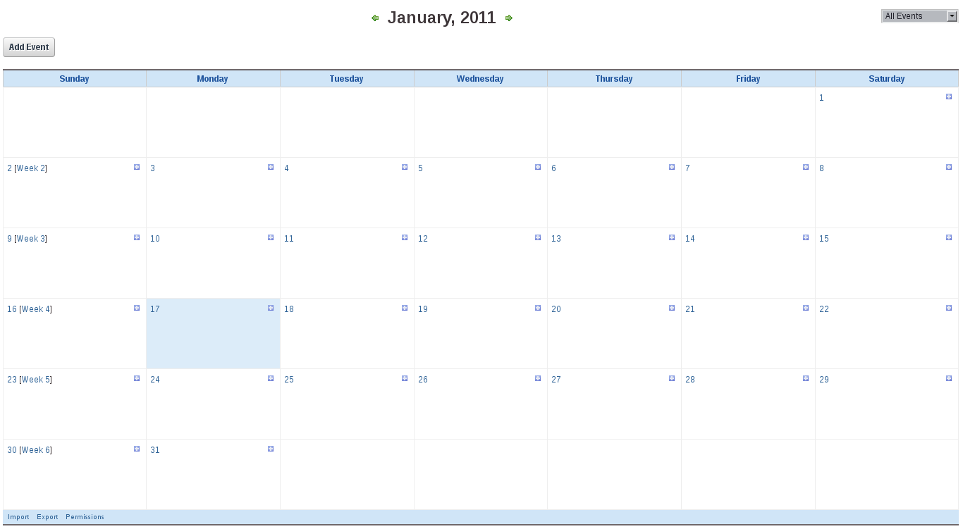Illustration 7: Main Calendar View.

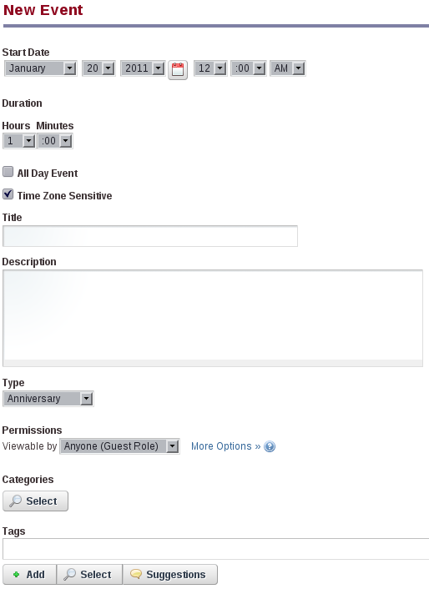Illustration 8: Adding an Event
To create an event, go to the Calendar application page and click Add Event. From here, you'll be given the following options for setting up the event:
Start Date/Time: The date and time the event starts.
Duration: How long the event will last.
All Day Event: Check this box to disassociate time from the event and make it last all day.
Time Zone Sensitive: Leave this box checked to make sure that the portal keeps track of the event regardless of time zone.
Title: The title of the event.
Description: A description of the event.
Type: Select from a number of pre-configured event types. You can change these in the portal-ext.properties file.
Permissions: This field contains a check box that enables you to toggle whether the event is public or private, and the ability to configure more specific options. Clicking configure will allow you to choose in more detail what guests or members of the community are allowed to see and edit.
Categories: Calendar events can have one or more categories. For information about categories, please see the section on categories in Chapter 4: The Control Panel.
Tags: Calendar events can have one or more tags. For information about tags, please see the section on tags in in Chapter 4: The Control Panel.
Repeat: If the event repeats on a schedule, select the schedule.
End Date: If the event repeats on a schedule but there is an end to the set of meetings, enter the end date.
Reminders: Select whether to send a reminder, how long before the event to send it, and through what medium (email, text message, or instant message) to send it. Note that this feature is integrated with your profile on the portal, so you'll need to fill out your mobile phone number and / or instant messenger IDs in order to use those features.
Click Save to add the event to the Calendar.

Importing and Exporting Calendars
If you're migrating to Social Office from an existing platform, there's a good chance that you already have significant amount of Calendar data that you don't want to lose. To help make your life easier, Social Office supports importing calendar data in .ics format.
- To import an existing Calendar, go to the Calendar application page.
- Scroll down to the bottom and click Import.
- On the Import screen you can click Choose File and select the .ics file to import to the Calendar.
- You can also Export the Social Office calendar to .ics if necessary.

Documents
One of the keys to collaborating in a workplace is good handling of various documents which multiple members of a team might be working on simultaneously. Social Office contains a Document Library application which can help streamline this.
Let's say you're a graphic designer for the marketing department and you've just finished up an advertisement for several magazines. Before you can move on to the next steps, you'll need your team and a handful of executives to review and sign off on the content.
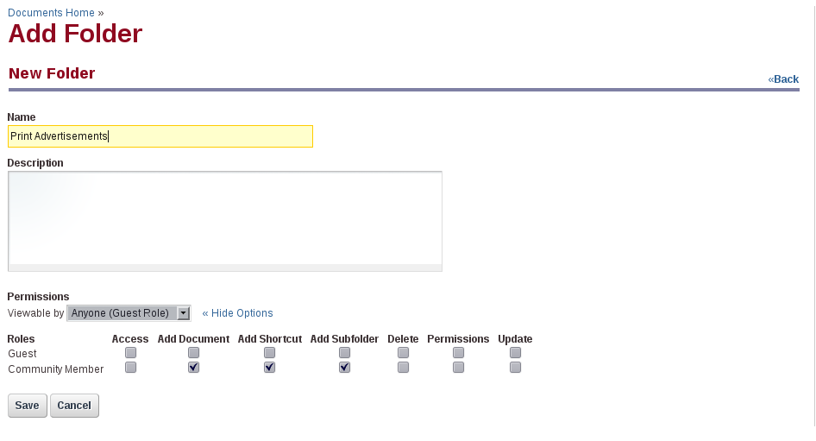Illustration 9: Adding a Folder.

Because your company has only recently adopted Social Office, the first thing you'll need to do is create the appropriate folders. Using the above scenario, begin by creating a Print Advertisements folder. Because you might want people from other departments to review documents posted here, select the Viewable by Anyone (Guest Role) entry in the Permissions drop-down list. Let's say that you also want to create a subfolder of Print Advertisements called Source Files to use for the original working files so that members of your team can make edits directly to the file. Even though anyone can view the root folder, you may not want everyone to have access to the source files, so when you create this one, you would make sure that the Viewable by Community option in the Permissions drop-down list is selected. By clicking More Options, you can also open up additional permission options to grant specific permissions to different roles.
You can continue to nest folders as deeply as necessary to keep things organized. In larger departments running multiple projects at once, having deep folder structures is a necessity to keep out of each others' way.
To add a new document, click Add Document. After you're brought to the next screen, click on Browse. Your browser will open a dialog box that you can use to select one or more files to upload; once the transfer is complete, you can set any details of the document from the folder in which it was placed. If you click Classic Uploader, you'll be presented with a web page that allows you to set the name, description, and permissions, as well as select a single file to upload.
A very useful feature of the Documents application is that it keeps track of past versions of a file after it's been updated. That way, if any information is overwritten or removed, you can easily access an older version of the file. It also features a simple locking mechanism, whereby a user can “lock” the file to make some changes and unlock it once he or she is finished. Use this feature to prevent duplicate work or important changes from being lost in the shuffle of multiple updates.
There are two places where you can lock a file. While viewing the list of files in a folder, you can simply click on the lock icon, or while on the Edit screen, you can click Lock.
To access more options for a file or a folder, click on the icon that looks like a wrench. You'll be presented with a menu containing the following items:
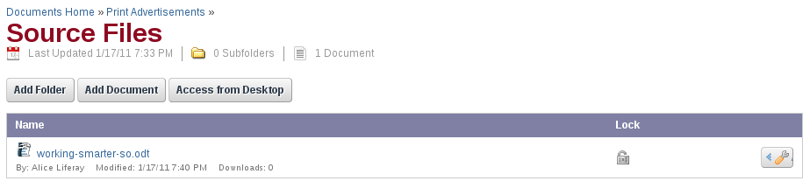Illustration 10: This file is currently not locked; clicking on the lock icon will lock it.

Edit: Change the details of the file or folder. Clicking on this for a file will enable you to upload a new version as well as leave comments or ratings. This way, discussions about a document are kept with the document itself.
Permissions: You can define who can view or edit a file or folder.
Delete: Remove the file or directory. Removing a directory will also remove any subdirectories and files contained in that directory.
Add Subfolder (Folders only): Add a folder inside of the existing folder.
Add Document (Folders only): Add a document inside of the existing folder.
Add Shortcut (Folders only): If you can read a document then you can create a shortcut to enable others to access the document. You need to set permissions on the shortcut to specify which users will have access to the document.
Access from Desktop (Folders Only): Enables you to access files and folders directly from your desktop operating system by specifying the WebDAV URL.
Download (Files Only): Enables you to download a file. Use this option if you need to change the details of a file in order to upload a new version.
Lock (Files Only): Enables you to lock a file.

Editing a File
The Edit screen is where most of the action is going to happen. Clicking on the name of a file will take you to the Edit page for that file. The Document properties section displays information about various attributes of the file, such as the name, the author, and the date of the last revision. It also displays the WebDAV URLs if you wish to access this file through your operating system. In the Social Data and Revision History section, you can leave comments or rate the file. There are a large number of fields on this page, and it can be confusing at first. Let's take a moment to go over the purpose and function of each field.
Document Properties:
Name: This is the name of the file that is always displayed. You can upload a file with a different name, but this will remain the same. The name also serves as a link to download the file.
Title: You can change the displayed name of the file here. Simply uploading a file with a different name will not change the name of the file in Social Office.
Description: You can fill in any notes or details about the file that other users will need to know here.
Current Revision: Social Office keeps track of the number of times a file has been edited and displays the latest version of the file. Each time the file is updated, Social Office will increment the Current Revision number.
Size: The size of the file on disk.
Author: The author of the file.
Creator: The creator of the file.
Create Date: The date the file was created.
Last Modified By: The user who last modified the file.
Modified Date: The date when the file was last modified.
Number of Downloads: The number of times users have downloaded the file.
URL: This is a URL that you can provide to users who may need access to a file hosted on the Site, but aren't members of that Site. Please note that in order for this to work, the file permissions must be set so that a guest can view it.
WebDAV URL: Fills the same purpose as the URL, but with the WebDAV protocol.

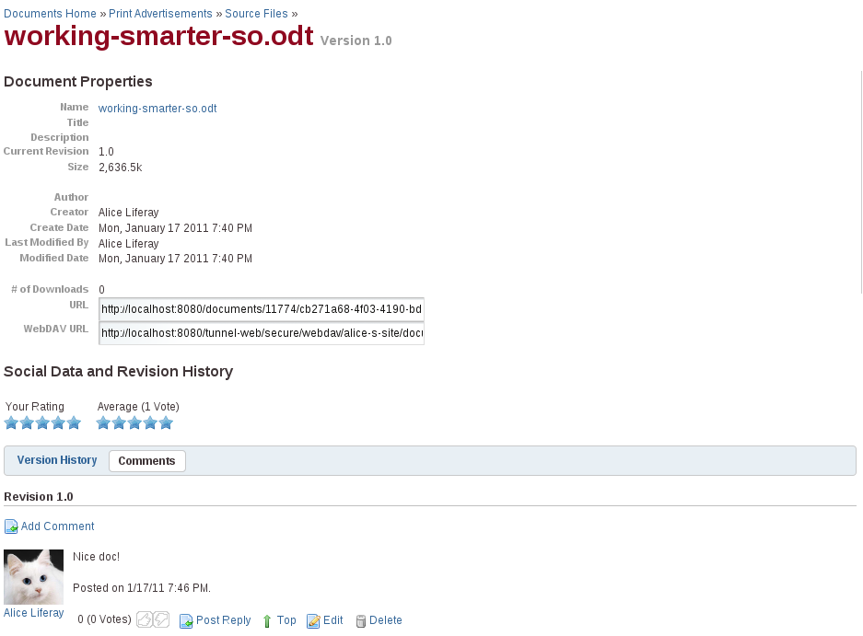Illustration 11: The screen for editing existing files.

Social Data and Revision History:
Ratings: Each user can rate a file, by giving it anywhere from 1 to 5 stars. This could be useful for peer or executive review of files.
Average Rating: This field displays the average rating of all the ratings the file has received.
Version History: You can view past versions of a file; this can be useful for tracking down specific changes to a file or to recover information that was accidentally removed in a newer version.
Comments: Along with rating a file, users can also leave comments. This is useful for discussion about the file.
There are also some useful links in the Document Actions section:
Lock Document: Clicking this allows to lock a document, as described above. No one can edit a locked document until you unlock it or the lock expires.
Move to: This allows you to move the file to a different location. You can choose a folder to move the file to or you can create a subfolder for your file within a chosen folder.
Edit Properties: This opens a window where you can change the following attributes of your file: the title, name, author, and description. You can also add tags to your file here. Tags are used throughout the site to enable users to search properly categorized data more quickly. For more information on tagging, see Chapter 5: The Control Panel.
Edit Permissions: This allows you to give different permissions related to the file to different users with various roles. You can allow certain users to view your file, edit your file, or not have any access to your file at all.
Delete Document and Revisions: Clicking this button will permanently delete your file and its entire revision history. You will receive a warning prompt before the deletion actually takes place.

Blogs
Social Office has a Blogs application which allows you to provide a blogging service to your users. Each site will have its own unique blog, and by default, all members of the site can post blog entries. Let's go over how to use the Blogs application to create an optimal blogging system.
On the Blogs page, you'll see four main options: RSS, Subscribe to this Blog, Add Blog Entry, and Permissions.
Illustration 12: Initial view of the Blogs application.
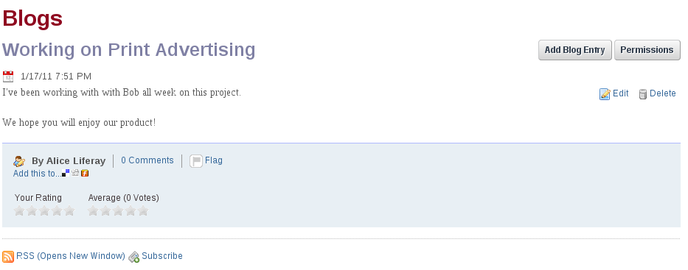
Clicking on RSS will open the RSS feed for this blog in a new window. This enables you to publish your blog as a feed to various feed readers that your users might be using.
Click Subscribe to this Blog to subscribe to the blog without opening a new window.
Click on Permissions and you'll be presented with a screen where you can set which users have to ability to blog. If you want to limit this to specific users, you can create a User Role for bloggers in the Control Panel and give that role permissions to add entries here.
The core functionally of this application is of course, writing blog entries. Click the Add Blog Entry button to get started.
Title: This is the title of the blog entry. It is displayed at the top of the post.
Display Date: You don't have to make the blog entry appear immediately. If you prefer to have it display later in the day or a few days later, you can set the display date here.
Content: The content entry area consists of two parts: the text entry field and the toolbar. The text entry field is where you do your typing, and the toolbar controls text formatting as well as embedding images, videos, or even adding various emoticons to the post. You also have the option to use either the default WYSIWYG text editor or enter your own HTML.
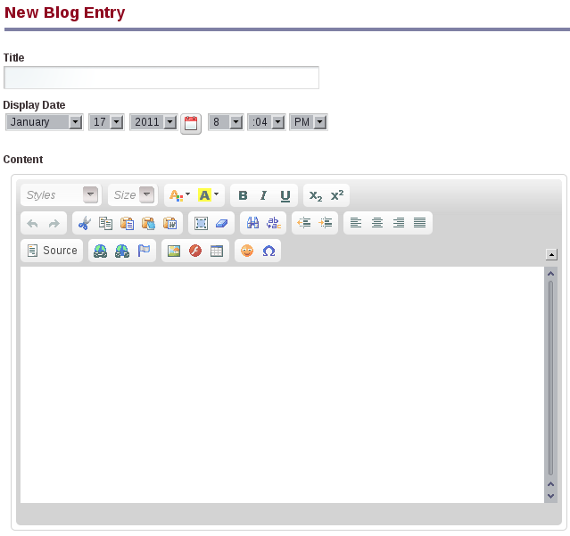Illustration 13: Adding a Blog entry.

Tags: The tags field give you the option to add tags to your entries to make them easier to find with Social Office's search feature. You can find more information about tagging and categories in Chapter 5: The Control Panel. Clicking Suggestions will automatically generate possible tags from your entry based on looking for keywords in your text.
Save as Draft, Publish, Cancel: Clicking on Save Draft will save your work. Note also that as you type, the entry is automatically saved as a draft at periodic intervals. This gives you peace of mind in using the application from within your browser, as you won't lose your entry in the event of a browser crash or network interruption. Publish will save and post your entry on the Blogs page, and Cancel will discard all of your work and send you back to Blogs page.
Permissions: Like almost anything else in Social Office, you have the ability to restrict what users can view or comment on your entry. You can also allow other users to edit it (in the case of a team blog).
Allow Incoming Trackbacks: If you're running Social Office on the Internet and not an Intranet, you might want to enable trackbacks to make it easier to track when other bloggers link to your blog. This could also potentially be useful on larger Intranets to reference other blogs that are part of other Social Office or Liferay Portal installations.
Trackbacks to Send: If you're referencing another blog that supports trackbacks in your post, you'll want to make sure that they receive the proper credit. Entering trackback URLs in his field will notify the owners of the other blogs that you referenced them in your post. Once you have finished your blog entry, click Publish. You'll go back to the list of entries, and you'll see your entry.

Forums
Social Office's Forums are one of the most widely used collaboration features provided by the product. The application is a state of the art forum application similar to many forums in which you may have participated. There are countless web sites out there where it's clearly evident that there is no link whatsoever between the main site and the message boards. In some cases, users are even required to register twice: once for the main site and once for the message boards. By providing a message boards application along with all of the other applications, Social Office can provide a unique, integrated approach, which is essential when creating an environment for people to work together and collaborate. We've already taken care of the integration of applications, so you can concentrate on using the tools we provide to streamline your workflow and improve the efficiency of business processes.
The Forums application is very straightforward to set up. To start, you'll want to configure who has access to the Moderator functions of the Forums, so click on Permissions.
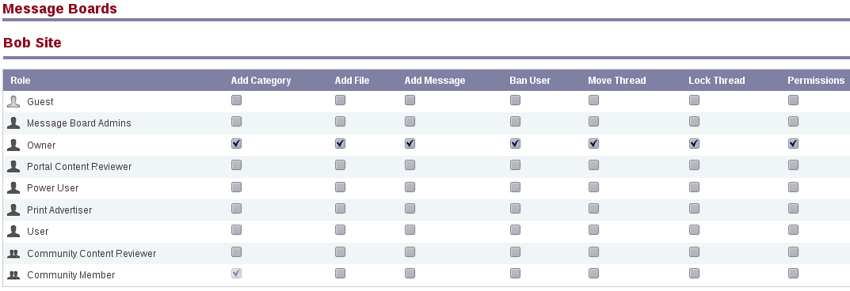Illustration 14: Editing Message Board Permissions.

Permissions
This page allows you to define which roles have the ability to add a category of threads or to ban abusive users from the forums. Select the roles and permissions you want to configure and then click Submit. You may want to set up a specific User Role for this. User Roles are covered in Chapter 5: The Control Panel.

Adding Categories and Mailing Lists
You're now ready to add categories to your forums. Click the Add Category button. Enter a name for the category and a description of the category. At the bottom of the form is a check box which allows you to enable the mailing list function.
The mailing list function works in concert with the message notification emails. If a user subscribes to a message board category, he or she will get emails when someone posts messages to that category. Enabling the mailing list function allows those users to simply reply to the notification messages in their email clients, and those replies are posted to the thread automatically.
To enable this functionality, you'll need a mail account for the category. Once you click the check box, a number of other options will appear.
Email Address: Enter the email address of the account that will receive the messages.
Next, there are two tabs: Incoming and Outgoing. These define the mail settings for receiving mail and for sending mail. The Incoming tab has the following options:
Protocol: Select POP or IMAP.
Server Name: Enter the host name of the mail server you're using.
Server Port: Enter the port on which your mail service is running.
Use a Secure Network Connection: Check this box to use an encrypted connection if your server supports it.
User Name: The login name on the mail server.
Password: The password for the account on the server.
Read Interval (Minutes): Social Office will poll the server at this interval looking for new messages to post.
The Outgoing tab has the following options:
Email Address: Enter the email address that messages from this category should come from. If you want your users to reply to the categories using email, this should be the same address configured on the Incoming tab.
Use Custom Outgoing Server: If you need to use a different mail server than the one that's configured for the portal, check this box. If you check the box, a number of other options will appear.
Server Name: Enter the host name of the SMTP mail server you're using.
Server Port: Enter the port on which your mail service is running.
Use a Secure Network Connection: Check this box to use an encrypted connection if your server supports it.
User Name: Enter the login name on the mail server.
Password: Enter the password for the account on the mail server.
When finished adding your category, click Save. Add as many categories to your forums as you wish. Note that categories can have subcategories. You can add a number of top-level categories and then click on each one to add categories under that (to an unlimited level). For usability reasons, you don't want to nest your categories too deep, or your users will have trouble finding them. You can always add more categories as your forums grow.

Using the Forums
Upon seeing Social Office's Forums application, your users will immediately recognize that the interface is similar to many other implementations they've seen before. Forums are nothing new to the Internet, and many people have been using them for quite a long time. For that reason, Social Office's forums will seem very familiar to your users.
Threads can be viewed in many ways. At the left of the page is a set of quick links: Categories, My Posts, My Subscriptions, Recent Posts, and for administrative users, Statistics and Banned Users. The Categories tab allows users to browse the categories for an appropriate place to post a thread. The My Posts link shows all of the posts for the user who's currently logged in. This is a convenient way to get back to a conversation you had once in order to retrieve some pertinent information. The My Subscriptions link allows a user to manage thread subscriptions. If you lose interest in a particular topic, you may want to visit this tab and unsubscribe from a thread. The Recent Posts tab shows all posts from all categories by date, so you can keep up on all the most recent discussions in the forums.
For administrators, the Statistics link shows the number of categories, the number of posts, and the number of participants in your forums. It also has a list of who the top posters to your forums are. The Banned Users tab shows all of the users who have been banned from posting on the forums.
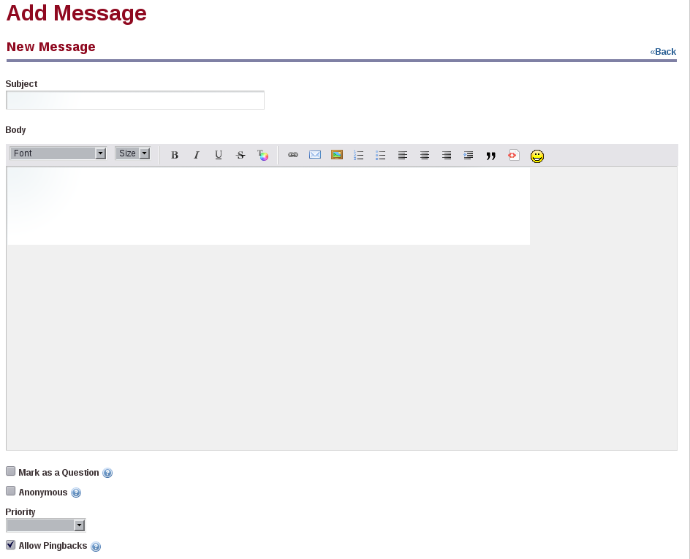Illustration 15: Editing a forums post. You can see the emoticons that are available in the editor, insert emoticons, add preformatted text, and more.

To post a new message thread, go to the Categories link, click on a category, and then click on the Post New Thread button. You'll see a message editing form. The body field on this form is different from that of the other applications in Social Office. The reason for this is to support BBCode, which is a standard form of markup used in many message board products. Users who have Moderator access to the board can modify the priority of messages. You can also use the editor to quote from messages that you're replying to.
Messages that are posted to the forums are shown by default in a threaded view, so that replies are attached to the proper parent message. This makes it easy to follow along with conversations.
When viewing a message board thread, users are given several options. At the top right of the thread are three icons, allowing users to view threads in a flat view, in a tree view, or in a combination view. A flat view shows all of the messages in the order in which they are posted. A tree view shows all of the messages in a threaded view, so that replies are next to the messages they are replying to. A combination view shows the threads at the top as subjects only, with the flat view underneath.
When viewing a thread, users can click links allowing them to post a new thread, subscribe to the thread they are viewing, or if they have administrative access, move a thread to another category. Subscribing to a thread causes Social Office to send the user an email whenever a new message is posted to the thread. If you have enabled the mailing list feature for the category in which the thread resides, users can simply reply to these messages in order to post back to the thread, without having to visit your site.
The Forums application is also highly integrated with Social Office's user management features. Posts on the message board show users' profile pictures if they have uploaded one for themselves, as well as the dates that users created an ID on your site.

Forums Administrative Functions
The Forums application provides for the day-to-day administration of the message threads. You may wish to separate this function out by a role, and then delegate that role to one or more of your users. That would free you up to concentrate on other areas of your web site. To do this, you can create a role called Message Board Administrator.
This role can be scoped by Social Office or a Site. If you have a Social Office scoped role, members of this role can administer any Message Boards in any Site to which they have access. If it's a Site scoped role, members of this role can administer a Message Boards portlet in only the Site in which they have the role.
Go to the Control Panel and create this role. Once it's created, click Actions → Define Permissions. Click the Portlet Permissions button. Browse the list until you find the Message Boards portlet and then click on it. You'll then see a screen which allows you to configure the various permissions on the portlet.
Grant the permissions you wish message board administrators to have and then click Save. You can then add users to this role and they will inherit the permissions.
Message Board administrators can perform all of the functions you have already seen, including creating and deleting categories and posting threads. In addition to these, a number of other functions are available.

Moving Threads
Many times a user will post a thread in the wrong category. Administrators may in this case want to move a thread to the proper category. This is very easy to do. First click on the Actions (wrench) icon at the right. If you have administrative access, there is a link in the list of options labeled Move Thread. Click this link. You'll be presented with a simple form which allows you to select a category to which to move the thread and a check box which allows you to post a message explaining why the thread was moved. This message is posted as a reply to the thread you're moving. When finished, click the Move Thread button and the thread is moved.

Deleting Threads
Users with administrative access to the forums can delete threads. Sometimes users begin discussing topics that are inappropriate or which reveal information which should not be revealed. In this case, you can simply delete the thread from the forums. This is easy to do. First, view the list of threads. Next to every thread is an Actions button. Click Actions → Delete to delete the thread. This doesn't prevent users from re-posting the information, so you'll need to be vigilant in deleting threads or consider the next option.

Banning Users
Unfortunately, sometimes certain users can become abusive. If you wind up with a user like this, you can certainly make attempts to warn him or her that the behavior he or she is displaying is unacceptable. If this doesn't work, you can ban the user from posting on the forums.
Again, this is very easy to do. Find any post which was written by the abusive user. Underneath the user's name / profile picture is a link called Ban this User. Click this link to ban the user from the forums.
If after taking this action the user apologizes and agrees to stop his or her abusive behavior, you can choose to reinstate the user. To do this, click the Banned Users tab at the top of the Forums application. This will show a list of all banned users. Find the user in the list and click the Unban this User link.

Splitting Threads
Sometimes a thread will go on for a while and the discussion completely changes into something else. In this case, you can split the thread where the discussion diverges and create a whole new thread for the new topic. Administrative users will see a Split Thread link on each post. To split the thread, click the link. You'll be brought to a form which allows you to add an explanation post to the split thread. Click Ok to split the thread.

Editing Posts
Administrative users can edit not only their own posts, but also all others. Sometimes users will post links to copyrighted material or unsuitable pictures. You can edit these posts, which allows you to redact information that should not be posted or to censor profanity that's not allowed on your forums.

Permissions
Permissions can be set not only on threads, but also on individual posts. You can choose to limit a particular conversation or a post to only a select group of people. To do this, click the Permissions link on the post and then select among the Delete, Permissions, Subscribe, Update, and View permissions for the particular role to which you want to grant particular access. This function can be used to make it so some privileged users can post on a certain thread, but others are only allowed to view it, or any combination of the above permissions.

Wikis
Social Office's Wiki application, like the Forums application, is a full-featured wiki application which has all of the features you would expect of a state of the art wiki. Again, though, it has the benefit of all of the features of the Social Office platform. As such, it's completely integrated with Social Office's user management, tagging, and security features.
So what is a wiki? Put simply, a wiki is an application which allows users to collaborate on information. This, of course, has many applications—the most famous of which is Wikipedia, which is a full encyclopedia developed collaboratively by users from all over the world, using a wiki. Another example would be Liferay's wiki, which is used for collaborative documentation for the Community Edition of the product.
A wiki application allows users to create and edit documents and then link them to each other. To accomplish this, a special form of markup is used which is sometimes called wikitext. Unfortunately, the proliferation of many different wiki applications resulted in slightly different syntax for wikitext in the various products, as each new wiki tried to focus on new features that other wikis didn't have. For that reason, a project called WikiCreole was started. This project resulted in the release of WikiCreole 1.0 in 2007, which is an attempt to define a standard wiki markup that all wikis can support.
Rather than define another wikitext syntax, Social Office's Wiki application supports WikiCreole as its syntax. This syntax is a best-of-breed wiki syntax and should be familiar for users of other wikis. The application provides a handy cheat sheet for the syntax on the page editing form, with a link to the full documentation if you wish to use some of WikiCreole's advanced features.

Navigating in the Wiki application
You'll start on the default page, which is called FrontPage. Initially, of course, it's blank—you'll have to fill it with your own wiki content. On the left are the Quick Links, which contain a set of navigational links:
Manage Wikis: This link takes you to a list of available wikis, with options to make administrative changes.
FrontPage: Takes you to the main page of the main wiki.
Recent Changes: Takes you to a page which shows all of the recently updated pages.
All Pages: Takes you to a flat, alphabetical list of all pages currently stored in the wiki.
Orphan Pages: This link takes you to a list of pages that have no links to them. This can happen if you take a link out of a wiki page in an edit without realizing it's the only link to a certain page. This area allows you to review wiki pages that are orphaned in this way so that you can re-link to them or delete them from the wiki if they are no longer relevant.
Search: Enter a term here and click the Search button to search for items in the wiki. If the search term is not found, a link is displayed which allows you to create a new wiki page on the topic for which you searched.

Getting Started with the Social Office Wiki
The Wiki application can contain many wikis. By default, it contains only one, called Main. If you wish to add, modify, or delete wikis, click on the Manage Wikis link in the quick links. You'll see that the Main wiki has already been added for you.
Clicking the Add Wiki button brings you to a screen which allows you to give the wiki a name and a description. You can also set up some default permissions. When you create a new wiki, it'll appear in a list at the top of the main page of the application.
Next to each wiki in the list of wiki nodes is an Actions button. This button contains several options:
Edit: Lets you edit the name and description of the wiki.
Permissions: Lets you define what roles can add attachments to wiki pages, add pages to the wiki, delete pages, import pages to the wiki, set permissions on the wiki, subscribe to the wiki, update existing pages, and view the wiki.
Import Pages: You can import your data from other wikis. This allows you to migrate off of another wiki which you may be using and use the Social Office wiki instead. You may wish to do this if you're migrating your site from a set of disparate applications (i.e., a separate forum or a separate wiki) to Social Office, which provides all of these features. Currently, MediaWiki is the only wiki that's supported, but others will likely be supported in the future.
RSS: This will bring you to an RSS feed of updates to the wiki.
Subscribe: A user can subscribe to a wiki node and any time a page is added or updated, Social Office will send an email to the user informing him or her what happened.
Delete: Deletes the wiki node. To go back to your wiki, click on its name in the list of wikis.

Adding and Editing Wiki Pages
By default, there is one page added to your wiki, called FrontPage. To get started adding data to your wiki, click the Edit link at the top right of the application. You'll be brought to a blank editing page.
You can now begin to add content to the page. Notice that there is a very convenient “cheat sheet” which can help with the wiki syntax. You can use this syntax to format your wiki pages. Consider for example the following wiki document:
== Welcome to Our Wiki! ==
This is our new wiki, which should allow us to collaborate on documentation. Feel free to add pages showing people how to do stuff. Below are links to some sections that have already been added.
[[Introduction ]]
[[Getting Started]]
[[Configuration]]
[[Development]]
[[Support]]
[[Community]]
This would produce the following wiki page:
Illustration 16: Adding a wiki page
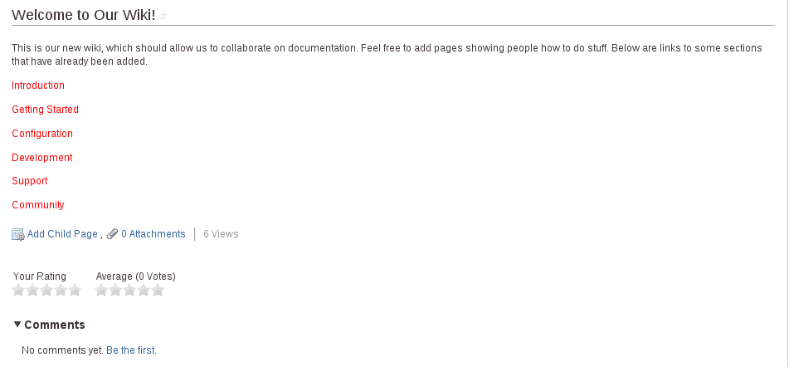
This adds a simple heading, a paragraph of text, and several links to the page. Notice that the links are red, instead of the normal blue color. This indicates that the page behind that link doesn't yet exist, and therefore needs to be created. If you click one of those links, you'll be brought immediately to the editing screen you were on previously when you edited the front page, except this time you'll be creating the page behind the link you just clicked. Social Office will display a notice at the top of the page stating that the page doesn't exist yet, and that you're creating it right now. As you can see, it's very easy to create wiki pages. All you have to do is create a link from an existing page.
Note that at the top of the screen you can select from the Creole wiki format and the HTML editor that comes with Social Office. We generally recommend that you stick with the Creole format, as it allows for a much cleaner separation of content and code. If you want all of your users to use the Creole format, you can disable the HTML format using the portal-ext.properties file. See the Liferay Portal Administrator's Guide for further information on this configuration file.
At the bottom of the page editing screen, you can select categories or tags for the article. Categories are a hierarchical list of headings under which you can create wiki pages, and tags are lists of topics covered by your articles. Both allow you to organize your content for searching. Tags can be created inline; categories can be created using the Control Panel in the Tags and Categories section.

Page Details
When viewing a page, you can view its details by clicking the Details link which appears in the top right of the page. This allows you to view many properties of the page. There are several tabs which organize all of the details into convenient categories.

Details
The Details tab shows various statistics about the page and also contains a few actions that you can perform on the page.
Title: Displays the title of the page.
Format: Displays the format for the page—either Creole or HTML.
Latest Version: Displays the latest version of the page. The wiki application automatically keeps track of page versions whenever a page has been edited.
Created By: Displays the user who created the page.
Last Changed By: Displays the user who last modified the page.
Attachments: Displays the number of attachments to the page.
RSS Subscription: Displays links which allow you to subscribe to the page as an RSS feed in three formats: RSS 1.0, RSS 2.0, and Atom 1.0.
Email Subscription: Contains links allowing you to subscribe to the entire wiki or just to this page.
Advanced Actions: Contains links allowing you to modify the permissions on the page, make a copy of the page, move (rename) the page, or delete the page.

History
This tab shows a list of all of the versions of the wiki page since it was created. You can revert a page back to a previous state and you can also compare the differences between versions by selecting the versions and then clicking the Compare Versions button.

Incoming / Outgoing Links
The next two tabs are for incoming and outgoing links. These are wiki links to and from the page. You can use this tab to examine how this page links to other pages and how other pages link back to this page.

Attachments
The last tab is for attachments. You can attach any file to the wiki. This is mostly used to attach images to wiki articles which can then be referenced in the text. Referencing them using the proper WikiCreole syntax renders the image inline, which is a nice way to include illustrations in your wiki documents.

Members
In order for a site to function properly, it must have members. Site owners have the ability to allow anyone to join or to restrict membership to invitation only. They also have the option to allow anyone to view the site or to restrict site viewing to members only. Individual applications within each site also have configurable permissions as to whether they can be viewed or edited by anyone or only by members of the site. In most cases you'll want to restrict membership of a site, but allow everyone to view certain sections of the site.
As an example, a company's Marketing Site might have, among other things, a Brand Style Guide and a Marketing Events Calendar. These are things that they would want accessible to various people in the company, such as web developers or retail associates. They would not, however, want everyone to view specifics on upcoming promotions still in development—or the time and locations of meetings with vendors. Using Social Office, you can easily separate items like this—with some documents and items on a Calendar being viewable to everyone, while others would be invisible to everyone who wasn't a member of the site.
The standard permissions available to users are Add Discussion, Delete, Delete Discussion, Permissions, Update, Update Discussion, and View. These are very granular throughout the various applications, so you have a lot of flexibility in determining who can do what, not just for the application itself, but for specific files, events, discussions, or just about anything else.

Other Site Options
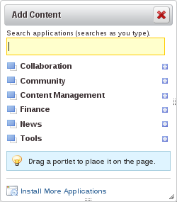Illustration 17: Add Applications Dialog

While the applications we've been describing above are included by default in Social Office's Sites and are where users are going to spend the majority of their time, there are a few other tools and configuration options that you'll want to know about when you're setting up Sites.

Adding/Removing Applications
By default, there is a fairly large number of applications on users' personal home pages and the Site home pages. In some cases, you may want exactly what's there by default, but in others, you may want less or more.
If a user has permission to remove a particular application, an X will appear in the top right corner of the application box; clicking the X will remove the application. If a user has permission to add an application to a page, they will see an Applications button at the top of the screen. Clicking on it will display a menu on the left side of the screen with a list of applications that they can add to a page. The applications are organized by category.
Users own their personal home pages and are free to make changes to them. Any changes made by one user affects only his or her personal home page. Site home pages, on the other hand, belong to the Site, so changes made by one user will affect all users of that Site. This is why only the Site Owner, Social Office Administrator, or someone given increased permissions via User Roles in the Control Panel can modify the Site home page.

Layouts
Along with adding or removing applications, pages have customizable layouts. Each page has a selectable Layout template (accessed through the Layout button at the top of the screen). Simply choose the best layout for your page. You can also drag and drop individual applications anywhere on the page; however, the layout template will determine the size and shape of the Application box, as well as details of its exact placement on the screen.
You can also apply layouts to Site and personal home pages. We suggest experimenting with a variety of layouts to determine what works best for your site and your users.
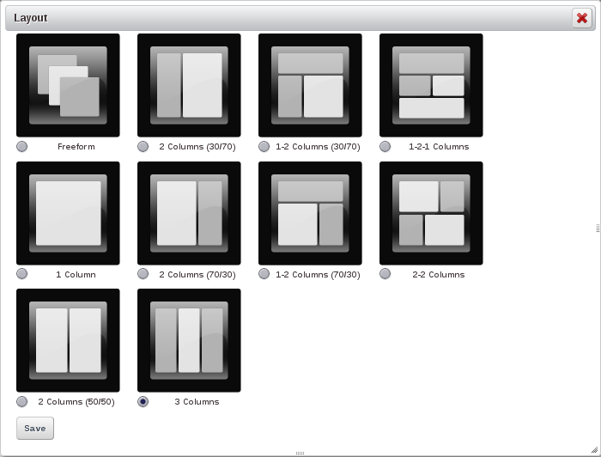Illustration 18: Layout Selection.

Announcements
The Announcements application is Social Office's main method of conveying information to larger groups of users at once. You can make announcements to all other users or only to members of a specific site.
The Announcements application is displayed in two places: the user's home page and the site home page. The Announcements application displays different information for each user based on the user's site membership. For example, if a user is a member of the Sales site, but is browsing the home page of the Marketing site, he will see announcements from Sales in the Announcements application, not announcements from Marketing.
By default, only Administrators or site owners can post announcements. They can also create a User Role (via the Control Panel) with the ability to post announcements. See Chapter 5: The Control Panel, for more information about creating User Roles.
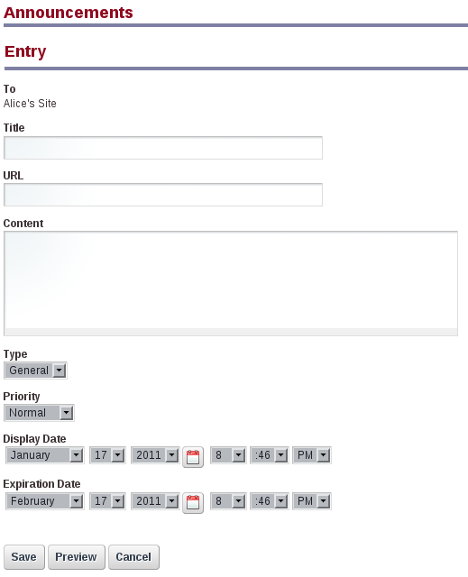Illustration 19: The Add Announcements Screen.

To create an announcement, a user with sufficient permissions simply needs to click the Add Announcement button and fill in the necessary fields:
To: This is the Site where the announcement is posted. If a user is accessing this application through a Site home page, or if he or she can only make announcements for one Site, this will only display one value. However, if a user with announcement privileges on multiple Sites accesses the application from his or her personal home page, he or she will see a selection box with all of the available Sites.
Title: You can enter a title here that serves as the headline for the announcement.
URL: This field enables you to set a URL for the announcement. This is useful if you want to link directly to the announcement from somewhere else.
Content: This is where you enter the main content for the announcement. Unlike some of the more advanced text entry fields in other applications, this field only accepts plain text characters.
Type: You can set the type as General, News, or Test, depending on what type of announcement you're making.
Priority: Mark this as Important or Normal. Marking an item Important will make it stay persistently above all Normal entries until you edit the entry and change its priority, delete it, or the item expires.
Display Date / Expiration Date: You can set a date range for when the item will first appear and when it will stop displaying. You can use this feature to have announcements post or expire off the list when you're unavailable to manually make changes. By default, all announcements expire one month after they are first posted, but you can increase or decrease the amount of time each item is displayed.
Clicking the Manage Entries button will bring you to a screen displaying all announcements and allow you to edit or delete them. You can use this to fix any errors in existing entries or to remove unwanted entries. You can also add entries from this page.

Chat
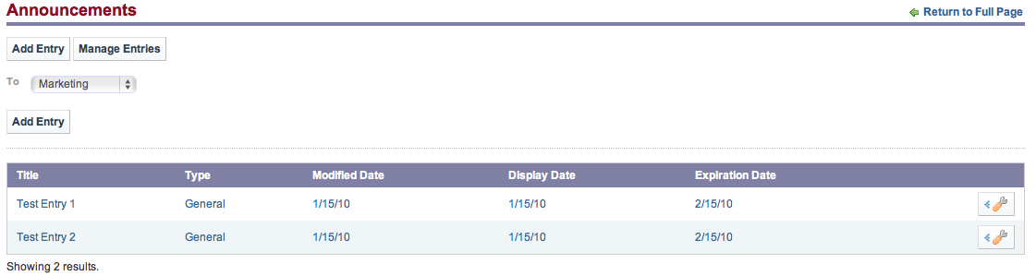Illustration 20: Manage Entries Screen.
The Chat application is integrated throughout the whole of Social Office. It's a convenient way of allowing your users to IM each other when they're logged into your web site at the same time. It appears as a bar at the bottom of every page—displaying who's logged on, whether they're available, and any chats the logged-in user has open.
The Chat application is very simple to use. To change the settings, click Settings. Here you can set your status (online/offline) or have the application play a sound if someone sends you a message when the window or tab is in the background.
Additionally, the application shows the number of your friends online. To chat with one of them, click the Online Friends link, click the friend's name, and then begin chatting. That's it! You can have multiple chats open at a time, and even have one or more of them minimized. Your friends are anyone that shares membership of a Site with you.

Summary
Social Office provides an environment for easy collaboration with one another. All of the applications are geared toward working together and informing the team about everyone's activities. This environment facilitates the easy sharing of data and seamless communication among teammates. You'll find that it's much easier to work together on common tasks when using Social Office.

Control Panel
Once Liferay Social Office is successfully installed, you can begin configuring it to fit it to your environment and your particular collaboration needs. You can perform many of these configuration tasks through Social Office's control panel.
You'll want to customize Social Office by configuring various settings such as email notifications, integration with services such as LDAP, creating users, user groups, and roles, and readying your installation to have its content and applications loaded by users. This chapter covers the following activities:
- Social Office's User Interface: How to navigate around Social Office and make use of the Control Panel.
- Social Office Administration: How to administer a Social Office install.
- Global Settings: Password policies, Settings, Monitoring, and more.

Navigating the Control Panel
The control panel is very easy to navigate. On the left side is a list of headings with functions underneath them. The headings are in alphabetical order, but the functions are in a logical order.
User Name: The first section is always the logged in user's personal space. Here, you can change your account information and manage your own personal pages.
Portal: The Portal section allows administrators to set up and maintain Social Office. This is where you can add and edit users, sites, roles, and configure the server settings.
Server: The Server section contains administrative functions for configuring portal instances, runtime settings, plugins, connecting Social Office to OpenOffice.org for document conversion, and more.
All of the functions that you'll need to maintain Social Office or its content is found in the Control Panel.

Social Office Architecture
Before we dive into the user interface for adding and maintaining various resources, it's best to go over the concepts Social Office uses to organize itself.

Users
Users are accounts on the system which are accessed by real people. Users can be collected in multiple ways. They can be members of sites which draw together common interests. They can have roles which describe their functions in the system, and these roles can be scoped by Portal or Site. They can also be collected into User Groups.

Roles
There are two kinds of roles:
- Portal Roles
- Site Roles
These are called role scopes. Roles are used to define permissions across their scope: across the portal or across a site. For example, consider a role which grants access to create a Message Board category. A Portal role would grant that access across the portal, wherever there was a Message Board portlet. A Site role would grant that access only within a single site.
Because Roles are used strictly for security, they also don't have pages, like Sites.
Users or Sites can be members of a role.

Sites
Sites are collections of Users who have a common interest. There are two types of Sites:
- Open
- Private
An Open Site (the default) allows Social Office users to join and leave the Site whenever they want to, using the Control Panel or a Sites portlet added to a page to which they have access. A Private site requires that users be added to the Site by a site administrator and doesn't show up at all in the Sites portlet or the Control Panel.

Using the Control Panel
The Portal section of the Control Panel is used for most administrative tasks. You'll find there an interface for the creation and maintenance of
- Users
- Roles
Additionally, it allows you to configure many server settings, including:
- Password Policies
- Authentication options, including Single Sign-On and LDAP integration
- Default User Associations
- Reserved Screen Names
- Mail Host Names
- Email Notifications
You will use the Portal section of the Control Panel to create your portal structure, implement security, and administer your users. Note that only users with the Administrator role—a portal scoped role—have permission to view this section of the Control Panel. You can, of course, grant permissions to roles that you create yourself.

Adding Users
Let's begin by adding a user account for yourself. We will then configure this account so that it has the same administrative access as the default administrator account. Go up to the global navigation area and click the Control Panel link, if you aren't there already. Then under the Portal category, click Users. Click the Add button.
You'll then be presented with the Add User form. Fill out the form using your name and email address. When you're finished, click Save.
The page will then reappear with a message saying that the save was successful, and there will now be an expanded form which allows you to fill out a lot more information about the user. You don't have to fill anything else out right now, but one thing is important to note: when the user ID was created, a password was automatically generated and, if Social Office has been correctly installed (see Chapter 2), an email message with the password in it was sent to the user. This of course requires that Social Office can properly communicate with your SMTP mail server in your organization.
If you have not yet set up your mail server, you'll need to use this screen to change the default password for the user ID to something you can remember. You can do this by clicking on the Password link in the box on the right, entering the new password in the two fields, and clicking Save.
Next, you'll want to give your user account the same administrative rights as the default administrator's account. This will allow you to perform administrative tasks with your own ID instead of having to use the default ID. This also allows you to make your portal more secure by deleting or disabling the default ID.
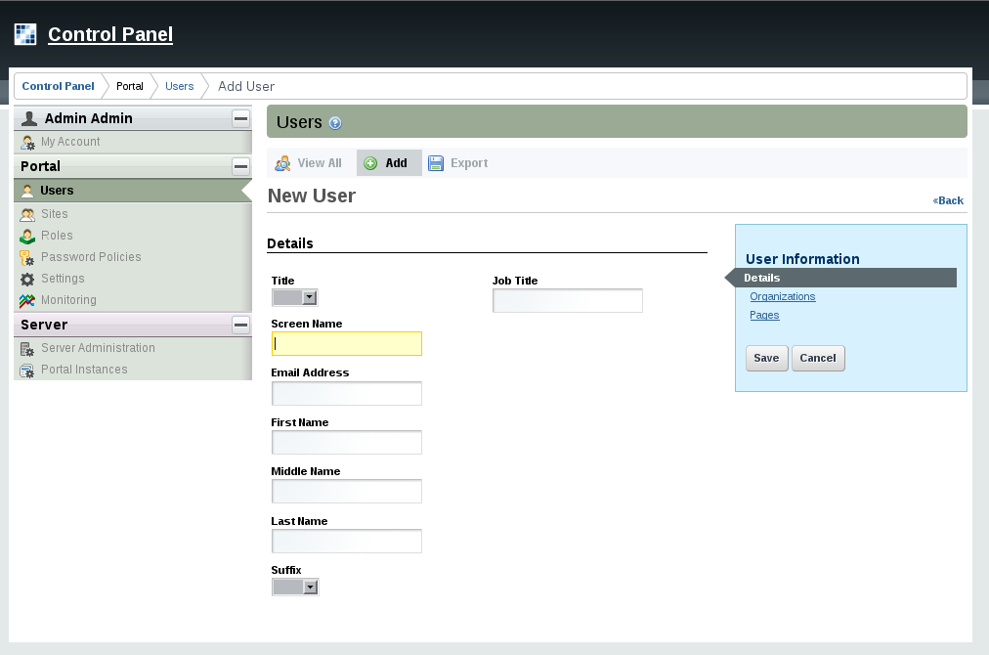Illustration 21: The Add User screen.

Click the Roles link. You'll then be taken to a screen which shows the roles to which your ID is currently assigned. By default, you should have one role: Power User. By default, all users are also assigned the Power User role. You can give this role certain permissions if you wish or disable it altogether. You can also define the default roles a new user receives; we will go over this later.
To make yourself an Administrator, click the Select link. A window will pop up with a list of all the roles in the system. Select the Administrator role from the list and the window will disappear and you'll see that the role has been added to the list of roles to which you're assigned. Next, click the Save button, which is at the bottom of the blue bar of links on the right. You're now an administrator of the portal. Log out of the portal and then log back in with your own user ID.

User Management
If you click the Users link on the left of the Control Panel, you'll see that there are now two users in the list of users. If you wanted to change something about a particular user, you can click the Actions button next to that user.
Edit User: This takes you back to the Edit User page, where you can modify anything about the user.
Permissions: This allows you to define which Roles have permissions to edit the user.
Impersonate User: This opens another browser window which allows you to browse the site as though you were the user.
Deactivate: Clicking this will deactivate the user's account.
Note that most users can't perform most of the above (in fact, they won't even have access to this section of the Control Panel). Because you have administrative access, you can perform all of the above functions.

Roles
Roles are groupings of users that share a particular function within Social Office, according to a particular scope. Roles can be granted permissions to various functions within portlet applications. Think of a role as a description of a function, such as Message Board Administrators. A role with that name is likely to have permissions to functions of the Message Board portlet delegated to it. Users who are placed in this role then inherit those permissions.
Roles are scoped by Portal or Site. The Control Panel makes it easy for you to assign users to Roles and to assign permissions to Roles. You only have to go to one place: the Roles link. From there, you can add roles scoped by Portal or Site from one interface.
To create a Role, click the Roles link, and then click the Add button. Type a name for your role and an optional description. The drop down box at the bottom of the form lets you choose whether this is a Regular or Site role. When you have finished, click Save.
You'll be back at the list of roles. To see what functions you can perform on your new role, click the Actions button.
Edit: Click this action to edit the role. You can change its name or description.
Permissions: This allows you to define which Users, User Groups, or Roles have permissions to edit the Role.
Define Permissions: Click this to define what permissions this role has. This is outlined in the next section.
Assign Members: Takes you to a screen where you can search and select users in the portal to be assigned to this role. These users will inherit any permissions given to the role.
View Users: Lets you view the users who are in the Role.
Delete: Deletes the Role.
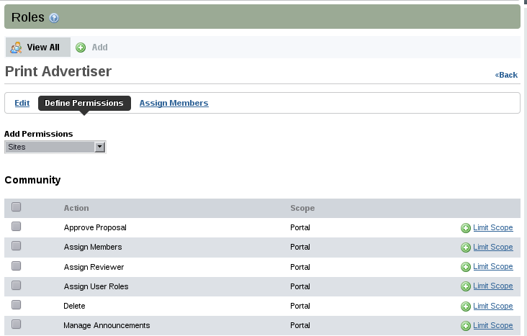Illustration 22: Defining Permissions on a Role.

Defining Permissions on a Role
Roles exist as a bucket for granting permissions to the users who are members of them. So one of the main tasks you'll be doing with a role is granting it the permissions that you want members of the role to have.
When you click the Define Permissions action on a Portal scoped Role, you're given a choice of two kinds of permissions that can be defined for this role: Portal Permissions and Portlet Permissions. For other Roles, you only see the portlet permissions.
Portal permissions cover portal-wide activities that are in several categories, such as Site, Location, Password Policy, etc. This allows you to create a Role that, for example, can create new Sites in the portal. This would allow you to grant users that particular permission without making them overall portal administrators.
Portlet permissions cover permissions that are defined within various portlets. Since Social Office inherits from the design of Liferay Portal, its applications are referred to in the Control Panel as portlets. If you're familiar, therefore, with Liferay Portal, administering Social Office is the same exact experience. Clicking the Portlet Permissions button brings you to a page where you can browse the names of the portlets that are currently installed in your portal. Once you choose a portlet, you can then define the actions within this portlet that the role will have permission to perform.
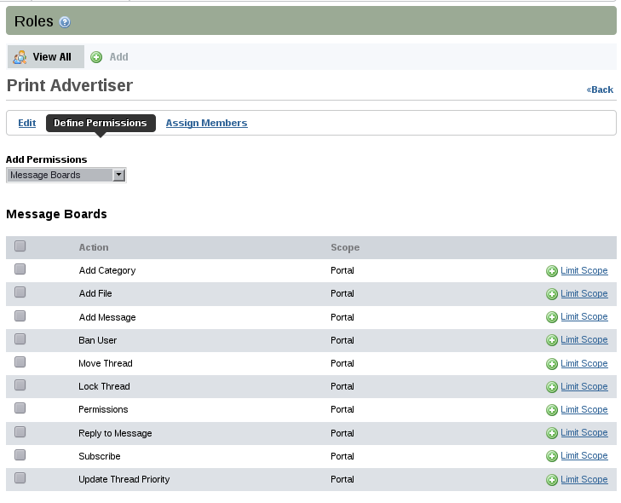Illustration 23: Message Boards permissions.

If we stick with our example of a Message Boards Admin role, we would then find the Message Boards portlet in the list and click on it. A new page with configurable permissions would then be displayed (see above).
Each possible action to which permissions can be granted is listed. To grant a permission, choose the scope of the permission. You have two choices: Portal and Communities. These labels are inherited from Liferay Portal, but they correspond to global Social Office permissions and Site permissions. Granting Portal permissions means that permission to the action is granted across Social Office, in any site where there is a Message Boards portlet.
If you choose Communities, a button appears next to the permission allowing you to choose one or more sites in which the permission is invalid. This lets you pick and choose specific sites (for a portal scoped role) in which these permissions are valid for users in this role.
Once you have chosen the permissions granted to this role, click Save. For a Message Boards Admin role, you would likely grant Portal permissions to every action listed. After you click Save, you'll see a list of all permissions that are currently granted to this role. From here, you can add more permissions (by clicking Add Portlet Permissions or Add Portal Permissions), or go back by clicking a link in the breadcrumb list or the Return to Full Page link.
Roles are very powerful, and allow portal administrators to define various permissions in whatever combinations they like.

Global Server Settings
Now that you've navigated in the Control Panel, you should be pretty familiar with how it works, and hopefully now you're comfortable exploring around the various options on the left. We've focused so far on the maintenance of users and portal security. The remaining links in the Portal category focus on various portal settings which cover how Social Office operates and integrates with other systems you may have.

Password Policies
Password policies can help to enhance the security of Social Office. Using password policies, you can set password rules such as password strength, frequency of password expiration, and more. Additionally, you can apply different rule sets to different sets of portal users.
In the Control Panel, click on the Password Policies link on the left side of the screen in the Portal category. You'll see that there is already a default password policy in the system. You can edit this in the same manner as you edit other resources in the portal: click Actions and then click Edit.
You'll then see the Password Policy settings form:
Changeable: Selects whether a user can change his or her password.
Change Required: Selects whether a user must change his or her password upon first log in.
Minimum Age: You can choose how long a password must remain in effect before it can be changed.
Syntax Checking: Allows you to choose whether dictionary words can be in passwords as well as the minimum password length.
Password History: Keeps a history (with a defined length) of passwords and won't allow users to change their passwords to one that was previously used.
Password Expiration: Lets you choose an interval where passwords can be active before they expire. You can select the age, the warning time, and a grace limit.
Lockout: Allows you to set the number of failed log in attempts before a user's account becomes locked. You can choose whether an administrator needs to unlock the account or if it becomes unlocked after a specific duration.
From the list of password policies, you can perform several other actions.
Edit: Brings you to the form above and allows you to modify the password policy.
Permissions: This allows you to define which Users, User Groups, or Roles have permissions to edit the Password Policy.
Assign Members: Takes you to a screen where you can search and select users to be assigned to this password policy. The password policy is enforced for any users who are added here.
Delete: This shows up for any password policies that you add beyond the default policy. You cannot delete the default policy.

Settings
The Settings link is where most of the global portal settings are.
General: This lets you configure global settings, such as the company name, domain, the virtual host, a global portal logo, and more.
Authentication: Allows you to configure log in IDs, connection to LDAP, and Single Sign-On.
Users: Has three tabs, labeled Fields, Reserved Credentials, and Default User Associations. The Fields tab enables or disables some user fields, such as birthday or terms of use. The Reserved Credentials tab lets you reserve screen names and email addresses so that users cannot register using them. You might use this to prevent users from registering on the portal with user names that contain profanity or that sound official, such as admin or president. The Default User Associations tab lets you configure default membership to Roles, User Groups, and Communities for new users, and provides a check box which allows you to retroactively apply these to existing users.
Mail Host Names: You can add a list of other mail host names that are associated with your organization. For example, your main domain might be mycompany.com, but you might use mycompany-marketing.com for your email newsletters. Any domain names associated with your organization can go here.
Email Notifications: Social Office sends email notifications for certain events, such as user registrations, password changes, etc. You can customize those messages here.
We will go over these settings in detail below.

General
The General link allows you to set the name of the company / site which is running the portal.

Authentication: General Settings
The Authentication link has several tabs under it. All of these are used for configuring how users will authenticate to Social Office. Because Social Office supports a number of authentication methods, there are settings for each.
The general settings affect only Social Office functionality, and don't have anything to do with any of the integration options on the other tabs. This tab allows you to customize Social Office's out-of-box behavior regarding authentication. Specifically, the General tab allows you to select from several global authentication settings:
- Authenticate via email address (default), screen name, or user ID (a numerical ID auto-generated in the database—not recommended).
- Enable / Disable automatic login. If enabled, Social Office allows users to check a box which will cause the site to “remember” the user's log in by placing a cookie on his or her browser. If disabled, users will have to log in manually.
- Enable / Disable Forgot Password functionality.
- Enable / Disable account creation by strangers. If you're running an Internet site, you'll probably want to leave this on so that visitors can create accounts on your site. For internal sites, you may want to turn this off so that accounts will have to be created by administrators.
- Enable / Disable account creation by those using an email address in the domain of the company running the site (which you just set on the General tab).
- Enable / Disable email address verification. If you enable this, Social Office, will send users a verification email with a link back to the portal to verify the email address they entered is a valid one they can access.
By default, all settings except for the last are enabled by default. One default that's important is that users will authenticate by their email address. Social Office defaults to this for several reasons:
- An email address is, by definition, unique to the user who owns it.
- People can generally remember their email addresses. If you have a user who hasn't logged into the portal for a while, it's possible that he or she will forget his or her screen name, especially if the user was not allowed to use his or her screen name of choice (because somebody else already used it).
- If a user changes his or her email address, if it's not used to authenticate, it's more likely that the user will forget to update his or her email address in his or her profile. If the user's email address is not updated, all notifications sent by the portal will fail to reach the user. So it's important to keep the email address at the forefront of a user's mind when he or she logs in to help the user keep it up to date.
For these reasons, Social Office defaults to using the email address as a user name.

Authentication: LDAP
Connecting Social Office to an LDAP directory is a straightforward process through the Control Panel. Configuring LDAP in the control panel will allow you to setup multiple LDAP servers.
The LDAP settings screen is very detailed, so we will look at it in chunks.

Global Values
There are two global LDAP settings.
Enabled: Check this box to enable LDAP Authentication.
Required: Check this box if LDAP authentication is required. Social Office will then not allow a user to log in unless he or she can successfully bind to the LDAP directory first. Uncheck this box if you want to allow users that have Social Office accounts but no LDAP accounts to log in to the portal.
Managing LDAP servers in Social Office is done by adding LDAP server configurations. To add an LDAP server for Social Office to use, click on the Add button. Here you’ll be presented with configuration options that will allow Social Office to communicate with your LDAP server—these are described in detail below. After you have configured some LDAP servers for Social Office to use, you’ll notice that you can also edit, delete and order your servers in the list. Be mindful of how you order them because Social Office will attempt to authenticate to LDAP from your list of servers in order from top to bottom.
Furthermore, the first LDAP server is considered your default LDAP server; any interactions where a user cannot be matched to one of the servers in the list—such as exporting a new user—will occur on the first LDAP server.

Default Values
Several leading directory servers are listed here. If you're using one of these, select it and the rest of the form is populated with the proper default values for that directory.

Connection
These settings cover the basic connection to LDAP.
Base Provider URL: This tells the portal where the LDAP server is located. Make sure that the machine on which Social Office is installed can communicate with the LDAP server. If there is a firewall between the two systems, check to make sure that the appropriate ports are opened.
Base DN: This is the Base Distinguished Name for your LDAP directory. It's usually modeled after your organization. For a commercial organization, it may look something like: dc=companynamehere,dc=com.
Principal: By default, the administrator ID is populated here. If you have removed the default LDAP administrator, you'll need to use the fully qualified name of the administrative credential you do use. You need an administrative credential because Social Office is using this ID to synchronize user accounts to and from LDAP.
Credentials: This is the password for the administrative user.
This is all you need in order to make a regular connection to an LDAP directory. The rest of the configuration is optional: generally, the default attribute mappings are sufficient data to synchronize back to the Social Office database when a user attempts to log in. To test the connection to your LDAP server, click the Test LDAP Connection button.
If you're running your LDAP directory in SSL mode to prevent credential information from passing through the network unencrypted, you'll have to perform extra steps to share the encryption key and certificate between the two systems.
For example, assuming your LDAP directory is Microsoft Active Directory on Windows Server 2003, you would take the following steps to share the certificate:
On the Windows 2003 Domain Controller, open the Certificates MMC snapin. Export the Root Certificate Authority certificate by selecting Certificates (Local Computer) mmc snapin -> Trusted Root Certification Authorities -> MyRootCACertificateName. Right click this certificate and select All Tasks -> export -> select DER encoded binary X.509 .CER. Copy the exported .cer file to your Social Office server.
As with the CAS install (see the below section entitled Single Sign-On), you'll need to import the certificate into the cacerts keystore. The import is handled by a command like the following:
keytool -import -trustcacerts -keystore /some/path/jdk1.5.0_11/jre/lib/security/cacerts -storepass changeit -noprompt
-alias MyRootCA -file /some/path/MyRootCA.cer
The keytool utility ships as part of the Java SDK.
Once this is done, go back to the LDAP page in the Control Panel. Modify the LDAP URL in the Base DN field to the secure version by changing the protocol to https and the port to 636 like the following:
ldaps://myLdapServerHostname:636
Save the changes. Your Social Office server will now use LDAP in secure mode for authentication.

Users
This section contains settings for finding users in your LDAP directory.
Authentication Search Filter: The search filter box can be used to determine the search criteria for user logins. By default, Social Office uses the email address as a user login name. If you have changed this setting—which can be done on the General tab that's next to the LDAP tab in the Settings->Authentication section of the Control Panel—you'll need to modify the search filter here, which has by default been configured to use the email address attribute from LDAP as search criteria. For example, if you changed Social Office's authentication method to use the screen name instead of the email address, you would modify the search filter so that it can match the entered login name:
(cn=@screen_name@)
Import Search Filter: Depending on the LDAP server, there are different ways to identify the user. Generally, the default setting (objectClass=inetOrgPerson) is fine, but if you want to search for only a subset of users or users that have different object classes, you can change this.
User Mapping: The next series of fields allows you to define mappings from LDAP attributes to Social Office fields. Though your LDAP user attributes may be different from LDAP server to LDAP server, there are five fields that Social Office requires to be mapped in order for the user to be recognized. You must define a mapping to the corresponding attributes in LDAP for the following Social Office fields:
- Screen Name
- Password
- Email Address
- First Name
- Last Name
The Control Panel provides default mappings for commonly used LDAP attributes. You can also add your own mappings if you wish.
Test LDAP Users: Once you have your attribute mappings set up (see above), click the Test LDAP Users button, and Social Office will attempt to pull LDAP users and match them up with their mappings as a preview.

Groups
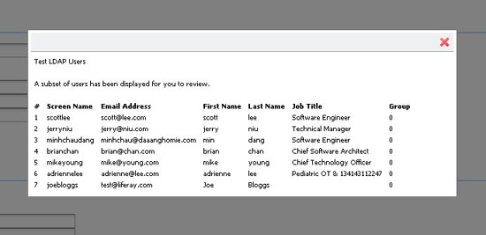Illustration 24: Testing LDAP Users
This section contains settings for mapping LDAP groups to Social Office.
Import Search Filter: This is the filter for finding LDAP groups that you want to map to Social Office. Enter the LDAP group attributes that you want retrieved for this mapping. The following attributes can be mapped:
- Group Name
- Description
- User
Test LDAP Groups: Click the Test LDAP Groups to display a list of the groups returned by your search filter.

Import/Export
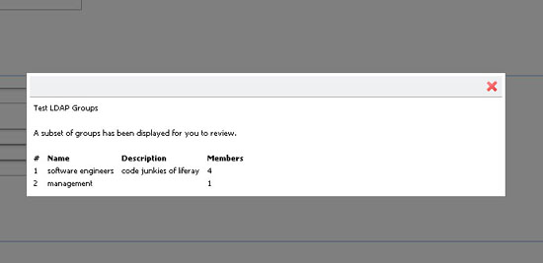Illustration 25: Mapping LDAP Groups.
Users DN: Enter the location in your LDAP tree where the users are stored. When Social Office does an export, it will export the users to this location.
User Default Object Classes: When a user is exported, the user is created with the listed default object classes. To find out what your default object classes are, use an LDAP browser tool such as JXplorer to locate a user and view the Object Class attributes that are stored in LDAP for that user.
Groups DN: Enter the location in your LDAP tree where the groups are stored. When Social Office does an export, it will export the groups to this location.
Once you have completed configuring LDAP, click the Save button. This will take you back to the General tab under Settings. Click the LDAP tab to get back to the LDAP settings, where you can define the global LDAP settings as shown below.

Global LDAP Options
Use LDAP Password Policy: Social Office uses its own password policy by default. This can be configured on the Password Policies link in the Portal section on the left side of the Control Panel. If you want to use the password policies defined by your LDAP directory, check this box. Once this is enabled, the Password Policies tab will display a message stating that you're not using a local password policy. You'll now have to use your LDAP directory's mechanism for setting password policies. Social Office does this by parsing the messages in the LDAP controls that are returned by your LDAP server. By default, the messages in the LDAP controls that Social Office is looking for are the messages that are returned by the Fedora Directory Server. If you're using a different LDAP server, you'll need to customize the messages in Social Office's portal-ext.properties file, as there is not yet a GUI for setting this. See below for instructions describing how to do this.
Import Enabled: Check this box to cause Social Office to do a mass import from your LDAP directories. If you want Social Office to only synchronize users when they log in, leave this box unchecked. Definitely leave this unchecked if you're working in a clustered environment. Otherwise, all of your nodes would try to do a mass import when each of them starts up.
If you check the box, several other options become available.
Import on Startup Enabled: Check this box to have Social Office run the import when it starts up. This box only appears if you check Import Enabled above.
Export Enabled: Check this box to enable Social Office to export user accounts from the database to LDAP. Social Office uses a listener to track any changes made to the User object and will push these changes out to the LDAP server whenever the User object is updated. Note that by default on every login, fields such as LastLoginDate are updated. When export is enabled, this has the effect of causing a user export every time the user logs in. You can disable this by setting the following property in your portal-ext.properties file:
users.update.last.login=false

LDAP Options Not Available in the GUI
Though most of the LDAP configuration can be done from the Control Panel, there are several configuration parameters that are only available by editing portal-ext.properties. These options are available in the GUI in future versions of Social Office, but for now they can only be configured by editing the properties file.
If you need to change any of these options, copy the LDAP section from the portal.properties file into your portal-ext.properties file. Note that since you have already configured LDAP from the GUI, any settings from the properties file that match settings already configured in the GUI is ignored. The GUI, which stores the settings in the database, always takes precedence over the properties file.
ldap.auth.method=bind
#ldap.auth.method=password-compare
Set either bind or password-compare for the LDAP authentication method. Bind is preferred by most vendors so that you don't have to worry about encryption strategies. Password compare does exactly what it sounds like: it reads the user's password out of LDAP, decrypts it, and compares it with the user's password in Social Office, syncing the two.
ldap.auth.password.encryption.algorithm=
ldap.auth.password.encryption.algorithm.types=MD5,SHA
Set the password encryption to used to compare passwords if the property ldap.auth.method is set to password-compare.
ldap.import.method=[user,group]
If you set this to user, Social Office will import all users from the specified portion of the LDAP tree. If you set this to group, Social Office will search all the groups and import the users in each group. If you have users who don't belong to any groups, they will not be imported.
ldap.error.password.age=age
ldap.error.password.expired=expired
ldap.error.password.history=history
ldap.error.password.not.changeable=not allowed to change
ldap.error.password.syntax=syntax
ldap.error.password.trivial=trivial
ldap.error.user.lockout=retry limit
These properties are a list of phrases from error messages which can possibly be returned by the LDAP server. When a user binds to LDAP, the server can return controls with its response of success or failure. These controls contain a message describing the error or the information that's coming back with the response. Though the controls are the same across LDAP servers, the messages can be different. The properties described here contain snippets of words from those messages, and will work with Red Hat's Fedora Directory Server. If you're not using that server, the word snippets may not work with your LDAP server. If they don't, you can replace the values of these properties with phrases from your server's error messages. This will enable Social Office to recognize them.

Single Sign-On
Single Sign-On solutions allow you to provide a single log in credential for multiple systems. This allows you to have people authenticate to the Single Sign-On product and they are automatically logged in to Social Office and to other products as well.
Social Office at the time of this writing supports several single sign-on solutions. Of course if your product is not yet supported, your organization can choose to sponsor support for it. Please contact sales@liferay.com for more information about this.

Authentication: Central Authentication Service (CAS)
CAS is an authentication system that was originally created at Yale University. It's a widely-used open source single sign-on solution, and was the first SSO product supported by Social Office.
Please follow the documentation for CAS to install it on your application server of choice.
Your first step is to copy the CAS client .jar file to Social Office's library folder. In the bundle, this is in [Social Office Home]/tomcat-[version]/webapps/ROOT/WEB-INF/lib. Once you've done this, the CAS client is available to Social Office the next time you start it.
The CAS Server application requires a properly configured Secure Socket Layer certificate on your server in order to work. If you wish to generate one yourself, you'll need to use the keytool utility that comes with the JDK. Your first step is to generate the key. Next, you export the key into a file. Finally, you import the key into your local Java key store. For public, Internet-based production environments, you'll need to either purchase a signed key from a recognized certificate authority (such as Thawte or Verisign) or have your key signed by a recognized certificate authority. For Intranets, you should have your IT department pre-configure users' browsers to accept the certificate so that they don't get warning messages about the certificate.
To generate a key, use the following command:
keytool -genkey -alias tomcat -keypass changeit -keyalg RSA
Instead of the password in the example (changeit), use a password that you can remember. If you're not using Tomcat, you may want to use a different alias as well. For First and Last name, enter localhost, or the host name of your server. It cannot be an IP address.
To export the key to a file, use the following command:
keytool -export -alias tomcat -keypass changeit -file server.cert
Finally, to import the key into your Java key store, use the following command:
keytool -import -alias tomcat -file %FILE_NAME% -keypass changeit -keystore $JAVA_HOME/jre/lib/security/cacerts
If you're on a Windows system, replace $JAVA_HOME above with %JAVA_HOME%. Of course, all of this needs to be done on the system on which CAS is running.
Once your CAS server is up and running, you can configure Social Office to use it. This is a simple matter of navigating to the Settings -> Authentication -> CAS tab in the Control Panel. Enable CAS authentication, and then modify the URL properties to point to your CAS server.
Enabled: Set this to true to enable CAS single sign-on.
Import from LDAP: A user may be authenticated from CAS and not yet exist in the portal. Select this to automatically import users from LDAP if they don't exist in the portal.
The rest of the settings are various URLs, with defaults included. Change localhost in the default values to point to your CAS server. When you're finished, click Save. After this, when users click the Sign In link from the Dock, they are directed to the CAS server to sign in to Social Office.

Authentication: Facebook
Social Office also enables users to log in using their Facebook accounts. To enable this feature, you simply need to select the Enable box and enter the Application ID and Application Secret which should have been provided to you by Facebook. Facebook SSO works by taking the primary Facebook email address and searching for the same email address in Social Office's User_ table. If a match is found, the user is automatically signed on (provided that user clicked allow from the Facebook dialog). If there isn't a match, the user is prompted in Social Office to add a user from Facebook. Once selected, a new user is created by retrieving four fields from Facebook (first name, last name, email address, and gender).

Authentication: NTLM
NTLM is a Microsoft protocol that can be used for authentication through Microsoft Internet Explorer. Though Microsoft has adopted Kerberos in modern versions of Windows server, NTLM is still used when authenticating to a workgroup.
Enabled: Check the box to enable NTLM authentication.
Domain Controller: Enter the IP address of your domain controller. This is the server that contains the user accounts you want to use with Social Office.
Domain: Enter the domain / workgroup name.

Authentication: OpenID
OpenID is a new single sign-on standard which is implemented by multiple vendors. The idea is that multiple vendors can implement the standard, and then users can register for an ID with the vendor they trust. The credential issued by that vendor can be used by all the web sites that support OpenID. Some high profile OpenID vendors are AOL (http://openid.aol.com/screenname), LiveDoor (http://profile.livedoor.com/username), and LiveJournal (http://username.livejournal.com). Please see the OpenID site (http://www.openid.net) for a more complete list.
The obvious main benefit of OpenID for the user is that he or she no longer has to register for a new account on every site in which he or she wants to participate. Users can register on one site (the OpenID provider's site) and then use those credentials to authenticate to many web sites which support OpenID. Many web site owners often struggle to build sites because end users are reluctant to register for so many different accounts. Supporting OpenID makes it easier for site owners to build their sites because the barriers to participating (i.e., the effort it takes to register for and keep track of many accounts) are removed. All of the account information is kept with the OpenID provider, making it much easier to manage this information and keep it up to date.
Social Office can act as an OpenID consumer, allowing users to automatically register and sign in with their OpenID accounts. Internally, the product uses OpenID4Java (http://code.google.com/p/openid4java/) to implement the feature.
OpenID is enabled by default in Social Office, but can be disabled on this tab.

Authentication: OpenSSO
OpenSSO is an open source single sign-on solution that comes from the code base of Sun's System Access Manager product. Social Office integrates with OpenSSO, allowing you to use OpenSSO to integrate Social Office into an infrastructure that contains a multitude of different authentication schemes against different repositories of identities.
You can set up OpenSSO on the same server as Social Office or a different box. Follow the instructions at the OpenSSO site (http://opensso.dev.java.net) to install OpenSSO. Once you have it installed, create the Social Office administrative user in it. Users are mapped back and forth by screen names. By default, the Social Office administrative user has a screen name of test, so in OpenSSO, you would register the user with the ID of test and an email address of test@liferay.com. Once you have the user set up, log in to Open SSO using this user.
In the same browser window, go to the URL for your server running Social Office and log in as the same user, using the email address test@liferay.com. Go to the Control Panel and click Settings -> Authentication -> OpenSSO. Modify the three URL fields (Login URL, Logout URL, and Service URL) so that they point to your OpenSSO server (i.e., only modify the host name portion of the URLs), click the Enabled check box, and then click Save. Social Office will then redirect users to OpenSSO when they click the Sign In link.

Authentication: SiteMinder
SiteMinder is a single sign-on implementation from Computer Associates. Social Office now has built-in integration with SiteMinder. SiteMinder uses a custom HTTP header to implement its single sign-on solution.
To enable SiteMinder authentication in Social Office, check the Enabled box on the SiteMinder tab. If you're also using LDAP with Social Office, you can check the Import from LDAP box. If this box is checked, user authenticated from SiteMinder that don't exist in the portal is imported from LDAP.
The last field defines the header SiteMinder is using to keep track of the user. The default value is already populated. If you have customized the field for your installation, enter the custom value here.
When you're finished, click Save.

Default User Associations
The Default User Associations link has three fields allowing you to list (one per line) sites, roles, and user groups that you assign new users by default. Social Office's default is to assign new users both the Users role and the Power Users role.
The Power Users role allows used to allow users to have their own set of pages. This is now provided to all users and can be modified using the portal-ext.properties file. You can now use the Power Users role to provide your own differentiation between regular users and users to whom you wish to give more privileges in the portal, or you can remove it altogether.
If you have defined other user groups, sites, or roles that you want assigned to newly created users by default, enter them here. For example, you may have defined page templates in certain user groups to pre-populate end users' private pages. If there's a particular configuration that you want everyone to have, you may want to enter those user groups here.

Reserved Credentials
The next link is Reserved Credentials. You can enter screen names and email addresses here that you don't want others to use. Social Office will then prevent users from registering with these screen names and email addresses. You might use this feature to prevent users from creating IDs that look like administrative IDs or that have reserved words in their names.

Mail Host Names
The next link is Mail Host Names. You can enter (one per line) other mail host names besides the one you configured on the General tab. Social Office will fail over to these host names in the event that the connection to the main one fails.

Email Notifications
There are three tabs under the Email Notifications link. The Sender tab allows you to set the portal administration name and email address. By default, this is Joe Bloggs and test@liferay.com. You can change it to anything you want. This name and address will appear in the From field in all email messages sent by the portal.
The other two tabs (Account Created Notification and Password Changed Notification) allow you to customize the email messages that are sent to users on those two events. A list of tokens for inserting certain values (such as the portal URL) is given if you wish to use those.

Identification
The identification section has several links for addresses, phone numbers, and other information you can configure in your portal. This allows you to set up contact information for the organization that's running the installation of Social Office.

Miscellaneous: Display Settings
This section allows you to set the default portal language and the time zone. You can also set the site-wide logo which appears in the top left corner of each page. Be careful when using this option to choose an image file that fits the space. If you pick something that's too big, it will mess up the navigation.

Monitoring
The next link on the left side of the Control Panel is for monitoring. Using this, you can see all of the live sessions in the portal. For performance reasons, this setting is generally turned off in production, but if you have it turned on, you can view the active sessions here.

Server Administration
The Server Administration link lets you perform various tasks relating to administration of the overall Social Office installation, as opposed to administering resources in the site. Clicking the link makes this abundantly clear: you're immediately presented with a graph showing the resources available in the JVM.

Resources
The first tab is called Resources. This tab contains the aforementioned graph plus several server wide actions that an administrator can execute. These are:
- Garbage collection: You can send in a request to the JVM to begin the garbage collection task.
- Clearing caches: You can send in a request to the JVM to clear a single VM cache, the cluster cache, or the database cache.
- Reindex: You can send in a request to regenerate all search indexes.
- Generate Thread Dump: If you're performance testing, you can generate a thread dump which can be examined later to determine if there are any deadlocks and where they might be.

Log Levels
Here you can dynamically modify the log levels for any class hierarchy in the portal. If you have custom code that you have deployed which isn't in the list, you can use the Add Category tab to add it. If you change the log level near the top of the class hierarchy (such as at com.liferay), all the classes under that hierarchy will have their log levels changed. If you're testing something specific, it's much better to be as specific as you can when you change log levels, as by modifying them too high in the hierarchy you can generate a lot more log messages than you probably need.

System Properties
This tab shows an exhaustive list of system properties for the JVM, as well as many Social Office system properties. This information can be used for debugging purposes or to check the configuration of the currently running portal.

Portal Properties
This tab shows an exhaustive list of the portal properties. These properties are customizable, which you'll see in the next chapter. If you need to check the current value of a particular property, it can be viewed from this screen without having to shut down the portal or open any properties files.

Shutdown
If you ever need to shut down your Social Office server while users are logged in, you can use the Shutdown tab to inform your logged-in users of the impending shutdown. You can define the number of minutes until the shutdown and a custom message that is displayed.
Users will see your message at the top of their portal pages for the duration of time you specified. When the time expires, all portal pages will display a message saying the portal has been shut down. At this point, restart the server to restore access.

OpenOffice
Social Office contains a Document Library application. This application allows users to upload documents in many formats into a folder structure that they define.
OpenOffice.org is an open source office suite which is normally run in graphical mode to create documents, but it can be run in “server” mode. When run in server mode, OpenOffice.org can be used to convert documents to and from all of the file types it supports. Social Office's Document Library application can make use of this feature to automatically convert documents on the fly.
You would use this tab to tell Social Office how to connect to your running instance of OpenOffice.org. You can install OpenOffice.org on the same server upon which Social Office is running. Once you have it installed, you can start OpenOffice.org in server mode with the following command:
soffice -headless -accept="socket,host=127.0.0.1,port=8100;urp;" -nofirststartwizard
As you can see, the command above specifies that OpenOffice.org will run on port 8100, which is the default port in the Control Panel. If you can use this port, all you need to do is check the Enabled box, and Social Office is integrated with OpenOffice.org.
If you have something else running on this port, find a port that's open and specify it both in the command above and on the Control Panel's OpenOffice.org configuration page. When you're finished, click Save.

Summary
We went in-depth through Social Office's Control Panel. Using the Control Panel, we learned how to manage users and roles. We also learned how to configure various server settings, such as authentication, LDAP integration, and single sign-on. We also learned how to associate users by default with different sites and roles, and we saw how to reserve screen names and email addresses so that users cannot register in the portal with them.
Next, we saw how to view and configure overall server settings. We saw how to view the memory currently being used by the server, as well as how to initiate garbage collection, a thread dump, search engine re-indexing, and the clearing of various caches. We learned how to debug parts of the portal by changing log levels, and by viewing the various properties that are defined in the portal.
Finally, we learned how to properly notify users that the portal is about to shut down and how to enable the OpenOffice.org integration.
All of this information should help to bring you well on your way to becoming a seasoned Liferay Social Office Administrator.

