What is Liferay?
Let's attempt some mind reading: you're reading this because you need to build a website. You're thinking about using Liferay for your site, or you've already decided to use it and you want to learn all about it. Either way, you've come to the right place. What you'll find here is that Liferay Portal is the right decision, and we'll be happy to tell you all the reasons why. But since you might be in a rush, we'll give you all the reasons in a nutshell right here, and then you can read the details in the rest of the articles.
The reasons to use Liferay Portal for your website are simple: it provides a robust platform to build your site on quickly and serve it to all clients, be they desktop, mobile, or anything in between; it provides all the standard applications you need to run on your site; and it provides an easy to use development framework for new applications or customization. In addition to this, Liferay Portal is developed using an open source methodology, by people from around the world. The code base is solid and has been proved to be reliable and stable in mission critical deployments in diverse industries.
But don't just take our word for it. Let us show you how Liferay does all this. Probably the first thing you want to do after you install Liferay Portal to manage your site is to get your content published. Let's dive right in and see how Liferay Portal handles that task.

Building a site with Liferay Web Experience
When you log into Liferay and look at its default screen, one thing to notice is that it's built for all clients that access the web, not just desktop browsers.
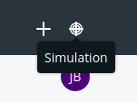
Figure 1.1: If you click this button, a preview appears that lets you see how the page would look when displayed at various device resolutions.
Another thing to notice is that all the page controls are right there for you. For example, to add content or applications to the page, click the + button, and then you can add any kind of content Liferay supports. The interface has been designed to get out of your way and let you do your work.
Liferay Web Experience Management scales to work for the tiniest of sites all the way up to the largest of sites. For example, you can click that Add button, choose Add New → Basic Web Content, and immediately start typing content into a WYSIWYG editor, in place. Or you can set up Liferay to host many different web sites, all with their own domain names. Each site can take advantage of a separate staging server, where content and pages are created by teams of people using structures and templates, and updates to the production server are published on a schedule, only after having gone through a multi-step approval process.
That's powerful.
By default, Liferay Portal starts with a single site that has a single page. You can build any website you wish out of this, complete with multi-nested page hierarchies, as the figure below shows.
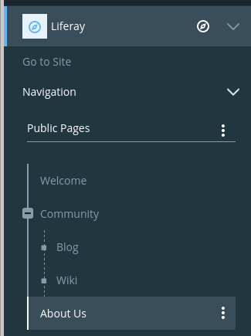
Figure 1.2: Liferay's page hierarchies are easy to create, using a tree structure that's familiar to anyone who has used a file manager.
These pages can have any layout you like: Liferay Portal ships with several built-in, and you can create your own custom layouts and deploy them easily. Pages can be added, removed, or reordered any time, and you have the full flexibility of all the HTML page attributes, such as meta tags and robot file declarations, that you need.
Pages are also integrated with Liferay's powerful permissions system, so it's easy to restrict access to certain portions of your site. You can give individual users sites of their own, with public pages that have their content and blog, and private pages that contain their calendars and email.
If you're running a large website that has lots of different sub-sites for individuals and groups, you can use page templates and site templates. The former enables you to set up templates of pages with predefined layouts and applications already on them, and the latter enables you to create a whole site made up of multiple, predefined pages.
There's even more. If you have a very large site, you might need multiple people to work on it. And you certainly don't want the live site changing before your users' eyes. For that reason, Liferay Portal provides a feature called staging that lets you place your changes in a holding area while they're being worked on. You can have a local staging server, where the staged site resides on the same server as the live site, or you can have a remote staging server, where all web content work happens on a separate server from your live site. In either case, when you're ready, site changes can be pushed to the live site, either manually or on a schedule.
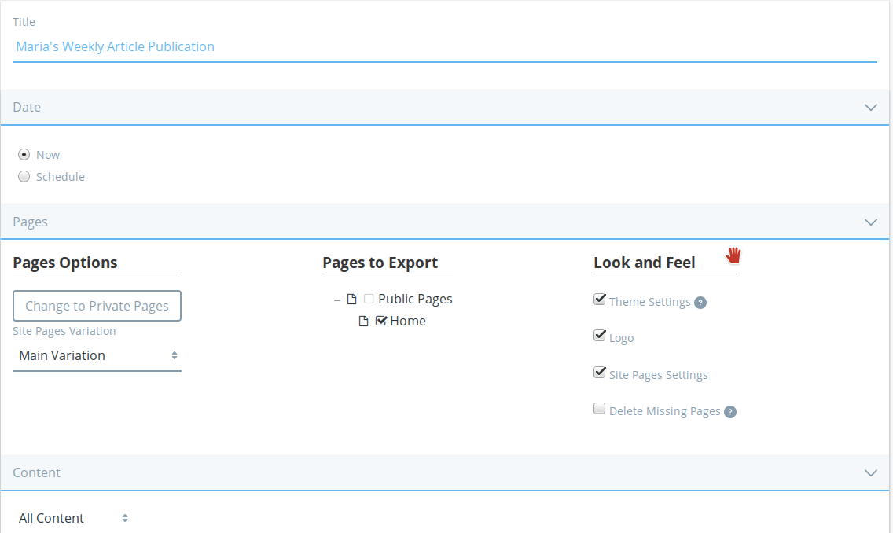
Figure 1.3: Staging supports publishing manually or on a schedule.
Liferay Portal's web content creation tools are easy and intuitive to use at all levels. If you need only basic content management capabilities for your site, you can jump right in. You can add new content from the Add menu and drag it right into place. It's easy to go from this basic level of content management to more sophisticated levels of functionality.
For example, suppose you wanted to build a news-oriented site. Most of the content you'll publish is an article of some kind. Liferay's web content management system lets you create a structure for this, so that you can capture all the information from your writers that you'd need in an article. The figure below shows what this structure might look like to a journalist who'd be entering his or her article into the system.
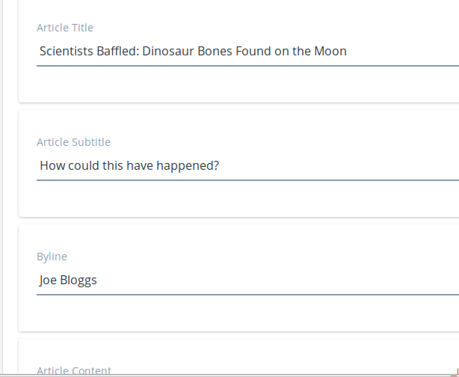
Figure 1.4: Structures allow you to specify exactly the type of data that makes up your content. You can also include tooltips to help your users understand what each field is for.
As you can see, you can use structures to make sure writers provide the title of the story, what type of story it will be, and the byline (i.e., the writer's name). You've made sure that all the relevant information for the story is captured in the system.
Web content is one example of an asset. Assets are meta-data attached to content types, and that meta-data is used to aggregate similar assets together in searches or as published content. One way to do this in the example above is to tag and categorize stories so they can be found more easily by users.
This is just one example, of course. But the concept is applicable to any kind of site you'd want to build. For example, if you were building a site for a zoo, you could use web content structures to help users enter data about animals in the zoo, such as their common names, their scientific names, their species, their locations in the wild, and more.
When it comes time to publish content, structures are combined with templates. Templates are instructions for how to display structures, written in Freemarker, a well-known templating language used for mixing HTML with programmatic elements. Because of this, templates are very easy to write and can help you ensure that your site has a consistent look and feel.
There is much more to web content. You can create abstracts, schedule when content is published and when it should be taken down (or reviewed), define related assets, and more.
This is just the web content portion of Liferay's content management system. Liferay Portal is also great at managing file-based content.

Keeping track of documents, images, video, and more
It's rare to find a full-featured content management system in an open source project. Most of the time, you'll find web content management systems and file-based content management systems as separate projects. Liferay Portal, however, provides you with both. As shown above, the web content management system is as robust as any other you'll find, and its file-based content management system is the same.
You'll find Liferay's file-based content management system in an application called Documents and Media Library. This application resides on the Site Administration page or can be added to any page, and, as shown below, looks very much like the file manager that you're already familiar with from your operating system.
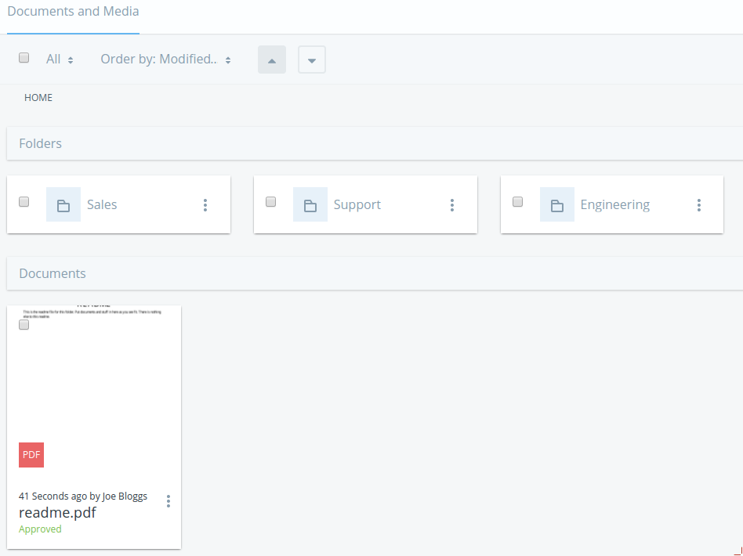
Figure 1.5: Liferay Portal's Documents and Media library was purposefully designed to be familiar to anyone who uses a computer.
Like a file manager, you can browse files and folders in nested hierarchies. You can also mount other repositories that you might have in your environment, such as any system that implements Content Management Interoperability Services (CMIS) or Documentum (enterprise subscribers only). It provides previews of just about every document type you can think of. And, like a file manager, you can upload, copy, and move files between folders by dragging and dropping them. Of course, if you still want to use your operating system's file manager, you can, because Liferay's Documents and Media library supports WebDAV, using the same credentials you use to log in to Liferay.
Liferay Portal's Documents and Media library, however, is much more robust than a file manager is, because it's a full content management system. You can define ways of classifying files that may be of different types, but are meant for the same, overarching purpose.
For example, metadata sets are groups of fields describing attributes of a file. One that ships with the product is called meeting metadata, and it contains fields such as Meeting Name, Date, Time, Location, Description, and Participants. This is a generic set of fields that go together and that you'd want to use as a group. You can create as many of these as you want.
For files, you can define document types. They provide a more natural way of working with files. For example, you might create a document type called Meeting Minutes. The file format doesn't matter: whether it's a Microsoft Word document, an HTML file, or a text file, the document contains meeting minutes. Once you've created the document type, you can attach the Meeting Metadata set that contains many of the fields you'd want, and you can also add extra fields, such as a field for action items. When users want to add files containing their notes for meeting minutes, they can also add all the relevant metadata about the meeting (such as the time, location, and action items). This captures the context information that goes with the document, and it provides a much more natural way of working with documents than just dumping them into a shared file system.
Of course, the system goes much further than this. Folders can be set so that only certain document types can be added to them. Workflow rules can also be added to folders to run files through an approval process that you define. In short, Liferay's file-based content management system gives you all the features you need to manage and share files in a group.
Many Liferay Portal users see it as a robust content management system, and they use it primarily for that purpose. Now, hopefully, you can see why. We'll cover the system in-depth in the relevant section on the left, but for now we need to look at some of the other ways you can use Liferay Portal, starting with its fantastic collaborative tools.

Using Liferay Portal as a collaborative platform
Many sites have grown organically. You may have grown your community by using separate tools: first a forums application, and then a wiki for collaborative documentation, and maybe even a chat application. It can be hard (and error-prone) to integrate all these applications so your users can use them seamlessly. Thankfully, Liferay includes a suite of collaborative applications, and they're all integrated together.
Liferay Portal offers every standard collaborative application that's available. These applications range from personal productivity applications like a calendar and email, to community-building applications like message boards, polls, and wikis.
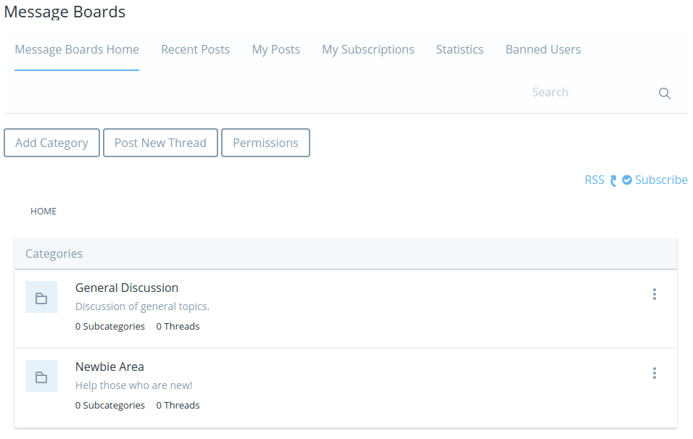
Figure 1.6: Liferay Portal's message boards are as fully featured as any standalone forum application, with the added benefit that they're integrated with the rest of the system.
This is a suite of integrated applications with all the features of similar, standalone applications. For example, Liferay Portal's message boards include categories and subcategories, message threads, captcha, RSS feeds, email notification, posting via email, and much more. But more than this, the applications are integrated with the rest of Liferay Portal's framework. Users log in and their profiles are used automatically by the message boards and all the other collaborative applications. And as we'll see later, functionality from the built in applications can be added to your own to provide features like comments in your own software, and you don't have to write any code to do it.
Liferay Portal's wiki is another example of a full-featured collaborative application. It has support for authoring pages in a WYSWYG editor, or more advanced users can use the easy-to-learn standard Wiki Creole syntax. The wiki keeps a full history of every change that's been made, allowing users to revert back to any change. Users can comment on wiki articles or read them via RSS feeds (just about every Liferay application supports this). Each site can have one or more wikis, and each wiki can have one or more top-level nodes.
One important feature of all the collaborative applications--as well as web content and documents--is the Recycle Bin. If users delete content that needs to be restored later, you don't have to find it in your backups: it's in the Recycle Bin.
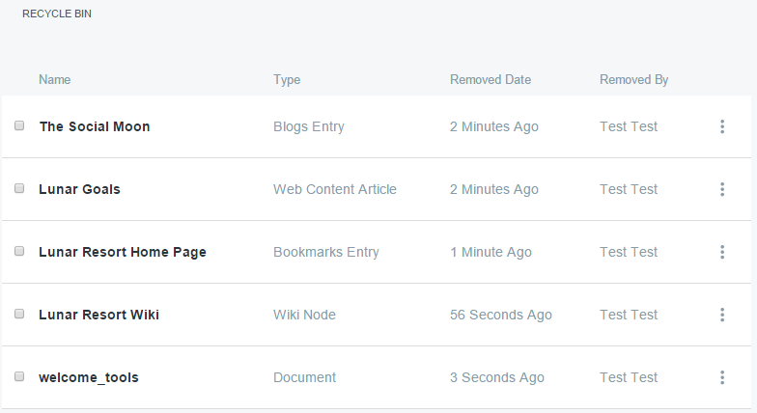
Figure 1.7: The Recycle Bin can hold any kind of content.
Liferay Portal's suite of collaborative applications includes a blog (complete with blog aggregation features so you can publish multiple users' blog entries in one place), a chat application for users who are online at the same time, message boards, a wiki, a knowledge base that you can use to publish a library of articles, a polling system you can use to have users vote on certain questions, and personal productivity applications like a calendar.
Liferay Portal includes every application you'll need to enable users to collaborate. Next, you'll see how Liferay can host multiple web sites.

Using Liferay as a web platform
We can't even begin to imagine what you're thinking of building, but whatever it is, you're going to put your heart and soul into it. Building it on Liferay's web platform can give you a leg up. It provides everything you need to support your application, so you can concentrate solely on what you're building, and not the rest of the features your users expect to come along with it.
Imagine your application for a moment. Does it require users to register on your site? Can users comment on content contained in your application? Is there something that users can tag or categorize? If you think about the layout of the application, would it benefit from modularization? Could you make use of a rich JavaScript framework with many components built into it? How about security--will you need to make information available to some users, but not to all users? Liferay Portal has all of this and more available to developers.
Liferay Portal's development framework is a great help when you're building an application for the web, for mobile, or for anything in between. For example, bug fixes to your applications are easy to apply, because Liferay applications are hot deployed to the running server. Liferay's Marketplace gives you a ready-made shopping center for your applications. And Liferay's web services and JSON architecture make it easy for you to share data from your applications with other systems running on different platforms.
You get all this and much more. It's a very powerful platform, and certainly worth your investigation. Read the developer section of this site to learn more.

A great integration platform
If you're building an enterprise system, portals were designed in the first place to be a single point of entry to your users' applications and content. Since Liferay Portal integrates well with user directories such as LDAP and Active Directory, along with single sign-on systems such as SAML and OpenSSO, it fits well into your enterprise systems. This allows you to use it as an integration platform for existing applications.
Liferay Portal, since it adheres to the JSR standard for portlets, was designed from the ground up for application integration. You can add any application installed on the system to any page in the portal. You can make use of APIs provided by other systems to integrate their data into an application window in Liferay. And applications you create with Liferay's Service Builder framework are web service-enabled from the start.

Hosting multiple sites on Liferay Portal
Liferay Portal excels as a multi-site hosting platform. You can use it to host multiple sites under the same overall architecture, or you could host several completely different websites based solely on Liferay's ability to serve multiple instances of itself from the same physical installation.
In the first scenario, Liferay Portal's Sites architecture lets you create multiple, different websites that have public and/or private sets of pages and as many pages within those sets as you'd like. Users can join and leave open sites with one click. Alternatively, sites can be defined as restricted or private, and users can't access those unless they're added by site administrators. All these sites can have canonical domain names such as baseballcards.liferay.com or progrock.liferay.com.
Using this construct, you can build anything you can imagine. There is no limit to the number of sites you can have: some Liferay installations have only one or two, but others have many thousands. For those larger installations, Liferay Portal contains a complete site membership management framework that lets administrators manage automatic site members for groups of users. It really is built to scale to the size you need.
In the second scenario, Liferay Portal lets you create completely separate instances of itself from the same installation. Users, groups, organizations, sites, and roles from each instance are kept completely separate. If a user registers for a user id on one instance, he or she would have to register as a new user on one of the other instances.
This lets you host many different, separate websites from one Liferay Portal installation. Users of each instance have access to the same powerful content management, collaboration, social, and web development platform that they'd have if they were operating from a single, standalone installation.
Let's see how you can customize Liferay Portal so that it looks and operates exactly the way you've envisioned for your site.

Extending and customizing Liferay for your own needs
Beyond using it as a development platform for new applications, Liferay Portal has also been designed to be extended and modified. As an open source project, its source code is available, but Liferay Portal's developers have designed the product to make it easy to build whatever you want out of it.
The first (and easiest) way of customizing parts of Liferay Portal is with Application Display templates. These let you change the way built-in applications look. For example, if you don't like the Documents and Media Library's file manager view with large icons, you can create an Application Display template that shows documents in some other view. If you don't like the layout of the Blogs application, you can change it so that it has the look you want.
Liferay Portal goes far beyond this, though. Special software components called modules enable developers to change Liferay's interface and behavior--without having to modify any of Liferay Portal's source code. This provides you all the benefits of building your site from scratch, but without all the effort to actually build from scratch. If you want to make a change to the user registration screens, add support for a proprietary single sign-on mechanism that you've written, add a feature to the message boards application or anything else, you can make those customizations. And if you're a developer, you know that it's a whole lot easier to customize something that almost does things exactly the way you want than it is to write that feature from scratch. With Liferay Portal, you can have your cake and eat it too.

Summary
So what is Liferay? As you can see, it's hard to describe, because it does so much. What we've essentially done is say it's a totally awesome content and document managing, user collaborating, socially enabling, application developing, corporate integrating, completely customizable platform for building the Internet. If we'd said that up front, you'd probably have doubted us. Hopefully now you can see that it's true.
If you're interested in using Liferay Portal for your product, continue reading. All of these features (and more that we couldn't mention) are covered here.

