**I. INTRUCTIONS**

The pack includes 3 *.py files:

1. hw_rest_api.py - REST_API engine

2. hw_rest_api_post.py - Run to POST input data

3. hw_rest_api_get.py - Run to GET calculated quantile using input data from POST request

**II. TEST CASES**

Local host environment

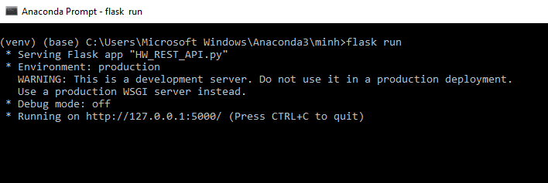

**Ex1**: {'pool': [1,7,2,6], 'percentile': 99.5}

python hw_rest_api_post.py

python hw_rest_api_get.py

np.quantile()

**Ex2**: {'pool': [100, 50, 500, 400, 700, 200], 'percentile': 80}

python hw_rest_api_post.py

python hw_rest_api_get.py

np.quantile()

**Ex3**: {'pool': [100, 90, 80, 70, 60, 50, 40, 30, 20, 10], 'percentile': 94}

python hw_rest_api_post.py

python hw_rest_api_get.py

np.quantile()