Performance Evaluation of Word Representation
Techniques using Deep Learning Methods

Anjali Bohra
MBM Engineering College
(Jai Narain Vyas University, Jodhpur) Jodhpur, India vyas.anjalilucky@gmail.com
Dr N C Barwar
MBM Engineering College
(Jai Narain Vyas University, Jodhpur) Jodhpur, India
ncbarwar@jnvu.edu.in

Abstract—Word vectors are the real-valued numbers which allow machine learning algorithms to extract the semantic information concern with the words when trained on natural language corpora. The paper explores word representation techniques with evaluation criteria to measure the quality of representation through deep learning models like BERT. The performance of these words vectors can be evaluated using certain measures. Broadly, the two classes of evaluation are intrinsic and extrinsic evaluation. Intrinsic evaluators directly extract syntactic or semantic relationships between the words independent of any language processing task. These evaluators focus on subtasks while extrinsic evaluators consider complete natural language processing task as a measure of performance like chunking, sentiment analysis etc. The experiments have been performed using BOW model, Word2Vec and BERT language model. In this research work word-similarity task is considered for intrinsic evaluation and part-of-speech (POS) tagging task is used as a measure for extrinsic evaluation. The experiments have been performed using python, sklearn machine learning toolkit and keras deep learning framework. BERT language model is used which has recently emerged as the prominent tool for natural language processing. The result obtained from the experiment in this research for word embedding representation techniques are efficient and better compared to other existing traditional models. However, considering large datasets this can be enhanced for better accuracy

Keywords— Word Vector, Word Embedding, Distributed Representation, Intrinsic Evaluators, Extrinsic Evaluators, BOW, Word2Vec, BERT , Pre-trained Embedding.

I. INTRODUCTION
The role of natural language processing is to extract information from unstructured text. A natural language processing system allows computers to understand the natural language and perform specific tasks like classification, part-of-speech tagging or sentiment analysis etc. The most significant task is to represent the meaning of words in a computer. The systems should be able to extract the similarity and difference between the words. Generally, the taxonomy like WordNet is used to express the hypernyms and synonyms sets. But this leads to a problem of missing words i.e. the words which are not defined in the corpus cannot be expressed. Word vectors are the real number vectors that encode the notion of similarity and difference between the words. These are the learned representation of the input. For example if there are k-million words in a language, then there exists some k-dimensional space to encode the semantics of the language. Each dimension encodes specific meaning which is transferred during communication. The numbers in the word vector represent the word’s distributed weight across dimensions. The numerical weight of the word represents the closeness of the concept [10]. The vector embeds both semantic and syntactic information of the word obtained from the corpus.
The semantic dimension indicate tense (past/present/future tense), number (singular/plural number), gender (masculine/feminine gender) etc. As shown in figure 1, each column represents the dimension which captures defined meaning or some specific concept. The four dimensions are animal, domestic, pet and fluffy respectively. The each weight of the word within the column (dimension) represents its closeness with the concept.

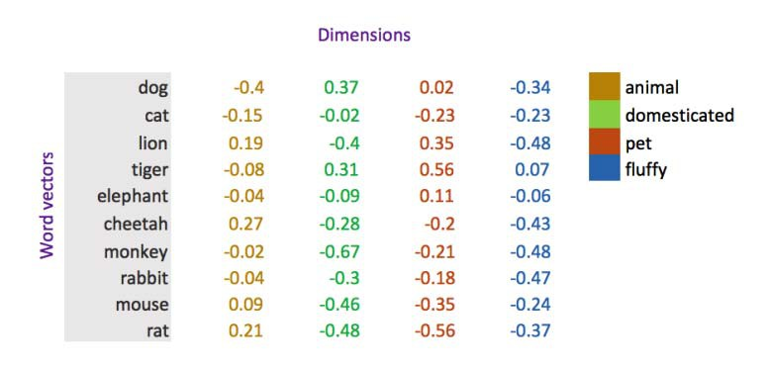

Figure 1: word vector representation with specific dimensions [10].

The dimensions of the vector contain the meaning of the word. Using these continuous vectors space machines can extract similarities between the different words [10]. The words with similar word vectors means they are similar in some context. Word-embedding is a significant tool of natural language processing to learn quality representation for various tasks like semantic analysis, information retrieval, question- answering systems and machine translation etc [1]. The most significant point in the study of distributional semantics is to evaluate the quality of word representation models [15]. There are no clear criteria about the evaluation of these models. lp engineers evaluate the performance of these models by experimenting on specific tasks like pos tagging, classification etc while computational linguistics perform experimentation using methods of cognitive science.

The paper presents the significance of word representation in natural language processing with various word representation approaches. It explains the comparative analysis of conventional and current word representational techniques for intrinsic and extrinsic evaluation. The paper is organized as follows: The section 1 cover the basic introduction and section 2 shows the related work done in the domain. Section 3 describes various approaches to word representation. The section 4 exposes the two classes of evaluation i.e. Intrinsic and extrinsic evaluation of word representations. The section 5 covers the experimental setup and results regarding performance evaluation of the word representation models. The next section concludes the work with specific points to be considered for further work.

978-1-7281-9180-5/20/$31.00 ©2020 IEEE

II. RELATED WORK
The section briefly describes the previous work done for word embedding evaluation. The first work in the field was proposed in the year 2007[16]. In 2010, survey for the word embedding tasks was preformed with the help of distributional semantics model [17]. In 2011, first paper was published regarding comparison of performance of various distributional semantic models [18]. In 2013, word2vec tool was released, which explained novel approaches to evaluation like word analogy task [19]. In 2015, the approaches to word evaluation were classified into two classes’ intrinsic and extrinsic evaluation [20]. In 2016, the first workshop on word embeddings evaluation was held at annual meeting of association of computational linguistics[21].Thus, lot of research have been performed but the domain still contain un-answered questions.

III. APPROACHES TO WORD REPRESENTATION
The Neural networks are the building blocks of natural language processing tasks. Before the advent of these networks the words were mapped into real-valued number through some basic approaches [3]. Based on the use of networks for generating word-embeddings, the approaches are classified into three categories: traditional word vectors, neural network based word embeddings and lastly pre- trained word embeddings. Bag-of-Words vector representation is the most common traditional word representation. Each word or n-gram is linked to a vector marked as 0 or 1 depending on its occurrence. TF-IDF is another traditional technique used to find the weights of the given words based on the context. BOW is used for text classification while TF-IDF used for document classification task. Neural-based word representations assign contextual information by representing the word vector in terms of dimensions known as distributional embeddings. Each dimension represents semantic information as well the contextual information regarding the word. Word2Vec is most prominent model implementing neural-based approach. Other models are Glove and FastText. With advent of deep neural networks remarkable results have been shown in field of computer vision and sequence based task. Recently, the introduction of encoder and attention based models has changed the working pattern. These models help in predicting the contextual information in efficient way. These are pre-trained using large datasets which are further used for solving specific tasks. ELMo and BERT are the most prominent pre-trained models. Broadly, word representation techniques are classified into two categories: Vector Representation and Distributed Representation.

A. VECTOR REPRESENTATIONS
1. One-hot vector
One-hot vector is the simplest word representation. Each word is represented as an independent entity of real number with |V| X 1 vector having all 0s and one 1 only at the index of that word. R is the set of real numbers and |V| is the size of vocabulary. The representation of each word in a complete vocabulary space which is very large therefore subspace is preferred to encode the relationships between words.
2. Singular Value Decomposition Method (SVD)
The method finds word co-occurrence counts (relation)
through iterative numerical methods. Using the given
dataset, the values regarding word are stored in a form of matrix. The matrix should be decomposed to easy calculations. SVD is a matrix decomposition method for reducing a matrix into its constituents. If A is a matrix then, singular value decomposition of a matrix A is UDVT .where U and V are left and right singular vectors and D is diagonal matrix whose diagonal entries are the singular values [2]. If (n X d) is the dimension of A, then (n X r ) ,(r X r) and (r X d) are the dimensions of U,D and V vector respectively. For all words in the dictionary, the rows of matrix U is used as the word embeddings [3].
The word co-occurrence matrix is either word-document matrix or window based co-occurrence matrix. The window-base co-occurrence matrix counts the word frequency inside a window of particular size. Both the word-document matrix and word co-occurrence matrix provide word vectors which sufficiently encode semantic and syntactic information. For M million documents and V vocabulary of words, the size of word-document matrix is |V| X M. The matrix obtained from these methods is high dimensional and sparse.
3. Iteration-based Methods
Iteration-based models create a model (language model) for learning to encode the probability of a word for the given context. Based on the training, the probabilistic model learns little information for the unknown parameters. Iteration generates errors which are updated accordingly to improve the performance of the model. The language model assigns a probability to a sequence of tokens. The probability of any given sequence of n words is represented as P(w1,w2,………wn). If the words are completely independent then, probability is given by:

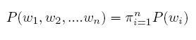
…(1)
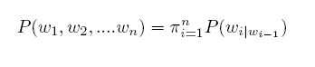
The representation in equation 1 is known as unigram model. But in general, the next word is dependent on previous word, therefore probability is given by:

…..(2) Equation 2, is known as Bigram model. But the next word is dependent not only on previous words but also on overall context of the word i.e dependent on whole sentence. Therefore, the next approach consider over all sentence as a context of word. Language model is known as continuous bag of words (CBOW) which predict the center word from the surrounding context. Another approach is that the model should predict the surrounding words. This type of model is known as Skip-Gram model.

B. DISTRIBUTED REPRESENTATIONS
Word representation approach which learns a distributed representation is called word embeddings. Word Embeddings are low dimensional representations of a point in a higher dimensional vector space. Embedding convert a word into its numeric form to implement mathematical operation for extracting the semantic of a word. Each dimension of the embedding captures semantic properties [4]. Word embeddings are the successful applications of unsupervised learning [5]. Deep learning research have attributes major progress in the field of natural language processing. Google introduced a neural network architecture which has many benefits over conventional sequential models [22]. Neural network architecture is an encoder-decoder model which uses attention mechanism to forward sequence to the decoder [23]. Attention was first introduced in natural language processing for machine translation task [24]. A transformer is a popular attention mechanism to learn contextual relations between words in a text. These models do not require annotated corpus rather extract information by learning itself from an available un-annotated corpus.
Every feed-forward neural network that accepts words from vocabulary embeds them as vectors into a lower dimensional space which is fine-tuned through back-propagation algorithm. The model generates word embeddings as the weights of the first layer which is known as Embedding layer. These models predict the probability that words other
than input words in the corpus are context of the given word.
An embedding matrix W € R KXD is a linear mapping from original k-dimensional space to a real-valued d-dimensional vector space. Intermediate layers produce an intermediate representation of the input which is generally a LSTM network. A softmax layer which is the final layer produces a probability distribution over words in vocabulary V.
1. Pre-trained word embeddings
Word embedding can be of two types namely non- contextual and contextual word embedding. Each word x in a vocabulary V is represented by vector v € Ŕ D of hyper-parameters, where R is the set of positive real numbers and D is the dimension used for word embedding. These embeddings are trained for specific tasks. The non contextual word embeddings are static in nature and cannot capture the meaning of polysemous words and lead to the problem of out-of-vocabulary. The problems can be resolved by using character-level and sub-word level word representations. The problem of polysemous words is solved by using contextual word representations. Each word or sub-word x t in a vocabulary (V) is calculated by following equation.

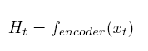
……(3)
Where f encoder is neural contextual encoder which can be sequential or hierarchical( graph)[6]. H t is an embedding or representation of a word in a vector space. The tanh activation then rearranges the word representation in its current vector space. The final layer learns information of the new vector space by combining the previous content according to their relevance to the problem [25].These character-level and word-level embeddings belong to the class of pre- trained word embedding. The word embeddings learned for one task which can be used for solving another similar task. These embeddings are trained on large datasets which are saved and further used for solving other tasks. Transfer learning learns either embeddings
or weights. If it learns embeddings then it is known as pre-trained word embeddings and if learns weights then it is known as pre-trained models. Embeddings from language models (ELMo) accepts complete sentence as input and generate representation by using trained LSTM network for a specific dataset. BERT[7] and OpenAI GPT[8] are pre-trained neural work models which have proved their efficiency in various language processing tasks like POS tagging, chunking etc. BERT is the best method in natural language processing to understand the contextual information for text.
IV. EVALUATION TECHNIQUES FOR WORD VECTORS The words vectors embed syntactic and semantic
information concerned with words of a language. The methods like Word2vec and Glove deals with hidden information of a word in semantic context. The performance of these words vectors can be evaluated using certain measures. An ideal word evaluator analyzes word embedding models from different perspectives using quantitative and representative metric. An efficient word embedding evaluator should have some specific properties like good testing data, comprehensiveness, high correlation, efficiency and statistical significance. The two types of evaluation criteria are intrinsic and extrinsic evaluation.

A. Intrinsic Evaluation
Intrinsic evaluation evaluates those word vectors which are generated for specific natural language processing tasks. Intrinsic evaluation of word vectors is less significant unless it is coupled with an extrinsic task. It act as proxy for the downstream tasks [14]. These tasks are fast, simple and help to understand the system. These evaluators measure syntactic or semantic relationships between the words directly.

1. Word similarity

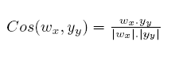
The word similarity evaluator correlates word vectors and human perceived semantic similarity. The evaluator measures the efficiency of human perceived similarity which is obtained by the word vector representations [1]. The commonly used evaluator is the cosine similarity defined as

……..(4)

For a given word, the evaluator computes the correlation between all vector dimensions independent of their relevance in a semantic cluster.

2. Word analogy

The popular intrinsic evaluation criteria for word vectors are finding word vector analogies. In a word vector analogy, the system is provided with incomplete analogy i.e. the relation of a and b is defined and system have to
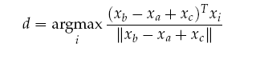
find the relation between c and d ( a : b :: c : d?). The evaluator is to find the cosine similarity between the word vectors. The system identifies that word vector which maximizes the cosine similarity defined as follows:

…….(5)

Generally, analogies are fundamental to solving human reasoning and logic[13]. The model which is trained for finding the analogies do not encode the exact mapping of human reasoning, therefore; the word embedding model may obtain different relationship as obtained from humans.

3. Concept categorization

The evaluator splits the words into different categories. There is no specific method for evaluating the quality of cluster. For separating words into categories, the model should categorize the words like milk, juice, soup burger, dhokla into two groups. The evaluator calculates corresponding word vectors for the given words using clustering algorithm like k-means for classification into two different categories.[12].

4. Outlier detection

Outlier detection evaluates word clustering to obtain compactness score of pair-wise similarities of the word [9]. If W is the set of words composed of 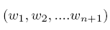 , then the compactness score c(w) can be obtained as follows:

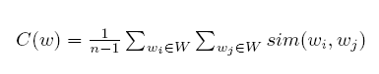
…….(6) The word with the lowest compactness score is the outlier.

5. QVEC

QVEC is an intrinsic evaluator that measures correlation between word vectors and manually constructed linguistic word vectors. Manually constructed linguistic word vectors are defined in the dataset named SemCor dataset. [11]. Linguistic word vectors are constructed to define well-defined linguistic properties. As manually man-made word vectors are not completely defined and currently word embedding models perform much better as based on statistical relation from data; therefore this evaluator does not perform well for other defined downstream tasks.

B. Extrinsic Evaluation
Extrinsic evaluation concern with the evaluation of word vectors for the real natural processing task. The subsystems involved in the process are elaborative, slow in
computation and are dependent on intrinsic computation. While intrinsic evaluation measure the performance of an NLP component on defined subtask extrinsic evaluation focus on performance of complete task. If the performance of the system is weak then modification is required in implementation of intrinsic subtasks. The system which allows for the evaluation of answers from the questions is the extrinsic evaluation system. Optimization for under- performing extrinsic evaluation rather than identifying the subsystem at fault there is a requirement of intrinsic evaluation.
Generally, most natural language processing tasks can be formulated as classification tasks. For sentiment analysis task, the given sentence can be classified as the positive, negative or neutral sentiment. For identifying NER for the given word, it is required to classify words as context or the center word. For such problems, the training set is defined as {(x_{i},y_{i})} where x_{i} is a d-dimensional word vector and y_{i} is a C- dimensional one-hot vector representing the labels for prediction. In machine learning task using input and target data training is implemented using optimization techniques such as gradient descent etc. methods. However, in natural language processing applications the word vectors are pre- trained when used for extrinsic tasks [13].

V. EXPERIMENTAL RESULTS

A. EXPERIMENTAL SETUP
The experiment is performed using three word representation models: Bag-of-Word, Word2Vec and BERT. Each word model follows different approach for word representation. Bag-of-words is traditional approach to word representation, Word2Vec is a neural based approach and BERT is the pre- trained word embedding model. The performance evaluation of these models is performed using intrinsic and extrinsic evaluation methods. Intrinsic evaluation is performed for word-similarity task and part-of-speech tagging is used for extrinsic evaluation. Task-specific datasets are used in experimentation.

B. DATASETS
• All the three models are given the same dataset as input for intrinsic evaluation as well as for extrinsic evaluation domain.

• For intrinsic evaluation Artificial Intelligence dataset available at http://en.wikipedia.org/wiki/Artificial- Intelligence is use. The corpus is preprocessed and sequence of tokens are generated fro BOW and Word2Vec Model. For BERT experimentation separate sequence of sentences is generated as the accepts sentences as input

• For extrinsic evaluation UD-English-ParTUT dataset is used. UD-English-ParTUT dataset is a morphosyntactically annotated collection of different languages parallel sentences. The treebank comprises of 167,000 tokens with an average amount of 2,100 sentences per language. The dataset is in conllu format. The training, development and testing dataset are available at
o http://archive.aueb.gr:8085/files/en_partut-ud- dev.conllu

o http://archive.aueb.gr:8085/files/en_partut-ud- test.conllu

o http://archive.aueb.gr:8085/files/en_partut-ud- train.conllu respective url.

C. EXPERIMENTATION
1. Methodology

All experiments are performed and implemented using python 3 and sklearn machine learning toolkit. For neural network and pre-trained embedding, the model is created using keras deep learning framework. The bag of words is created and using sklearn toolkit and the cosine similarity is obtained for the query word. For Word2Vec Model genisem library is used. Using most-similar function the word-similarity is obtained for the given word. The proposed algorithm AIWE explains the procedure of intrinsic evaluation for word-similarity and algorithm AIEE explains the procedure of extrinsic evaluation for POS tagging using BERT.
Algorithm AIWE:
DATA := Collect the data
stDATA := Setencetokenization(DATA)
for sentance in stDATA:
wDATA.append(Wordtokenization(sentance))
for word in wDATA:
srwDATA.append(RemoveStopword(word))
algoObject := createObject(srwDATA)
vocab := algoObject.getVocab()
w1 := 'artificial'
w2 := 'intelligence'
w1Vector := algoObject.getWordVector(w1) sim_words := algoObject.getMostSimilar(w2) file := openFile('sim')
for element in sim_words:
file.write(w1, element)
file.close()
coRelation:= algoObject.evaluateWordPairs(file)
Algorithm AIEE:
train_conllu_data := DownloadData('conllu_train') dev_conllu_data := DownloadData('conllu_dev') test_conllu_data := DownloadData('conllu_test') train_text = text_sequence(train_sentences)
test_text = text_sequence(test_sentences) train_label = tag_sequence(train_sentences) test_label= tag_sequence(test_sentences) BertBaseModel = brtObject.getBaseModel()
input_ids = brtObject.convert_tokens_to_ids([tokens[i] for i in orig_to_tok_map]) input_id=brtObject.layers.Input(shape=(max_seq_len gth,), name="input_ids") input_mask=brtObject.layers.Input(shape=(max_seq_ length,), name="input_masks") input_segment=max_seq_length.layers.Input(shape=( max_seq_length,), name="segment_ids")

bert_inputs = [input_id, input_mask, input_segment] bert_output = brtObject.BertLayer()(bert_inputs) outputs=brtObject.layers.Dense(n_tags,activation=brt Object.softmax)(bert_output) model.compile(optimizer=brtObject.optimizers.Adam( lr=0.00004), loss=brtObject.losses.categorical_crossentropy, metrics=['accuracy'])
2. Inrinsic evaluation results

As implemented according to algorithm, the figure 2 shows the word similarity of the given word 'intelligence' with words present in the corpus. It reveals that the word intelligence is having highest relevance with word
‘artificial Intelligence’. The figure 3 shows the sentence similarity of the given sentences with other sentences of the corpus using BERT model. The sentence ‘nobody explained the thoughts’ is more close to ‘A man is reading a book’.

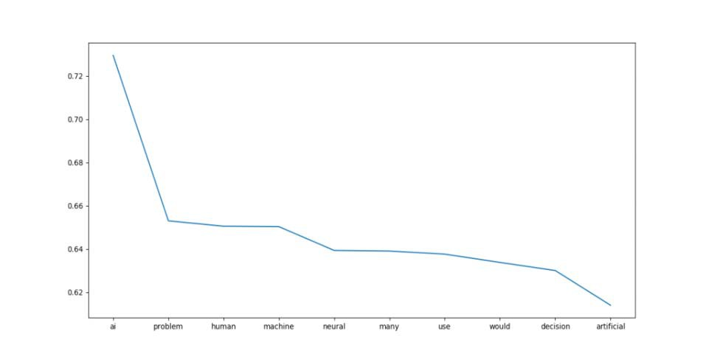

Figure 2: word2vec similarity

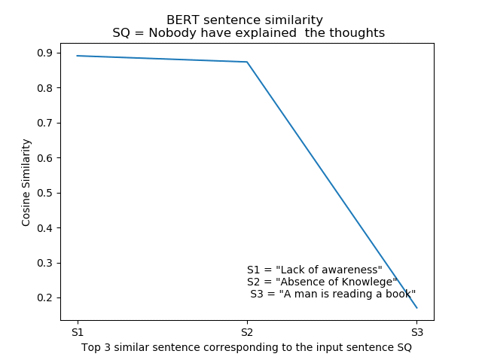

Figure 3: Bert-sentence-similarity
3. Extrinsic evaluation results

Using the pre-defined training, development and testing datasets, the POS tagging is implemented for BOW and Word2Vec model. For POS tagging using BERT, first the pre-trained model is obtained which is available at https://tfhub.dev/google/bert_uncased_L-12_H-768_A-
12/1. Fine tuning of the model is done for prediction. As per algorithm B, the experiment is performed using specified dataset and word embeddings were obtained. The figure 4 shows POS tagging of the input sentence using BERT Model. It displays the predicted tagging obtained using fine-tuned bert model. The accuracy shows the efficiency of the model.

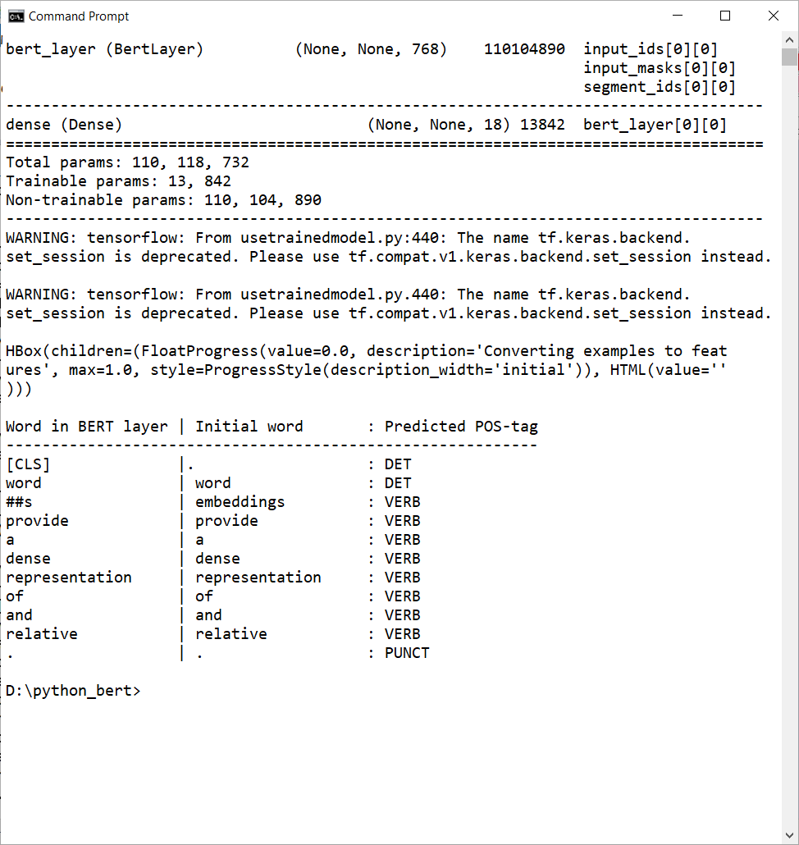
Figure 4: POS Tagging Of BERT Model
4. Experimental Results and Discussion

The table 1 shows the comparative analysis for extrinsic and intrinsic evaluation. It shows the performance of three word-representation models for word-similarity and POS tagging task for the two defined datasets. Using different word embedding models, the word vectors were computed and their accuracy is obtained. The percentage in the table shows the efficiency of the model for specific purpose.
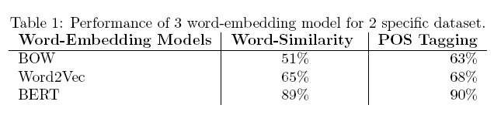
• BOW and Word2vec models shows average results for both extrinsic and intrinsic evaluation but performance changes for BERT model.

• For intrinsic evaluation manual processing of data is performed, the use of defined datasets for word similarity pair like WS-353 can improve the results.

• For extrinsic evaluation, the best results are obtained using BERT model which have been trained using large training and development dataset in specified task format.

• Generally, contextualized word-embedding models give best results when trained with large datasets.

VI. CONCLUSION
The word vectors contain the syntactic and semantic information concerned with words. Word-embedding is the building block of modern natural language processing tasks. The performance of word vectors can be evaluated using certain measures. The paper has explained detailed approaches for word representation which can be evaluated using intrinsic and extrinsic evaluations. Intrinsic evaluators directly capture syntactic or semantic relationships with the words. Extrinsic evaluators are concerned with real and complete natural processing tasks. The work shows that:
• The contextualized word-embedding models though perform well need large and task specific datasets for efficient performance.

• Providing generalized and large datasets, the contextualized word-embedding models give average results.

• Based on the researchers work and literature review in the area of the research, still no prominent single evaluation measure exists for intrinsic and extrinsic evaluation.

• We are continuing the research for exploring the methods to improve linguistic information extraction of words in a language.

REFERENCES
[1] Bin Wang et al , ‘ Evaluating word embedding models: methods and experimental results.’, APSIPA Transaction on Signal and Information Processing, 8, E19, DOI: 10.1017/ATSIP.2019.12
[2] Avrim Blum, John Hopcroft et al , ‘Foundations of Data Science’, June 2017, Cambridge University Press, 2020, ISBN 978-1-108-
48506-7, DOI:10.1017/9781108755528
[3] Francois Chaubard, Rohit Mundra et al , ‘Deep Learning for NLP’ lecture notes: Part I2, Spring 2016 accessed at https://cs224d.stanford.edu/lecture_notes/notes1.pdf
[4] Yoshua Bengio et al , ‘ Word representations: a simple and generated method for semi-supervised learning’, proceedings of the 48th Annual Meeting of the Association for computational Linguistics, pages 384-
394, Uppsala, Sweden, 11-16 July 2010.
[5] Sebastian Ruder, ‘An overview of word embedding and their connections to distributional semantic models’, Oct 2016, accessed on
31-5-2020.
[6] Xipeng Qiu, Tianxiang Sun, Yige Xu, Yunfan Shao,Ning Dai, and Xuanjing Huang. 2020. Pre-trained Models for Natural Language Processing: A Survey.
[7] J. Devlin, M.-W. et al ,’Bert: Pre- training of deep bidirectional transformers for language understanding,’, arXiv:1810.04805, 2018.
[8] A. Radford et al, ‘Improving language understanding by g enerative pre-training,’ Technical report, OpenAI, 2018.
[9] J. Camacho-Collados and R. Navigli, ‘Find the word that does not belong: A framework for an intrinsic evaluation of word vector representations’, Proceedings of the 1st Workshop on Evaluating Vector-Space Representations for NLP, 2016, pp. 43–50.
[10] Jayesh Bapu Ahire, ‘Introduction to Word Vectors’, MVB, March 14, AI DZone, accessed ON 3rd June.
[11] Y. Tsvetkov et al , ‘Evaluationof word vector representations by subspace alignment’, Proceedings of the 2015 Conference on Empirical Methods in Natural Language Processing, 2015, pp. 2049–2054
[12] M. Baroni et al , ‘Don’t count, predict! a sys- tematic comparison of context-counting vs. context-predicting semanticvectors’, in Proceedings of the 52nd Annual Meeting of the Associationfor Computational Linguistics (Volume 1: Long Papers), vol. 1, 2014,pp. 238–247.
[13] Francois Chaubard, Rohit Mundra et al , ‘Deep Learning for NLP’ lecture notes: Part I2, Spring 2016 accessed at https://cs224d.stanford.edu/lecture_notes/notes2.pdf
[14] Yulia Tsvetkov, Manaal Faruqui and Chris Dyer, 2016 ‘Correlation- based Intrinsic Evaluation of Word Vector Representations’.
[15] Amir Bakarov, 2018, A Survey of Word Embeddings Evaluation
Methods.
[16] Griffiths et al., Griffiths, T. L., Steyvers, M., and Tenenbaum, J. B. (2007). Topics in semantic representation. Psychological review,
114(2):21, 2007
[17] Turney and Pantel et al ,’ From frequency to meaning: Vector space models of semantic’, Journal of artificial intelligence research, volume 37, pages 141–188.
[18] McNamara, 2011. McNamara, D. S. (2011). Computational methods to extract meaning from text and advance theories of human cognition. Topics in Cognitive Science, 3(1):3–17.
[19] Mikolov et al., ‘Efficient estimation of word representations in vector space.’, arXiv preprint arXiv:1301.3781, 2013.
[20] Schnabel et al., 2015. Schnabel, T., Labutov, I., Mimno, D. M., and Joachims, T. (2015). Evaluation methods for unsupervised word embeddings. In EMNLP, pages 298–307.
[21] Faruqui et al, ‘Problems with evaluation of word embeddings using word similarity tasks.’,2016, arXiv preprint arXiv:1605.02276.
[22] A. Vaswani, N. Shazeer, N. Parmar, J. Uszkoreit, L. Jones, A.Gomez, L. Kaiser and I. Polosukhin, Attention Is All You Need (2017).
[23] Andrea Galassi, Marco Lippi, ‘ Attention in Natural Language
Processing.’, 28 May 2020.
[24] D. Bahdanau, K. Cho, et at, ‘Neural machine translation by jointly learning to align and translate,’ in ICLR, 2015.
[25] Scott Rome. ‘Understanding Attension in Neural Networks Mathematically’, accessed at https://srome.github.io/Understanding- Attention-in-Neural-Networks-Mathematically/ on 7 Sep 2020.

