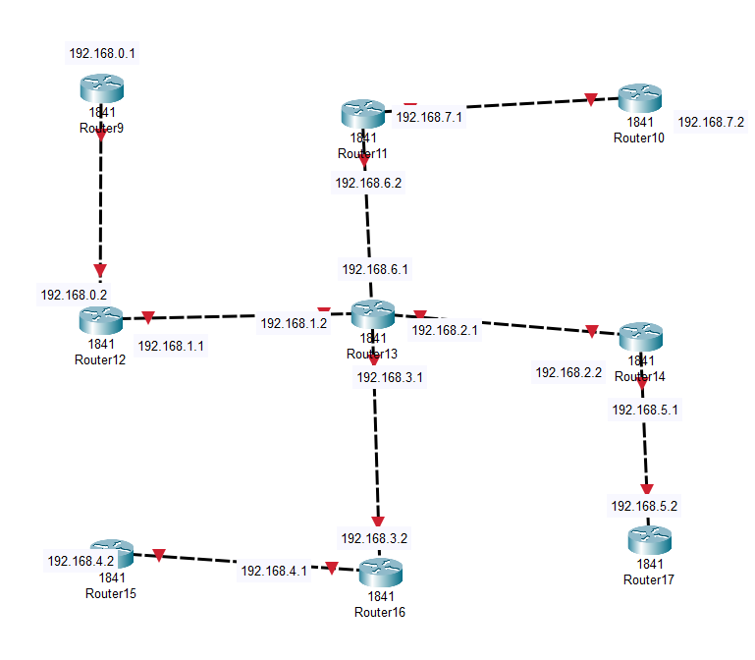

Satitc madhe gelelo bah apan tithun karyucha

Router 9 :  
ip:192.168.0.1 sathi: 192.168.3.1 ->next hop: 192.168.1.1  
 192.168.6.2 ->next hop 192.168.1.1  
 192.168.7.2 ->same

192.168.5.1 ->next hop same   
 192.168.5.2 ->dame  
 192.168.3.2  
 192.168.4.2  
 khali me chatgpt kelaty tasach rahudfe just directly mentioned ahe jyat te tya sotyacha router cha ip ahde

**Router 9**

IP: 192.168.0.1

* 192.168.3.1 -> Next Hop: 192.168.1.1
* 192.168.6.2 -> Next Hop: 192.168.1.1
* 192.168.7.2 -> Next Hop: 192.168.1.1
* 192.168.5.1 -> Next Hop: 192.168.1.1
* 192.168.5.2 -> Next Hop: 192.168.1.1
* 192.168.3.2 -> Next Hop: 192.168.1.1
* 192.168.4.2 -> Next Hop: 192.168.1.1

**Router 10**

IP: 192.168.7.2

* 192.168.0.1 -> Next Hop: 192.168.7.1
* 192.168.1.1 -> Next Hop: 192.168.7.1
* 192.168.3.1 -> Next Hop: 192.168.7.1
* 192.168.6.1 -> Next Hop: 192.168.7.1
* 192.168.6.2 -> Next Hop: 192.168.7.1
* 192.168.5.1 -> Next Hop: 192.168.6.1
* 192.168.5.2 -> Next Hop: 192.168.6.1

**Router 11**

IP: 192.168.6.2

* 192.168.0.1 -> Next Hop: 192.168.6.1
* 192.168.1.1 -> Next Hop: 192.168.6.1
* 192.168.3.1 -> Next Hop: 192.168.6.1
* 192.168.7.2 -> Next Hop: 192.168.7.1
* 192.168.5.1 -> Next Hop: 192.168.6.1
* 192.168.5.2 -> Next Hop: 192.168.6.1

**Router 12**

IP: 192.168.1.1

* 192.168.0.1 -> Directly Connected
* 192.168.3.1 -> Next Hop: 192.168.1.2
* 192.168.6.1 -> Next Hop: 192.168.1.2
* 192.168.6.2 -> Next Hop: 192.168.1.2
* 192.168.7.2 -> Next Hop: 192.168.1.2
* 192.168.5.1 -> Next Hop: 192.168.1.2
* 192.168.5.2 -> Next Hop: 192.168.1.2

**Router 13**

IP: 192.168.3.1

* 192.168.0.1 -> Next Hop: 192.168.1.1
* 192.168.1.1 -> Directly Connected
* 192.168.6.1 -> Directly Connected
* 192.168.6.2 -> Next Hop: 192.168.6.1
* 192.168.7.2 -> Next Hop: 192.168.6.1
* 192.168.5.1 -> Next Hop: 192.168.3.2
* 192.168.5.2 -> Next Hop: 192.168.3.2

**Router 14**

IP: 192.168.5.1

* 192.168.0.1 -> Next Hop: 192.168.2.2
* 192.168.1.1 -> Next Hop: 192.168.2.2
* 192.168.3.1 -> Next Hop: 192.168.2.2
* 192.168.6.1 -> Next Hop: 192.168.2.2
* 192.168.6.2 -> Next Hop: 192.168.2.2
* 192.168.7.2 -> Next Hop: 192.168.2.2
* 192.168.5.2 -> Directly Connected

**Router 15**

IP: 192.168.4.2

* 192.168.0.1 -> Next Hop: 192.168.3.2
* 192.168.1.1 -> Next Hop: 192.168.3.2
* 192.168.3.1 -> Next Hop: 192.168.3.2
* 192.168.6.1 -> Next Hop: 192.168.3.2
* 192.168.6.2 -> Next Hop: 192.168.3.2
* 192.168.7.2 -> Next Hop: 192.168.3.2
* 192.168.5.1 -> Next Hop: 192.168.3.2

**Router 16**

IP: 192.168.3.2

* 192.168.0.1 -> Next Hop: 192.168.3.1
* 192.168.1.1 -> Next Hop: 192.168.3.1
* 192.168.3.1 -> Directly Connected
* 192.168.6.1 -> Next Hop: 192.168.3.1
* 192.168.6.2 -> Next Hop: 192.168.3.1
* 192.168.7.2 -> Next Hop: 192.168.3.1
* 192.168.5.1 -> Next Hop: 192.168.3.1

**Router 17**

IP: 192.168.5.2

* 192.168.0.1 -> Next Hop: 192.168.5.1
* 192.168.1.1 -> Next Hop: 192.168.5.1
* 192.168.3.1 -> Next Hop: 192.168.5.1
* 192.168.6.1 -> Next Hop: 192.168.5.1
* 192.168.6.2 -> Next Hop: 192.168.5.1
* 192.168.7.2 -> Next Hop: 192.168.5.1
* 192.168.4.2 -> Next Hop: 192.168.5.1