# CWVS: Critical Window Variable Selection

## CWVS_Example

[1] Simulate data for analysis:

* Setting the reproducibility seed and initializing packages for data simulation:

set.seed(4679)  
  
library(CWVS)   
library(boot) #Inverse logit transformation

* Setting the global data values:

n<-5000 #Sample size  
m<-27 #Number of exposure time periods  
x<-matrix(1,   
 nrow=n,   
 ncol=1) #Covariate design matrix  
z<-matrix(rnorm(n=(n*m)),   
 nrow=n,   
 ncol=m) #Exposure design matrix  
  
for(j in 1:m){  
 z[,j]<-(z[,j] - median(z[,j]))/IQR(z[,j]) #Data standardization (interquartile range)  
 }

* Setting the values for the statistical model parameters:

beta_true<- -0.30  
theta_true<-rep(0.60, times=m)  
gamma_true<-c(rep(0, times=12),   
 rep(1, times=4),   
 rep(0, times=11))  
alpha_true<-gamma_true*theta_true  
logit_p_true<-x%*%beta_true +   
 z%*%alpha_true  
probs_true<-inv.logit(logit_p_true)  
hist(probs_true)

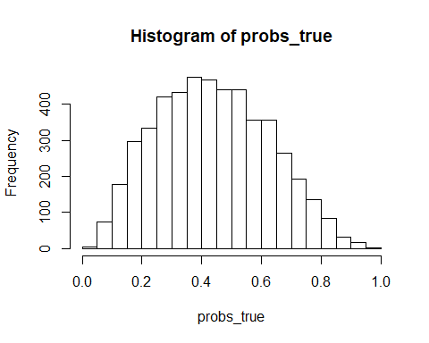

* Simulating the analysis dataset:

y<-rbinom(n=n,   
 size=1,   
 prob=probs_true)

[2] Fit GPCW to estimate critical windows of susceptibility:

results<-CWVS(mcmc_samples = 10000,  
 y = y, x = x, z = z,  
 metrop_var_phi1_trans = 1.00,  
 metrop_var_phi2_trans = 1.00,  
 metrop_var_A11_trans = 0.05,  
 metrop_var_A22_trans = 0.50,  
 metrop_var_A21 = 1.00)

## Progress: 10%  
## phi1 Acceptance: 37%  
## phi2 Acceptance: 37%  
## A11 Acceptance: 17%  
## A22 Acceptance: 24%  
## A21 Acceptance: 22%  
## *******************  
## Progress: 20%  
## phi1 Acceptance: 36%  
## phi2 Acceptance: 37%  
## A11 Acceptance: 18%  
## A22 Acceptance: 25%  
## A21 Acceptance: 20%  
## *******************  
## Progress: 30%  
## phi1 Acceptance: 35%  
## phi2 Acceptance: 37%  
## A11 Acceptance: 18%  
## A22 Acceptance: 23%  
## A21 Acceptance: 20%  
## *******************  
## Progress: 40%  
## phi1 Acceptance: 34%  
## phi2 Acceptance: 37%  
## A11 Acceptance: 18%  
## A22 Acceptance: 25%  
## A21 Acceptance: 20%  
## *******************  
## Progress: 50%  
## phi1 Acceptance: 35%  
## phi2 Acceptance: 37%  
## A11 Acceptance: 18%  
## A22 Acceptance: 24%  
## A21 Acceptance: 21%  
## *******************  
## Progress: 60%  
## phi1 Acceptance: 35%  
## phi2 Acceptance: 36%  
## A11 Acceptance: 19%  
## A22 Acceptance: 24%  
## A21 Acceptance: 22%  
## *******************  
## Progress: 70%  
## phi1 Acceptance: 34%  
## phi2 Acceptance: 36%  
## A11 Acceptance: 19%  
## A22 Acceptance: 25%  
## A21 Acceptance: 22%  
## *******************  
## Progress: 80%  
## phi1 Acceptance: 34%  
## phi2 Acceptance: 36%  
## A11 Acceptance: 19%  
## A22 Acceptance: 24%  
## A21 Acceptance: 21%  
## *******************  
## Progress: 90%  
## phi1 Acceptance: 34%  
## phi2 Acceptance: 37%  
## A11 Acceptance: 19%  
## A22 Acceptance: 23%  
## A21 Acceptance: 21%  
## *******************  
## Progress: 100%  
## phi1 Acceptance: 34%  
## phi2 Acceptance: 36%  
## A11 Acceptance: 19%  
## A22 Acceptance: 21%  
## A21 Acceptance: 21%  
## *******************

[3] Analyzing Output:

par(mfrow=c(2,2))  
plot(results$beta[1, 1001:10000],   
 type="l",  
 ylab="beta",  
 xlab="Sample")  
abline(h=beta_true,  
 col="red",  
 lwd=2) #True value  
plot(rowMeans(results$alpha[,1001:10000]),   
 pch=16,  
 ylab="alpha",  
 xlab="Time")  
points(alpha_true,   
 pch=16,   
 col="red") #True values  
plot(rowMeans(results$gamma[,1001:10000]),  
 pch=16,  
 ylab="gamma",  
 xlab="Time")  
points(gamma_true,  
 pch=16,  
 col="red") #True values

