LiftOff
User Manual

Content
Content 2
Introduction 3
Features 3
Program Layout 3
Creating a sample model 5
Calculations 9
Wing Designer interface 10
Conclusion 11

Introduction
The roots of the LiftOff Software go back to 1983 when calculations for glide and sink polar curves were done on a pocket calculator. Based on this history a software called “Aerocalc” was developed by H.- W. Bender. According to these basic concepts he and Mr. Ludwig Wiechers developed the successor of Aerocalc called “Aerodesign”.
In years of work Hans and Marc Dürst redesigned the software as a state of the art Windows Desktop application which is known today as LiftOff. LiftOff in its current version not only contains the formulas from Aerodesign but also a lot of new features. In cooperation with Dr. Ing. Christian Baron the wingspar and the wing joiner tube calculations were added to the LiftOff software as well.
As time goes by further developments will be made and hopefully more features will find their way into LiftOff to make your life easier.

Layout and program features.
Lift related performance data, Reynolds numbers, glide ratios, speed, incidence angle and center of gravity calculations.
Measurements of statistical values as well as recommended stability margins and related stabilizer sizes.
Graphic sink and glide polar curves.
Graphic 3- view presentation.
Neutral and pressure point positions for 3-views and wing plan forms of your choice and sweep back with lift and incidence angle dependent suggestions for center of gravity positions according to the pilots flying experience.
Spar dimensions for wings built from glassfibre or wood with variable estimated loads and flying conditions.
Dimensions of wing joiners at any position in the wing produced from glass fiber, carbon fiber or steel.
Import-/Export interfaces to the STEP FOUR Software “Wing Designer”.

Program layout on the screen
After LiftOff is started the main screen shows the three major sections “Basics”, “Wing plan form” and “Calculations”.
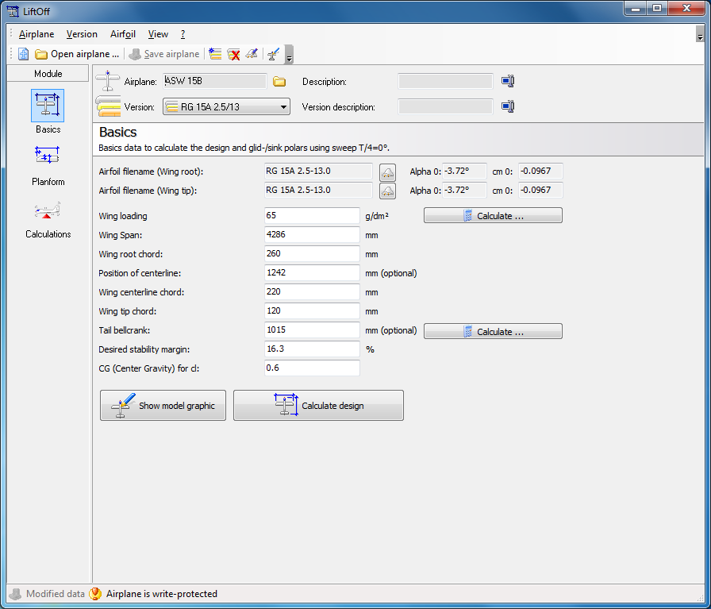
The “Basics” screen contains the data used for model design, glide- and sink polar-curves with sweep T/4 0°. The main usage of this application is to enter the most basic data and measured performance of different airfoils. The wing geometry used for this is a neutral one with a sweep back of T/4 0°. That’s the only way to get comparable results for the performance of different airfoils. For other sweep back angles the section “Planform” is used. Please note that the sweep back needs to be entered in the following way: Think of a straight line at a right angle to the fuselage line at the leading edge of the wing root. The value for the sweep back is the distance from this line to the individual panel edge. Forward sweep is recorded with minus values.
Section “Planform” contains the detailed data for the wing and the stabilizer. You can add as much panels to the wing and the stabilizer as you like. Please also specify the thickness of the airfoil and the spar - width. This data is then used for spar and wing joiner tube calculations.
In the section “Calculations” you will find the requested measurements and values at your disposition ready to be shown on screen or printed.

Creating a sample model ASW 15 B
As a sample let’s create the above model. After this you should be able to design your own custom model using LiftOff within a few minutes.
On the “Basics” screen the following values are collected and filled in:
Model ASW 15B
Version RG 15A 2.5/13
Root airfoil RG 15A 2.5-13.0
Tip airfoil RG 15A 2.5-13.0
Wing loading 65
Wing span 4286
Root chord 260
Position trapeze panel line 1242
Wing chord at trapeze panel 220
Wing tip chord 120
Leverage from wing to stabilizer 1015
Desired stability margin 16.3
Center of gravity for which Cl (lift coefficient). 0.6
Note: You can check the settings of your model visually by clicking the button “Show model graphic”. The window showing the model graphic can stay visible while you are editing the model specs. It will be updated in real-time to always inform you of the current model settings.
The required stability margin will be normally between 12% to 17% depending on the pitching moment values of the chosen airfoil. The Software shows you a recommendation for the “Layout calculation” using the “Perseke” algorithm. These values worked quite well in practical application. The stability margin figures will depend on the size of the stabilizer.
Next you have to enter the data for the “wing and stabilizer planform” in the wing geometry file (planform). This defines the details for wing and stabilizer.
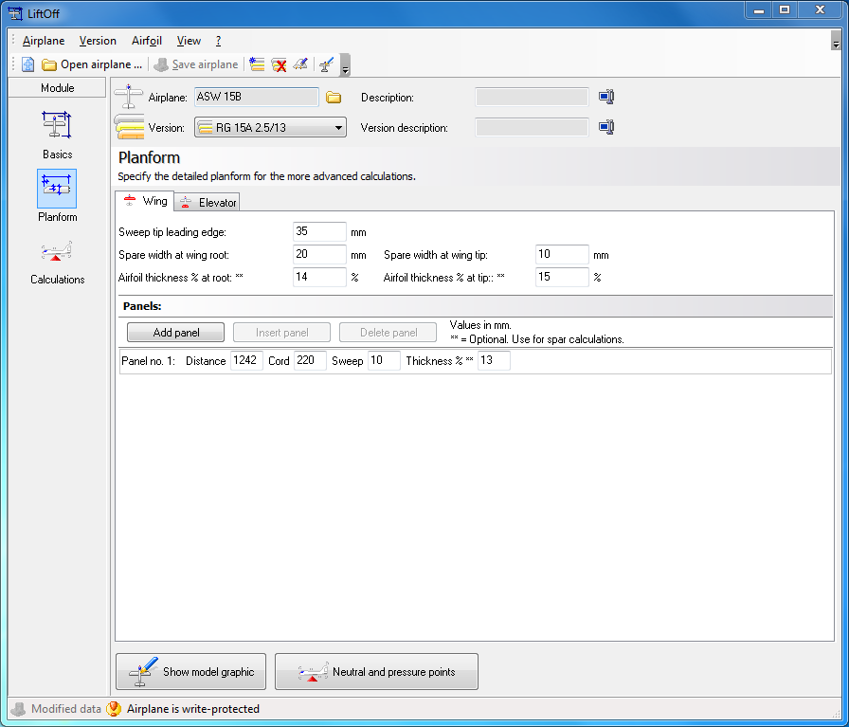
Wing:
Sweep leading edge to wing tip 35
Spar width wing root 20
Spar width wing tip 10
Airfoil thickness in % at root 14
Airfoil thickness in % at tip 15

Add trapeze panel dehydral:
Distance 1242
Chord 220
Sweep 10
Airfoil thickness 13

Stabilizer:
Distance from leading edge of wing 1040
Stabilizer root chord 160
Wing tip chord 115
Sweep 11

At this point the data entry is completed. You will find this ASW 15 B model under airplane > Samplemodels” as “ASW 15B”. Open the sample model file and compare the values in case of mistakes during data entry. You can make corrections now if needed. You will find some more samples within the Sample models file including models with different sweep settings. Have a look at these models if you are not sure how to enter such models.

Calculations
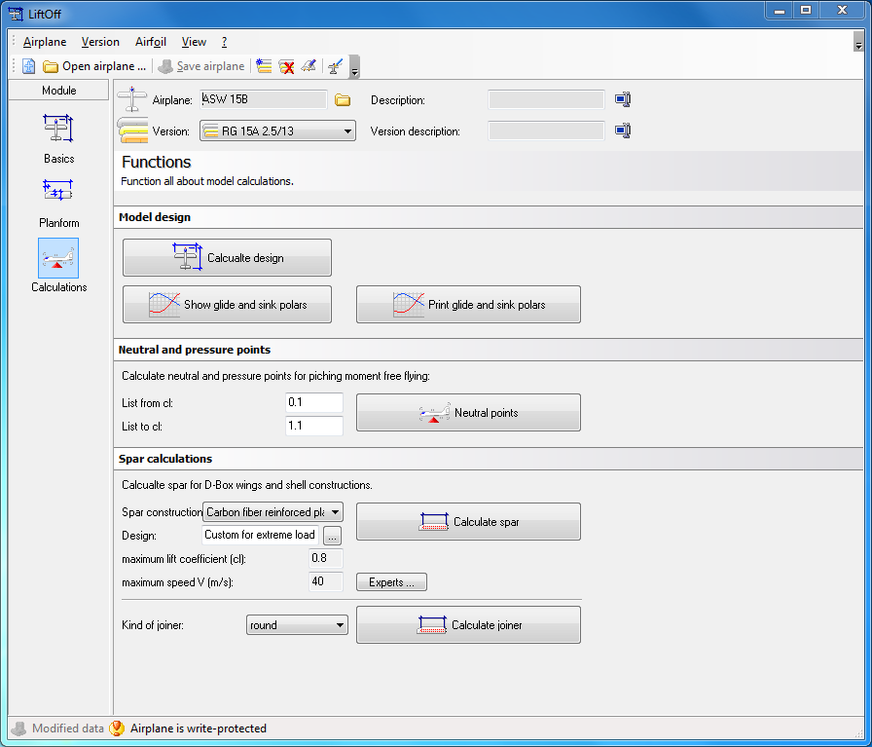
The button “Calculate design” will get you results of some basic calculations of model layouts, measurements and statistical values. These calculations give you a center of gravity based on a sweep of T/4 0°. This applies for the ASW15 B but for other layouts with different sweep back use the function “Neutral and pressure points for more detailed information as the CG will change.
The function „Glide and sink polar curves“ is used to show/print a graphical chart of the glide and sink polar. This chart for example shows if there are critical slow flight phases (indicated by some extreme values in the chart). In the sample model ASW 15B no such problems where expected. This was also confirmed in real flight performance.
With “Neutral and pressure points” detailed results for the exact wing plan form including sweep details are shown. This is also the place where you’ll find recommendations on how to set up the center of gravity position for this model depending on the competence of the pilot.
Note: For the first flight one should choose settings for “Stability margin 1”. Later on you can change to other settings as recommended by LiftOff depending on personal preferences.
Before calculating the spars please enter the spar construction and the design. If you have a good basic knowledge about aerodynamics you can use the button “Experts” to choose custom parameter values.
In the spar calculation the number of carbon fiber roving’s needed according to the thickness and the distance from the wing root is shown. Analogue the thickness of the required spar and webbing for a wood wing construction is shown as well.
To “calculate wing joiner” you need to choose the kind of joiner first: round or square. In the report you then will find the required dimensions of the joiner depending on the distance from the wing root and the material of the spar (carbon fiber, glass fiber or steel). You will see that a wooden spar will not work for all stresses, strains and loads a carbon fiber spar can take. Wooden spars are simply not as strong as carbon fiber and glass fiber are.

Wing Designer interface
You’ll find the import/export interface to STEP-FOUR’s “Wing Designer” in the main menu option “Airplane > Wing-Designer Import/Export”.
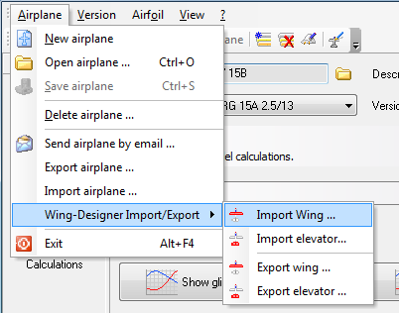
With a simple click you can import or export wings or stabilizer settings from or to Wing Designer. Please note that Wing Designer doesn’t know if a “design” is a wing or a stabilizer. You have to differentiate between these in LiftOff. You can then continue construction of your wings in Styrofoam or wood. Using LiftOffs interface to Wingdesigner the problem of inaccurate airfoils is solved as well.
.

Conclusion
To get started with LiftOff we recommend to enter the data of some already built and flown airplane models and compares the calculations with your real flight experience. You will see that the calculated values will compare nicely for most airplanes. Please also keep in mind that the performance of the final airplane depends not only on mathematical calculations but also on the accuracy, precision and care while building the model. An imprecise and inaccurate course of airfoil for example would result in totally different results.
Finally we wish you good luck!
Sincerely your STEP FOUR team

