# Lab #5a:

SERVER-SIDE SCRIPTING (PHP)

|  |  |
| --- | --- |
| **Topic** | Web page development using PHP |
| **Domain of Learning** | Psychomotor (P2: Set; P3: Guided Respond; P4: Mechanism) |
| **Learning objective** | 1. To evaluate the response to solve the problem as required. (P2) 2. To evaluate the skill of how the web page is developed while using the code/tags correctly. (P3) 3. To evaluate the value added of creativity/knowledge/skill in web page development. (P4) |
| **Lab activity objective** | To use the combination of HTML tags and PHP scripting adequately based on the suitable requirement of a case study. |

**Instruction: Answer all questions. Write your answer and screenshot the output in Microsoft Word. Submit through Author in PDF format.**

1. **Create a folder named** lab_5a in your XAMPP’s htdocs folder. **Create a PHP file** named lab5a_q1.php inside the folder. Copy and paste the code below. Then, **start** your Apache web server. Open your browser and enter localhost/yourfoldername/yourphpfilename.

<!DOCTYPE html>

<html lang="en">

<head>

<title>Lab 5a Q1</title>

</head>

<body>

<?php

$name = "Nur Ariffin Mohd Zin";

?>

<table>

<tr>

<td>Name</td>

<td><?php echo "$name"; ?></td>

</tr>

</table>

</body>

</html>

Edit the PHP file to create variables of your details and display them on the HTML table. Your details should be as follows:

1. Name
2. Matric number
3. Course
4. Year of study
5. Address

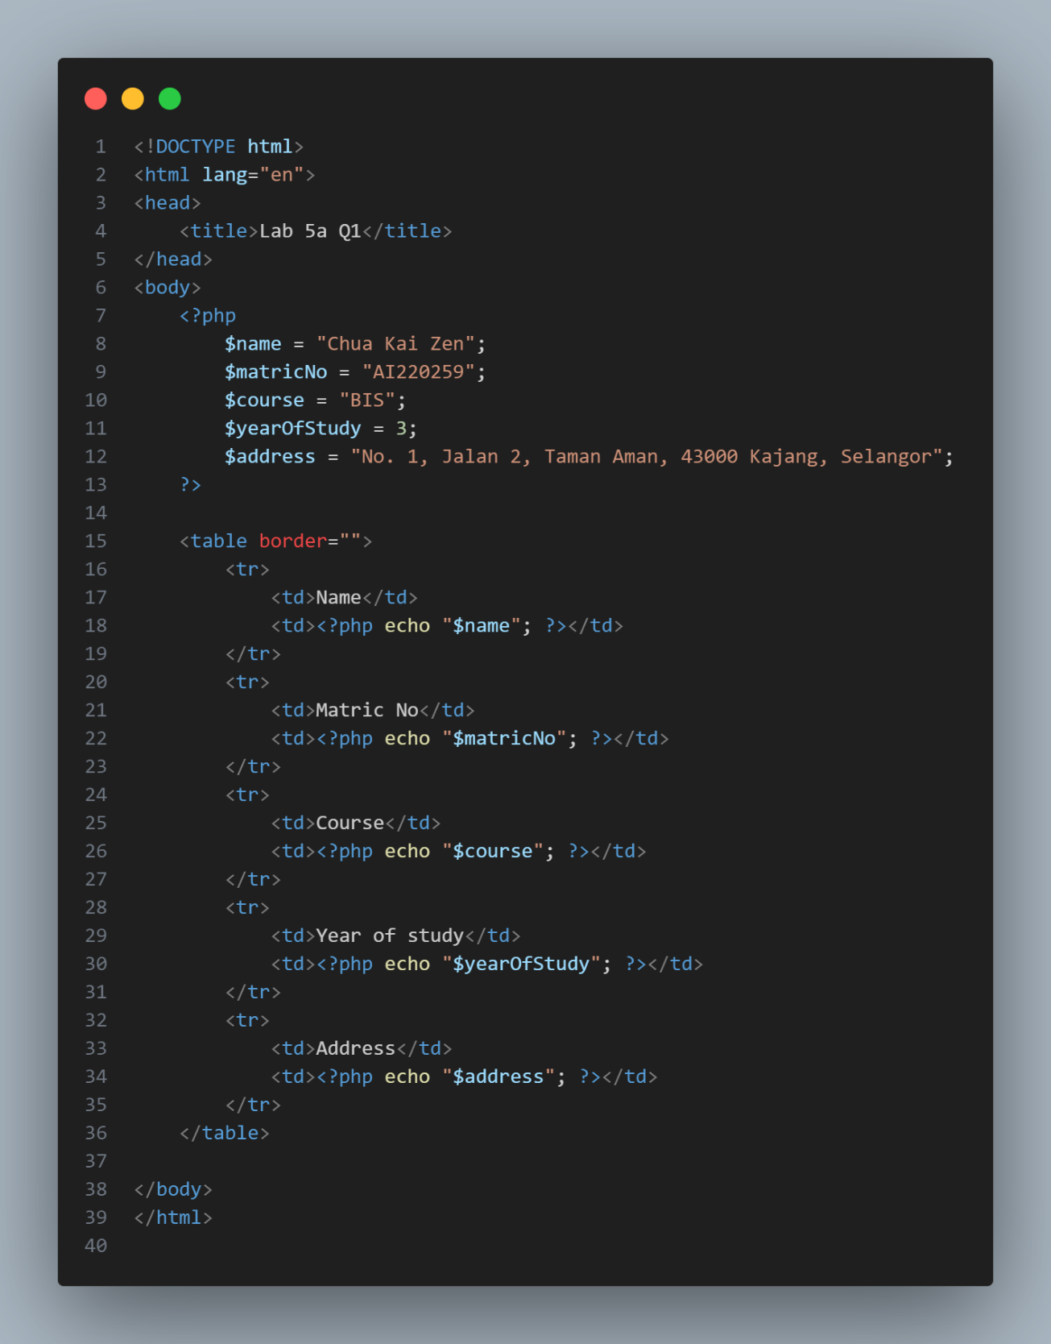

1. Create a new PHP file named lab5a_q2.php and write the following associative array:

Use foreach loop to display the content of $students on an **HTML table as below**.

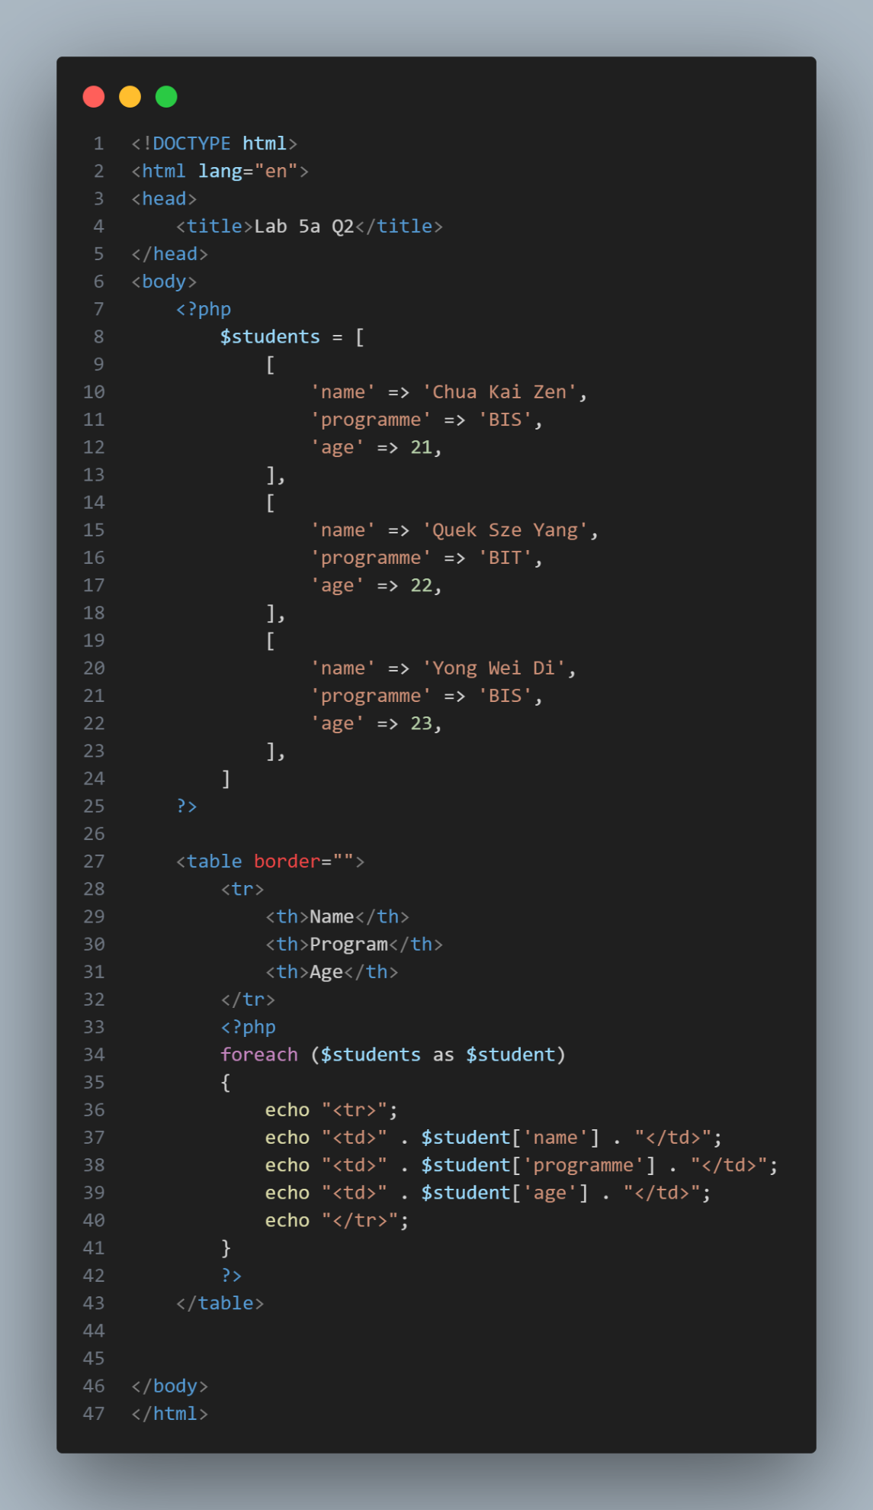

1. Create a new PHP file named lab5a_q3.php and write a PHP function named calculateArea to calculate the **area of a rectangle**. The function should **receive two parameters** and **return the area**. Call the function with any value of your choice and display the result. Below is an output sample of the function.



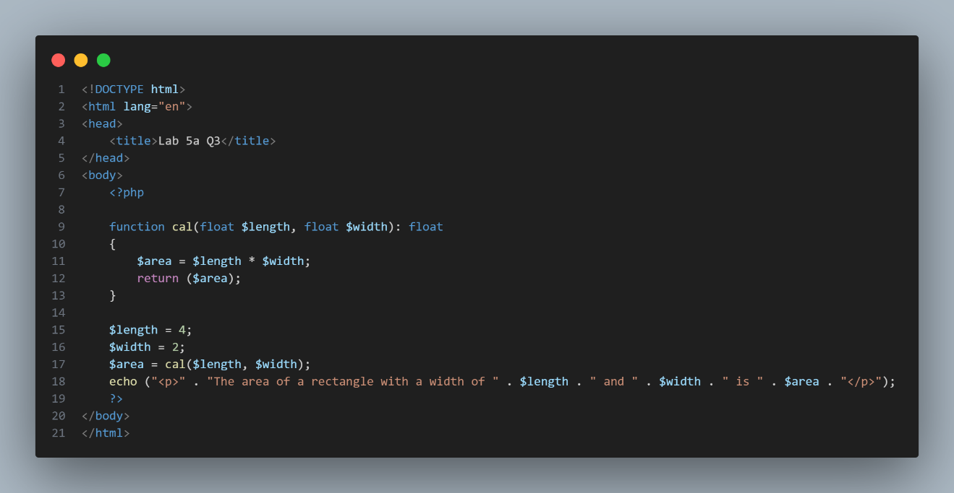

1. Push all your codes to GitHub and provide the link of your repository in the PDF report (along with your codes and screenshot of the output). You do not need to enable GitHub Pages since it cannot render server-side scripting like PHP.

<https://github.com/liftlobby/Lab5a.git>