Contributor:-

Sandesh Kumar Jha- 240961108

Intelligent Water Leakage and Water Quality Monitoring System

Mission Statement

The Intelligent Water Management and Monitoring System is designed to ensure efficient and safe water usage. The system maintains a constant water level in the source tank using PID control and supplies water to the receiver tank. It continuously monitors water flow to detect any leakage in real time, ensuring minimum wastage. Once the water reaches the receiver tank, its quality is tested using turbidity and TDS sensors to check purity. This project integrates control, monitoring, and safety into one smart solution..

Components Planned

• Microcontroller (ESP32) – central unit with Wi-Fi
• Water Leakage Sensor Module – detects leakages in pipes/tanks
• Water Flow Sensor – measures flow rate and detects irregular consumption
• TDS (Total Dissolved Solids) Sensor – measures purity and contamination levels
• Buzzer/LED Alarm – gives instant alert locally in case of leakage/poor quality
• Relay Module – controls pump/valve if leakage or contamination detected
• Power Supply (5V/12V)
• IoT Platform (Blynk/ThingSpeak/MQTT) – for mobile notifications and data logging

Block Circuit Diagram

The following block diagram illustrates the connection of the microcontroller with the sensors and output devices:
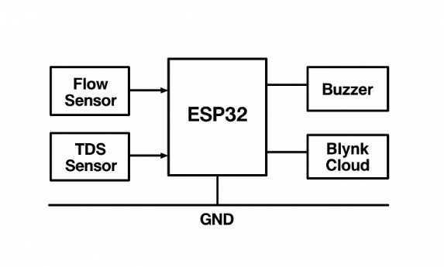

Societal Impact

1. Prevents wastage of water by detecting leaks early.
2. Improves health and safety by alerting users if water quality is unsafe.
3. Reduces repair and water bills for households and industries.
4. Helps municipal authorities manage supply lines better.
5. Supports sustainable resource management in both urban and rural areas.

Alignment with SDGs and Government Schemes

• SDG 6: Clean Water and Sanitation → ensures availability of clean, safe water.
• SDG 12: Responsible Consumption and Production → promotes efficient resource use.
• Jal Jeevan Mission (JJM) → clean water supply to every rural household.
• Atal Bhujal Yojana (ABHY) → efficient water conservation and management.
• Smart Cities Mission → IoT-based water monitoring fits into digital smart infrastructure.

Plan of Action

Phase 1 – Research & Design:
• Study leakage and contamination issues.
• Choose sensors suitable for microcontroller integration.
Phase 2 – Prototype Development:
• Interface microcontroller with leakage sensor, TDS sensor, pH sensor, and buzzer.
• Set up real-time monitoring and alerts.
Phase 3 – IoT Integration:
• Configure system with IoT platform for live dashboard and notifications.
• Enable remote control of pumps/valves.
Phase 4 – Testing & Optimization:
• Simulate leakages and water quality variations.
• Test accuracy, response time, and cloud alerts.
Phase 5 – Final Deployment:
• Package the system for households/industries.
• Prepare final report and demonstration.

