MINI PROJECT REPORT
Microcontrollers – (ICE 2221)

Fourth Semester B.Tech Cyber-Physical Systems

Smart Dustbin Using ESP32, Ultrasonic Sensor and Servo Motor

Submitted By: Name: Sandesh Kumar Jha
Section: CPS B
Roll No: 11.



Table of Contents
- Introduction
- Statement of Problem
- Components Required
- Block Diagram
- Methodology
- Code
- Expected Results
- Conclusion
- Future Scope
- References

Introduction
In an era where hygiene and automation are becoming essential, smart systems play a vital role in improving daily life. The Smart Dustbin is an innovative solution that enables touch-free waste disposal using modern embedded technology. By integrating an ultrasonic sensor with an ESP32 and a servo motor, the system automatically opens and closes the lid based on user presence. This reduces human contact, enhances cleanliness, and promotes a healthier environment.

Key Objective :-
- To design a touch-free automatic dustbin system
- To interface an ultrasonic sensor with ESP32
- To control a servo motor for automatic lid operation
- To improve hygiene and convenience using embedded systems

- Statement of Problem :

Traditional dustbins require manual handling to open and close the lid, which can lead to the spread of germs and unhygienic conditions. In public places and households, this creates discomfort and increases the risk of contamination. There is a need for a system that minimizes human contact while disposing of waste. The challenge is to design a simple, cost-effective, and reliable automatic dustbin that operates without touch . System should detect user presence and respond quickly to ensure ease of use. Hence, this project aims to develop a smart dustbin that improves hygiene and user convenience.

- Components Required :

  - ESP32 (32-pin)
  - Ultrasonic Sensor (HC-SR04)
  - Servo Motor (SG90)
  - Breadboard
  - Jumper Wires
  - Power Supply (5V)

- Block Diagram :

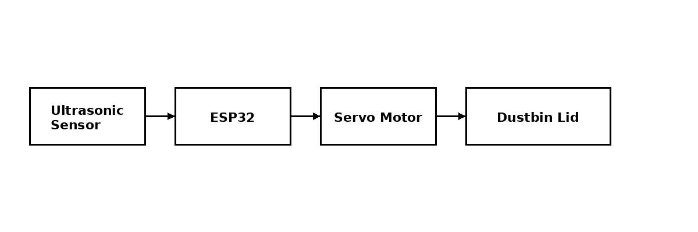

- Methodology :


- Input Section:
The ultrasonic sensor detects the presence of a hand by measuring distance.

- Processing Section:

The ESP32 processes the distance data and checks if it is less than a predefined threshold (15 cm). c) Output Section:
If the condition is satisfied, the servo motor rotates to open the lid. After a delay, it returns to close the lid.

Working Principle:

  - Sensor detects object distance

  - If distance < 15cm

  - Servo rotates → Lid opens

  - After 10 seconds → Lid closes

6.Code :

#include <ESP32Servo.h>

#define TRIG 5
#define ECHO 18
#define SERVO_PIN 13

Servo lid;

float getDistance() { long duration;

digitalWrite(TRIG, LOW);
delayMicroseconds(2); digitalWrite(TRIG, HIGH); delayMicroseconds(10); digitalWrite(TRIG, LOW);

duration = pulseIn(ECHO, HIGH, 30000);

if (duration == 0) return -1;

return duration * 0.034 / 2;
}

void setup() {
Serial.begin(115200);

pinMode(TRIG, OUTPUT); pinMode(ECHO, INPUT);

lid.attach(SERVO_PIN, 500, 2400); lid.write(90); // CLOSED (reversed)

Serial.println("Smart Dustbin Ready");
}

void loop() {

float d = getDistance();

Serial.print("Distance: ");
Serial.println(d);

if (d > 2 && d < 15) {

Serial.println("Opening Lid..."); lid.write(0); // OPEN (reversed)

delay(4000);

Serial.println("Closing Lid..."); lid.write(90); // CLOSE

delay(3000);
}

delay(300);
}

- Results :

The smart dustbin system detect the presence of a hand accurately using the ultrasonic sensor. When an object is detected within the specified range, the servo motor will automatically open the lid. After a short delay, the lid will close smoothly without any manual intervention. If no object is detected, the lid will remain closed to maintain hygiene. The system is expected to respond quickly and operate efficiently under normal conditions. Overall, the project demonstrates a reliable and touch-free solution for waste disposal.

- Conclusion :

The smart dustbin system using ESP32 successfully provides an automatic and touch-free waste disposal solution. By integrating an ultrasonic sensor and servo motor, the system ensures hygienic operation and user convenience. The project demonstrates the practical application of embedded systems in improving everyday life. It is simple, cost-effective, and easy to implement in realworld environments. Overall, the system performs efficiently and meets its intended objectives.

- Future Scope :
- Integration of IoT using ESP32 to enable remote monitoring and control through a mobile application
- Addition of a level detection sensor to indicate when the dustbin is full
- Implementation of buzzer or LED alerts for user notification and system status
- Use of solar power to make the system energy-efficient and ecofriendly
- Enhancement with advanced sensors (IR or AI-based detection)
for improved accuracy and performance

10. References :
- Espressif Systems, “ESP32-WROOM-32 Datasheet.”
- B. W. Evans, “Arduino Programming Notebook,”
- HC-SR04 Ultrasonic Sensor Datasheet.
- SG90 Servo Motor Datasheet.

