Setup the Virtual Machine

1. Download VirtualBox and install (depending on your operating system, Mac/Linux/Windows)
2. Download the VM image from Google drive
3. Open VirtualBox, click File->import Appliance, and then select the image you downloaded.
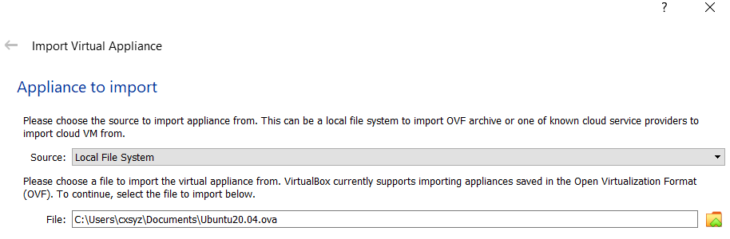
Click next, and then confirm to import the image.
4. Wait for a few minutes, and you will see the operating system “Ubuntu 22.04” listed in the left panel. Click it to start the VM (it may take a few minutes at the first time).
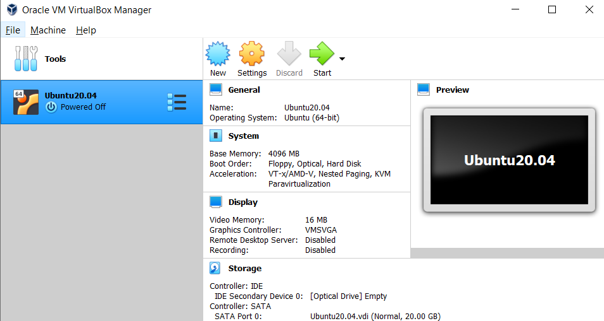
5. Both the username and password are “comp9313”.
6. Make the clipboard shared by the host operating system and the VM: click Devices->Shared Clipboard, and then select “Bidirectional”. You need to restart the VM to make it work. If it still fails, try to install the VirtualBox Guest Additions again: click Devices->Insert Guest Additions CD Image
7. Create a folder shared by the host operating system and the VM, and thus you can easily copy files between them:
a). In your host operating system, assuming Windows 10, create a folder D:/VMfolder, and put a file into this folder for testing.
b). In the VM, create a folder at /mnt/shared (sudo password is also “comp9313”):
$ sudo mkdir /mnt/shared
c). In VirtualBox, click Devices->Shared Folders->Shared Folders Settings, and you will see:
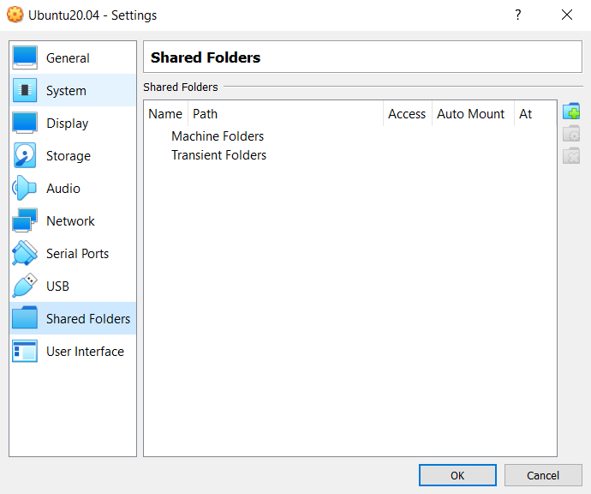
d). Click the adding folder button (the “+” button), and in the pop-up window, do the configurations like below:
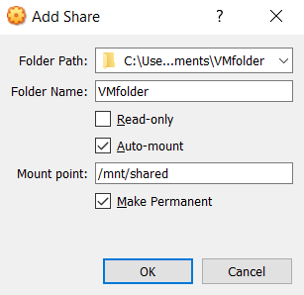
Folder Path: your host operating system folder, e.g., D:/VMfolder
Folder Name: automatically using “VMfolder”
Mount point: your VM folder, e.g., /mnt/shared
Tick “Auto-mount” and “Make Permanent”
e). In the VM, you would be able to see the testing file in /mnt/shared:

