Aims
This exercise aims to get you to:
- Analyze data using Spark shell with RDD
- Monitor Spark tasks using Web UI

Background
The detailed Spark programming guide is available at:
http://spark.apache.org/docs/latest/programming-guide.html
The RDD APIs in pyspark can be found here:
https://spark.apache.org/docs/latest/api/python/reference/api/pyspark.RDD.html
The answers to the questions are given at the end of this file. Please try to answer all questions by yourself utilizing the above documents, and then check your results with the answers provided.

Install and Configure Spark
1. You need to check JAVA_HOME first. In ~/.bashrc, if not exist, add:
export JAVA_HOME=/usr/lib/jvm/java-11-openjdk-amd64
Please note that, if you use mac and the default terminal is zsh, then add this line to “~/.zshrc” instead. Do not naively paste this command to your laptop, please check your own java location by “whereis java” and paste it.
You can skip this step if Java home is already configured in previous labs.
2. Download the Spark package by the command (or use a web browser):
$ wget https://dlcdn.apache.org/spark/spark-3.4.1/spark-3.4.1-bin-hadoop3.tgz
Then unpack the package:
$ tar xvf spark-3.4.1-bin-hadoop3.tgz
$ mv spark-3.4.1-bin-hadoop3 spark
Now you have Spark installed under ~/spark. We need to configure this folder as the working directory of Spark.
Open the file ~/.bashrc and add the following lines to the end of this file:
export SPARK_HOME=/home/comp9313/spark
export PATH=$SPARK_HOME/bin:$PATH
(If you copy and paste the above two lines, please do it line by line, not together.)
Save the file, and then run the following command to take these configurations into effect:
$ source ~/.bashrc
Next, start HDFS by:
$ start-dfs.sh

Interactive Analysis with the Spark Shell Using RDD
Use the following command for opening pySpark shell:
$ pyspark

1. Load and inspect data from a text file:
1. Create an RDD from local files using textFile()
$ >>> textFile = sc.textFile("file:///home/comp9313/spark/README.md")
The file path varies according to your own installation directory, please modify it in the case you need.
Spark’s primary abstraction is a distributed collection of items called a Resilient Distributed Dataset (RDD). RDDs can be created from Hadoop InputFormats (such as HDFS files) or by transforming other RDDs. This command makes a new RDD from the text of the README file in the Spark source directory.
You can apply the RDD transformation and action functions on “textFile”.
2. Count the number of items in an RDD (count() is a built-in method of spark RDD)
$ >>> textFile.count()
You should see results: 125
3. Get the first item in an RDD
$ >>> textFile.first()
You should see results: “# Apache Spark”
4. Get lines containing “Spark” using the function filter()
$ >>> linesWithSpark = textFile.filter(lambda x: "Spark" in x)

Please note that the anonymous function is optional, the filter method also accepts “def” defined functions. For further information (Section: Passing Functions to Spark):
https://spark.apache.org/docs/latest/rdd-programming-guide.html#passing-functions-to-spark
5. Use the function collect() to see the contents of linesWithSpark
$ >>> linesWithSpark.collect()
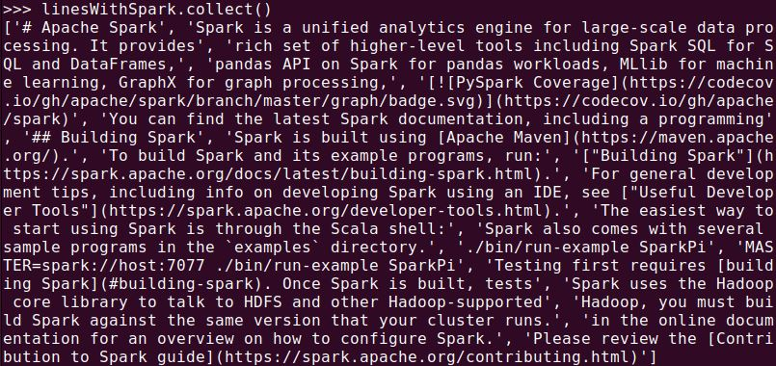
6. Print all the items in linesWithSpark
$ >>> linesWithSpark.foreach(print)
print() is a function, and it is used as an argument in function foreach(). Please note that you must remove the brackets since “foreach” accept a function as input rather than the return from a function. “print” can be regarded as a pointer of this function.
7. Use function map() to map each line to the number of words contained in it
$ >>> lineNumOfWords = textFile.map(lambda line: len(line.split(" ")))
The argument of map() is an anonymous function, which takes a line as the input, and returns the number of words (separated by space). Check the contents of lineNumOfWords.
8. Find the largest number of words contained in a line using reduce()
$ >>> lineNumOfWords.reduce(lambda a, b : a if (a > b) else b)
You should see the result is 16. The reduce function takes an anonymous function as an argument, which takes two arguments and returns the larger one.
You can also call functions declared elsewhere. For example, you can use max() function to make this code easier to understand:
$ >>> lineNumOfWords.reduce( lambda a,b: max(a,b))
Or
$ >>> lineNumOfWords.reduce(max)
9. Convert RDD textFile to an array of words using flatMap()
$ >>> words = textFile.flatMap(lambda line: line.split(" "))
This will split each line to a list of words, and store all of them in one array. You can compare the result obtained by flatMap() with that obtained by map(). What are the differences?
$ >>> words = textFile.map(lambda line: line.split(" "))
10. Count the distinct words in textFile using distinct()
$ >>> words.distinct().count()
Compare the results with words.count().
11. (Question) Find the longest line together with the length in textFile.
Hint: first map a line to a pair of (line, length), and then use reduce() to find the longest line.
12. (Question) Print the lines containing “Spark” with line numbers (starting from 0). Each line is printed in format of:
Line Number in textFile: the contents of the line
Hint: Use function zipWithIndex().
Zip the elements of the RDD with its element indexes. The indexes start from 0.

2. More operations on pair RDD:
1. Download the data set auctiondata.csv from the course webpage, and store it in your home folder.
Define the mapping for the input variables. They are used to refer to different fields of the data set.
$ >>> aucid = 0
$ >>> bid = 1
$ >>> bidtime = 2
$ >>> bidder = 3
$ >>> bidderrate = 4
$ >>> openbid = 5
$ >>> price = 6
$ >>> itemtype = 7
$ >>> dtl = 8
2. Load data into Spark
$ >>> auctionRDD = sc.textFile("file:///home/comp9313/auctiondata.csv").map(lambda line : line.split(","))
In auctionRDD, each item is an array containing 9 fields, and you can use the defined variables to access each field. Note that you need to use the correct file path.
3. Count the total number of item types that were auctioned.
$ >>> auctionRDD.map(lambda x: x[itemtype]).distinct().count()
Each item in auctionRDD is an array of String objects. x[itemtype] is equivalent to x[7], and it is used to get the 8th object in the array.
4. (Question) What is the total number of bids per item type? The output is a list of key-value pairs <item type, number of bids>.
Hint: First create a pair RDD by mapping each record to a pair of (item type, 1), and then use reduceByKey() to do the aggregation for each item type
5. (Question) Across all auctioned items, what is the maximum number of bids?
Hint: First use reduceByKey() to count the number of bids for each auctioned item, and then find the maximum number using reduce()
6. (Question) Across all auctioned items, what are the top-5 items that have the most number of bids?
Hint: First use reduceByKey() to count the number of bids for each auctioned item, and then use sortBy() to sort the key-value pairs in descending order. Finally use take() to get the top-5 results. You can also use the top() operation to complete this task. You can pass a function to top() to let Spark know how to sort your data.

3. Do word count in Spark shell
Start HDFS, get the file “pg100.txt” from WebCMS3 and put it to HDFS
$ hdfs dfs –put pg100.txt
Load the file into Spark from HDFS, and use the functions map(), flatMap(), reduceByKey() to do word count (split the documents by the space character). Finally, store the results in HDFS using saveAsTextFile() and check the output.
RDD partitions: In the function reduceByKey(), set the number of tasks to 3, and check the results again (each task will be processed by one reducer, and thus three output files) .

Spark Web UI
Browse the web interface for the information of Spark Jobs, storage, etc. at: http://localhost:4040. You will see something like:
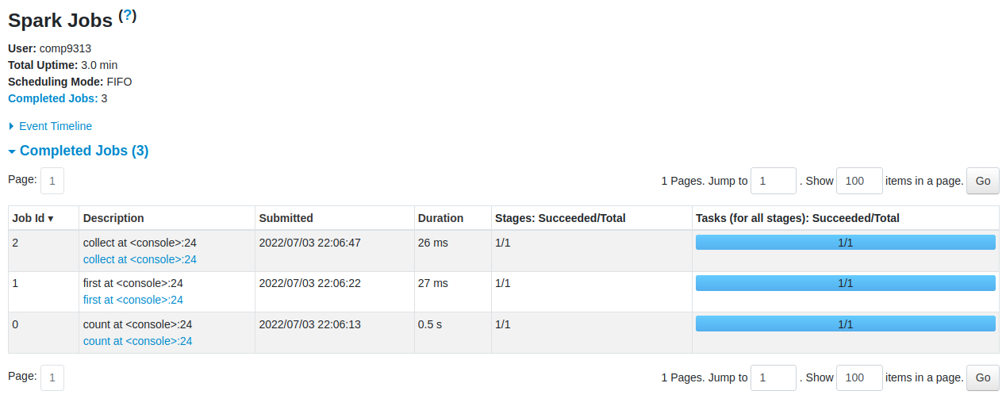
You can click each task to see more details of the execution.

Answers:
1.11. (Question) Find the longest line together with the length in textFile.
>>> pairs = textFile.map(lambda line : (line,len(line)))
>>> res = pairs.reduce(lambda x,y : x if x[1] > y[1] else y)
1.12. (Question) Print the lines containing “Spark” with line numbers (starting from 0).
>>> lineWithNumber = textFile.zipWithIndex()
>>> lineWithSpark = lineWithNumber.filter(lambda line: "Spark" in line[0]).map(lambda line:(line[1],line[0]))

2.4. (Question) What is the total number of bids per item type? The output is a list of key-
>>> from operator import add
>>> auctionRDD.map(lambda x: (x[itemtype],1)).reduceByKey(add).collect()
2.5. (Question) Across all auctioned items, what is the maximum number of bids?
>>> auctionRDD.map(lambda x: (x[aucid],float(x[bid]))).reduceByKey(max).collect()
2.6. (Question) Across all auctioned items, what are the top-5 items that have the most number of bids?
>>> auctionRDD.map(lambda x: (x[aucid],1)).reduceByKey(add).sortBy(lambda x:x[1],ascending=False).take(5)
You can also try the “takeOrdered()” method, which is more efficient than “sortBy().take()”.
or
>>> auctionRDD.map(lambda x: (x[aucid],1)).reduceByKey(add).top(5,key=lambda x:x[1])

