Aims
This exercise aims to get you to:
- Analyze data using Spark shell with RDD
- Monitor Spark tasks using Web UI

Background
The detailed Spark programming guide is available at:
http://spark.apache.org/docs/latest/programming-guide.html
The transformation and action functions examples are available at:
http://homepage.cs.latrobe.edu.au/zhe/ZhenHeSparkRDDAPIExamples.html
A tutorial of Scala 2 is available at:
http://docs.scala-lang.org/tutorials/?_ga=1.99469143.850382266.1473265612
A cheat sheet of Scala 2 is at:
https://docs.scala-lang.org/cheatsheets/index.html
The answers to the questions are given at the end of this file. Please try to answer all questions by yourself utilizing the above documents, and then check your results with the answers provided.

Install and Configure Spark
1. You need to check JAVA_HOME first. In ~/.bashrc, if not exist, add:
export JAVA_HOME=/usr/lib/jvm/java-11-openjdk-amd64
Please note that, if you use mac and the default terminal is zsh, then add this line to “~/.zshrc” instead. Do not naively paste this command to your laptop, please check your own java location by “whereis java” and paste it.
2. Download the Spark package by the command (or use a web browser):
$ wget https://dlcdn.apache.org/spark/spark-3.3.0/spark-3.3.0-bin-hadoop3.tgz
Then unpack the package:
$ tar xvf spark-3.3.0-bin-hadoop3.tgz
$ mv spark-3.3.0-bin-hadoop3 spark
Now you have Spark installed under ~/spark. We need to configure this folder as the working directory of Spark.
Open the file ~/.bashrc and add the following lines to the end of this file:
export SPARK_HOME=/home/comp9313/spark
export PATH=$SPARK_HOME/bin:$PATH
Save the file, and then run the following command to take these configurations into effect:
$ source ~/.bashrc
Next, start HDFS by:
$ start-dfs.sh

Interactive Analysis with the Spark Shell Using RDD
Use the following command for opening Spark shell:
$ spark-shell

1. Load and inspect data from a text file:
1. Create an RDD from local files using textFile()
$ scala> val textFile = sc.textFile("file:///home/comp9313/spark/README.md")
Spark’s primary abstraction is a distributed collection of items called a Resilient Distributed Dataset (RDD). RDDs can be created from Hadoop InputFormats (such as HDFS files) or by transforming other RDDs. This command makes a new RDD from the text of the README file in the Spark source directory.
You can apply the RDD transformation and action functions on “textFile”.
2. Count the number of items in an RDD (count() is an action)
Definition: def count(): Long
$ scala> textFile.count()
You should see results: “res0: Long = 124”
3. Get the first item in an RDD
Definition: def first(): T
$ scala> textFile.first()
You should see results: “res1: String = # Apache Spark”
4. Get lines containing “Spark” using the function filter()
Definition: def filter(f: T => Boolean): RDD[T]
$ scala> val linesWithSpark = textFile.filter(line => line.contains("Spark"))
You can also use underscore in the argument, that is, filter(_.contains(“Spark”)). Try to count the items in linesWithSpark.
5. Use the function collect() to see the contents of linesWithSpark
Definition: def collect(): Array[T]
$ scala> linesWithSpark.collect()
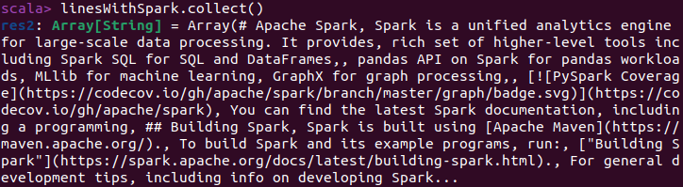
6. Print all the items in linesWithSpark
Definition: def foreach(f: T => Unit)
$ scala> linesWithSpark.foreach(println)
println() is a function, and it is used as an argument in function foreach().
7. Use function map() to map each line to the number of words contained in it
Definition: def map[U: ClassTag](f: T => U): RDD[U]
$ scala> val lineNumOfWords = textFile.map(line => line.split(" ").size)
The argument of map() is an anonymous function, which takes a line as the input, and returns the number of words (separated by space). Check the contents of lineNumOfWords.
8. Find the largest number of words contained in a line using reduce()
Definition: def reduce(f: (T, T) => T): T
$ scala> lineNumOfWords.reduce((a, b) => if (a > b) a else b)
You should see the result is 16. The reduce function takes an anonymous function as an argument, which takes two arguments and returns the larger one.
You can also call functions declared elsewhere. For example, you can use Math.max() function to make this code easier to understand:
$ scala> import java.lang.Math
$ scala> lineNumOfWords.reduce( (a, b) => Math.max(a, b) )
9. Convert RDD textFile to an array of words using flatMap()
Definition: def flatMap[U: ClassTag](f: T => TraversableOnce[U]): RDD[U]
$ scala> val words = textFile.flatMap(_.split(" "))
This will split each line to a list of words, and store all of them in one array. You can compare the result obtained by flatMap() with that obtained by map(). What are the differences?
$ scala> val words2 = textFile.map(_.split(" "))
10. Count the distinct words in textFile using distinct()
Definition: def distinct(): RDD[T]
$ scala> words.distinct().count()
Compare the results with words.count(). You can ignore “()” if there is no argument, that is, words.distinct.count.
11. (Question) Find the longest line together with the length in textFile.
Hint: first map a line to a pair of (line, length), and then use reduce() to find the longest line. To access the second field of an argument x, you can use x._2.
12. (Question) Print the lines containing “Spark” with line numbers (starting from 0). Each line is printed in format of:
Line Number in textFile: the contents of the line
Hint: Use function zipWithIndex().
Definition: def zipWithIndex(): RDD[(T, Long)]
Zip the elements of the RDD with its element indexes. The indexes start from 0.

2. More operations on pair RDD:
1. Download the data set auctiondata.csv from the course webpage.
Define the mapping for the input variables. They are used to refer to different fields of the data set.
$ scala> val aucid = 0
$ scala> val bid = 1
$ scala> val bidtime = 2
$ scala> val bidder = 3
$ scala> val bidderrate = 4
$ scala> val openbid = 5
$ scala> val price = 6
$ scala> val itemtype = 7
$ scala> val dtl = 8
2. Load data into Spark
$ scala> val auctionRDD = sc.textFile("file:///home/comp9313/auctiondata.csv").map(_.split(","))
In auctionRDD, each item is an array containing 9 fields, and you can use the defined variables to access each field.
3. Count the total number of item types that were auctioned.
$ scala> auctionRDD.map(_(itemtype)).distinct.count
or
$ scala> auctionRDD.map( x => x(itemtype)).distinct.count
Each item in auctionRDD is an array of String objects. x(itemtype) is equivalent to x(7), and it is used to get the 8th object in the array. You can also use x._7 to do the same work.
4. (Question) What is the total number of bids per item type? The output is a list of key-value pairs <item type, number of bids>.
Hint: First create a pair RDD by mapping each record to a pair of (item type, 1), and then use reduceByKey() to do the aggregation for each item type
Definition: def reduceByKey(func: (V, V) => V): RDD[(K, V)]
5. (Question) Across all auctioned items, what is the maximum number of bids?
Hint: First use reduceByKey() to count the number of bids for each auctioned item, and then find the maximum number using reduce()
6. (Question) Across all auctioned items, what are the top-5 items that have the most number of bids?
Hint: First use reduceByKey() to count the number of bids for each auctioned item, and then use sortByKey(false) to sort the key-value pairs in descending order. Note that sortByKey() works on keys, not values, and thus you need to swap the key and value. You can do this by “map(x => (x._2, x._1))” or “map(x => x.swap)”. Finally (use take() to get the top-5 results, and swap the key and value back.
Definition: def sortByKey(ascending: Boolean = true, numPartitions: Int = self.partitions.size): RDD[P]

3. Do word count in Spark shell
Start HDFS, get the file “pg100.txt” from WebCMS3 and put it to HDFS
$ hdfs dfs –put pg100.txt
Load the file into Spark from HDFS, and use the functions map(), flatMap(), reduceByKey() to do word count (split the documents by the space character). Finally, store the results in HDFS using saveAsTextFile() and check the output.
RDD partitions: In the function reduceByKey(), set the number of tasks to 3, and check the results again (each task will be processed by one reducer, and thus three output files) .

Spark Web UI
Browse the web interface for the information of Spark Jobs, storage, etc. at: http://localhost:4040. You will see something like:
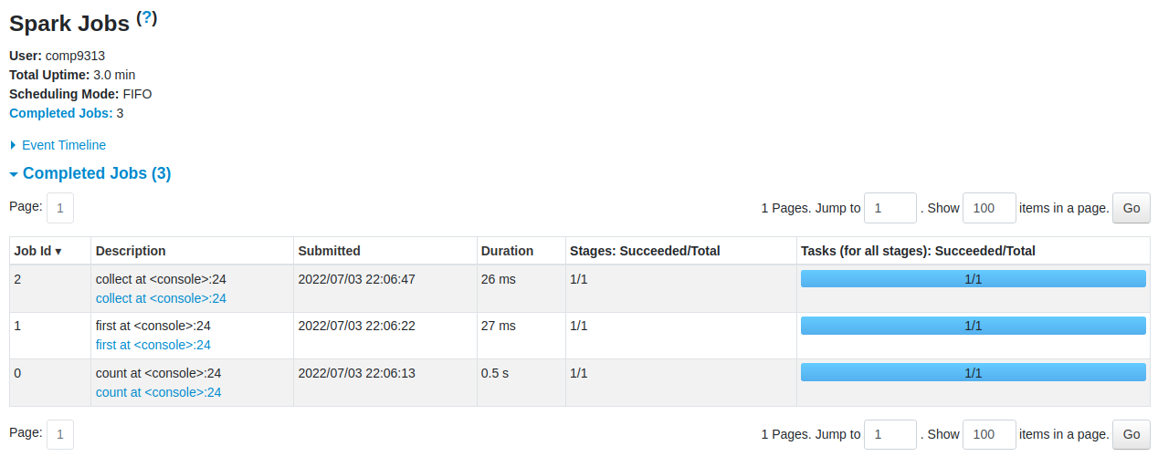
You can click each task to see more details of the execution.

Answers:
Note that for all answers you can define some intermediate variables to make the command clearer.

Interactive Analysis with the Spark Shell
1.11. $ scala> textFile.map(line => (line, line.length)).reduce( (a, b) => if(a._2 > b._2) a else b)
Result: 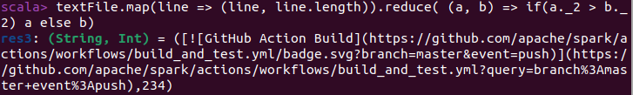
1.12. $ scala> textFile.zipWithIndex().filter(a => a._1.contains("Spark")).foreach(a => println(a._2.toString() + ": " + a._1))
Result: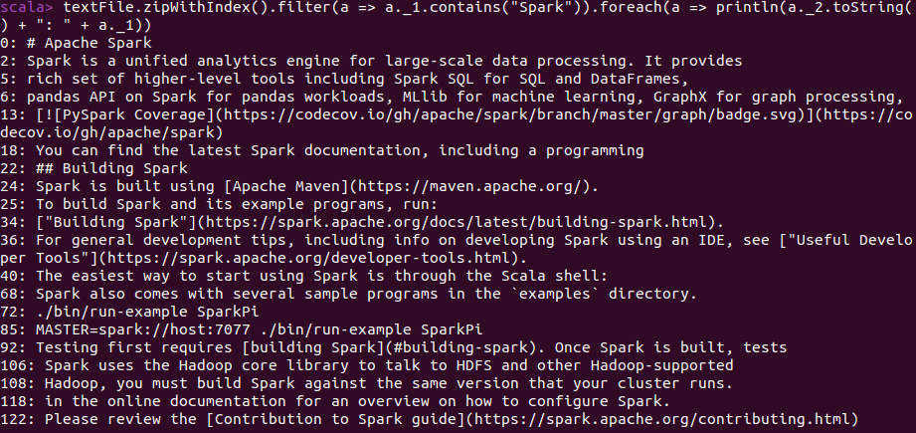
2.4. $ scala> auctionRDD.map(x=>(x(itemtype),1)).reduceByKey(_+_).collect()
Or $ scala> auctionRDD.map(x=>(x(itemtype),1)).reduceByKey((a, b) => a + b).collect()
Result:
2.5. $ scala> auctionRDD.map(x=>(x(aucid),1)).reduceByKey(_+_).reduce((a, b) => if(a._2 > b._2) a else b)._2
Result: 75
2.6. $ scala> auctionRDD.map(x=>(x(aucid),1)).reduceByKey(_+_).map(x => (x._2, x._1)).sortByKey(false).take(5).map(x => (x._2, x._1))
or
$ scala> auctionRDD.map(x=>(x(aucid),1)).reduceByKey(_+_).map(_.swap).sortByKey(false).take(5).map(_.swap)
Result:
You can also try the “takeOrdered()” method, which is more efficient than “sortByKey().take()”.
3. $ scala> val textFile = sc.textFile("pg100.txt")
$ scala> textFile.flatMap(line => line.split(" ")).map(word => (word, 1)).reduceByKey((a, b) => a + b).saveAsTextFile("output")
$ scala> textFile.flatMap(line => line.split(" ")).map(word => (word, 1)).reduceByKey((a, b) => a + b, 3).saveAsTextFile("output")

