Aims
This exercise aims to get you to practice:
- Create a Cloud Storage bucket in Dataproc
- Create a cluster in Dataproc
- Run Spark jobs in Dataproc

Background

Google Cloud:
Google Cloud consists of a set of physical assets, such as computers and hard disk drives, and virtual resources, such as virtual machines (VMs), that are contained in Google's data centers around the globe. Each data center location is in a region. Regions are available in Asia, Australia, Europe, North America, and South America. Each region is a collection of zones, which are isolated from each other within the region. Each zone is identified by a name that combines a letter identifier with the name of the region.
In cloud computing, what you might be used to thinking of as software and hardware products, become services. These services provide access to the underlying resources. The list of available Google Cloud services is long, and it keeps growing. When you develop your website or application on Google Cloud, you mix and match these services into combinations that provide the infrastructure you need, and then add your code to enable the scenarios you want to build. See more documentation at:
https://cloud.google.com/docs/overview

Dataproc:
Dataproc is a fully managed and highly scalable service for running Apache Spark, Apache Flink, Presto, and 30+ open source tools and frameworks. Use Dataproc for data lake modernization, ETL, and secure data science, at planet scale, fully integrated with Google Cloud, at a fraction of the cost. See more documentation at:
http://docs.aws.amazon.com/AmazonS3/latest/gsg/GetStartedWithS3.html
Caution: Before doing the lab, please make sure that you have a google account in Dataproc with $300 free credits!!! We are NOT responsible for any charge of your credit cards if you do not follow the lab instructions.

Register Google Cloud
If you have an existing google account, you can use the same email and password for Google Cloud. Otherwise, please follow the below instructions:
- Go to https://cloud.google.com/free and click “Get started for free”.

- Click “Create account”.
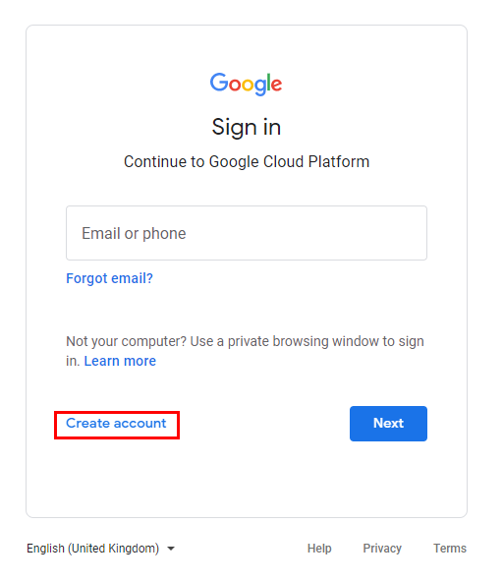
- Select “For myself”.
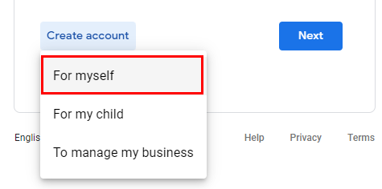
- Enter your name and email, then verify your email address.
- Enter your personal information and, and you’ll need to agree to the Terms of Service to create a Google Account.
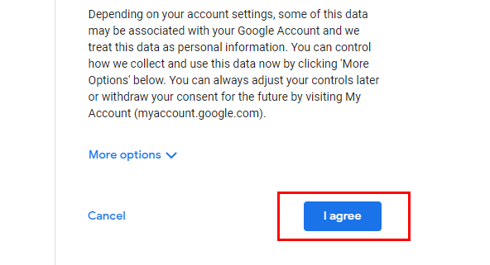
- Enter your account information.
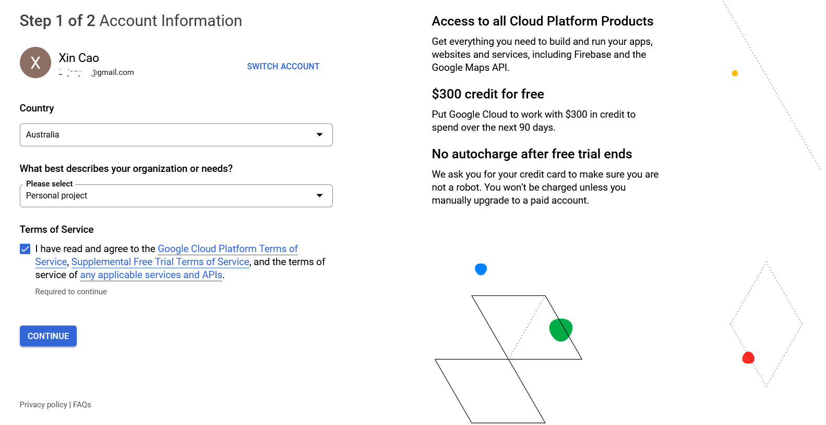
- Complete Identity Verification and Contact Information.
- Enter your payment information. (Google asks for your credit card or PayPal to make sure you are not a robot. You won’t be charged unless you manually upgrade to a paid account or the $300 credits have been spent.)
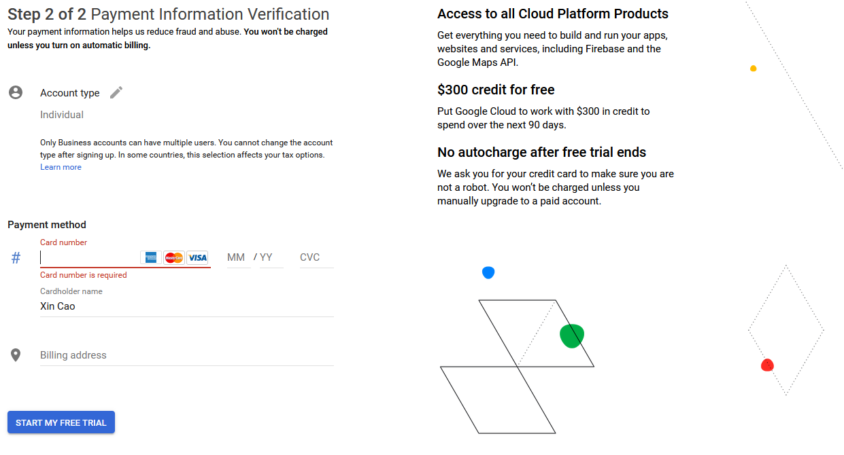

Check your free trial credit
- In the navigation menu of Google Cloud Platform, select “Billing -> overview”, or go to https://console.cloud.google.com/billing/ and then select “My Billing Account”

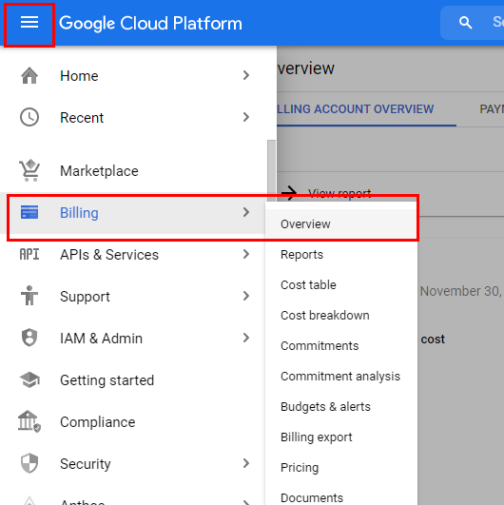

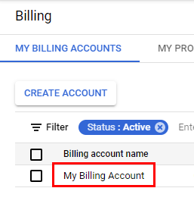
- Make sure that you have the free trial credit.
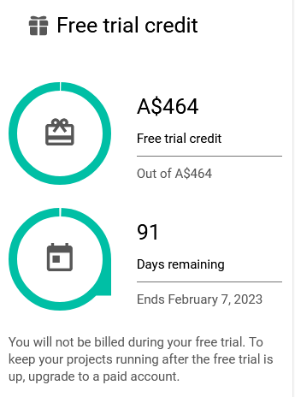
Create a Cloud Storage bucket
If you need to store some data in Google Could, you need to create a bucket for your data.

Navigate to Cloud Storage
- Open the menu on the left side of the console.
- In the Storage section, click Cloud Storage->Browser.
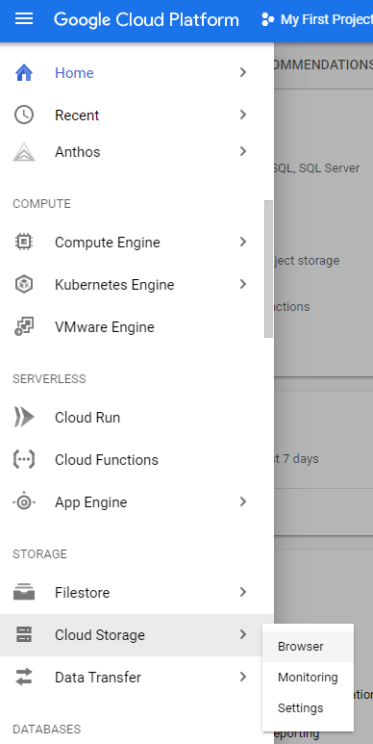

Set up a Project
- In order to create a bucket, you need to first create a project if it does not exist.
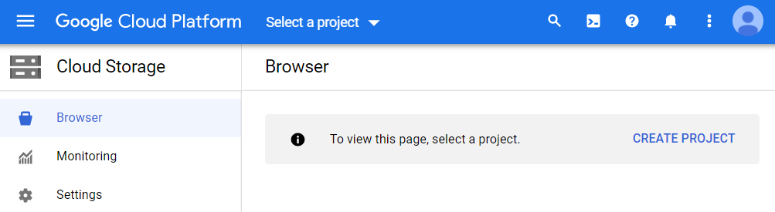
- For example, you can name your project as “My First Project”.

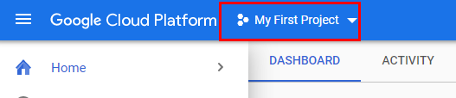

Name your bucket
- Begin by clicking Create Bucket.
- Enter a name for your bucket. (You can use “comp9313-zID” by replacing “zID” with your own zID). Note: Bucket names must be globally unique (among all buckets ever created by any user).
- Click Continue and you will finish creating the bucket.
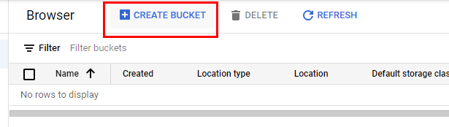

Choose storage location
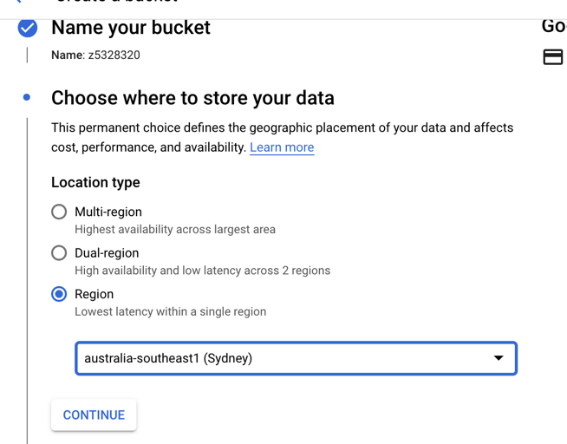
- Select the Location Type for your data.
  - The default, Multi-region, delivers the highest availability.
  - For lower latency, you may wish to choose Region.
  - Choosing Dual-region strikes a balance between them.
- Select “Australia-southeast1(Sydney)” as the location of your storage.
- Click Continue (you can also skip the following and click “Create” directly).

(optional) Select Storage Class (use the default in this lab)
- Select a default storage class for data in this bucket. The default is Standard, but you may wish to choose a different option based on your needs.
  - This decision should be based on how long you plan to store your data and how often it will be accessed. Learn more about storage classes.
- Click Continue.

(optional) Access Control (use the default in this lab)
- Specify how to control access to objects, whether you want to control access at the bucket level only (Uniform), or to also enable individual stored objects to have additional permission settings (Fine-grained). Learn more about the differences here.
- Click Continue.

(optional) Choose how to protect object data (use the default in this lab)
- Your data is always protected with Cloud Storage but you can also choose from these additional data protection options to prevent data loss. Note that object versioning and retention policies cannot be used together.
After configuring your bucket setting, you can click the “CREATE” button.
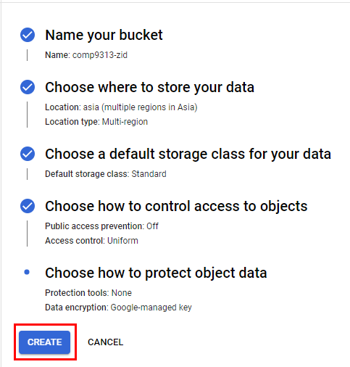

Create a cluster
In the navigation menu of Google Cloud Platform, click Dataproc->Clusters, and then in the new page click CREATE CLUSTER. You can also access Dataproc by searching it at the head of the webpage. In the creating cluster panel, most fields are filled with default values already. You can change these default values to customize your own cluster.
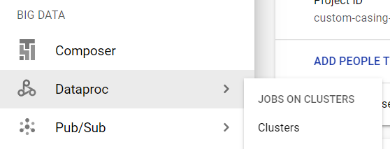

Set up cluster
You need to at least give a name, select a location, and select “Cluster on Computer Engine” for your cluster, like below:
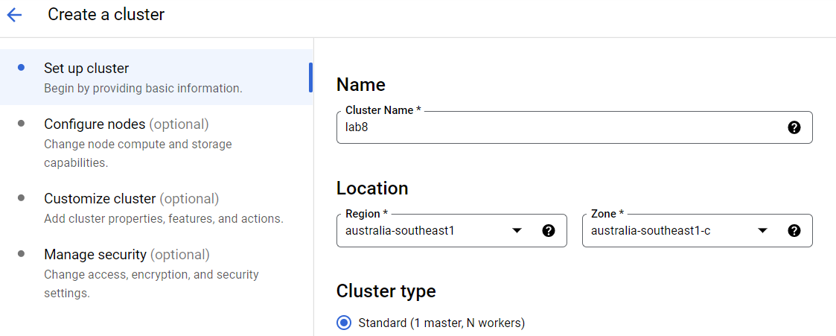
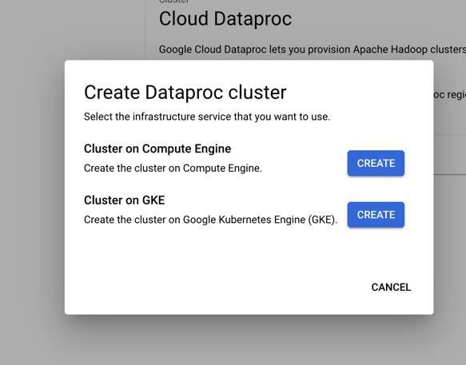
The cluster name appears on the Clusters page, and its status is updated to Running after the cluster is provisioned. Click the cluster name to open the cluster details page where you can examine jobs, instances, and configuration settings for your cluster and connect to web interfaces running on your cluster.

(Optinal) Configure nodes
You can optionally configure the nodes you are going to use for both master and worker nodes. For example, you can set the machine type as “n1-standard-2”, the disk sizes of master and worker nodes to 30GB as below:
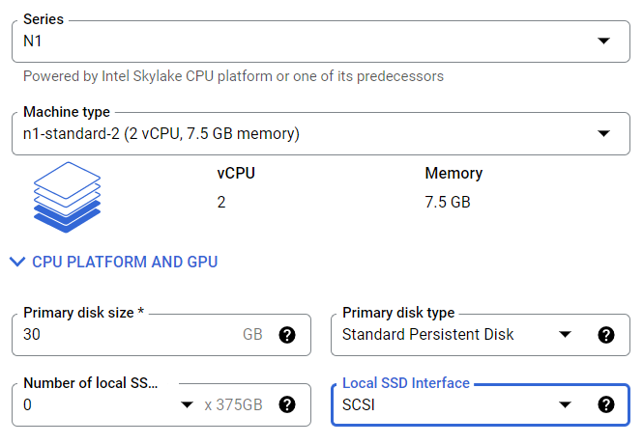
For the panels of “Customize cluster” and “Manage security”, you just need to use the default values in this lab.
After clicking the “CREATE” button, if you get an error message like this:
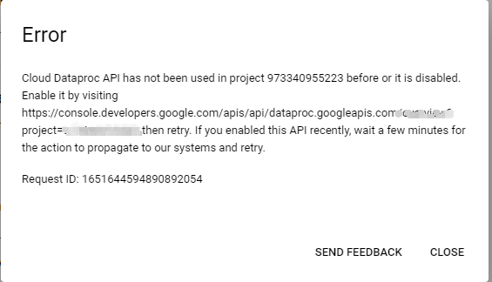
You should visit the link shown in the message, and enable the Cloud Dataproc API. Then, try to create the cluster again.
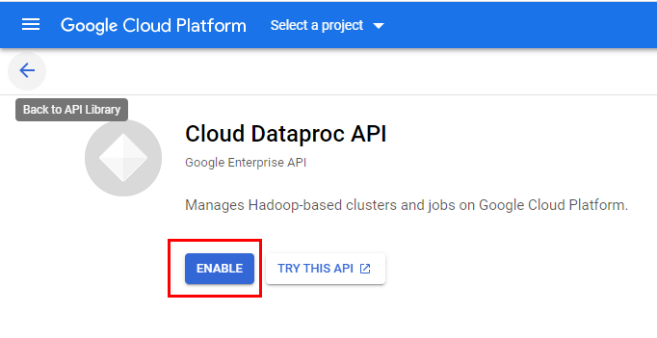
If it is successful, you can find a cluster in your Clusters panel.
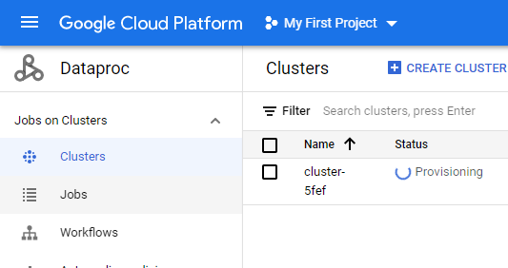
The status will change from “Provisioning” to “Running” when it is ready.
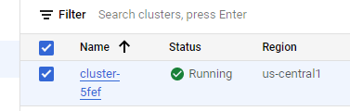

Run Spark Jobs in Google Dataproc

Upload jar file to Google Cloud Storage
In Lab 6, you have learned how to create a jar file with SBT for your Spark project. Now you should first upload the jar file to Google Cloud Storage.
- Click the bucket you just created with name comp9313-<ZID>
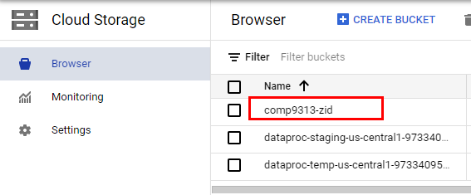
- Select “UPLOAD FILES” and upload the word-count_2.12-1.0.jar file on https://webcms3.cse.unsw.edu.au/COMP9313/23T2/resources/88419
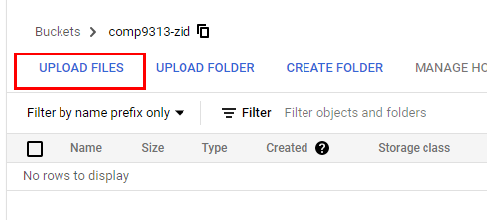
- Click the file, then in the new page find its gsutil URI.
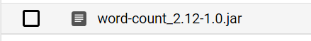
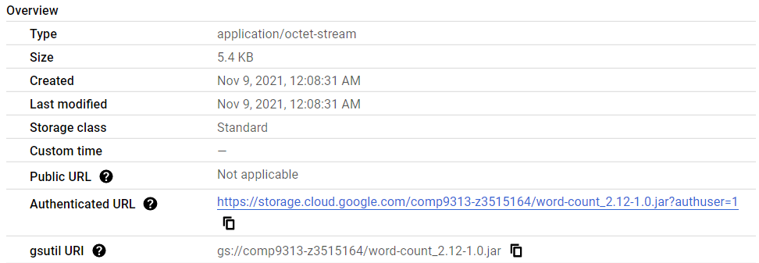

Upload Input File to Google Could Storage
Download the pg100.txt as the input file, and upload it to your bucket as well. After the file is uploaded, check its gsutil URI, which will be used later.
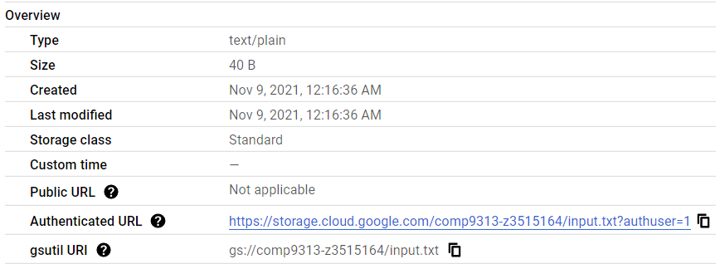

Run Your Spark Job in Dataproc
- In the navigation menu of Google Cloud Platform, click Dataproc->Jobs. In the new page, click “SUBMIT JOB”.
- Configure your Spark job in the new page. First, select the region as “Australia-southeast1”, the one you used when creating the cluster. Then, the created cluster would be visible to you:
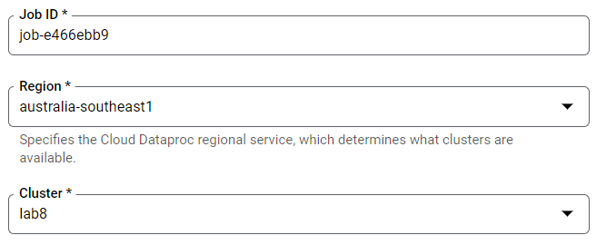
- Next, select the job type, configure the class, the jar file, and the arguments. Please make sure that there is no unexpected char (e.g. unexpected space) following your arguments. If you paste all these arguments into the webpage, you must be careful about this issue.
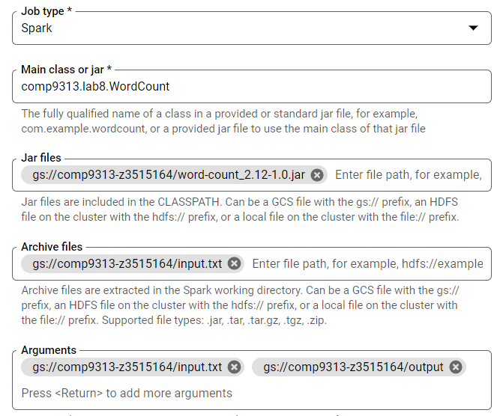
  - Job type: Spark
  - Main class: comp9313.lab8.WordCount
  - Jar file: Specify the Cloud Storage URI path to your WordCount jar (gs://your-bucket-name/word-count_2.12-1.0.jar).
  - Archive files: gs://your-bucket-name/input.txt
  - Arguments: gs://your-bucket-name/input.txt gs://your-bucket-name/output
- Click Submit to start the job. You will see the details of the job running.
- Once the job starts, it is added to the Jobs list. The elapsed time of the job is also displayed to you after the job completes successfully.
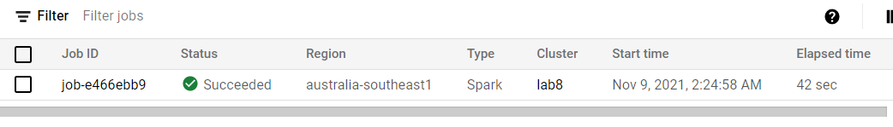
- Click the Job ID to open the Jobs page, where you can view the job's driver output
- You can see your output in your bucket now:
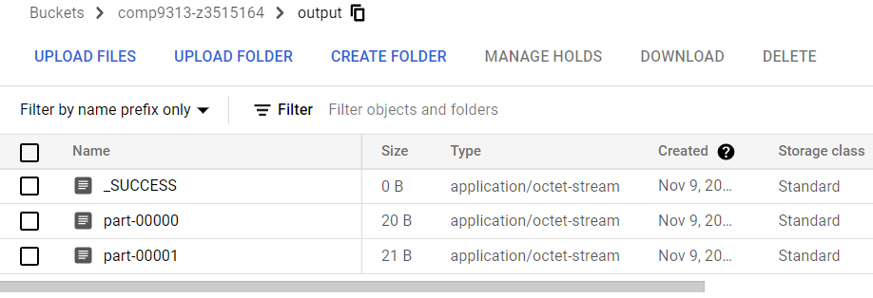
Caution: Do not forget to stop the cluster after you finish all labs (Click “STOP”) and delete all the data in your bucket!!!
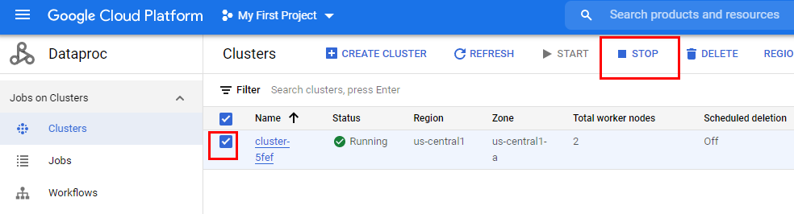
You can try submitting your solutions to problems in Labs 6 and 7 to Dataproc and check the running time.
Before submitting a Spark job to Dataproc, you always need to start a cluster first, and remember to stop the cluster when your job completes.

