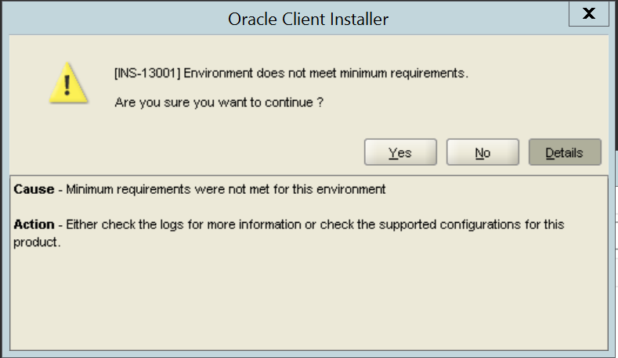

下記の設定をすれば、setup.exeを起動できません。

<https://stackoverflow.com/questions/35906768/oracle-installerins-13001-environment-does-not-meet-minimum-requirements>

To prevent this dialog box from appearing, do the following:

1. Right click on the setup.exe for the Oracle 11g 32-bit client, and select Properties.
2. Select the Compatibility tab, and set the Compatibility mode to Windows 7. Click OK to close the Properties tab.
3. Double click setup.exe to install the client.

Default path settings:

%SystemRoot%\system32;%SystemRoot%;%SystemRoot%\System32\Wbem;%SYSTEMROOT%\System32\WindowsPowerShell\v1.0\

Install Java8.0

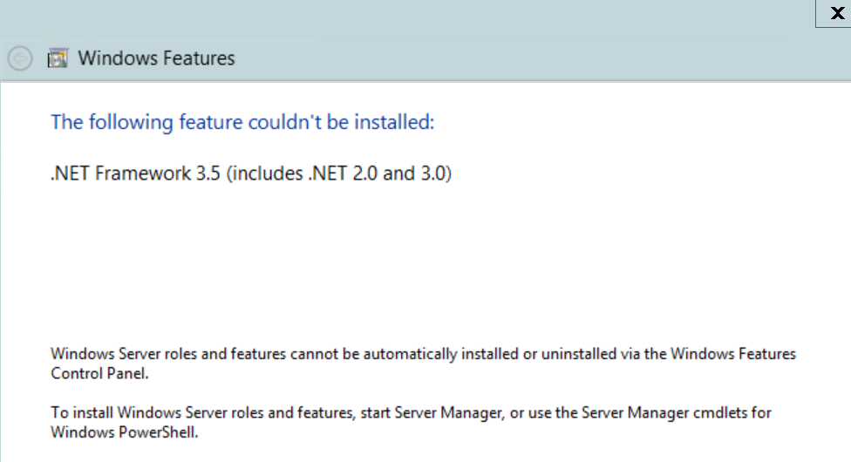

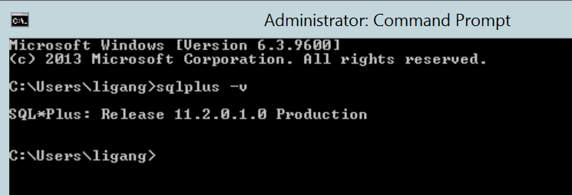

C:\Users\ligang>echo %path%

C:\app\ligang\product\11.2.0\client_1\bin;C:\Program Files (x86)\Common Files\Oracle\Java\javapath;C:\windows\system32;C:\windows;C:\windows\System32\Wbem;C:\windows\System32\WindowsPowerShell\v1.0\