PENETRATION TESTING & VULNERABILITY ASSESSMENT REPORT
Target: Brooklyn Nine-Nine | Prepared by Farhan Ansari (G14)

Target Environment: Brooklyn Nine-Nine (Aetheris Global) | Assessment Date: October 2026
Target IP Address: 10.48.142.204 | Testing Team: G14

1. Executive Summary
An authorized penetration test and vulnerability assessment was conducted on the Brooklyn Nine-Nine machine (Aetheris Global infrastructure) at IP address 10.48.142.204 by Project Group G14. The assessment evaluated the target environment for security vulnerabilities, access control flaws, and privilege escalation paths.
The attack lifecycle was successfully executed from initial network reconnaissance to full root compromise. Key security gaps identified include unauthenticated FTP access, weak SSH password policies vulnerable to brute-force attacks, and improper sudo configuration permitting root shell escaping via the 'less' utility.
1.1 Vulnerability Risk Matrix
Severity | Vulnerability / Issue | Affected Component | CVSS v3.1
CRITICAL | Sudo Rights Misconfiguration (/usr/bin/less) | /etc/sudoers (NOPASSWD) | 9.8
HIGH | Weak SSH Credentials & Lack of Rate Limiting | SSH Service (Port 22) | 7.5
MEDIUM | Unauthenticated Anonymous FTP Access | vsFTPd 3.0.3 (Port 21) | 5.3

2. Technical Findings & Attack Lifecycle
Phase 1: Reconnaissance & Enumeration
Nmap scan revealed open ports including Port 21 (FTP) and Port 22 (SSH). Testing FTP revealed that Anonymous login was enabled on vsFTPd 3.0.3, allowing unauthorized file downloads.
ftp 10.48.142.204
Name: anonymous | Password: [any]
ftp> get note_to_jake.txt
cat note_to_jake.txt
-> Output revealed username 'jake' and password hint from Amy.

Phase 2: Credential Spraying & Initial Access
Using the target username 'jake' extracted from note_to_jake.txt, Hydra was utilized against the SSH service. Wordlist extraction was completed using gzip, yielding valid credentials.

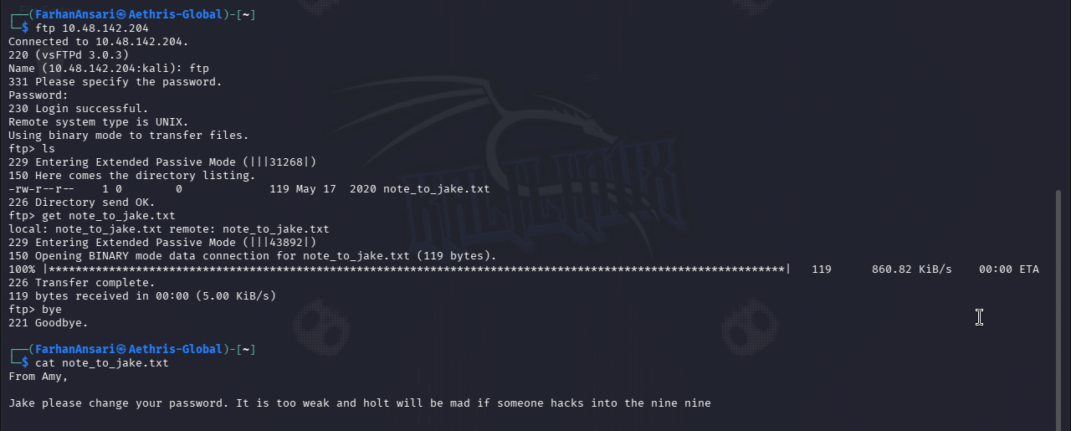
After establishing SSH session as 'jake', local enumeration located the user flag in Holt's home directory:

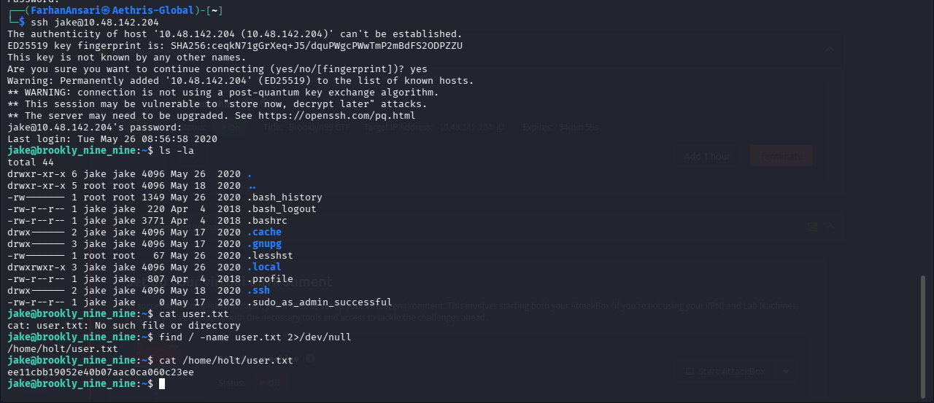
Phase 3: Privilege Escalation to Root
Running 'sudo -l' identified that user 'jake' had NOPASSWD sudo privileges for /usr/bin/less. Exploiting GTFOBins interactive shell escape feature yielded instant root shell access:

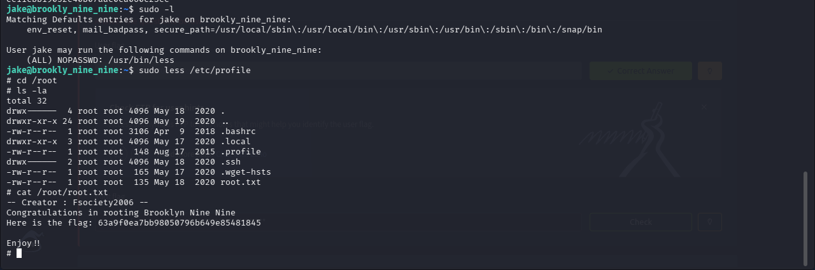
3. Defensive Recommendations & Mitigation
To remediate the vulnerabilities identified during this assessment, the following hardening steps are recommended:
- Disable Anonymous FTP Access: Update /etc/vsftpd.conf to set 'anonymous_enable=NO' and restart the service.
- Enforce Strong SSH & Password Policies: Implement strong password complexity requirements (minimum 12 characters) and configure Fail2Ban to block brute-force attempts.
- Sudoers Hardening (Principle of Least Privilege): Remove NOPASSWD privileges for binaries capable of shell execution (GTFOBins) such as less, vim, find, and nano.
- Network Segmentation & Hostname Resolution: Ensure correct /etc/hosts configuration and restrict SSH access to designated IP ranges.

