**Assignment Four**

**Evaluation**

Cezmi Aktepe (n01379944)

I have designed various methods of this assignment and the major challenge was to find desired record in the database. I tried different ways to extract desired data from database, but I failed. Finally, I used another way to extract data and I managed to extract. I used three different data types to extract data productid, price range and keyword.

I had little bit problem with displaying data. I found a way to display data on text area.

I have written the following codes.

**Business Package**

Customers.java Whole Class Data

Products.java Whole Class Data

**Data Package**

**DataIO.java**

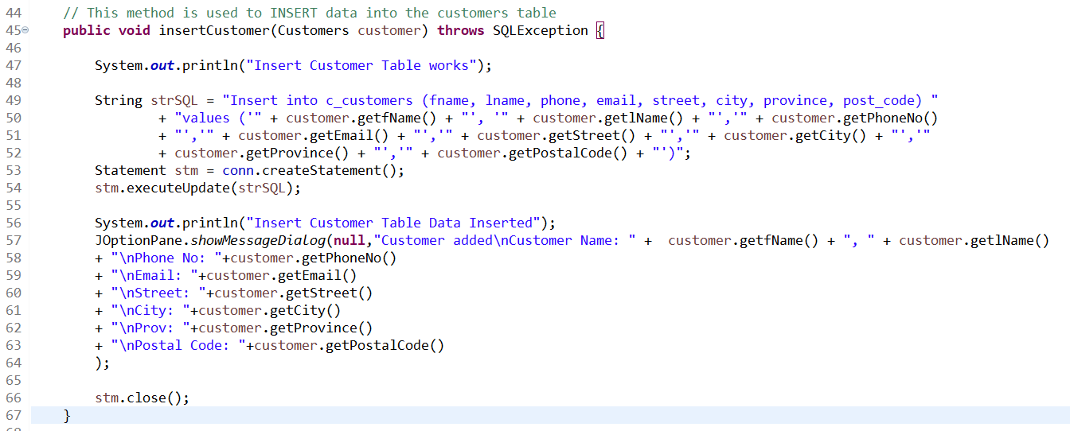

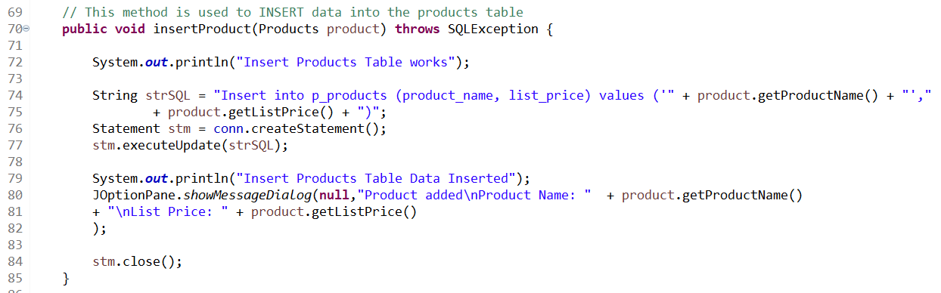

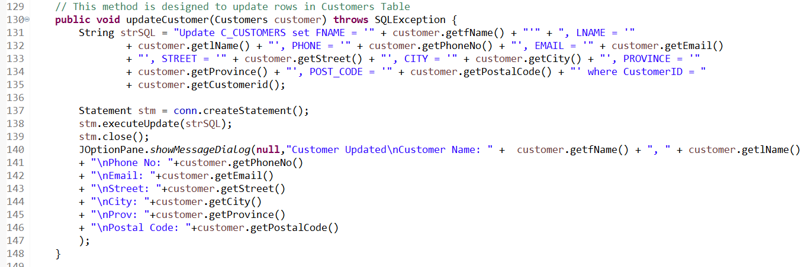

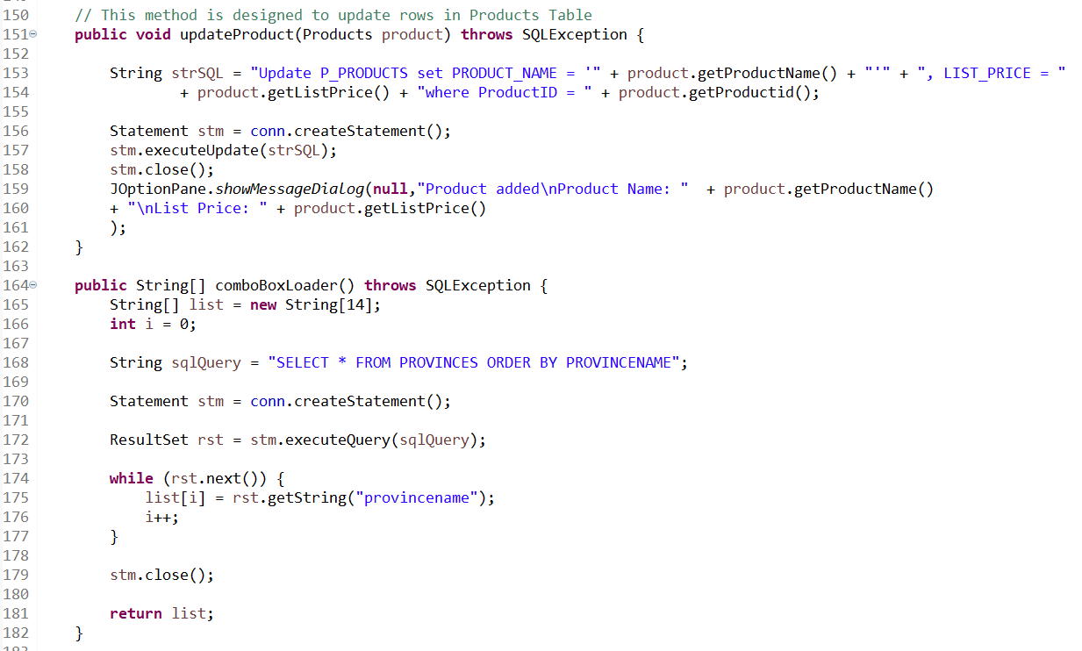

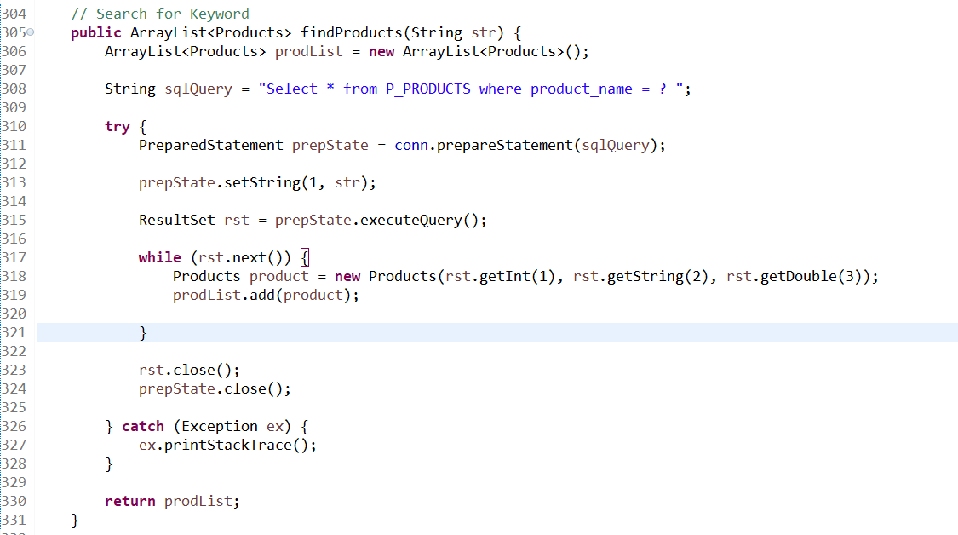

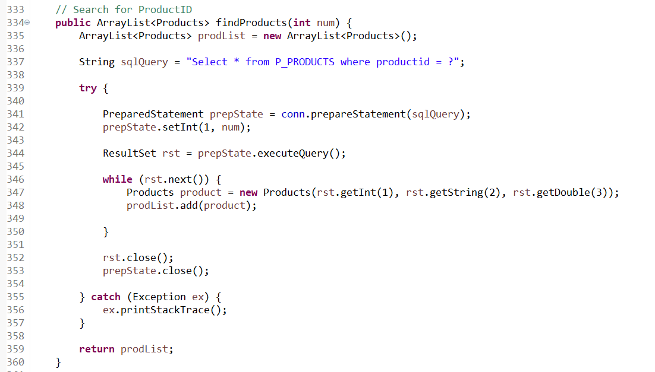

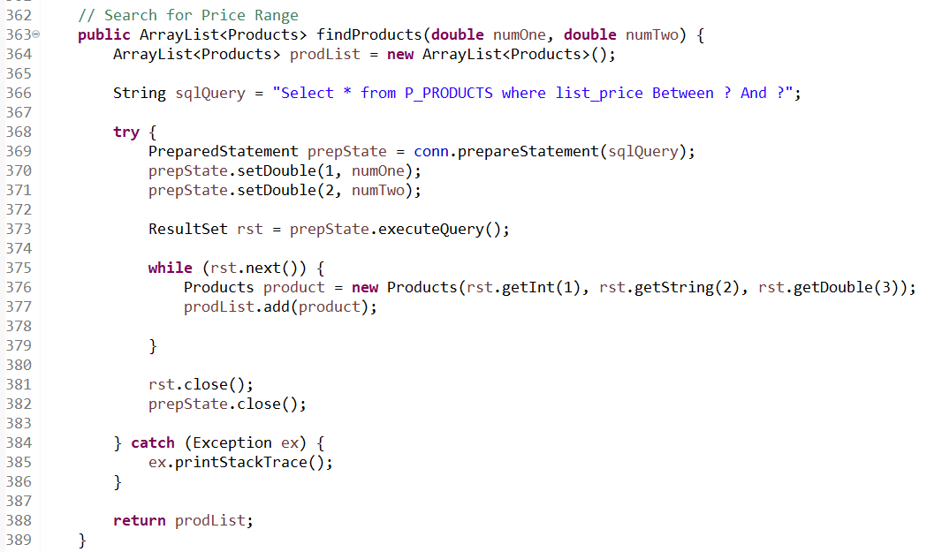

**Presentation Package**

**ProductGUI.java**

