|  |
| --- |
| Faculty of Applied Sciences and Technology |
| **XML/JSON Data Processing** |
| ITC5202 - Project |
|  |
| **Group Member name**  **Submission Date** |
| **[Pick the date]** |

|  |
| --- |
| This document explains how to process XML/JSON data …………………………. |

Table of Contents

Question 1: Use JavaScript/Ajax to process XML data 2

Question 2,3,4,6: Use JavaScript/jQuery to process JSON data 3

Question 5 and 7(Bonus) : XSLT and XPath 4

Summary 5

# Question 1: Use JavaScript/Ajax to process XML data

(Describe the major steps for designing the JavaScript function(s), how you test this program, add some screenshots of the output )

1. I created an XMLHttp object to connect xml file.

2. I created a function and assigned to a button onclick attribute.

3. Created needed variables and assign them to the xml tags.

4. Using for loops and if clauses to extract data from file and assign the data to an output variable.

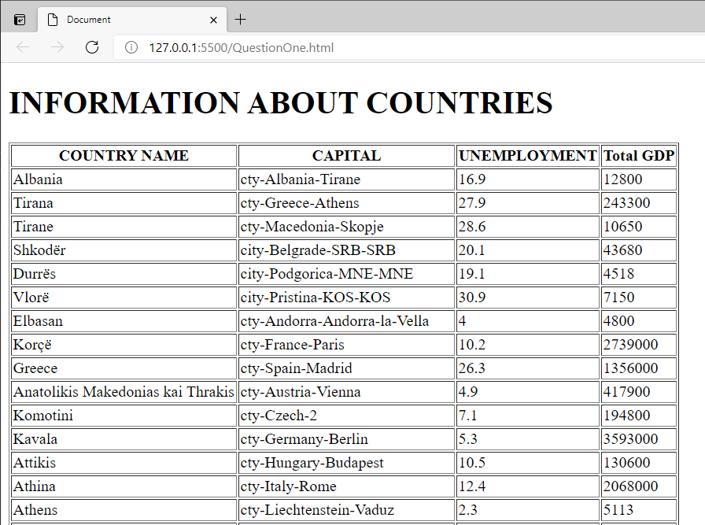

# Question 2: Use JavaScript/jQuery to process JSON data

(Describe the major steps for designing the JavaScript function(s), how you test this program, add some screenshots of the output)

# Question 3: Use JavaScript/jQuery to process JSON data

(Describe the major steps for designing the JavaScript function(s), how you test this program, add some screenshots of the output)

# Question 4: Use JavaScript/jQuery to process JSON data

(Describe the major steps for designing the JavaScript function(s), how you test this program, add some screenshots of the output)

1. I created an XMLHttp object to connect to json file and parse json file in order to extract information.

2. I created a function and assigned to a button onclick attribute.

3. Created needed variables to assign data to each of them.

4. Using for loops and if clauses to extract data from file and assign the data to an output variable.

5. Display extracted data in a beautiful way on a html file.

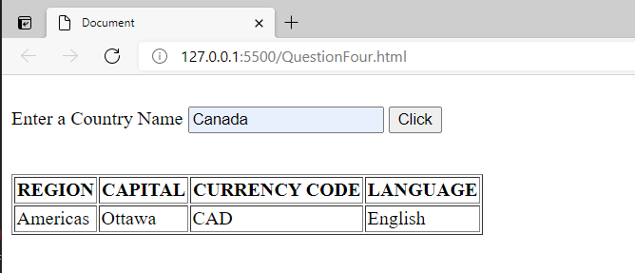

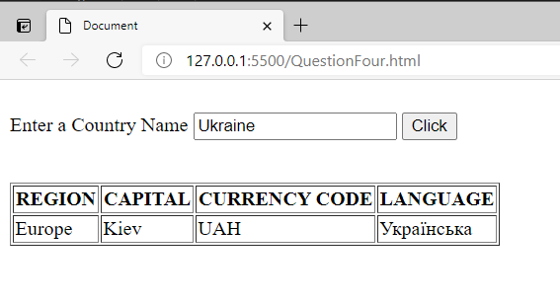

# Question 6: Use JavaScript/jQuery to process JSON data

(Describe the major steps for designing the JavaScript function(s), how you test this program, add some screenshots of the output)

1. I created a connection to jquery library.

2. I created a function and assigned to a button onclick attribute.

3. I started JQUERY command line to use jquery commands in my document.

4. I used getJSON function to link API and extract data from the API.

5. I used for each loop to check existence of data from whole json file loaded on API.

6. I used conditional to filter the data and assign the data to proper variables to be displayed later.

7. I used to getJSON function to link another API in order to extract currency information of countries based on EUR.

8. Display extracted data in a beautiful way on a html file.

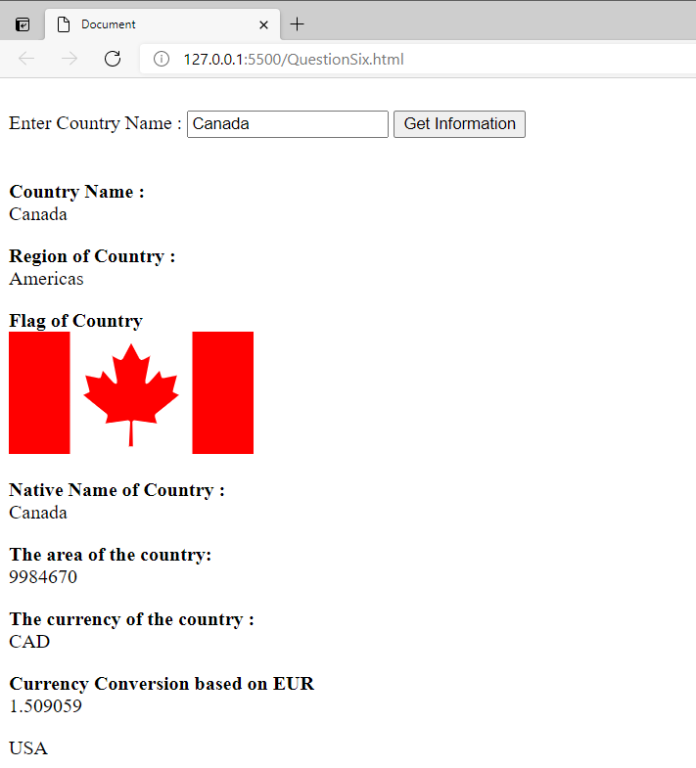

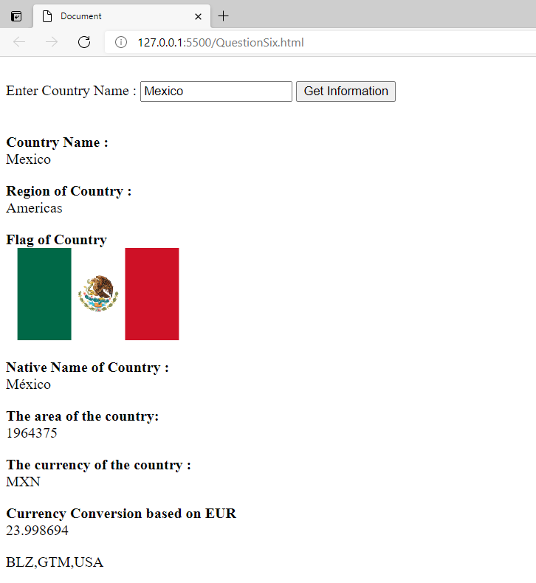

# Question 5 and 7(Bonus) : XSLT and XPath

(Describe the major steps for designing the XSLT. How did you use XPath in the XSLT?

Add screenshot of the XPath testing and the output of XSLT)

# Summary

(Describe how did you divide the work, share your feedback about this project like new points that you learn, challenges, …)

This project gave me a great experience on how to work with API, JSON and XML files. I tested my knowledge by extracting various data from these sources.

The biggest challenge for me is to show full name of the countries by using abbreviations. I tried various method but I could not mange it. I created another function to get data but it did not work as well.