Introduction
This report presents a comprehensive analysis of service requests in New York City, focusing on the COVID-19 pandemic. By examining the data collected from the NYC 311 system, we aim to understand the impact of these crises on public service demands and the shifting priorities of residents during these turbulent times.
COVID-19 pandemic presented unique challenges that transformed public service needs across the city. From noise complaints during lockdown to sanitation requests after restrictions eased, the analysis captures the evolving landscape of public concerns. By exploring the data from the onset of the pandemic through its various phases, this report sheds light on how New Yorkers navigated a public health crisis and how city agencies responded to these urgent needs.
Ultimately, the findings from this analysis underscore the importance of effective resource allocation and emergency preparedness, providing valuable insights for future public policy efforts aimed at enhancing community resilience in the face of disasters.

COVID-19 Service Requests Overview

Data Collection
The COVID-19 service requests dataset used for this analysis was sourced from various agencies across New York City, capturing the public's response to the pandemic and the associated service needs. Covering a timeframe from October 31, 2019, to July 1, 2020, the dataset includes a total of 1,462,013 entries. It encompasses a wide array of complaint types, agency information, and geographic details, making it a comprehensive resource for understanding public concern during this unprecedented period. The dataset specifically tracks service requests related to issues such as noise complaints, sanitation needs, and other public safety matters.
To ensure the integrity and usability of the data, extensive cleaning and preprocessing were undertaken. This involved removing duplicates, handling missing values, and focusing on key columns that would provide the most relevant insights for analysis. The cleaned dataset retains 13 essential columns, including complaint type, borough, agency, and geographic coordinates. By concentrating on these variables, the analysis aims to yield meaningful insights into how service requests evolved during the pandemic's critical phases, particularly before, during, and after New York City's first lockdown.

Data Summary
After thorough data cleaning, the resulting dataset reveals a comprehensive picture of service requests related to COVID-19 in New York City. The total of 1,462,013 entries is categorized across 13 columns, providing a clear overview of the nature and distribution of complaints. Notably, the dataset features a variety of complaint types, ranging from "Noise - Residential" to "Illegal Parking," indicating the diverse concerns of residents during the pandemic. The geographic distribution of these requests also offers insights into which areas were most affected, as the data includes borough-level information.
Statistical summaries of the dataset highlight key trends and patterns in service requests. For instance, the analysis shows that specific types of complaints surged during certain periods, reflecting the changing concerns of the public as the pandemic unfolded. With a focus on the most common complaint types, agencies involved, and geographic distribution, this summary sets the stage for a deeper analysis of service requests and their implications during the COVID-19 crisis.

Data Analysis

Change in Service Requests Before and After the First Lockdown
The analysis of service requests demonstrates a profound shift in public demand before, during, and after the first lockdown implemented on March 22, 2020. Prior to the lockdown, the dataset recorded 806,377 service requests, indicating a robust engagement with city services as residents sought assistance for various issues. However, this number declined sharply during the lockdown period, where only 573,637 requests were logged. This dramatic reduction is likely a reflection of the restrictions on public movement and the overall change in daily life, which limited individuals' ability to report issues or seek services.
Following the lockdown, the number of service requests plummeted further to just 81,999. This drop suggests that as the city began to reopen, residents may have continued to face barriers in accessing services or may have prioritized different issues as they adjusted to life post-lockdown. The data clearly illustrates how the pandemic fundamentally altered the landscape of public service needs in New York City, providing critical insights into the response and adaptation of both residents and agencies during this tumultuous time.
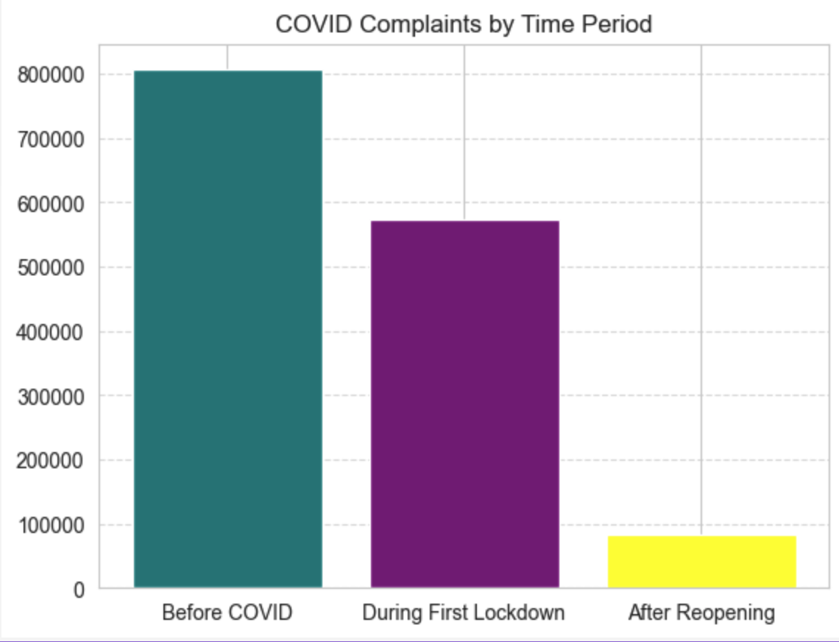

Common Types of Service Requests
The examination of common service requests reveals significant differences in public concerns across the three analyzed periods. Before the lockdown, the leading complaint type was "HEAT/HOT WATER," with a staggering 124,972 requests. This indicates that issues related to heating and hot water were of paramount concern for residents, possibly exacerbated by the onset of winter and the pandemic’s impact on living conditions.
During the lockdown, however, the landscape of complaints shifted dramatically. The most common complaint type became "Noise - Residential," which received 107,230 requests. This change suggests that as people were confined to their homes, noise disturbances became a significant source of frustration, reflecting the challenges of living in close quarters during a public health crisis. After the lockdown, service requests again shifted; "Noise - Street/Sidewalk" emerged as the most common complaint, highlighting ongoing public disturbances as the city began to reopen. This evolving narrative underscores the shifting priorities of New Yorkers as they navigated the complexities of the pandemic, illustrating how the nature of complaints can evolve in response to changing circumstances.
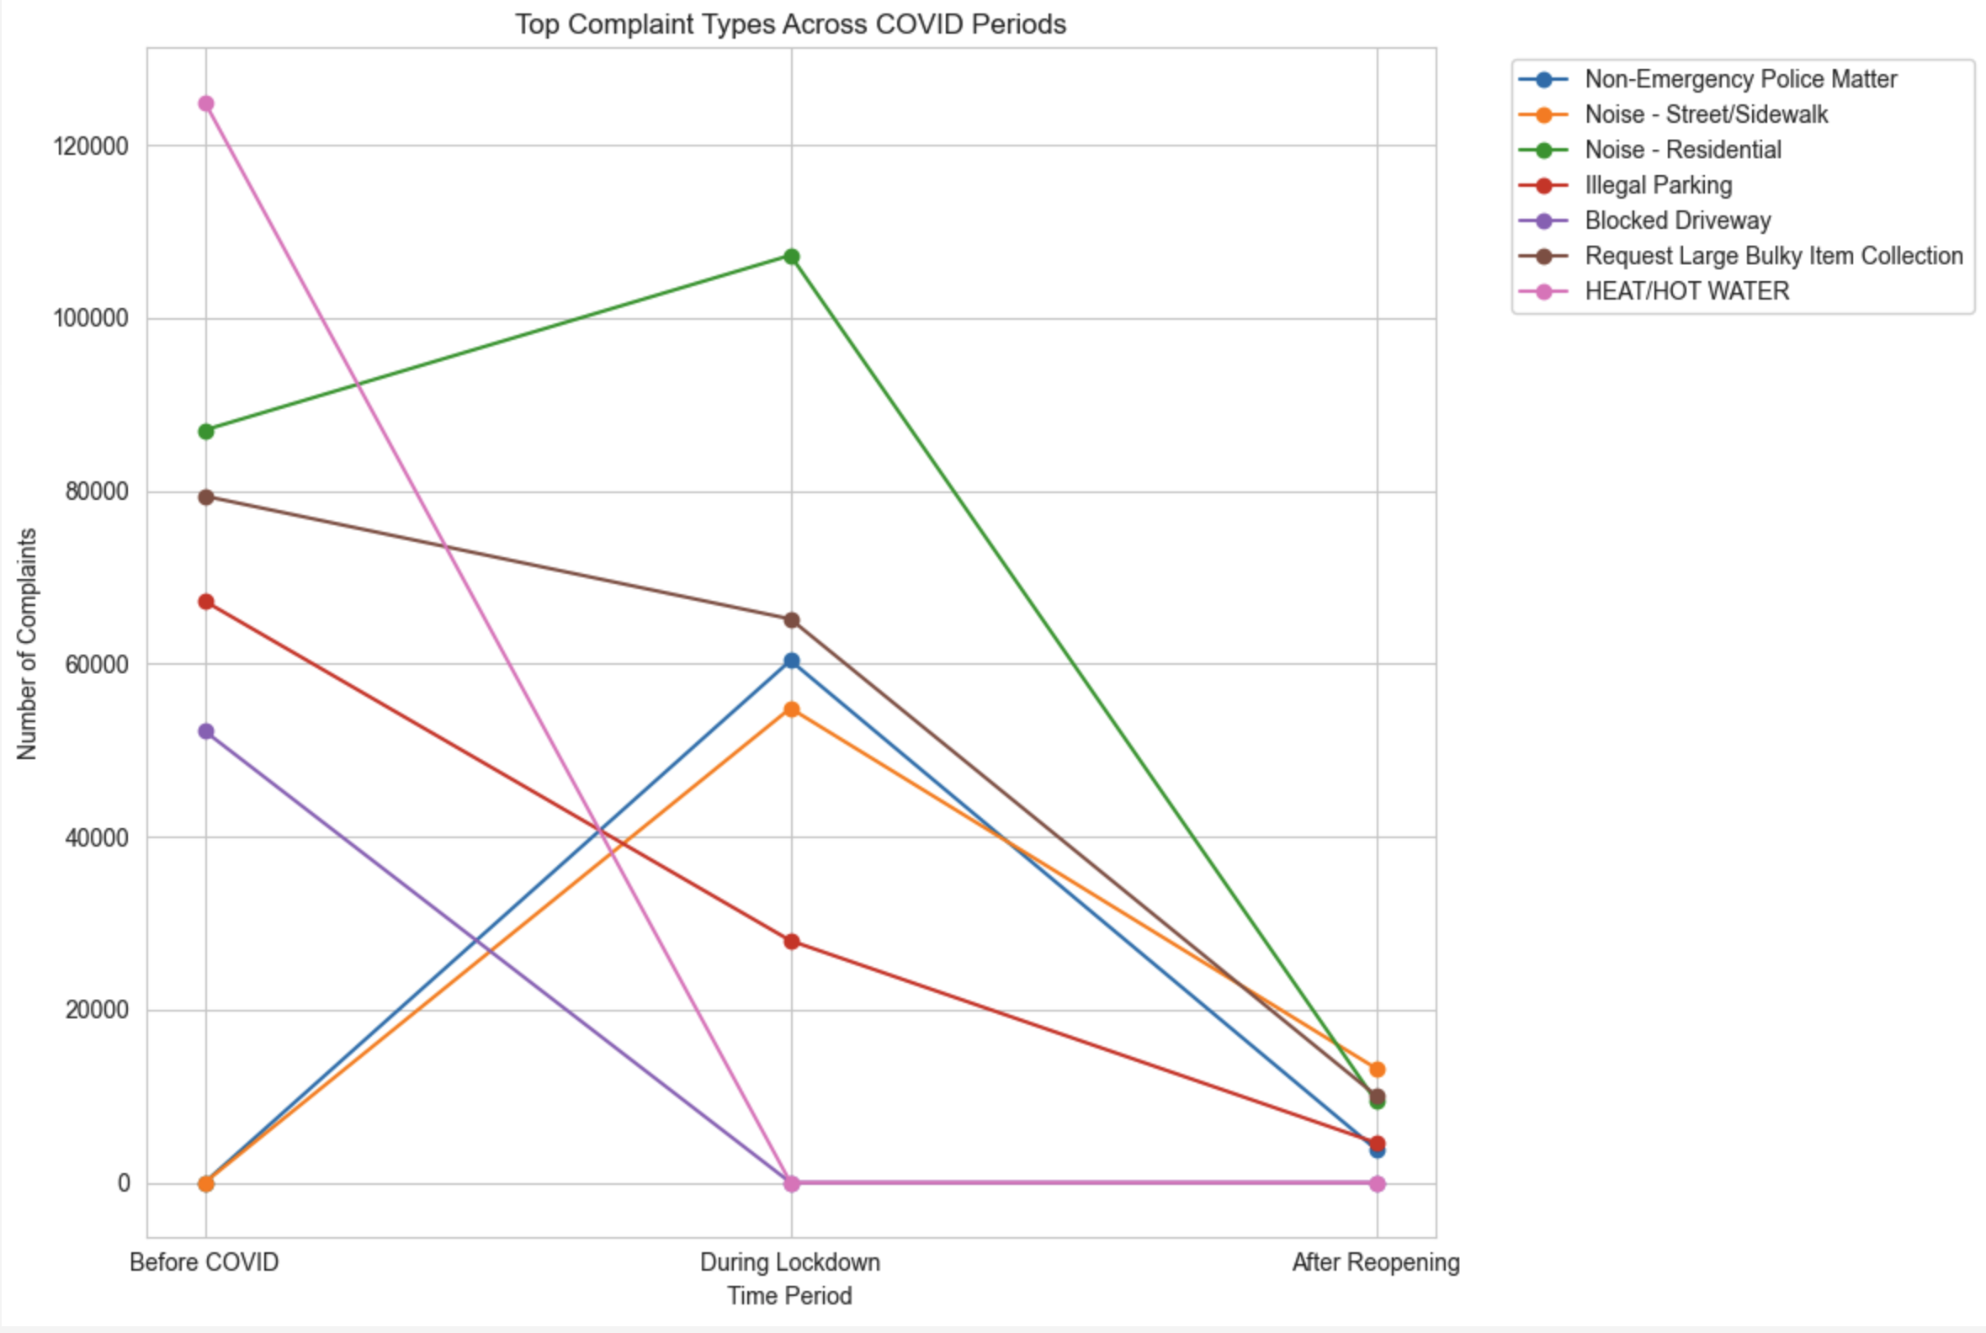

Areas Most Affected by COVID-19
Geographic analysis of the service requests indicates that certain areas of New York City were more affected by COVID-19 than others, as evidenced by the frequency and type of service requests. Brooklyn consistently emerged as the borough with the highest number of requests across all periods analyzed. Before the lockdown, Brooklyn recorded 256,721 requests, maintaining its status as the area with the most significant public service needs. During the lockdown, this trend continued, with 171,612 requests, reinforcing the notion that Brooklyn residents faced substantial challenges during this time.
After the lockdown, Brooklyn still led in the number of service requests, albeit with a decrease to 25,445 requests. This sustained trend suggests that the borough not only faced significant issues during the lockdown but also required ongoing attention as it transitioned back to a state of relative normalcy. The consistent pattern of high service requests in Brooklyn highlights the borough's unique challenges during the pandemic, emphasizing the need for targeted support and resources in areas most affected by COVID-19.
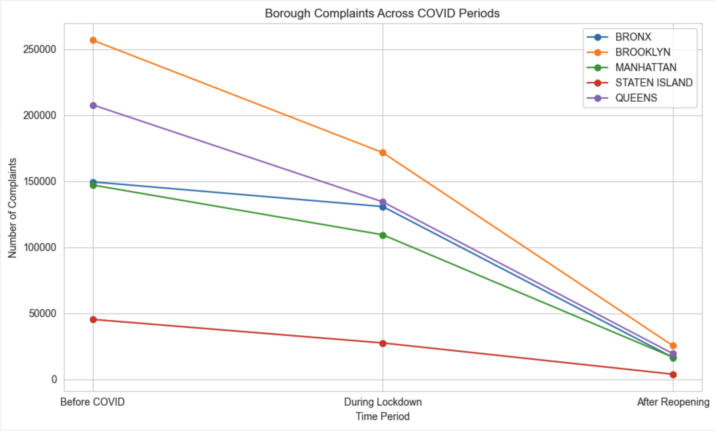

Agencies Receiving the Most Requests
The analysis of service requests by agencies provides insights into which governmental bodies were most engaged in addressing public concerns during the pandemic. The New York City Police Department (NYPD) consistently received the highest number of service requests across all periods. Before the lockdown, the NYPD handled 267,063 requests, reflecting its critical role in maintaining public safety and addressing community needs. This figure increased during the lockdown to 298,324 requests, indicating a surge in demand for police services as residents navigated the challenges of confinement and public health measures.
After the lockdown, the number of requests directed to the NYPD decreased to 39,611, yet it remained the agency with the highest service request volume. This trend underscores the NYPD's central role in managing public concerns, particularly during times of crisis. The data suggests that while the urgent needs of the community shifted over time, the NYPD remained a pivotal agency in addressing a wide range of service requests, highlighting the importance of law enforcement in public health emergencies.
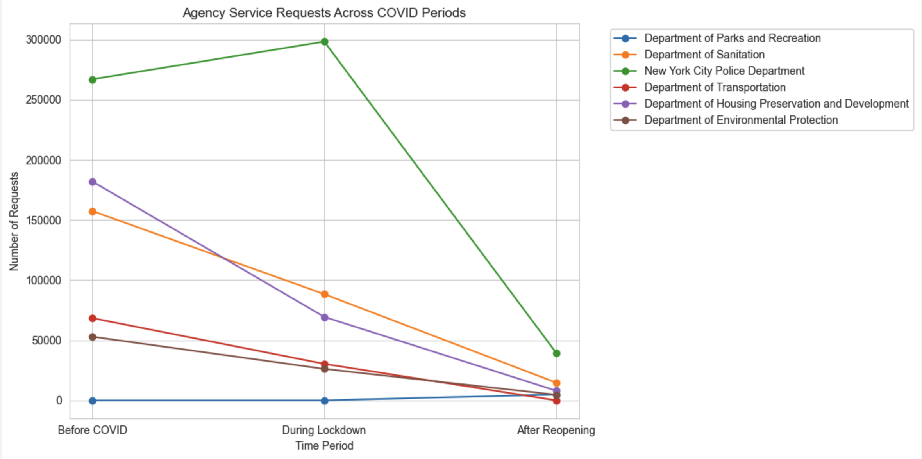

Conclusion
The analysis of COVID-19 service requests in New York City provides invaluable insights into the public's evolving needs during a critical period. The data reveals a marked decline in service requests during the lockdown, alongside shifts in the types of complaints made, illustrating how the pandemic influenced public priorities. Notably, Brooklyn emerged as the most affected borough, consistently leading in service requests before, during, and after the lockdown. The NYPD's role as the agency receiving the most requests further emphasizes the significance of law enforcement in addressing community concerns during the pandemic.
This report not only highlights the challenges faced by residents but also underscores the adaptability of public services in responding to the evolving landscape of community needs. As New York City continues to navigate the ongoing effects of COVID-19, the insights gleaned from this analysis can inform future public policy and resource allocation, ensuring that agencies are better equipped to address the diverse concerns of New Yorkers in times of crisis.

