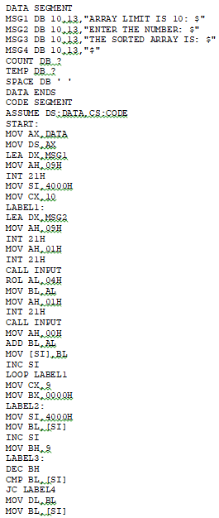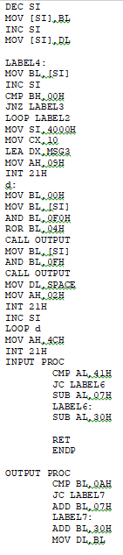

MOV AH,02H

INT 21H

RET

ENDP

CODE ENDS

END START

**OUTPUT**

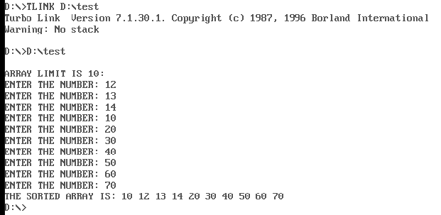

**Dscending**

**PROGRAM**

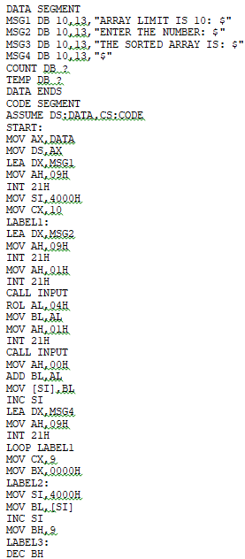 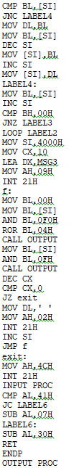

CMP BL,0AH

JC LABEL7

ADD BL,07H

LABEL7:

ADD BL,30H

MOV DL,BL

MOV AH,02H

INT 21H

RET

ENDP

CODE ENDS

END START

**OUTPUT**

