LAB0

Part 3

1.
Tp = T * Z /8 + T * (1 – Z) = (1- Z*7/8)*T
Pp = 1/Tp = (1/(1-Z*7/8))*(1/T)
So the performance is (1/(1-Z*7/8)) times the old one.

2.
0.5 : 1.78 times
0.7: 2.58 times
0.8: 3.3 times
0.9: 4.7 times
0.95: 5.9 times
0.99: 7.48 times

3.
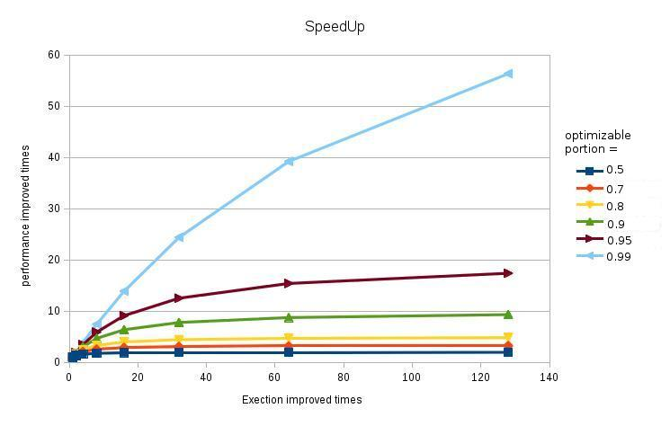
4.
In a naïve model, when executing time of the parallelised part being improve, the speedup will keep increasing and will infinite approach 1/(1-Z) times the original (Z is the parallelisable portion).

Part 2
0.96 * 1+ 0.04 * 0.75 * 4 + 0.04 * 0.25 * 50 = 1.58 ns
So the average access time is 1.58ns.
The average access time is 1.58 nanosecond.

