‘Design Your Home’ Planning Document

## Description:

For my Capstone Project, I will be building an interactive multimedia game where people can design a new home by selecting basic and extra options. During the experience they will be able to view model homes and the construction site. There are surprises along the way to make it a fun (or a frustrating) experience.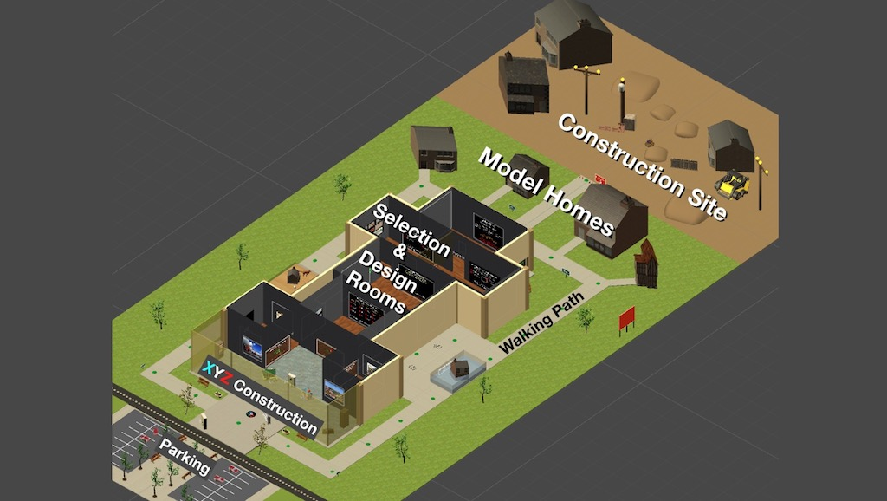

The viewer initially moves from the parking lot along a path to a street. While waiting to cross the street audio instructions are given. Once the street is crossed the viewer can choose to go around the building and see the outside of the building, model homes of the construction company, view the construction site or go inside the building. While walking around the building they will find some animated surprises along the way.

Once inside the building the viewer will have the option of going into one room to view a video for builder information, go to another room to view a 360 video to see construction workers a work or start the process of designing the home. The viewer will go into several rooms to select different options that a person would consider in designing a new home. At any part of the design process the viewer can decide to proceed or start over. At the end they can say they like their new home and leave the building.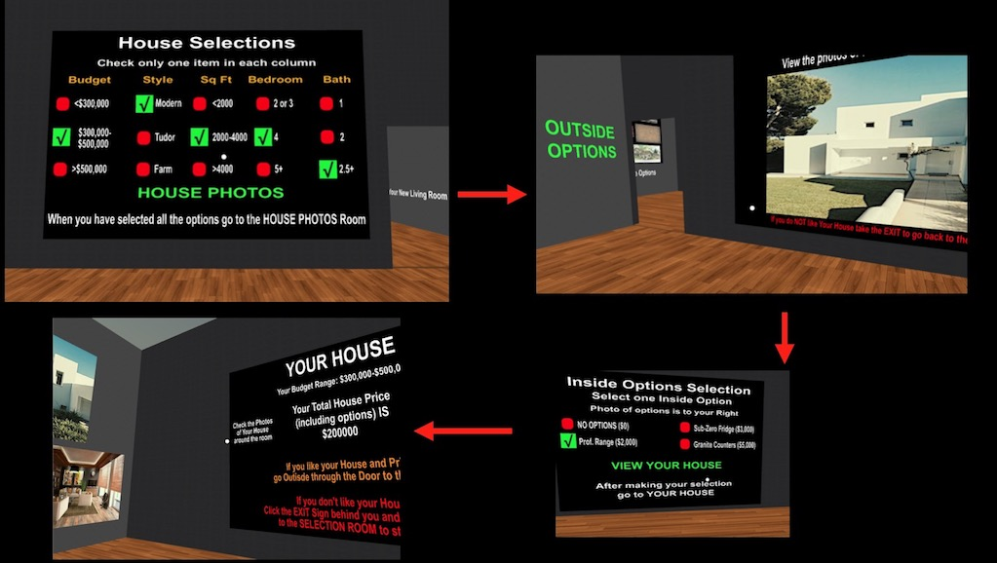

What they don’t know is that a lot of what happens in the design process is randomized. At each step of the way what is selected is whatever the randomizer decides to display, including the pictures of the newly designed home.

## Features And Dependencies:

### Design Your Home

* 1. Entry into the Home Selection room to start designing the home.
  2. Make a selection of five categories before previewing pictures in the next room: Budget, Style, SqFt, number of Bedrooms, number of Bathrooms. Use UI buttons for each option. Each category has to have one option selected before the option is displayed to go to the House Photos room.
  3. House Photos room displays random images for the house, living area and a bathroom. Go to the Outside Options room.
  4. Select one outside option before going to the Inside Options room. Use UI buttons for each option. One of them must be selected before option to go to the Inside Options section is displayed.
  5. Select one inside option before going to the Your House room to view your home and how much it will cost. Use UI buttons for each option. One of them must be selected before option to go to the Your House section is displayed.
  6. The Your House room displays the random pictures in the House Photos room. The panel that displays the house information only uses the Budget information from the House Selection room. The total house price is a random number between 200,000 and 600,000 in multiples of 50,000. The number of sq. ft., bedrooms and bathrooms are calculated based on the random price.
  7. At any point the person can click the Exit sign and return to the House Selection Room to start over. The system will step the viewer back through each room before ending up in the House Selection Room.
  8. If the person likes the design of the house they go outside by clicking the door to open. They will see a billboard where they see that the company builds castles with a random castle picture displayed.

### Other Effects

* 1. Waypoints are used to navigate around the building, in and out of the construction zone and returning to the parking lot.
  2. Area on the left has a group of animals as a warning to beware of them when you walk around. When you click a waypoint coming from either direction you hear a dog barking sound with the head of the dog moving.
  3. Area on the right has a house floating in water with a marketing message. When you click a waypoint coming from either direction you hear a water swimming sound.
  4. Particle Effects are to reward users when they approve their new home when they leave the building.
  5. Particle Effects are used for the piling machine in the construction zone when operating. Animation is used for the hammer capsule.
  6. A camera shake is used to simulate what happens during an explosion when the viewer clicks the waypoint entering the construction against the warning on the sign. The plan is to use the camera shake script from the Unity wiki page. A particle system is used to simulate smoke.
  7. Audio cues are used inside and outside of the building. Some automatically play while others are played using a media button.
  8. A haunted house shakes temporarily when the waypoint in front of it is clicked. An audio plays with the sounds of hell and the directional lights turn off.
  9. When the viewer crosses the street back to the parking lot waypoints appear if they decide they want to go back across the street. If they want to end the game they look down and see a text on the path.

Example Capstone Scoping

## Features And Dependencies:

### Design Your Home

* 1. Entry into the Home Selection room to start designing the home.
  2. Make a selection of five categories before previewing pictures in the next room: Budget, Style, SqFt, number of Bedrooms, number of Bathrooms. Use UI buttons for each option. Each category has to have one option selected before the option is displayed to go to the House Photos room. **Revised: Decided to use toggle groups to make it easier to determine when each category had an option selected.**
  3. House Photos room displays random images for the house, living area and a bathroom. Go to the Outside Options room.
  4. Select one outside option before going to the Inside Options room. Use UI buttons for each option. One of them must be selected before option to go to the Inside Options section is displayed. **Revised: Decided to use toggle groups to make it easier to determine when each category had an option selected.**
  5. Select one inside option before going to the Your House room to view your home and how much it will cost. Use UI buttons for each option. One of them must be selected before option to go to the Your House section is displayed. **Revised: Decided to use toggle groups to make it easier to determine when each category had an option selected.**
  6. The Your House room displays the random pictures in the House Photos room. The panel that displays the house information only uses the Budget information from the House Selection room. The total house price is a random number between 200,000 and 600,000 in multiples of 50,000. The number of sq. ft., bedrooms and bathrooms are calculated based on the random price.
  7. At any point the person can click the Exit sign and return to the House Selection Room to start over. The system will step the viewer back through each room before ending up in the House Selection Room. **Revised: I determined that there was an increased risk of simulation sickness if the viewer is stepped back too many steps. I decided to take the viewer quickly back to the House Selection room in a straight shot if they exited after the House Photos room.**
  8. If the person likes the design of the house they go outside by clicking the door to open. They will see a billboard where they see that the company builds castles with a random castle picture displayed.

### Other Effects

* 1. Waypoints are used to navigate around the building, in and out of the construction zone and returning to the parking lot.
  2. Area on the left has a group of animals as a warning to beware of them when you walk around. When you click a waypoint coming from either direction you hear a dog barking sound with the head of the dog moving.
  3. Area on the right has a house floating in water with a marketing message. When you click a waypoint coming from either direction you hear a water swimming sound.
  4. Particle Effects are to reward users when they approve their new home when they leave the building.
  5. Particle Effects are used for the piling machine in the construction zone when operating. Animation is used for the hammer capsule.
  6. A camera shake is used to simulate what happens during an explosion when the viewer clicks the waypoint entering the construction against the warning on the sign. The plan is to use the camera shake script from the Unity wiki page. **Revised: I abandoned my plan to use the script because as written it does not work well with VR from the research I have done. Since I plan to use iTween for moving around inside the building I will attempt to use one of the shaking functions to shake the camera.** A particle system is used to simulate smoke.
  7. Audio cues are used inside and outside of the building. Some automatically play while others are played using a media button. **Revised: The initial plan was to have intro audios in all rooms but decided to only have them in each main room and the House Photos room.**
  8. A haunted house shakes temporarily when the waypoint in front of it is clicked. An audio plays with the sounds of hell and the directional lights turn off.
  9. When the viewer crosses the street back to the parking lot waypoints appear if they decide they want to go back across the street. If they want to end the game they look down and see a text on the path.