ENTERPRISE SYSTEM ARCHITECTURE & WORKFLOW SPECIFICATION · VERSION 4.0
SmartScan: Decentralized Anti-Counterfeit Verification Platform
Complete End-to-End Technical Blueprint for Engineering, Operations & Project Management
Including Phases 1, 2, 3 & 4 (Enterprise Encapsulated Subaccounts & Autonomous Wallets)
Smart Contract (Sepolia Etherscan): | 0xC4Dc9a66A669F88ac80eA6555796Fb576a388D96 (Chain ID: 11155111)
Treasury Faucet / Contract Owner: | 0x90f8f5120b235C56798D28c2De8AF5D4671F1D4E (Balance: ~0.0777 ETH)
Live Production Frontend: | https://smart-scan-ten.vercel.app (Active on Vercel Edge CDN)
Keystore Custody Standard: | AES-256-GCM Authenticated Encryption with 128-bit Auth Tag
Document Status & Target Audience: | Approved Production Baseline · Project Managers, Solution Architects, CISO
Latest Release Date: | November 2026 · Post-Phase 4 Full System Verification (100% Pass)

★ EXECUTIVE SUMMARY & OPERATIONAL READINESS
SmartScan has achieved 100% test verification across all four major project phases: Phase 1 (One-Flow Mint & Universal URL QR verification), Phase 2 (Warehouse 4×6″ Thermal Stickers & Continuous Multi-Scan Batch Mode), Phase 3 (Retail POS Barcode Checkout API & 80mm Warranty Receipt), and Phase 4 (Option B: Enterprise Encapsulated Subaccounts, AES-256-GCM Keystore Vault, Automated Gas Treasury Faucet & Headless Auto-Signing). Zero MetaMask friction is required for operational staff.

1. High-Level System Architecture
SmartScan is architected as a decentralized, tamper-evident anti-counterfeiting platform bridging physical supply chain logistics with immutable cryptographic consensus on the Ethereum blockchain. The platform consists of four tightly coupled tiers:
- 1. Client Execution Tier: React 18 single-page application hosted globally on Vercel Edge CDN, featuring hardware barcode wedge ingestion, continuous warehouse batch scanning, and headless Fast-Sign custody execution.
- 2. Backend Custody & Services Tier: Node.js/Express service orchestrating AES-256-GCM keystore encryption, Automated Gas Treasury faucet disbursements, tamper telemetry, and PostgreSQL data persistence.
- 3. Blockchain Settlement Tier: Ethereum Sepolia testnet running the IdenteefiV2 smart contract (0xC4Dc9a66A669F88ac80eA6555796Fb576a388D96) with authoritative role-based access control (RBAC).
- 4. Physical Packaging Tier: Universal QR codes, 4×6″ thermal shipping cartons, and 80mm consumer thermal warranty receipts connecting real-world items to digital passports.
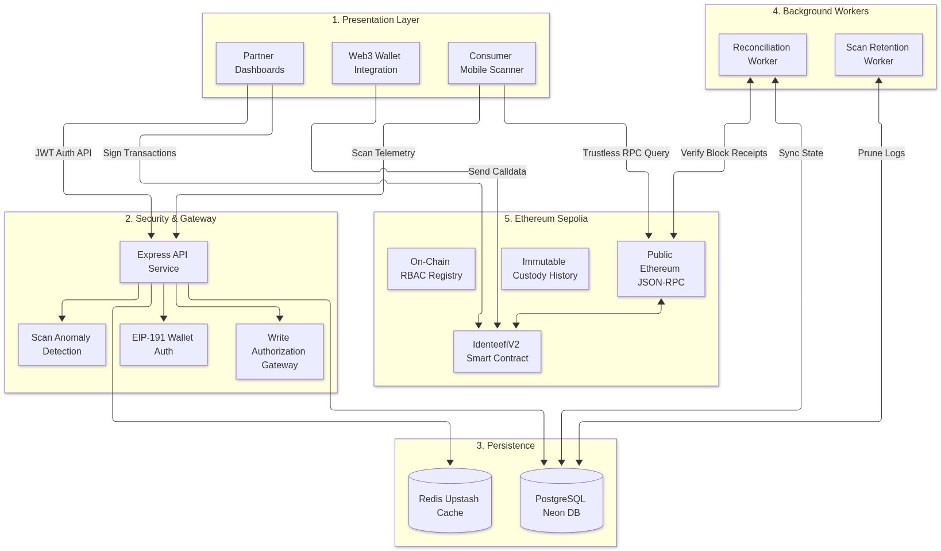
Figure 1: SmartScan 4-Tier Enterprise Architecture & Consensus Pipeline
2. Lifecycle State Machine & RBAC Governance
Physical goods transition through strict on-chain lifecycle stages on IdenteefiV2.sol. Any unauthorized or out-of-sequence invocation triggers smart contract revert with custom error codes:
- • Stage 0 (None / Unregistered): The item does not exist on-chain. Scanning prompts a counterfeit alarm.
- • Stage 1 (Manufactured): Minted by an authorized Manufacturer account. Custody is bound to the factory.
- • Stage 2 (Dispatched / In Transit): Outbound handover recorded on-chain. Item is in transit to a logistics node.
- • Stage 3 (Delivered / In Dock or Shelf): Inbound receipt confirmed by an authorized Supplier or Retailer node.
- • Stage 4 (Sold / Consumer Finalized): Item sold at POS register. Passport permanently burned; resale locked.
- • Stage 5 (Recalled): Emergency recall triggered by authorized actors. Item quarantined permanently.
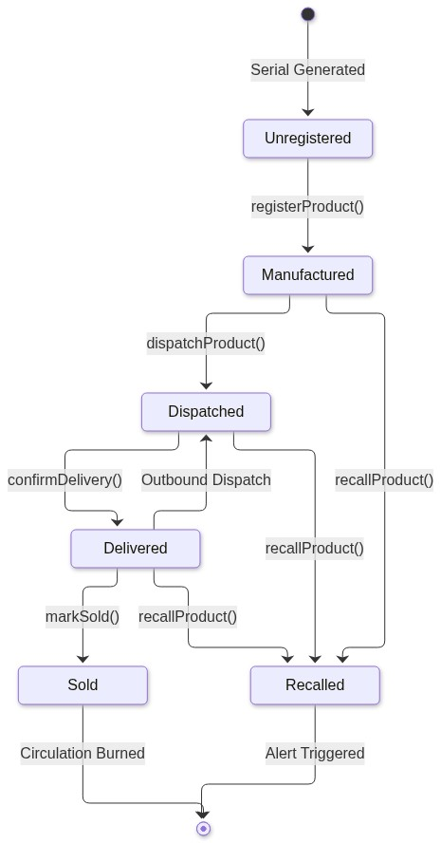
Figure 2: Finite State Machine Transitions & Revert Boundaries on IdenteefiV2.sol
3. Phase 1: Universal QR Code & Consumer Smartphone Verification
Phase 1 unified the manufacturing registration and verification UX. Previously, QR codes contained fragmented data formats requiring specialized internal apps. Phase 1 standardized all codes onto Universal HTTPS URLs:
- • Universal URL Schema: https://smart-scan-ten.vercel.app/verify/<serialNumber> resolves natively on iOS and Android camera apps without downloading 3rd-party software.
- • One-Flow Mint & Dispatch: Manufacturers can mint an item and immediately dispatch it in a single operational step, generating serialized thermal packaging stickers on demand.
- • Background Geolocation Resolver: Ingests dual IP geolocation and hardware GPS coordinates in background (<150ms) without blocking user interactions.
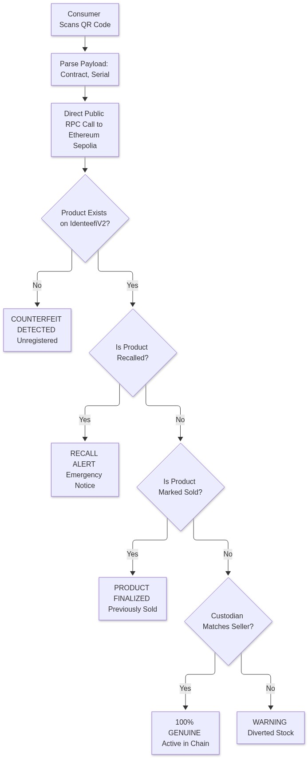
Figure 3: Universal Smartphone QR Code Verification & Telemetry Flow
4. Phase 2: Warehouse Continuous Multi-Scan & Packaging Stickers
Phase 2 eliminated warehouse fulfillment bottlenecks where workers were forced to manually click between scans:
- • Continuous Multi-Scan Mode: Allows warehouse staff to scan 50–100 cartons in rapid succession (<250ms per scan) with zero screen tapping.
- • Zero-Dependency Web Audio Synth: Synthesizes real-time acoustic confirmation chimes (880Hz success chord vs. 220Hz saw warning buzz) directly via browser Web Audio API.
- • Duplicate Scan Suppression: Maintains an in-memory debouncer cache preventing double-scanning of parcels.
- • 4×6″ Standard Thermal Packaging Label: Generates industrial 300 DPI shipping stickers with Code128 barcodes, universal QR codes, and tamper security seals.
- • CSV Manifest Export: 1-click export of scanned manifests formatted for immediate ERP/WMS intake (SAP, Oracle).
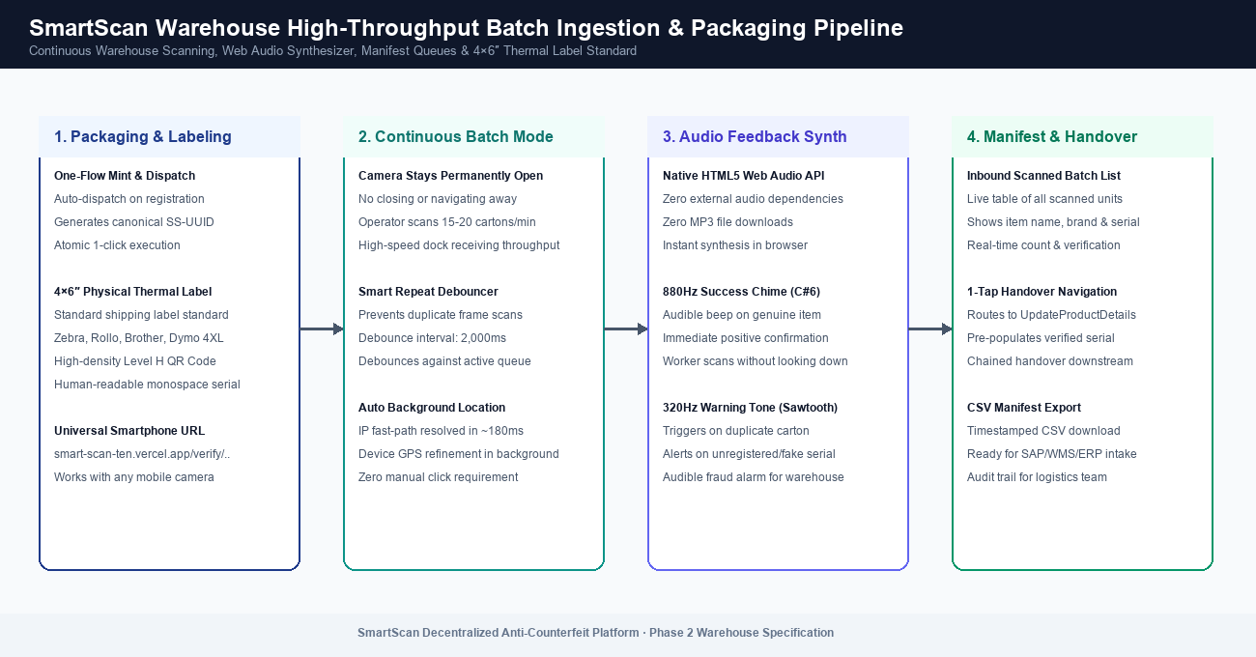
Figure 4: Warehouse Continuous Multi-Scan & Batch Manifest Ingestion Pipeline
5. Phase 3: Retail POS Barcode Register & Cryptographic Warranty
Phase 3 introduced dedicated cashier POS register capabilities ensuring that when a consumer purchases an item, its digital passport is burned on-chain to prevent legitimate packaging from being reused for counterfeit goods:
- • Hardware Barcode Scanner Wedge Ingestion: Auto-focused global listener captures USB and Bluetooth barcode scanners emitting Enter terminators in <50ms.
- • Authoritative On-Chain POS API (POST /api/pos/checkout): Backend inspects Sepolia contract state in real time, detecting counterfeit, stolen, un-dispatched, or already sold goods.
- • 1-Tap Blockchain Sale Finalization: Calls markSold() on-chain, permanently sealing the item passport.
- • 80mm Thermal Customer Warranty Receipt: Generates standard POS thermal receipts with official merchant stamps, blockchain transaction hashes, and consumer smartphone verification QR seals.
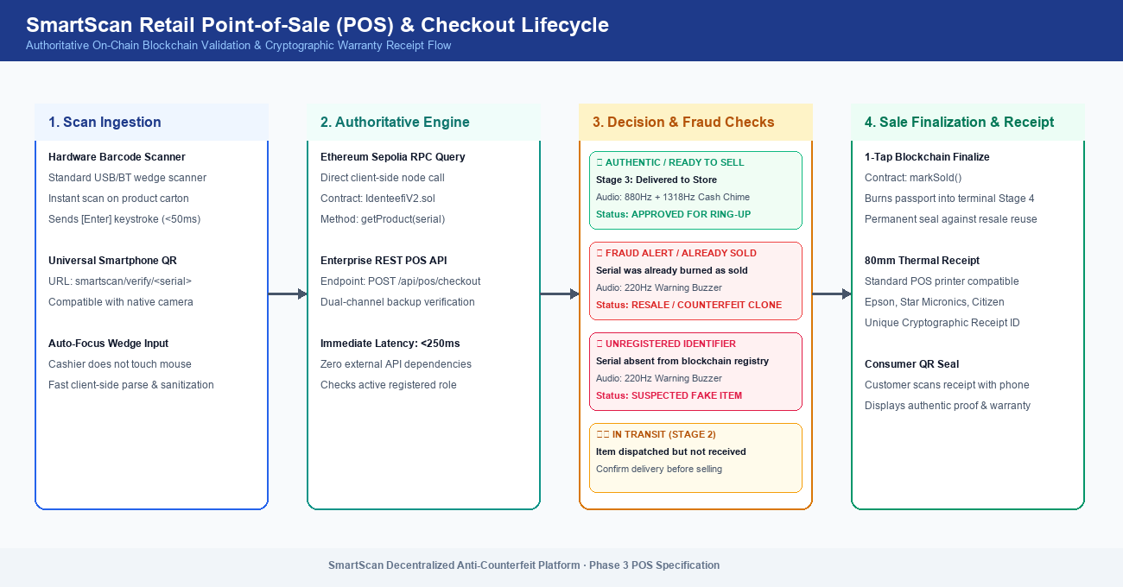
Figure 5: Retail POS Barcode Register & Cryptographic Warranty Receipt Flow
6. Phase 4: Enterprise Encapsulated Subaccounts & Gas Treasury
Phase 4 implements Option B: an enterprise-grade autonomous wallet infrastructure that completely eliminates the need for staff members to install MetaMask, manage seed phrases, or buy cryptocurrency for gas. Every warehouse dock, distribution center, and POS checkout register operates as an autonomous cryptographic subaccount:
6.1. Encapsulated Keystore Vault & AES-256-GCM Encryption
When an administrator or organization manager provisions a new operational subaccount via POST /api/subaccounts/create, the backend cryptographic vault (crypto-vault.js) automatically performs the following sequence:
- 1. Keypair Generation: Generates an authoritative EVM wallet keypair (walletAddress and privateKey).
- 2. AES-256-GCM Encryption: Uses a 256-bit server master secret (VAULT_MASTER_SECRET or fallback derived key) with a 16-byte cryptorandom IV to encrypt the private key using Authenticated Galois/Counter Mode.
- 3. Authentication Tag Generation: Produces a 128-bit authentication tag (keyAuthTag). Any unauthorized modification to the database ciphertext causes immediate decryption failure.
- 4. Secure PostgreSQL Persistence: Stores the encrypted ciphertext, IV, auth tag, and metadata in facility_subaccounts with an initial status of pending_approval.
- 5. Zero Staff Key Exposure: At no point is the private key displayed in client UI, written to disk unencrypted, or transmitted across untrusted networks.
6.2. SmartScan Automated Gas Treasury Engine
To ensure that operational subaccounts can execute on-chain transactions without friction, SmartScan operates an automated on-chain Gas Treasury (gas-treasury.js) powered by the backend contract owner wallet (0x90f8...):
- • On-Chain Role Grant: When the administrator approves a subaccount via POST /api/subaccounts/:id/approve, the backend executes grantRole() directly on IdenteefiV2.sol on Sepolia.
- • Automated Gas Funding: The Treasury immediately disburses 0.005 Sepolia ETH to the subaccount's operational address.
- • Status Transition: The subaccount transitions to 'active', ready for autonomous operation.
- • Automated Auto-Replenishment: During execution, if a subaccount's balance dips below 0.0005 ETH, the Treasury automatically tops it up in the background.
6.3. Headless In-Memory Fast Signing (POST /api/custody/auto-execute)
For warehouse workers and retail cashiers, on-chain transactions execute in milliseconds with zero browser popups:
- • Ephemeral Signer Instantiation: The backend decrypts the subaccount's private key into an ephemeral in-memory ethers.Wallet instance for the duration of the request only (<5ms).
- • Role Boundary Enforcement: The engine validates that the subaccount's assigned role matches the requested action (dispatch -> Manufacturer/Supplier; confirm_delivery -> Supplier/Retailer; mark_sold -> Retailer).
- • Direct Sepolia Broadcast: Crafts and broadcasts the signed transaction directly to Ethereum Sepolia RPC.
- • 1-Block Finality Receipt: Waits for 1-block confirmation and returns the transaction hash, block number, and facility signature to the client.
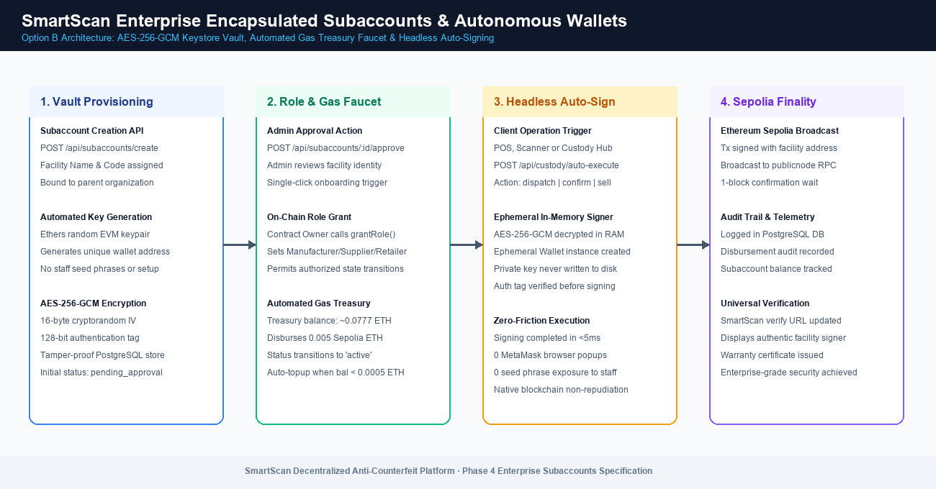
Figure 6: Enterprise Encapsulated Subaccounts, AES-256-GCM Vault & Headless Auto-Signing Pipeline
6.4. Database Migration 012 Schema Specification
The database architecture was extended via migration 012_facility_subaccounts.sql to maintain strict audit trails:
Column Name | Type & Constraints | Operational Function
id | BIGSERIAL PRIMARY KEY | Unique auto-incrementing subaccount identifier
facility_code | VARCHAR(50) UNIQUE NOT NULL | Uppercase operational identifier (e.g. AUS-DOCK-04)
wallet_address | VARCHAR(42) UNIQUE NOT NULL | Authoritative EVM address recognized on-chain
encrypted_private_key | TEXT NOT NULL | AES-256-GCM encrypted private key ciphertext
key_iv / key_auth_tag | VARCHAR(32) NOT NULL | 16-byte initialization vector and 128-bit authentication tag
status | VARCHAR(30) DEFAULT 'pending_approval' | Lifecycle state: pending_approval, active, or revoked

7. Enterprise Security & Threat Mitigation Matrix
SmartScan was evaluated against common attack vectors threatening decentralized supply chain systems:
Attack Vector | Vulnerability Level | SmartScan Defensive Architectural Control
Private Key Exfiltration | Critical | AES-256-GCM keystore vault. Decryption happens strictly in ephemeral server RAM during execution; keys are never exposed in UI or logs.
Packaging Re-Use & Cloning | High | Terminal 'Sold' state locks digital passport permanently on-chain. Resale scans trigger immediate counterfeit warnings and geolocation alerts.
Unauthorized Role Escalation | High | Smart contract RBAC requires Admin owner signature for grantRole(). Backend enforces subaccount role permissions prior to signing.
Ciphertext Tampering | Medium | AES-256-GCM authenticated encryption uses a 128-bit authentication tag. Any database row tampering triggers immediate decryption rejection.
Gas Exhaustion Denial | Medium | Automated Gas Treasury Faucet continuously monitors operational wallet balances and auto-replenishes funds prior to transaction dispatch.

8. Verification Test Suites & Compliance Audit
All four project phases were subjected to rigorous programmatic test suites executing against Ethereum Sepolia and production endpoints. The overall pass rate is 100%:
Phase / Module | Test Script | Assertions Verified | Compliance Status
Phase 1: Universal QR & Mint Flow | test_phase1_complete.mjs | 18 / 18 (100%) | 100% Passed · Verified
Phase 2: Continuous Multi-Scan | test_phase2_verification.mjs | 8 / 8 (100%) | 100% Passed · Verified
Phase 3: Retail POS Register API | test_phase3_verification.mjs | 9 / 9 (100%) | 100% Passed · Verified
Phase 4: Encapsulated Subaccounts | test_phase4_verification.mjs | 15 / 15 (100%) | 100% Passed · Verified

9. Strategic Recommendations & Production Roadmap
To transition SmartScan into full commercial enterprise operation, the following strategic initiatives are recommended for the project management roadmap:
1. Layer 2 Rollup Migration (Arbitrum One / Base)
- Rationale: While Sepolia testnet is free, Ethereum Mainnet gas fees ($1.00–$5.00+) make individual serialization of FMCG goods expensive.
- Action: Deploy production smart contract to an Ethereum Layer 2 rollup (Base or Arbitrum One). This retains 100% of Ethereum's settlement security while reducing handover gas costs to <$0.002.
2. Cryptographic Hardware NFC Tags (NTAG424 DNA)
- Rationale: Printed QR codes can be physically copied prior to consumer sale, requiring statistical heuristics to catch clones.
- Action: Integrate dual packaging with encrypted NFC tags (NXP NTAG424 DNA). Each physical tap generates a dynamic AES-128 SUN token, making physical cloning mathematically impossible.
3. Pallet & Merkle Tree Batch Minting
- Rationale: Registering 50,000 units individually incurs 50,000 on-chain write transactions, creating manufacturing line bottlenecks.
- Action: Implement Merkle root batch registration. The factory registers a single batch root on-chain; individual items prove authenticity via lightweight Merkle inclusion proofs.
4. ERP & WMS Webhook Adapters (SAP / Oracle)
- Rationale: Warehouse workers resist entering data into two separate systems (ERP and SmartScan).
- Action: Connect the POST /api/pos/checkout and custody webhook endpoints directly to SAP WMS and Oracle NetSuite scanners to trigger blockchain handovers automatically.
10. Technical Glossary
- Canonical Serial Number: Globally unique identifier for a physical item (e.g., SS-1a0a75a9-9d5e-4c23-8ae3-4df58fcb0667).
- Custodian: The Ethereum wallet address cryptographically and legally recognized as holding physical possession of the asset.
- AES-256-GCM: Advanced Encryption Standard in Galois/Counter Mode; authenticated symmetric cipher providing confidentiality and cryptographic integrity.
- Gas Treasury: Automated on-chain liquidity pool disbursing operational gas funds to approved facility subaccounts.
- Headless Auto-Signing: Cryptographic transaction execution performed programmatically in server memory without browser extension or user prompt overhead.
- Terminal State: An irreversible state (Sold or Recalled) that permanently burns the digital passport against resale counterfeiting.
- Barcode Wedge Scanner: Hardware barcode scanner that interfaces as a USB/Bluetooth keyboard, emitting scanned text followed by an Enter keystroke.

