**PROGRAM DOCUMENTATION**

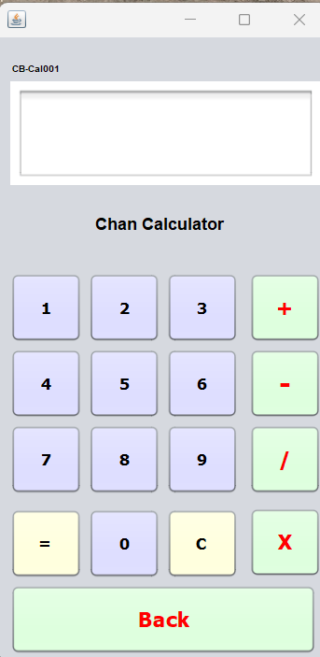**PROJECT DETAILS:**

**PROJECT NAME:** MyCalculator

**DEVELOPER:** CHRISTIAN BARBOSA BSIT-AI41

**PROGRAMMING LANGUAGE:** JAVA

**IDE:** APACHE NETBEANS IDE 18

**DATE-STARTED:** SEPTEMBER 02, 2023

**DATE-FINISHED:** SEPTEMBER 03, 2023

**LINKS:** <https://github.com/lightdarkmaster/Java_Calculator>

**FIRST-RELEASE:** SEPTEMBER 03, 2023

**Objectives:**

1. Develop a simple graphical calculator using java.
2. Perform basic operations (e.g., Addition, Subtraction, Multiplication and Division).
3. Apply Simple Graphical User Interface for the user.
4. Apply Object Oriented Programming Approach.

**Approach:**

1. Declare the Variables num1 and num2 as null and double as its data type.
2. Declare operators and set as null.
3. Create a new Jpanel.
4. Add buttons (0-9) operator buttons (e.g., +, -, /, *). Add back button and clear button.
5. Add label.
6. Add Text Area.
7. Use appropriate color pallets.
8. Add functions in each button.
9. In each number button keys ---get the value of the key pressed.
10. In operator button keys –get the value of the operation that will be apply.
11. Make the first input key as the value of num1 variable.
12. Get the value of the operator button and make it as the value of the operator variable.
13. After the operation set the second input as the value of the num2 variable.
14. Perform the operations in the two variables (num1 and num2).
15. Get the result of the operations and display it to the text area.
16. In the clear button –clear all the input and the output in the text area.
17. In the back button delete the last element in the text area.

**Sample Code Snippets / Logic Use:**

Source Code: <https://github.com/lightdarkmaster/Java_Calculator>

**Operator Logic**

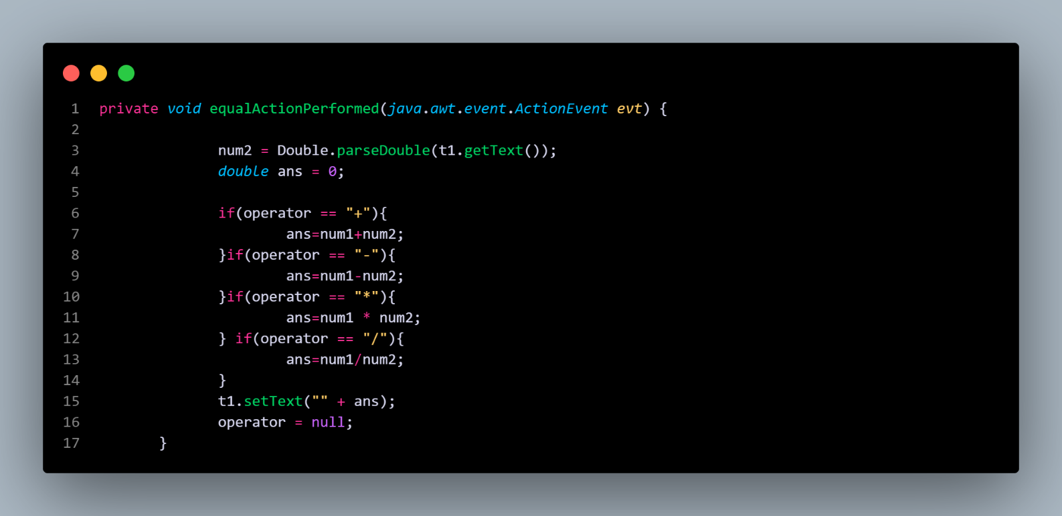

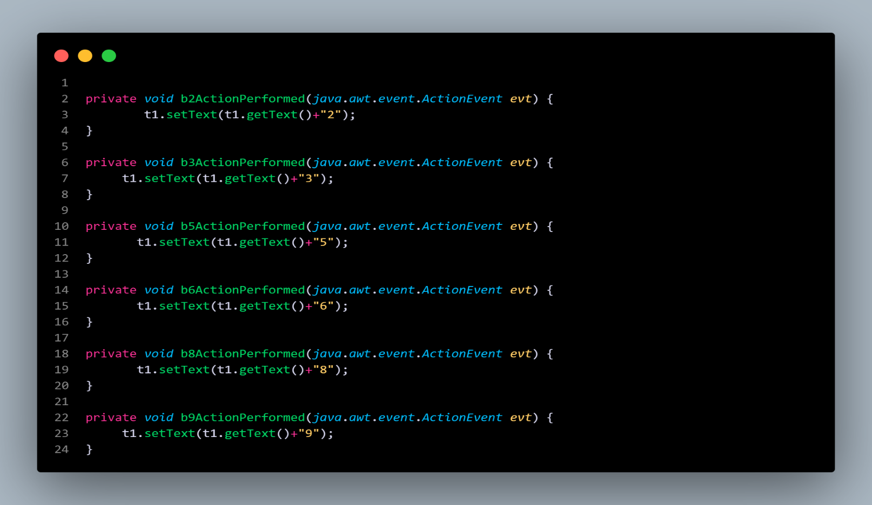**Getting the value of each button.**

**When App is Launch.**

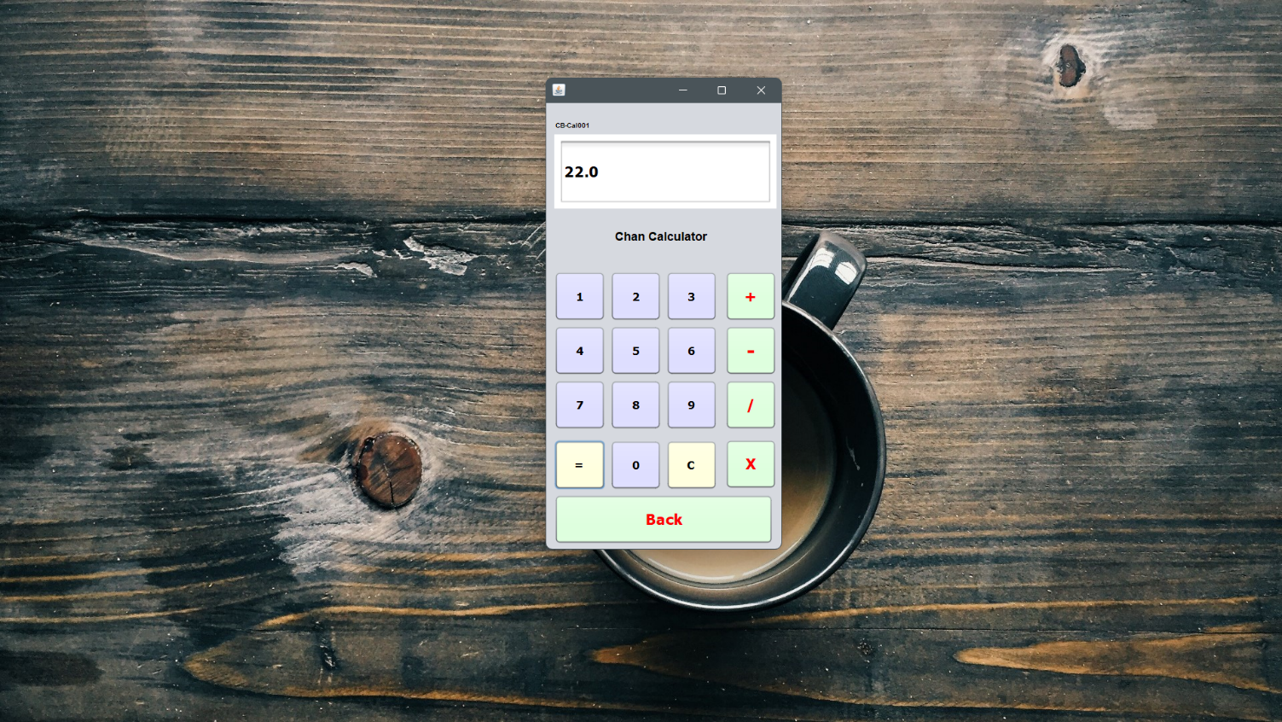

**THAT’S ALL THANK YOU!**