A PhD candidate from National Key Laboratory of Cognitive Neuroscience and Learning, Beijing Normal University, helped to preprocess some datasets as listed below. Source data was delivered at email by two times include PEBLpcpt.edf/PEBLtoav.edf which was recorded while doing PEBL tests both PCPT and TOAV, JRL helped recorded EO90_1.edf/ EO90_2.edf/ EO90_3.edf. She processed PEBLpcpt.edf, PEBLtoav.edf and EO90_3.edf. But due to format readability, I only have access to clear.set from EO90_3.edf and evaluate its effects below in Fig.1.
Fig.1 Two Fourier 3-D Representations of recorded EEG before and after removing artifacts: three dimensions
include experimental time, Fourier frequency and Fourier Coefficient in dB

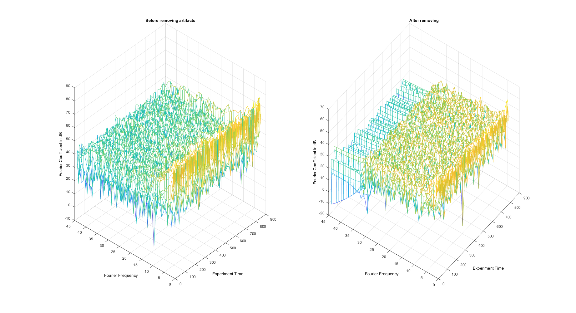

I also analyzed three subjects’ recording to remove artifacts and to see results include. JJH_RECORDINGS/2018/XXX/ 000/EOEC000_60.edf 001/openeyesclosedeyes60.edf 212/EO60EC60EO60.edf.

I also tried my way of processing some recordings from team members.
Take subject 961 as an example,
