**MINISTRY OF EDUCATION AND TRAINING**

**FPT UNIVERSITY**

Capstone Project Document

Football Pitches Booking

|  |  |
| --- | --- |
| **Group 10** | |
| **Group Members** | Nguyễn Duy Phương – SE60761 – [phuongndse60761@fpt.edu.vn](mailto:phuongndse60761@fpt.edu.vn)  Nguyễn Hữu Hoàng Giang – SE60606 – [giangnhhse60606@fpt.edu.vn](mailto:giangnhhse60606@fpt.edu.vn)  Nguyễn Đức Thịnh – 60398 – [thinhnd60398@fpt.edu.vn](mailto:thinhnd60398@fpt.edu.vn)  Nguyễn Quốc Khánh – 60556 – [khanhnq60556@fpt.edu.vn](mailto:khanhnq60556@fpt.edu.vn) |
| **Supervisor** | Lại Đức Hùng |
| **Ext Supervisor** |  |
| **Capstone Project code** | FPB |

- Ho Chi Minh, 01/2014 –

Table of Contents

Definitions, Acronyms, and Abbreviations 5

Report No.3: System Requirements Specifications (SRS) 6

3.1. User requirement specification 6

3.1.1. Guest: 6

3.1.2. Member: 6

3.1.3. Stadium Owner 6

3.1.4. Stadium Staff 6

3.1.5. Website Master 6

3.1.6. Website Staff 7

3.1.7. System 7

3.2. System requirement specification (Specific Requirements) 7

3.2.1. External Interface Requirements 7

3.2.2. Functional Requirements 8

3.2.3. Non-Functional Requirements 98

3.2.4. Entity Relationship Diagram 99

3.2.5. 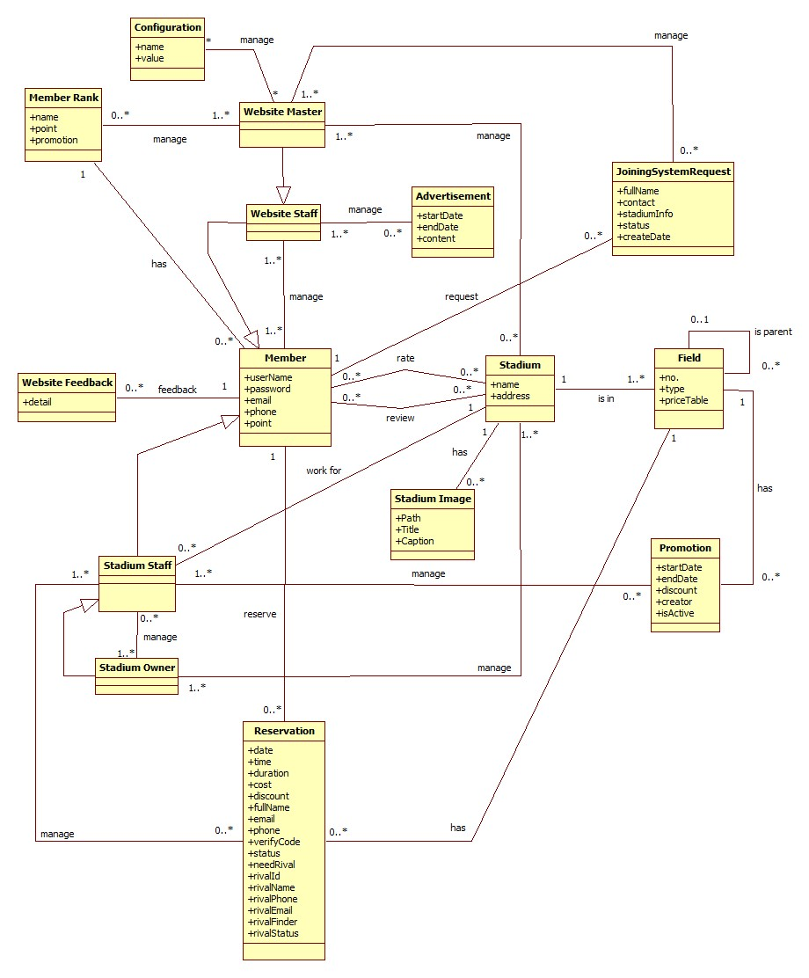 99

## Definitions, Acronyms, and Abbreviations

|  |  |  |
| --- | --- | --- |
| No. | Keyword | Definition |
| 1 | B2B2C | Stand for Business to business to customer.  In this system, first business is the organization that provides stadium owner to register their stadiums. The second business is stadium owner, who provides hire stadium service, and customer is the user, who want to hire field by this system. |
| 2 | FPB | Football Pitches Booking |
| 3 | ERD | Entity Relationship Diagram |
| 4 | API | Application Programmable Interface |
| 5 |  |  |

## System Requirements Specifications (SRS)

### User requirement specification

Football Pitches Booking is a website that allows customers to book field online. Beside that it helps the stadium owners with advertising football stadiums and managing reservation. In addition, the website enables its admin to manage customers and stadiums. More detail, the system should have list of features below:

#### Guest:

* Find and view the stadium’s detail
* Find available stadium at specific date, time and duration
* Find and view rival’s detail
* Register to become a member of website
* Login
* Recovery password

#### Member:

* Update account profile
* Book a field
* Cancel reservation
* View booking history
* Rate stadium
* Review stadium
* Feedback website
* Join rival
* Request for stadium to join into system
* Report user

#### Stadium Owner

* Update stadium profiles
* Manage fields of stadium:
  + Add field to stadium
  + Update field’s information
  + View list field of stadiums
  + View list of price tables
  + Create price table
  + Update price table

#### Stadium Staff

* Manage reservation of stadium:
  + Create new reservation
  + Edit reservation
  + List reservations
  + Approve reservation
  + Decline reservation
* Manage promotion of stadium
  + List promotions
  + Create promotion
  + Edit promotion

#### Website Master

* Manage stadium:
  + List join system requests
  + Handle join system request
  + List stadiums
  + Edit stadium
  + Create stadium
* Manage rank
  + List ranks
  + Edit rank
  + Create rank
* Manage configuration
  + Update configuration value

#### Website Staff

* Manage advertising
  + List advertising
  + Create advertising
  + Edit advertising
  + Delete advertising
* Manage user
  + List users
  + Edit user
  + Punish user

#### System

* Suggest Stadium
* Suggest Rival

### System requirement specification (Specific Requirements)

#### External Interface Requirements

##### User Interfaces

* The interface of website is simple and friendly
* Main function with multistep should be careful note, easy to understand
  + - 1. Hardware Interfaces

N/A

##### System Interfaces

N/A

##### Communications Protocol

Website using HTTP protocol for communication with the web browser and the web server

#### Functional Requirements

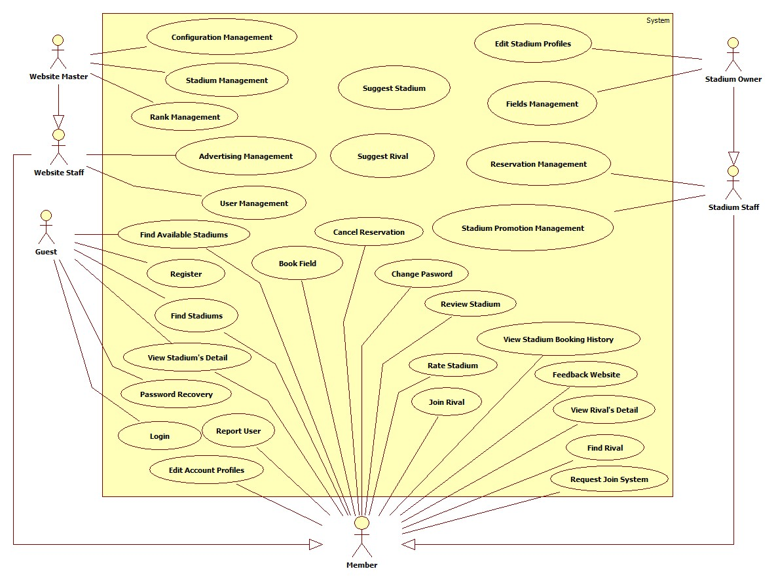

Figure 2: Use Case Summary

##### Stadium Management

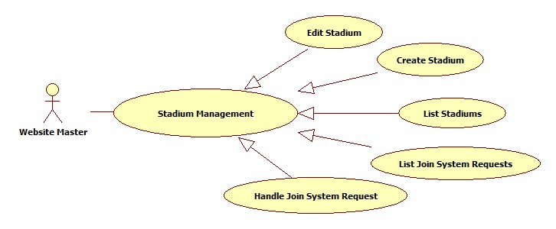

Figure 3: Stadium Management

###### List Stadiums

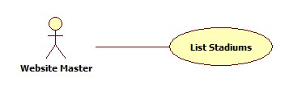

Figure 4: List Stadiums

|  |  |  |  |  |
| --- | --- | --- | --- | --- |
| **USE CASE-001 SPECIFICATION** | | | | |
| **Use-case No.** | UC_001 | **Use-case Version** | | 1.0 |
| **Use-case Name** | List Stadium | | | |
| **Author** | KhánhNQ | | | |
| **Date** | 12/02/2014 | **Priority** | High | |
| **Actor:**  Website Master  **Summary:**  This use case describes how to see list of stadiums  **Goal:**  List all stadiums in website  **Triggers:**  Actor goes to “Quản lý sân bóng” page  **Preconditions:**  Login as Website Master  **Post-conditions:**  N/A  **Main Success Scenario:**   |  |  |  | | --- | --- | --- | | Step | Actor Action | System Response | | 1 | Enter “Quản lý sân bóng” page | Display list of stadiums |   **Alternative Scenario:**  N/A  **Exceptions:**  N/A  **Relationships:**  N/A  **Business Rules:**  N/A | | | | |

###### Create Stadium

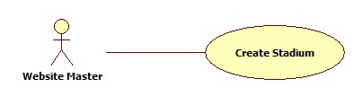

Figure 5: Create Stadium

|  |  |  |  |  |
| --- | --- | --- | --- | --- |
| **USE CASE-002 SPECIFICATION** | | | | |
| **Use-case No.** | UC_002 | **Use-case Version** | | 1.0 |
| **Use-case Name** | Create Stadium | | | |
| **Author** | KhánhNQ | | | |
| **Date** | 12/02/2014 | **Priority** | High | |
| **Actor:**  Website Master  **Summary:**  This use case describes how to create a stadium in website  **Goal:**  Create a stadium in website  **Triggers:**  Actor clicks on “Lưu” button after enter new stadium’s information  **Preconditions:**  Login as Website Master  **Post-conditions:**  N/A  **Main Success Scenario:**   |  |  |  | | --- | --- | --- | | Step | Actor Action | System Response | | 1 | Click “Thêm sân bóng” | The system will respond to “Thêm sân bóng” page | | 2 | Enter information of stadium. Click on “Lưu” button to finish | Display successful message |   **Alternative Scenario:**     |  |  | | --- | --- | | Actor Action | System Response | | Click on “Hủy bỏ” button to cancel | System will transfer to “Quản lý sân bóng” page |   **Exceptions:**  N/A  **Relationships:**  N/A  **Business Rules:**  N/A | | | | |

###### Edit Stadium

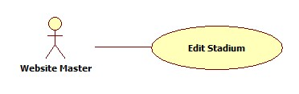

Figure 6: Edit Stadium

|  |  |  |  |  |
| --- | --- | --- | --- | --- |
| **USE CASE-003 SPECIFICATION** | | | | |
| **Use-case No.** | UC_003 | **Use-case Version** | | 1.0 |
| **Use-case Name** | Edit Stadium | | | |
| **Author** | KhánhNQ | | | |
| **Date** | 12/02/2014 | **Priority** | High | |
| **Actor:**  Website Master  **Summary:**  This use case describes how to edit information of a stadium  **Goal:**  View and change stadium’s information  **Triggers:**  Actor clicks on “Lưu” button after edit stadium’s information  **Preconditions:**  Login as Website Master  **Post-conditions:**  N/A  **Main Success Scenario:**   |  |  |  | | --- | --- | --- | | Step | Actor Action | System Response | | 1 | Click on “Chỉnh sửa” link of the stadium that actor wants to edit | Display stadium’s information | | 2 | Enter stadium’s information  Click on “Cập nhật” button to save new information | Display successful message |   **Alternative Scenario:**     |  |  | | --- | --- | | Actor Action | System Response | | Click on “Hủy bỏ” button to cancel | System will discard all recent action and transfer to “Quản lý sân bóng” page |   **Exceptions:**  N/A  **Relationships:**  N/A  **Business Rules:**  N/A | | | | |

###### List Join System Requests

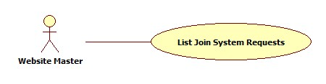

Figure 7: List Join System Requests

|  |  |  |  |  |
| --- | --- | --- | --- | --- |
| **USE CASE-004 SPECIFICATION** | | | | |
| **Use-case No.** | UC_004 | **Use-case Version** | | 1.0 |
| **Use-case Name** | List Join System Request | | | |
| **Author** | KhánhNQ | | | |
| **Date** | 12/02/2014 | **Priority** | High | |
| **Actor:**  Website Master  **Summary:**  This use case describes how to view the list of join system request.  **Goal:**  view the list of join system request  **Triggers:**  Actor enters “Yêu cầu tham gia” page  **Preconditions:**  Login as Website Master  **Post-conditions:**  N/A  **Main Success Scenario:**   |  |  |  | | --- | --- | --- | | Step | Actor Action | System Response | | 1 | Click on “Yêu cầu tham gia” to enter “Quản lý yêu cầu tham gia hệ thống” page | Display the list of join sysmte request |   **Alternative Scenario:**  N/A  **Exceptions:**  N/A  **Relationships:**  N/A  **Business Rules:**  N/A | | | | |

###### Handle Join System Request

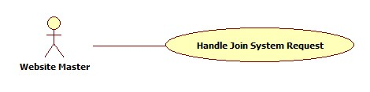

Figure 8: Handle Join System Request

|  |  |  |  |  |
| --- | --- | --- | --- | --- |
| **USE CASE-005 SPECIFICATION** | | | | |
| **Use-case No.** | UC_005 | **Use-case Version** | | 1.0 |
| **Use-case Name** | Handle Join System Request | | | |
| **Author** | KhánhNQ | | | |
| **Date** | 12/02/2014 | **Priority** | High | |
| **Actor:**  Website Master  **Summary:**  This use case describes how to handle join system request  **Goal:**  Handle request to join system  **Triggers:**  Actor clicks on “Cập nhật” button  **Preconditions:**  Login as Website Master  **Post-conditions:**  N/A  **Main Success Scenario:**   |  |  |  | | --- | --- | --- | | Step | Actor Action | System Response | | 1 | Click on “Chỉnh sửa” link of this request | View request’s detail | | 2 | Chose an option in “Trạng thái xử lý” combo box Click on “Cập nhật” button | Display successful message |   **Alternative Scenario:**   |  |  | | --- | --- | | Actor Action | System Response | | Click on “Hủy bỏ” button to cancel | Redirect to “Quản lý yêu cầu tham gia hệ thống” page |   **Exceptions:**  N/A  **Relationships:**  N/A  **Business Rules:**  N/A | | | | |

##### Configuration Management

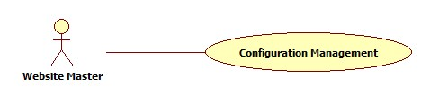

Figure 9: Configuration Management

|  |  |  |  |  |
| --- | --- | --- | --- | --- |
| **USE CASE-06 SPECIFICATION** | | | | |
| **Use-case No.** | UC_06 | **Use-case Version** | | 1.0 |
| **Use-case Name** | Configuration Management | | | |
| **Author** | KhanhNQ | | | |
| **Date** | 12/02/2014 | **Priority** | High | |
| **Actor:**  Website Master  **Summary:**  This use case describes how change the value of priorty norm for suggesting stadium or rival  **Goal:**  Edit value of configuration  **Triggers:**  Click “Lưu” button  **Preconditions:**  Login as Website Master  **Post-conditions:**    **Main Success Scenario:**   |  |  |  | | --- | --- | --- | | Step | Actor Action | System Response | | 1 | Enter quản “Quản lý gợi ý sân bóng” page | Display charts of priorty and value | | 2 | Drag the point to change value of priority Click on “Lưu” button | Display successful message |   **Alternative Scenario:**  N/A  **Exceptions:**  N/A  **Relationships:**  N/A  **Business Rules:**  N/A | | | | |

##### Advertising Management

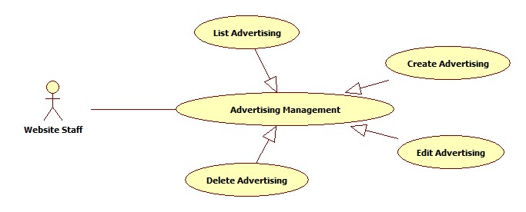

Figure 10: Advertising Management

###### List Advertisings

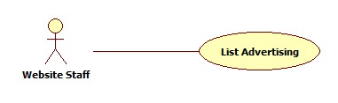

Figure 11: List Advertisings

|  |  |  |  |  |
| --- | --- | --- | --- | --- |
| **USE CASE-007 SPECIFICATION** | | | | |
| **Use-case No.** | UC_007 | **Use-case Version** | | 1.0 |
| **Use-case Name** | List Advertisings | | | |
| **Author** | KhanhNQ | | | |
| **Date** | 12/02/2014 | **Priority** | High | |
| **Actor:**  Website Master, Website Staff  **Summary:**  This use case describes how to see the list of advertisings in website  **Goal:**  See all advertisings  **Triggers:**  Actor goes to “Quảng cáo” page  **Preconditions:**  Login as Website Master or Website Staff  **Post-conditions:**    **Main Success Scenario:**   |  |  |  | | --- | --- | --- | | Step | Actor Action | System Response | | 1 |  | Display list of advertisings in system |   **Alternative Scenario:**  N/A  **Exceptions:**  N/A  **Relationships:**  N/A  **Business Rules:**  N/A | | | | |

###### Create Advertising

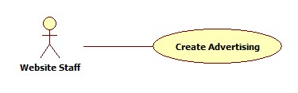

Figure 12: Create Advertising

|  |  |  |  |  |
| --- | --- | --- | --- | --- |
| **USE CASE-008 SPECIFICATION** | | | | |
| **Use-case No.** | UC_008 | **Use-case Version** | | 1.0 |
| **Use-case Name** | Create Advertising | | | |
| **Author** | KhanhNQ | | | |
| **Date** | 12/02/2014 | **Priority** | High | |
| **Actor:**  Website Staff, Website Master  **Summary:**  This use case describes how to create a new advertising in website  **Goal:**  Create advertising in Website  **Triggers:**  Actor clicks on “Thêm quảng cáo” button to create new advertising in website  **Preconditions:**  Login as Website Master or Website Staff  **Post-conditions:**    **Main Success Scenario:**   |  |  |  | | --- | --- | --- | | Step | Actor Action | System Response | | 1 | Click on “Thêm quảng cáo” | The system will respond to “Thêm quảng cáo” page | | 2 | Enter information of this advertising  Click “Lưu” button | Display successful message |   **Alternative Scenario:**   |  |  | | --- | --- | | Actor Action | System Response | | Click on “Hủy” button to cancel | System will transfer to “Quản lý quảng cáo” page |   **Exceptions:**  N/A  **Relationships:**  N/A  **Business Rules:**  N/A | | | | |

###### Edit Advertising

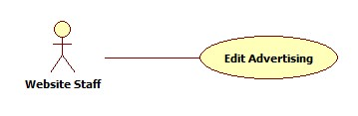

Figure 13: Edit Advertising

|  |  |  |  |  |
| --- | --- | --- | --- | --- |
| **USE CASE-009 SPECIFICATION** | | | | |
| **Use-case No.** | UC_009 | **Use-case Version** | | 1.0 |
| **Use-case Name** | Edit Advertising | | | |
| **Author** | KhanhNQ | | | |
| **Date** | 12/02/2014 | **Priority** | High | |
| **Actor:**  Website Master, Website Staff  **Summary:**  This use case describes how edit an advertising  **Goal:**  View and change Advertising’s information  **Triggers:**  Actor clicks on “Lưu” button after edit advertising’s information  **Preconditions:**  Login as Website Master or Website Staff  **Post-conditions:**  N/A  **Main Success Scenario:**   |  |  |  | | --- | --- | --- | | Step | Actor Action | System Response | | 1 | Click on “Chỉnh sửa” link of the advertising which will be edited | The system will show the “Chỉnh sửa thông tin quảng cáo” Page | | 2 | Update advertising’s information  Click “Lưu” button | Display successful message |   **Alternative Scenario:**   |  |  | | --- | --- | | Actor Action | System Response | | Click on “Hủy” button to cancel | System will transfer to “Quản lý quảng cáo” page |   **Exceptions:**  N/A  **Relationships:**  N/A  **Business Rules:**  N/A | | | | |

##### User Management

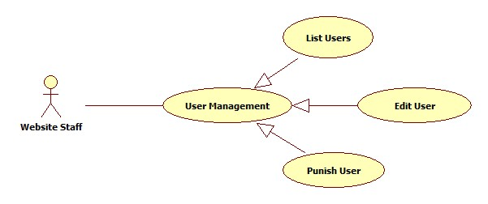

Figure 14: User Management

###### List Users

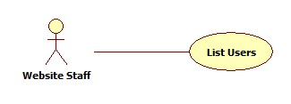

Figure 15: List Users

|  |  |  |  |  |
| --- | --- | --- | --- | --- |
| **USE CASE-010 SPECIFICATION** | | | | |
| **Use-case No.** | UC_010 | **Use-case Version** | | 1.0 |
| **Use-case Name** | List Users | | | |
| **Author** | KhanhNQ | | | |
| **Date** | 12/02/2014 | **Priority** | High | |
| **Actor:**  Website Staff, Website Master  **Summary:**  This use case describes how to see all users in website  **Goal:**  See all Users in website  **Triggers:**  Actor go to User Management page  **Preconditions:**  Login as Website Master or Website Staff  **Post-conditions:**  N/A  **Main Success Scenario:**   |  |  |  | | --- | --- | --- | | Step | Actor Action | System Response | | 1 |  | Display all users in system |   **Alternative Scenario:**  N/A  **Exceptions:**  N/A  **Relationships:**  N/A  **Business Rules:**  N/A | | | | |

###### Edit User

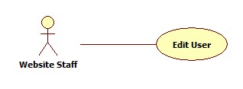

Figure 16: Edit User

|  |  |  |  |  |
| --- | --- | --- | --- | --- |
| **USE CASE-011 SPECIFICATION** | | | | |
| **Use-case No.** | UC_011 | **Use-case Version** | | 1.0 |
| **Use-case Name** | Edit User | | | |
| **Author** | KhanhNQ | | | |
| **Date** | 12/02/2014 | **Priority** | High | |
| **Actor:**  Website Staff, Website Master  **Summary:**  This use case describes how to edit user’s information  **Goal:**  View and change user’s information  **Triggers:**  Actor clicks on “Chỉnh sửa” link of the user which will be edited  **Preconditions:**  N/A  **Post-conditions:**  N/A  **Main Success Scenario:**   |  |  |  | | --- | --- | --- | | Step | Actor Action | System Response | | 1 | clicks on “Chỉnh sửa” link of the user which will be edited | The system will show the User’s Information Page | | 2 | Update information  Click on “Lưu” button to save information | Display successful message |   **Alternative Scenario:**   |  |  | | --- | --- | | Actor Action | System Response | | Click on “Hủy bỏ” button | System will transfer to “Thành viên” page |   **Exceptions:**  User login as Website Staff cannot edit information of other website staff or website master.  **Relationships:**  N/A  **Business Rules:**  N/A | | | | |

###### Punish User

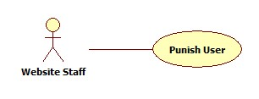

Figure 17: Punish User

|  |  |  |  |  |
| --- | --- | --- | --- | --- |
| **USE CASE-012 SPECIFICATION** | | | | |
| **Use-case No.** | UC_012 | **Use-case Version** | | 1.0 |
| **Use-case Name** | Punish User | | | |
| **Author** | KhanhNQ | | | |
| **Date** | 12/02/2014 | **Priority** | High | |
| **Actor:**  Website Staff, Website Master  **Summary:**  This use case describes how to punish an user  **Goal:**  Punish an user  **Triggers:**  Actor clicks “Cập nhật” button after choosing “Cấm hoạt động” option of the “Trạng thái hoạt động” drop down list.  **Preconditions:**  Login as Website Master or Website Staff  **Post-conditions:**  N/A  **Main Success Scenario:**   |  |  |  | | --- | --- | --- | | Step | Actor Action | System Response | | 1 | Chooses “Cấm hoạt động” option in the “Trạng thái hoạt động” drop down list |  | | 2 | Click “Lưu” button | Show successful message |   **Alternative Scenario:**     |  |  | | --- | --- | | Actor Action | System Response | | Click on “Hủy bỏ” button to cancel | Redirect to “Thành viên” page |   **Exceptions:**  User login as Website Staff cannot deactivate the other website staff or website master.  **Relationships:**  N/A  **Business Rules:**  N/A | | | | |

##### Rank Management

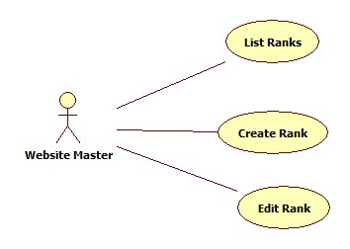

Figure 18: Rank Management

###### List Ranks

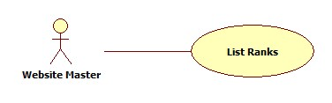

Figure 19: List Ranks

|  |  |  |  |  |
| --- | --- | --- | --- | --- |
| **USE CASE-013 SPECIFICATION** | | | | |
| **Use-case No.** | UC_013 | **Use-case Version** | | 1.0 |
| **Use-case Name** | List Ranks | | | |
| **Author** | ThinhND | | | |
| **Date** | 12/02/2014 | **Priority** | High | |
| **Actor:**  Website Master  **Summary:**  This use case describes how to view list of ranks  **Goal:**  List all ranks  **Triggers:**  Actor enter “Quản lý cấp độ thành viên” page  **Preconditions:**  Login as Website Master  **Post-conditions:**  N/A  **Main Success Scenario:**   |  |  |  | | --- | --- | --- | | Step | Actor Action | System Response | | 1 | Enter “Quản lý cấp độ thành viên” page | Display list of all ranks |   **Alternative Scenario:**  N/A  **Exceptions:**  N/A  **Relationships:**  N/A  **Business Rules:**  N/A | | | | |
|  | | | | |

###### Create Rank

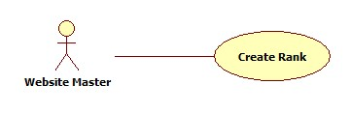

Figure 20: Create Rank

|  |  |  |  |  |
| --- | --- | --- | --- | --- |
| **USE CASE-014 SPECIFICATION** | | | | |
| **Use-case No.** | UC_014 | **Use-case Version** | | 1.0 |
| **Use-case Name** | Create Rank | | | |
| **Author** | ThinhND | | | |
| **Date** | 12/02/2014 | **Priority** | High | |
| **Actor:**  Website Master  **Summary:**  This use case describes how to edit stadium’s profiles  **Goal:**  Create new rank  **Triggers:**  Actor clicks on “Lưu” button  **Preconditions:**  Login as Website Master  **Post-conditions:**  N/A  **Main Success Scenario:**   |  |  |  | | --- | --- | --- | | Step | Actor Action | System Response | | 1 | Click on “Tạo cấp độ mới” link in “Quản lý cấp độ thành viên” | Display create rank form | | 2 | Enter new rank’s information  Click “Cập nhật” button | Display successful message |   **Alternative Scenario:**   |  |  | | --- | --- | | Actor Action | System Response | | Click on “Hủy bỏ” button | Discard all recent action and redirect to “Quản lý cấp độ thành viên” page |   **Exceptions:**  N/A  **Relationships:**  N/A  **Business Rules:**  N/A | | | | |

###### Edit Rank



Figure 21: Edit Rank

|  |  |  |  |  |
| --- | --- | --- | --- | --- |
| **USE CASE-015 SPECIFICATION** | | | | |
| **Use-case No.** | UC_015 | **Use-case Version** | | 1.0 |
| **Use-case Name** | Edit Rank | | | |
| **Author** | ThinhND | | | |
| **Date** | 12/02/2014 | **Priority** | High | |
| **Actor:**  Stadium Owner  **Summary:**  This use case describes how to edit user rank  **Goal:**  Edit rank  **Triggers:**  Actor clicks on “Lưu” button  **Preconditions:**  Login as Website Staff  **Post-conditions:**  N/A  **Main Success Scenario:**   |  |  |  | | --- | --- | --- | | Step | Actor Action | System Response | | 1 | Click on “Chỉnh sửa” link of the rank which will be edited | Display edit rank form with filled information | | 2 | Enter new information of rank  Click “Lưu” button | Display successful message |   **Alternative Scenario:**   |  |  | | --- | --- | | Actor Action | System Response | | Click on “Hủy bỏ” button | Discard all recent action and redirect to “Quản lý hệ thống cấp bậc thành viên” page |   **Exceptions:**  N/A  **Relationships:**  N/A  **Business Rules:**  N/A | | | | |

|  |  |  |  |  |
| --- | --- | --- | --- | --- |
| **USE CASE-016 SPECIFICATION** | | | | |
| **Use-case No.** | UC_016 | **Use-case Version** | | 1.0 |
| **Use-case Name** | Edit Stadium’s Profile | | | |
| **Author** | ThinhND | | | |
| **Date** | 12/02/2014 | **Priority** | High | |
| **Actor:**  Stadium Owner  **Summary:**  This use case describes how to edit stadium’s profiles  **Goal:**  Edit information of stadium  **Triggers:**  Actor clicks on “Cập nhật” button  **Preconditions:**  Login as Stadium Owner  **Post-conditions:**  N/A  **Main Success Scenario:**   |  |  |  | | --- | --- | --- | | Step | Actor Action | System Response | | 1 | Click on “Chỉnh sửa” link of the stadium which will be edited | Display Edit form with filled information | | 2 | Enter new information of stadium  Click “Cập nhật” button | Update new profiles for this stadium |   **Alternative Scenario:**   |  |  | | --- | --- | | Actor Action | System Response | | Click on “Hủy bỏ” button | Discard all recent action and redirect to “Quẩn lý sân bóng” page |   **Exceptions:**  N/A  **Relationships:**  N/A  **Business Rules:**  N/A | | | | |

##### Edit Stadium’s Profile

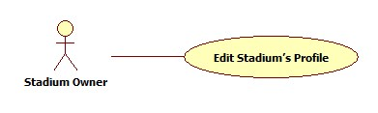

Figure 22: Edit Stadium's Profile

|  |  |  |  |  |
| --- | --- | --- | --- | --- |
| **USE CASE-016 SPECIFICATION** | | | | |
| **Use-case No.** | UC_016 | **Use-case Version** | | 1.0 |
| **Use-case Name** | Edit Stadium’s Profile | | | |
| **Author** | ThinhND | | | |
| **Date** | 12/02/2014 | **Priority** | High | |
| **Actor:**  Stadium Owner  **Summary:**  This use case describes how to edit stadium’s profiles  **Goal:**  Edit information of stadium  **Triggers:**  Actor clicks on “Cập nhật” button  **Preconditions:**  Login as Stadium Owner  **Post-conditions:**  N/A  **Main Success Scenario:**   |  |  |  | | --- | --- | --- | | Step | Actor Action | System Response | | 1 | Click on “Chỉnh sửa” link of the stadium which will be edited | Display Edit form with filled information | | 2 | Enter new information of stadium  Click “Cập nhật” button | Update new profiles for this stadium |   **Alternative Scenario:**   |  |  | | --- | --- | | Actor Action | System Response | | Click on “Hủy bỏ” button | Discard all recent action and redirect to “Quẩn lý sân bóng” page |   **Exceptions:**  N/A  **Relationships:**  N/A  **Business Rules:**  N/A | | | | |

##### Field Management

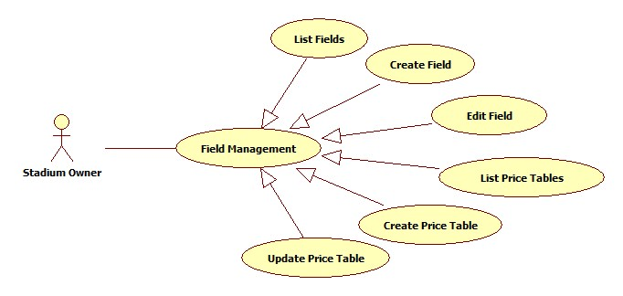

Figure 23: Field Management

###### List Fields

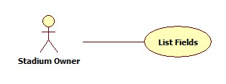

Figure 24: List Fields

|  |  |  |  |  |
| --- | --- | --- | --- | --- |
| **USE CASE-017 SPECIFICATION** | | | | |
| **Use-case No.** | UC_017 | **Use-case Version** | | 1.0 |
| **Use-case Name** | List Fields | | | |
| **Author** | ThinhND | | | |
| **Date** | 12/02/2014 | **Priority** | High | |
| **Actor:**  Stadium Owner  **Summary:**  This use case describes how to list all fields of a stadium.  **Goal:**  List all fields of stadium.  **Triggers:**  Actor clicks on “Sân con” link of the stadium  **Preconditions:**  Login as Stadium Owner  **Post-conditions:**  N/A  **Main Success Scenario:**   |  |  |  | | --- | --- | --- | | Step | Actor Action | System Response | | 1 | Actor clicks on “Sân con” link of the stadium | Show the field list of this stadium |   **Alternative Scenario:**  N/A  **Exceptions:**  Field has not been created by stadium owner.  **Relationships:**  N/A  **Business Rules:**  N/A | | | | |

###### Create Field

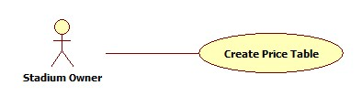

Figure 25: Create Field

|  |  |  |  |  |
| --- | --- | --- | --- | --- |
| **USE CASE-018 SPECIFICATION** | | | | |
| **Use-case No.** | UC_018 | **Use-case Version** | | 1.0 |
| **Use-case Name** | Create Field | | | |
| **Author** | ThinhND | | | |
| **Date** | 12/02/2014 | **Priority** | High | |
| **Actor:**  Stadium Owner  **Summary:**  This use case describes how to create a field of stadium.  **Goal:**  Create a field  **Triggers:**  Actor clicks on “Lưu” button  **Preconditions:**  Login as Stadium Owner role  **Post-conditions:**  N/A  **Main Success Scenario:**   |  |  |  | | --- | --- | --- | | Step | Actor Action | System Response | | 1 | Click on “Thêm sân con” button in the “Quản lý sân con” page | Display Create field form | | 2 | Enter information of this field  Click on “Lưu” button | Display successful message |   **Alternative Scenario:**   |  |  | | --- | --- | | Actor Action | System Response | | Click on “Hủy bỏ” button | Discard all recent activity and redirect to “Quản lý sân con” page |   **Exceptions:**  The List price has not been created.  **Relationships:**  N/A  **Business Rules:**  N/A | | | | |

###### Edit Field

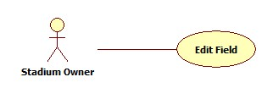

Figure 26: Edit Field

|  |  |  |  |  |
| --- | --- | --- | --- | --- |
| **USE CASE-019 SPECIFICATION** | | | | |
| **Use-case No.** | UC_019 | **Use-case Version** | | 1.0 |
| **Use-case Name** | Edit Field | | | |
| **Author** | ThinhND | | | |
| **Date** | 12/02/2014 | **Priority** | High | |
| **Actor:**  Stadium Owner  **Summary:**  This use case describes how to edit a field of stadium.  **Goal:**  Edit information of a field  **Triggers:**  Actor clicks on “Lưu” button  **Preconditions:**  Login as Stadium Owner role  **Post-conditions:**  N/A  **Main Success Scenario:**   |  |  |  | | --- | --- | --- | | Step | Actor Action | System Response | | 1 | Click on “Chỉnh sửa” link of the field which will be edited | Display Edit form with filled information | | 2 | Enter new information of this field  Click on “Lưu” button to finish | Display successful message |   **Alternative Scenario:**   |  |  | | --- | --- | | Actor Action | System Response | | Click on “Hủy bỏ” button | Discard recent filled information and redirect to “Quản lý sân con” page |   **Exceptions:**  N/A  **Relationships:**  N/A  **Business Rules:**  N/A | | | | |

###### List Price Tables

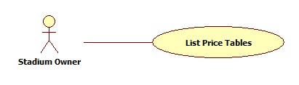

Figure 27: List Price Tables

|  |  |  |  |  |
| --- | --- | --- | --- | --- |
| **USE CASE-020 SPECIFICATION** | | | | |
| **Use-case No.** | UC_020 | **Use-case Version** | | 1.0 |
| **Use-case Name** | List Price Tables | | | |
| **Author** | ThinhND | | | |
| **Date** | 12/02/2014 | **Priority** | High | |
| **Actor:**  Stadium Owner  **Summary:**  This use case describes how view all price tables  **Goal:**  View list price tables  **Triggers:**  Actor clicks on “Bảng giá” button of the stadium  **Preconditions:**  Login as Stadium Owner role  **Post-conditions:**  N/A  **Main Success Scenario:**   |  |  |  | | --- | --- | --- | | Step | Actor Action | System Response | | 1 | Click on “Bảng giá” link in of the stadium which will be showed | Display price table list |   **Alternative Scenario:**  N/A  **Exceptions:**  N/A  **Relationships:**  N/A  **Business Rules:**  N/A | | | | |

###### Create Price Table

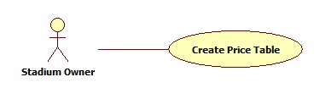

Figure 28: Create Price Table

|  |  |  |  |  |
| --- | --- | --- | --- | --- |
| **USE CASE-021 SPECIFICATION** | | | | |
| **Use-case No.** | UC_021 | **Use-case Version** | | 1.0 |
| **Use-case Name** | Create Field Price | | | |
| **Author** | ThinhND | | | |
| **Date** | 12/02/2014 | **Priority** | High | |
| **Actor:**  Stadium Owner  **Summary:**  This use case describes how to create price table  **Goal:**  Create a price table  **Triggers:**  Actor clicks on “Lưu” button  **Preconditions:**  Login as Stadium Owner role  **Post-conditions:**  N/A  **Main Success Scenario:**   |  |  |  | | --- | --- | --- | | Step | Actor Action | System Response | | 1 | Click on “Lưu” button in the “Quản lý bảng giá” page | Display create price table form | | 2 | Enter information of this price table  Click on “Thêm bảng giá” button | Display successful message |   **Alternative Scenario:**   |  |  | | --- | --- | | Actor Action | System Response | | Click on “Hủy bỏ” button | Discard all recent activity and redirect to “Quản lý bảng giá” page |   **Exceptions:**  N/A  **Relationships:**  N/A  **Business Rules:**  N/A | | | | |

###### Update Price Table

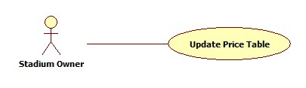

Figure 29: Update Price Table

|  |  |  |  |  |
| --- | --- | --- | --- | --- |
| **USE CASE-022 SPECIFICATION** | | | | |
| **Use-case No.** | UC_022 | **Use-case Version** | | 1.0 |
| **Use-case Name** | Update Price Table | | | |
| **Author** | ThinhND | | | |
| **Date** | 12/02/2014 | **Priority** | High | |
| **Actor:**  Stadium Owner  **Summary:**  This use case describes how to update price table’s detail  **Goal:**  Update price tables’s detail  **Triggers:**  Actor clicks on “Lưu” button  **Preconditions:**  Login as Stadium Owner role  **Post-conditions:**  N/A  **Main Success Scenario:**   |  |  |  | | --- | --- | --- | | Step | Actor Action | System Response | | 1 | Click on “Chỉnh sửa” link of the field which will be updated in “Quản lý bảng giá” page | Show price table’s detail | | 2 | Edit price table’s detail Click on “Lưu” button | Display successful message |   **Alternative Scenario:**   |  |  | | --- | --- | | Actor Action | System Response | | Click on “Hủy bỏ” button | Discard recent action and redirect to “Quản lý bảng giá” page |   **Exceptions:**  N/A  **Relationships:**  N/A  **Business Rules:**  N/A | | | | |

##### Reservations Management

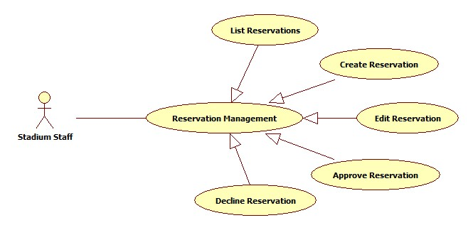

Figure 30: Reservation Management

###### List Reservations

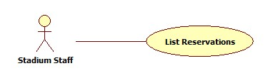

Figure 31: List Reservations

|  |  |  |  |  |
| --- | --- | --- | --- | --- |
| **USE CASE-023 SPECIFICATION** | | | | |
| **Use-case No.** | UC_023 | **Use-case Version** | | 1.0 |
| **Use-case Name** | List Reservations | | | |
| **Author** | ThinhND | | | |
| **Date** | 12/02/2014 | **Priority** | High | |
| **Actor:**  Stadium Staff, Stadium Owner  **Summary:**  This use case describes how to listt all reservations.  **Goal:**  List all reservations.  **Triggers:**  Actor goes to “Quản lý đặt sân” page  **Preconditions:**  Login as Stadium Staff or Stadium Owner role  **Post-conditions:**  N/A  **Main Success Scenario:**   |  |  |  | | --- | --- | --- | | Step | Actor Action | System Response | | 1 | Click on stadium link in “Quản lý đặt sân” page | The system shows the list of reservations of this stadium |   **Alternative Scenario:**  N/A  **Exceptions:**  N/A  **Relationships:**  N/A  **Business Rules:**  N/A | | | | |

###### Create Reservation

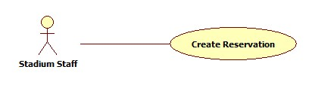

Figure 32: Create Reservation

|  |  |  |  |  |
| --- | --- | --- | --- | --- |
| **USE CASE-024 SPECIFICATION** | | | | |
| **Use-case No.** | UC_024 | **Use-case Version** | | 1.0 |
| **Use-case Name** | Create Reservation | | | |
| **Author** | ThinhND | | | |
| **Date** | 12/02/2014 | **Priority** | High | |
| **Actor:**  Stadium Staff, Stadium Owner  **Summary:**  This use case describes how to create a reservation  **Goal:**  Create a reservation.  **Triggers:**  Click on “Lưu” button in “Thêm đơn đặt sân” page  **Preconditions:**  Login as Stadium Staff or Stadium Owner role  **Post-conditions:**  N/A  **Main Success Scenario:**   |  |  |  | | --- | --- | --- | | Step | Actor Action | System Response | | 1 | Click on “Thêm đơn đặt sân” button | Display Book form | | 2 | Enter information of reservation  Click on “Lưu” button | Display successful message |   **Alternative Scenario:**   |  |  | | --- | --- | | Actor Action | System Response | | Click on “Hủy bỏ” button | Discard all recent action and redirect to “Quản lý đặt sân” page |   **Exceptions:**  This field is not available such as existing reservation, duplicate booking time, etc.  **Relationships:**  N/A  **Business Rules:**  N/A | | | | |

###### Edit Reservation

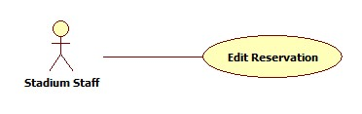

Figure 33: Edit Reservation

|  |  |  |  |  |
| --- | --- | --- | --- | --- |
| **USE CASE-025 SPECIFICATION** | | | | |
| **Use-case No.** | UC_025 | **Use-case Version** | | 1.0 |
| **Use-case Name** | Edit Reservation | | | |
| **Author** | ThinhND | | | |
| **Date** | 12/02/2014 | **Priority** | High | |
| **Actor:**  Stadium Staff, Stadium Owner  **Summary:**  This use case describes how to edit a reservation’s information.  **Goal:**  Edit reservation’s information.  **Triggers:**  Click on “Lưu” button  **Preconditions:**  Login as Stadium Staff or Stadium Owner role  **Post-conditions:**  N/A  **Main Success Scenario:**   |  |  |  | | --- | --- | --- | | Step | Actor Action | System Response | | 1 | Click on “Chỉnh sửa” button of this reservation | Display this Reservation’s information | | 2 | Enter new reservation information Click “Lưu” button | Display successful message |   **Alternative Scenario:**   |  |  | | --- | --- | | Actor Action | System Response | | Click on “Hủy bỏ” button | Discard all recent action and redirect to “Quản lý đặt sân” page |   **Exceptions:**  This field is not available such as existing reservation, duplicate booking time, etc.  **Relationships:**  N/A  **Business Rules:**  N/A | | | | |

###### Approve Reservation

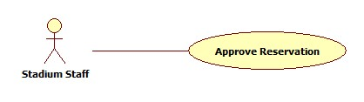

Figure 34: Approve Reservation

|  |  |  |  |  |
| --- | --- | --- | --- | --- |
| **USE CASE-026 SPECIFICATION** | | | | |
| **Use-case No.** | UC_026 | **Use-case Version** | | 1.0 |
| **Use-case Name** | Approve Reservation | | | |
| **Author** | ThinhND | | | |
| **Date** | 12/02/2014 | **Priority** | High | |
| **Actor:**  Stadium Staff, Stadium Owner  **Summary:**  This use case describes how to approve a reservation  **Goal:**  Approve a reservation  **Triggers:**  Click on “Lưu” button  **Preconditions:**  Login as Stadium Staff or Stadium Owner role  **Post-conditions:**  N/A  **Main Success Scenario:**   |  |  |  | | --- | --- | --- | | Step | Actor Action | System Response | | 1 | Click on “Chỉnh sửa” link of this reservation | Display this Reservation’s detail | | 2 | Click on “Lưu” button | Display successful message |   **Alternative Scenario:**   |  |  | | --- | --- | | Actor Action | System Response | | Click on “Quay lại” button | Discard all recent action and redirect to “Quản lý đặt sân” page |   **Exceptions:**  N/A  **Relationships:**  N/A  **Business Rules:**  N/A | | | | |

###### Decline Reservation

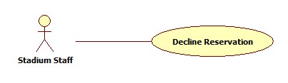

Figure 35: Decline Reservation

|  |  |  |  |  |
| --- | --- | --- | --- | --- |
| **USE CASE-027 SPECIFICATION** | | | | |
| **Use-case No.** | UC_027 | **Use-case Version** | | 1.0 |
| **Use-case Name** | Decline Reservation | | | |
| **Author** | ThinhND | | | |
| **Date** | 12/02/2014 | **Priority** | High | |
| **Actor:**  Stadium Staff, Stadium Owner  **Summary:**  This use case describes how to decline a reservation  **Goal:**  Decline a reservation  **Triggers:**  Click on “Từ chối” button  **Preconditions:**  Login as Stadium Staff or Stadium Owner role  **Post-conditions:**  N/A  **Main Success Scenario:**   |  |  |  | | --- | --- | --- | | Step | Actor Action | System Response | | 1 | Click on “Chi tiết” link of this reservation | Display this Reservation’s detail | | 2 | Click on “Từ chối” button | Display successful message |   **Alternative Scenario:**   |  |  | | --- | --- | | Actor Action | System Response | | Click on “Quay lại” button | Discard all recent action and redirect to “Quản lý đặt sân” page |   **Exceptions:**  N/A  **Relationships:**  N/A  **Business Rules:**  N/A | | | | |

##### Stadium Promotion Management

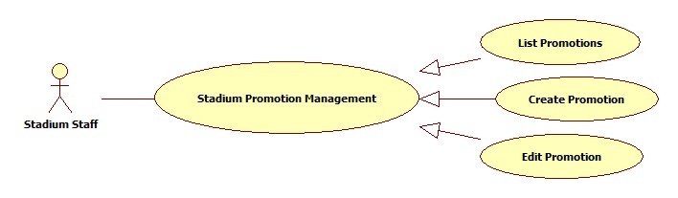

Figure 36: Stadium Promotion Management

###### List Promotions

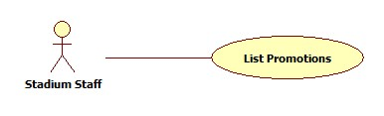

Figure 37: List Promotions

|  |  |  |  |  |
| --- | --- | --- | --- | --- |
| **USE CASE-028 SPECIFICATION** | | | | |
| **Use-case No.** | UC_028 | **Use-case Version** | | 1.0 |
| **Use-case Name** | List Promotions | | | |
| **Author** | ThinhND | | | |
| **Date** | 12/02/2014 | **Priority** | High | |
| **Actor:**  Stadium Staff, Stadium Owner  **Summary:**  This use case describe how to list all the promotion of stadium  **Goal:**  List all promotions of a stadium  **Triggers:**  Actor clicks on stadium of “Quản lý khuyến mãi” page  **Preconditions:**  Login as Stadium Staff or Stadium Owner role  **Post-conditions:**  N/A  **Main Success Scenario:**   |  |  |  | | --- | --- | --- | | Step | Actor Action | System Response | | 1 | Actor clicks on stadium of “Quản lý khuyến mãi” page | The system shows list of promotion. |   **Alternative Scenario:**  N/A  **Exceptions:**  N/A  **Relationships:**  N/A  **Business Rules:**  N/A | | | | |

###### Create Promotion

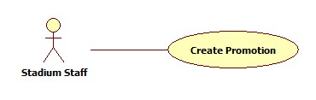

Figure 38: Create Promotion

|  |  |  |  |  |
| --- | --- | --- | --- | --- |
| **USE CASE-029 SPECIFICATION** | | | | |
| **Use-case No.** | UC_029 | **Use-case Version** | | 1.0 |
| **Use-case Name** | Create Promotion | | | |
| **Author** | ThinhND | | | |
| **Date** | 12/02/2014 | **Priority** | High | |
| **Actor:**  Stadium Staff, Stadium Owner  **Summary:**  This use case describes creating new promotion.  **Goal:**  Create a promotion for stadium.  **Triggers:**  Click on “Lưu” button  **Preconditions:**  Login as Stadium Staff or Stadium Owner role  **Post-conditions:**  N/A  **Main Success Scenario:**   |  |  |  | | --- | --- | --- | | Step | Actor Action | System Response | | 1 | Click on “Thêm khuyến mãi” of this stadium | Display create promotion form | | 2 | Enter information of this promotion Click “Lưu” button | Show successful message |   **Alternative Scenario:**   |  |  | | --- | --- | | Actor Action | System Response | | Click on “Hủy bỏ” button | Discard all recent action and redirect to “Quản lý khuyến mãi” page |   **Exceptions:**  N/A  **Relationships:**  N/A  **Business Rules:**  N/A | | | | |

###### Edit Promotion

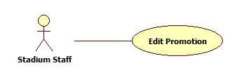

Figure 39: Edit Promotion

|  |  |  |  |  |
| --- | --- | --- | --- | --- |
| **USE CASE-030 SPECIFICATION** | | | | |
| **Use-case No.** | UC_030 | **Use-case Version** | | 1.0 |
| **Use-case Name** | Edit Promotion | | | |
| **Author** | ThinhND | | | |
| **Date** | 12/02/2014 | **Priority** | High | |
| **Actor:**  Stadium Staff, Stadium Owner  **Summary:**  This use case describes how to edit a promotion.  **Goal:**  Edit promotion’s information.  **Triggers:**  Click on “Lưu” button  **Preconditions:**  Login as Stadium Staff or Stadium Owner role  **Post-conditions:**  N/A  **Main Success Scenario:**   |  |  |  | | --- | --- | --- | | Step | Actor Action | System Response | | 1 | Click on “Chỉnh sửa” link of this promotion in “Quản lý khuyến mãi” page | Display this promotion’s information | | 2 | Enter new promotion’s information Click “Lưu” button | Show successful message |   **Alternative Scenario:**   |  |  | | --- | --- | | Actor Action | System Response | | Click on “Hủy bỏ” button | Discard all recent action and redirect to “Quản lý khuyến mãi” page |   **Exceptions:**  N/A  **Relationships:**  N/A  **Business Rules:**  N/A | | | | |

##### Register

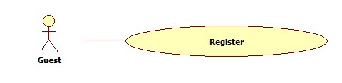

Figure 40: Register

|  |  |  |  |  |
| --- | --- | --- | --- | --- |
| **USE CASE-031 SPECIFICATION** | | | | |
| **Use-case No.** | UC_031 | **Use-case Version** | | 1.0 |
| **Use-case Name** | Register | | | |
| **Author** | KhánhNQ | | | |
| **Date** | 12/02/2014 | **Priority** | High | |
| **Actor:**  Guest  **Summary:**  This use case describes how to register a new account  **Goal:**  Register new account  **Triggers:**  Click on “Đăng ký” button  **Preconditions:**  N/A  **Post-conditions:**  N/A  **Main Success Scenario:**   |  |  |  | | --- | --- | --- | | Step | Actor Action | System Response | | 1 | Click on “Đăng Ký’ link | System will response Register page | | 2 | Enter account’s information  Click “Đăng ký” button | Display successful message |   **Alternative Scenario:**     |  |  | | --- | --- | | Actor Action | System Response | | Click on “Hủy” button to cancel | Redirect to Home page |   **Exceptions:**     |  |  |  | | --- | --- | --- | |  | Actor Action | System Response | | 1. | Account has existed in database. | Display error message: “Tên tài khoản đã được sử dụng. Xin vui lòng chọn tên khác” | | 2. | Email has existed in database. | Display error message: “Email đã được sử dụng. Xin vui lòng chọn email khác” | | 3. | Input not a valid information in Email’s textbox. | Display error message: “Email không đúng”. | | 4. | Password’s length is not in range: [6,20]. | Display error message: “Yêu cầu tài khoản từ 6 đến 32 kí tự”. | | 5. | Input confirm password information different with password. | Display error message: “Sai mật khẩu xác nhận”. |   **Relationships:**  N/A  **Business Rules:**  N/A | | | | |

##### Password Recovery

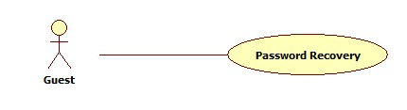

Figure 41: Password Recovery

|  |  |  |  |  |
| --- | --- | --- | --- | --- |
| **USE CASE-032 SPECIFICATION** | | | | |
| **Use-case No.** | UC_032 | **Use-case Version** | | 1.0 |
| **Use-case Name** | Password Recovery | | | |
| **Author** | KhánhNQ | | | |
| **Date** | 12/02/2014 | **Priority** | High | |
| **Actor:**  Guest  **Summary:**  This use case describes how to recovery member’s password  **Goal:**  Recovery password  **Triggers:**  Actor clicks on “Lấy lại mật khẩu” button  **Preconditions:**  Guest already has account  **Post-conditions:**  N/A  **Main Success Scenario:**   |  |  |  | | --- | --- | --- | | Step | Actor Action | System Response | | 1 | Click on “Quên mật khẩu” link | System will response Recovery Password page | | 2 | Enter required information  Click on “Lấy lại mật khẩu” button | Display sent email message |   **Alternative Scenario:**   |  |  | | --- | --- | | Actor Action | System Response | | Click on “Hủy” button to cancel | Redirect to Home page |   **Exceptions:**  Email that user provide does not exist in system  **Relationships:**  N/A  **Business Rules:**  N/A | | | | |

##### Login

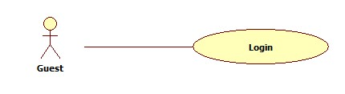

Figure 42: Login

|  |  |  |  |  |
| --- | --- | --- | --- | --- |
| **USE CASE-033 SPECIFICATION** | | | | |
| **Use-case No.** | UC_033 | **Use-case Version** | | 1.0 |
| **Use-case Name** | Login | | | |
| **Author** | KhánhNQ | | | |
| **Date** | 12/02/2014 | **Priority** | High | |
| **Actor:**  Guest  **Summary:**  This usecase describes how to login this website  **Goal:**  Login to website  **Triggers:**  Actors clicks “Đang nhập” button  **Preconditions:**  Guest already has an account  **Post-conditions:**  N/A  **Main Success Scenario:**   |  |  |  | | --- | --- | --- | | Step | Actor Action | System Response | | 1 | Enter username and password  Click Login button | Redirect user to homepage or specific page | |  |  |  |   **Alternative Scenario:**   |  |  | | --- | --- | | Actor Action | System Response | | Click on “Hủy bỏ” button to cancel | Redirect to Home page |   **Exceptions:**   |  |  |  | | --- | --- | --- | |  | Actor Action | System Response | |  | Invalid Inputted | Display error message |   **Relationships:**  N/A  **Business Rules:**  N/A | | | | |

##### View Stadium’s Detail:

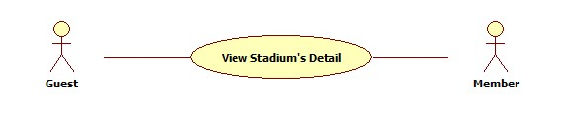

Figure 43: View Stadium's Detail

|  |  |  |  |  |
| --- | --- | --- | --- | --- |
| **USE CASE-034 SPECIFICATION** | | | | |
| **Use-case No.** | UC_034 | **Use-case Version** | | 1.0 |
| **Use-case Name** | View Stadium’s Detail | | | |
| **Author** | KhánhNQ | | | |
| **Date** | 12/02/2014 | **Priority** | High | |
| **Actor:**  Guest, Member, Stadium Staff, Stadium Owner, Website Staff, Website Master  **Summary:**  This use case describe how to view detail of a stadium  **Goal:**  View detail of stadium  **Triggers:**  Actor clicks on any stadium  **Preconditions:**  N/A  **Post-conditions:**  Display detail of stadium  **Main Success Scenario:**   |  |  |  | | --- | --- | --- | | Step | Actor Action | System Response | | 1 | Click on any stadium | Display detail of stadium |   **Alternative Scenario:**  N/A  **Exceptions:**  N/A  **Relationships:**  N/A  **Business Rules:**  N/A | | | | |

##### Find Available Stadiums

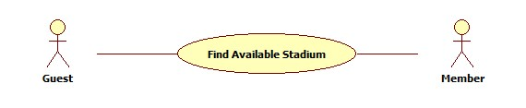

Figure 44: Find Available Stadium

|  |  |  |  |  |
| --- | --- | --- | --- | --- |
| **USE CASE-035 SPECIFICATION** | | | | |
| **Use-case No.** | UC_035 | **Use-case Version** | | 1.0 |
| **Use-case Name** | Find Available Stadiums | | | |
| **Author** | ThinhND | | | |
| **Date** | 12/02/2014 | **Priority** | High | |
| **Actor:**  Guest, Member, Stadium Staff, Stadium Owner, Website Staff, Website Master  **Summary:**  This use case describes how to find an available stadium with some conditions  **Goal:**  Find available stadium  **Triggers:**  Actor clicks on “Tìm kiếm” button  **Preconditions:**  N/A  **Post-conditions:**    **Main Success Scenario:**   |  |  |  | | --- | --- | --- | | Step | Actor Action | System Response | | 1 | Choose condition information  Click on “Tìm kiếm” button | Show list of stadiums |   **Alternative Scenario:**  N/A  **Exceptions:**  There is no available stadium for those condition  **Relationships:**  N/A  **Business Rules:**  N/A | | | | |

##### Find Stadiums

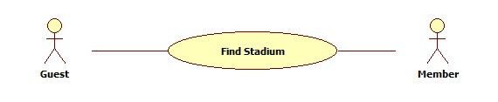

Figure 45: Find Stadium

|  |  |  |  |  |
| --- | --- | --- | --- | --- |
| **USE CASE-036 SPECIFICATION** | | | | |
| **Use-case No.** | UC_036 | **Use-case Version** | | 1.0 |
| **Use-case Name** | Find Stadium | | | |
| **Author** | ThinhND | | | |
| **Date** | 12/02/2014 | **Priority** | High | |
| **Actor:**  Guest, Member, Stadium Staff, Stadium Owner, Website Staff, Website Master  **Summary:**  This use case describes how to find stadium  **Goal:**  Find stadium  **Triggers:**  Actor clicks on “Tìm kiếm” button  **Preconditions:**  N/A  **Post-conditions:**  N/A  **Main Success Scenario:**   |  |  |  | | --- | --- | --- | | Step | Actor Action | System Response | | 1 | Enter “Hệ thống sân bóng” page | Show list of all stadiums | | 2 | Enter search information  Click on “Tìm kiếm” button” | Show result |   **Alternative Scenario:**  N/A  **Exceptions:**  N/A  **Relationships:**  N/A  **Business Rules:**  N/A | | | | |

##### Book Field

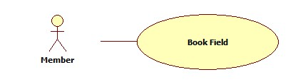

Figure 46: Book Field

|  |  |  |  |  |
| --- | --- | --- | --- | --- |
| **USE CASE-037 SPECIFICATION** | | | | |
| **Use-case No.** | UC_037 | **Use-case Version** | | 1.0 |
| **Use-case Name** | Book Field | | | |
| **Author** | ThinhND | | | |
| **Date** | 12/02/2014 | **Priority** | High | |
| **Actor:**  Member, Stadium Staff, Stadium Owner, Website Staff, Website Master  **Summary:**  This use case describes how to book a field  **Goal:**  Book a field of stadium  **Triggers:**  Actor clicks “Lưu” button  **Preconditions:**  Login as Member, Stadium Staff, Stadium Owner, Website Staff or Website Master  **Post-conditions:**  N/A  **Main Success Scenario:**   |  |  |  | | --- | --- | --- | | Step | Actor Action | System Response | | 1 | Click on “Đặt sân” button of stadium detail page or “Đặt” button after find stadium | Display reservation form | | 2 | Enter information of reservation  Click “Lưu” button | Display successful message |   **Alternative Scenario:**   |  |  | | --- | --- | | Actor Action | System Response | | There’s is no available field | Display message | | Click on “Hủy bỏ” button | Discard all recent action and redirect to Home page |   **Exceptions:**  This field is not available such as existing reservation, duplicate booking time, etc.  **Relationships:**  N/A  **Business Rules:**  N/A | | | | |

##### Rate Stadium

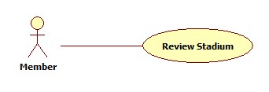

Figure 47: Review Stadium

|  |  |  |  |  |
| --- | --- | --- | --- | --- |
| **USE CASE-038 SPECIFICATION** | | | | |
| **Use-case No.** | UC_038 | **Use-case Version** | | 1.0 |
| **Use-case Name** | Rate Stadium | | | |
| **Author** | ThinhND | | | |
| **Date** | 12/02/2014 | **Priority** | High | |
| **Actor:**  Member, Stadium Staff, Stadium Owner, Website Staff, Website Master  **Summary:**  This use case describes how to rate a stadium  **Goal:**  Rate a stadium  **Triggers:**  Actor click on Rate stars of stadium  **Preconditions:**  Login as user  **Post-conditions:**  N/A  **Main Success Scenario:**   |  |  |  | | --- | --- | --- | | Step | Actor Action | System Response | | 1 | Click on Rate stars | Show result immediately |   **Alternative Scenario:**  N/A  **Exceptions:**  N/A  **Relationships:**  N/A  **Business Rules:**  N/A | | | | |

##### Rivew Stadium



Figure 48: Rate Stadium

|  |  |  |  |  |
| --- | --- | --- | --- | --- |
| **USE CASE-039 SPECIFICATION** | | | | |
| **Use-case No.** | UC_039 | **Use-case Version** | | 1.0 |
| **Use-case Name** | Review Stadium | | | |
| **Author** | ThinhND | | | |
| **Date** | 12/02/2014 | **Priority** | High | |
| **Actor:**  Member, Stadium Staff, Stadium Owner, Website Staff, Website Master  **Summary:**  This use case describes how to send review for a stadium  **Goal:**  Review a stadium  **Triggers:**  Actor clicks on “Gửi đánh giá” button  **Preconditions:**  Login as user  **Post-conditions:**  N/A  **Main Success Scenario:**   |  |  |  | | --- | --- | --- | | Step | Actor Action | System Response | | 1 | View stadium’s detail | Show stadium’s detail with review content field below | | 2 | Enter review content Click on “Gửi đánh giá” button | Show successful message |   **Alternative Scenario:**  N/A  **Exceptions:**  N/A  **Relationships:**  N/A  **Business Rules:**  N/A | | | | |

##### Feedback Website

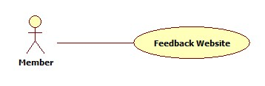

Figure 49: Feedback Website

|  |  |  |  |  |
| --- | --- | --- | --- | --- |
| **USE CASE-040 SPECIFICATION** | | | | |
| **Use-case No.** | UC_040 | **Use-case Version** | | 1.0 |
| **Use-case Name** | Feedback Website | | | |
| **Author** | ThinhND | | | |
| **Date** | 12/02/2014 | **Priority** | High | |
| **Actor:**  Member, Stadium Staff, Stadium Owner, Website Staff, Website Master  **Summary:**  This use case describes how to send FPB a feedback  **Goal:**  Feedback website  **Triggers:**  Actor clicks on “Gửi đánh giá” button  **Preconditions:**  Login as user  **Post-conditions:**  N/A  **Main Success Scenario:**   |  |  |  | | --- | --- | --- | | Step | Actor Action | System Response | | 1 | Click on “Gửi đánh giá” link in the footer of website | Display feedback form | | 2 | Enter feedback content Click on “Gửi đánh giá” button | Show successful message |   **Alternative Scenario:**  N/A  **Exceptions:**  N/A  **Relationships:**  N/A  **Business Rules:**  N/A | | | | |

##### Cancel Reservation

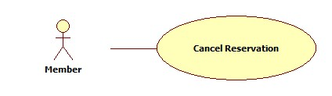

Figure 50: Cancel Reservation

|  |  |  |  |  |
| --- | --- | --- | --- | --- |
| **USE CASE-41 SPECIFICATION** | | | | |
| **Use-case No.** | UC_41 | **Use-case Version** | | 1.0 |
| **Use-case Name** | Cancel Reservation | | | |
| **Author** | ThinhND | | | |
| **Date** | 12/02/2014 | **Priority** | High | |
| **Actor:**  Member, Stadium Staff, Stadium Owner, Website Staff, Website Master  **Summary:**  This use case describes how to cancel reservation  **Goal:**  Cancel a reservation  **Triggers:**  Actor clicks “Hủy đặt sân” button  **Preconditions:**  Login as user. Reservation is not expired.  **Post-conditions:**  N/A  **Main Success Scenario:**   |  |  |  | | --- | --- | --- | | Step | Actor Action | System Response | | 1 | Click on “Lịch sử đặt sân” below the account | Show list of reservation | | 2 | Click on “Chỉnh sửa” link of the reservation which will be canceled | Show reservation detail | | 3 | Click on “Hủy đặt sân” button | Display Successful message |   **Alternative Scenario:**   |  |  | | --- | --- | | Actor Action | System Response | | Click on “Quay lại” button | Redirect to “Lịch sử đặt sân” page |   **Exceptions:**  Reservation is unable to cancel.  **Relationships:**  N/A  **Business Rules:**  N/A | | | | |
|  | | | | |

##### Edit Account Profile

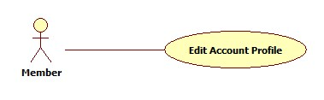

Figure 51: Edit Account Profile

|  |  |  |  |  |
| --- | --- | --- | --- | --- |
| **USE CASE-042 SPECIFICATION** | | | | |
| **Use-case No.** | UC_042 | **Use-case Version** | | 1.0 |
| **Use-case Name** | Edit Account Profiles | | | |
| **Author** | ThinhND | | | |
| **Date** | 12/02/2014 | **Priority** | High | |
| **Actor:**  Member, Stadium Staff, Stadium Owner, Website Staff, Website Master  **Summary:**  This use case describes how to edit user’s account profiles  **Goal:**  Update user’s account profiles  **Triggers:**  Actor clicks on“Lưu” button  **Preconditions:**  Login as user  **Post-conditions:**  N/A  **Main Success Scenario:**   |  |  |  | | --- | --- | --- | | Step | Actor Action | System Response | | 1 | Click on “Quảnh lý tài khoản” link below the account | Display account’s information | | 2 | Click on “Chỉnh sửa” button | Display “Cập nhật thông tin cá nhân” page | | 3 | Enter new information Click on “Lưu” button | Display successful message |   **Alternative Scenario:**   |  |  | | --- | --- | | Actor Action | System Response | | Click on “Quay lại” button | Redirect to “Chi tiết thông tin thành viên” page |   **Exceptions:**  N/A  **Relationships:**  N/A  **Business Rules:**  N/A | | | | |

##### Change Password

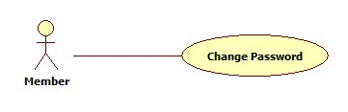

Figure 52: Change Password

|  |  |  |  |  |
| --- | --- | --- | --- | --- |
| **USE CASE-043 SPECIFICATION** | | | | |
| **Use-case No.** | UC_043 | **Use-case Version** | | 1.0 |
| **Use-case Name** | Change Password | | | |
| **Author** | ThinhND | | | |
| **Date** | 12/02/2014 | **Priority** | High | |
| **Actor:**  Member, Stadium Staff, Stadium Owner, Website Staff, Website Master  **Summary:**  This use case describes how to change password  **Goal:**  Change user’s password  **Triggers:**  Actor clicks on “Lưu” button  **Preconditions:**  Login as user  **Post-conditions:**  N/A  **Main Success Scenario:**   |  |  |  | | --- | --- | --- | | Step | Actor Action | System Response | | 1 | Click on “Quảnh lý tài khoản” link below the account | Display account’s information | | 2 | Click on “Đổi mật khẩu” button | Display “Đổi mật khẩu” page | | 3 | Enter new password Click on “Lưu” button | Display successful message |   **Alternative Scenario:**   |  |  | | --- | --- | | Actor Action | System Response | | Click on “Quay lại” button | Redirect to “Chi tiết thông tin thành viên” page |   **Exceptions:**  N/A  **Relationships:**  N/A  **Business Rules:**  N/A | | | | |

##### Find Rival

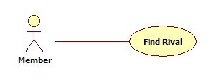

Figure 53: Find Rival

|  |  |  |  |  |
| --- | --- | --- | --- | --- |
| **USE CASE-044 SPECIFICATION** | | | | |
| **Use-case No.** | UC_044 | **Use-case Version** | | 1.0 |
| **Use-case Name** | Find Rival | | | |
| **Author** | ThinhND | | | |
| **Date** | 12/02/2014 | **Priority** | High | |
| **Actor:**  Guest, Member, Stadium Staff, Stadium Owner, Website Staff, Website Master  **Summary:**  This use case describes how to find a rival  **Goal:**  Find rival  **Triggers:**  Actor clicks on “Tìm kiếm” button  **Preconditions:**  N/A  **Post-conditions:**  N/A  **Main Success Scenario:**   |  |  |  | | --- | --- | --- | | Step | Actor Action | System Response | | 1 | Go to “Tìm kèo” page | Show list of all rivals | | 2 | Enter searching information Click on “Tìm kiếm” button | Show result |   **Alternative Scenario:**  N/A  **Exceptions:**  N/A  **Relationships:**  N/A  **Business Rules:**  N/A | | | | |

##### View Rival’s Detail

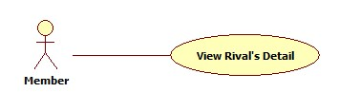

Figure 54: View Rival's Detail

|  |  |  |  |  |
| --- | --- | --- | --- | --- |
| **USE CASE-045 SPECIFICATION** | | | | |
| **Use-case No.** | UC_045 | **Use-case Version** | | 1.0 |
| **Use-case Name** | List Rivals | | | |
| **Author** | ThinhND | | | |
| **Date** | 12/02/2014 | **Priority** | High | |
| **Actor:**  Member, Stadium Staff, Stadium Owner, Website Staff, Website Master  **Summary:**  This use case describes how to view list of rivals  **Goal:**  View list of rivals  **Triggers:**  Actor enters “Tìm kèo” page  **Preconditions:**  Login as user  **Post-conditions:**  N/A  **Main Success Scenario:**   |  |  |  | | --- | --- | --- | | Step | Actor Action | System Response | | 1 | Enter “Tìm kèo” page | Display rival list |   **Alternative Scenario:**  N/A  **Exceptions:**  N/A  **Relationships:**  N/A  **Business Rules:**  N/A | | | | |

##### Join Rival

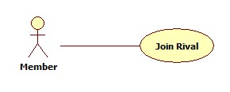

Figure 55: Join Rival

|  |  |  |  |  |
| --- | --- | --- | --- | --- |
| **USE CASE-046 SPECIFICATION** | | | | |
| **Use-case No.** | UC_046 | **Use-case Version** | | 1.0 |
| **Use-case Name** | Join Rival | | | |
| **Author** | ThinhND | | | |
| **Date** | 12/02/2014 | **Priority** | High | |
| **Actor:**  Member, Stadium Staff, Stadium Owner, Website Staff, Website Master  **Summary:**  This use case describes how to join a rival  **Goal:**  Join a rival  **Triggers:**  Actor clicks on “Cáp kèo” button  **Preconditions:**  Login as user  **Post-conditions:**  N/A  **Main Success Scenario:**   |  |  |  | | --- | --- | --- | | Step | Actor Action | System Response | | 1 | Click on “Chi tiết” link of this rival | Display rival’s detail | | 2 | Choose “Có” in “Bạn muốn cáp kèo này” combo box Enter additional information  Click “Cáp kèo” button | Display successful message |   **Alternative Scenario:**   |  |  | | --- | --- | | Actor Action | System Response | | Click on “Quay lại” button | Redirect to Home page |   **Exceptions:**  N/A  **Relationships:**  N/A  **Business Rules:**  N/A | | | | |

##### View Stadium Booking History

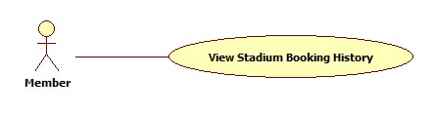

Figure 56: View Stadium Booking History

|  |  |  |  |  |
| --- | --- | --- | --- | --- |
| **USE CASE-047 SPECIFICATION** | | | | |
| **Use-case No.** | UC_047 | **Use-case Version** | | 1.0 |
| **Use-case Name** | View Stadium Booking History | | | |
| **Author** | ThinhND | | | |
| **Date** | 12/02/2014 | **Priority** | High | |
| **Actor:**  Member, Stadium Staff, Stadium Owner, Website Staff, Website Master  **Summary:**  This use case describes how to view reservation history  **Goal:**  View reservation history  **Triggers:**  Click on “Chi tiết” link of the reservation  **Preconditions:**  Login as user  **Post-conditions:**  N/A  **Main Success Scenario:**   |  |  |  | | --- | --- | --- | | Step | Actor Action | System Response | | 1 | Click on “Lịch sử đặt sân” link below the account | Show list of reservation | | 2 | Click on “Chi tiết” link of the reservation which will be viewed | Show reservation’s detail |   **Alternative Scenario:**  N/A  **Exceptions:**  N/A  **Relationships:**  N/A  **Business Rules:**  N/A | | | | |

##### Request Join System

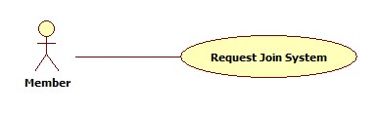

Figure 57: Request Join System

|  |  |  |  |  |
| --- | --- | --- | --- | --- |
| **USE CASE-048 SPECIFICATION** | | | | |
| **Use-case No.** | UC_048 | **Use-case Version** | | 1.0 |
| **Use-case Name** | Request Join System | | | |
| **Author** | ThinhND | | | |
| **Date** | 12/02/2014 | **Priority** | High | |
| **Actor:**  Member  **Summary:**  This use case describes how to request to join system  **Goal:**  Request join system  **Triggers:**  Actor clicks on “Gửi yêu cầu” button  **Preconditions:**  Login as user  **Post-conditions:**  N/A  **Main Success Scenario:**   |  |  |  | | --- | --- | --- | | Step | Actor Action | System Response | | 1 | Click on “Gia nhập chúng tôi” to enter “Đăng ký sân bóng của bạn” page | Display register new stadium form | | 2 | Enter information of stadium  Click on “Gửi yêu cầu” button | Display successful message |   **Alternative Scenario:**   |  |  | | --- | --- | | Actor Action | System Response | | Click on “Hủy” button | Dicard all recent action and redirect to Home page |   **Exceptions:**  N/A  **Relationships:**  N/A  **Business Rules:**  N/A | | | | |

#### Non-Functional Requirements

##### Reliability

* Mean Time Between Failures (MTBF): The acceptable failure is once a year
* Mean Time To Repair (MTTR): The acceptable mean time for a particular failure must be least than 12 hours
* Maximum Bugs or Defect Rate: 05 bugs / KLOC

##### Availability

* The system always responds to every user who got permission. The server shall be working 24/7.

##### Security

* Customer information must be secured
* The system always check authenticate and permission for every function

##### Maintainability

N/A

##### Portability

N/A

##### Performance

N/A

#### Entity Relationship Diagram



Figure 58: Entity Relationship Diagram