1. **Find Available Stadiums**

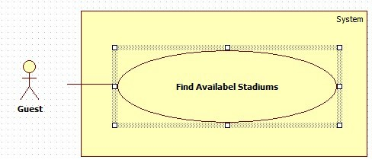

|  |  |  |  |  |
| --- | --- | --- | --- | --- |
| **USE CASE-n SPECIFICATION** | | | | |
| **Use-case No.** | <UC001> | **Use-case Version** | | <1.0> |
| **Use-case Name** | Find Available Stadiums | | | |
| **Author** | KhánhNQ | | | |
| **Date** | 12/02/2014 | **Priority** | High | |
| **Actor:**  Guest , Authorize Member  **Summary:**  This use case describe finding available stadium at specific date and time with duration  **Goal:**  Find out expect stadiums  **Triggers:**  Actor use Find Available Stadium forms on any page which contain the form.  **Preconditions:**  N/A  **Post-conditions:**  Display found stadiums those satisfy actor  **Main Success Scenario:**   |  |  |  | | --- | --- | --- | | Step | Actor Action | System Response | | 1 | User select options of group:   * Province/City radio button * District checkbox * Field type checkbox   User specify date on Date picker  User specify time on Time dropdown list  User specify duration on Duration dropdown list |  | | 2 | User click Find Stadium button |  | | 3 |  | Display results that correspond with user’s expect |   **Alternative Scenario:**  N/A  **Exceptions:**  N/A  **Relationships:**  N/A  **Business Rules:**  N/A | | | | |

1. **Register**

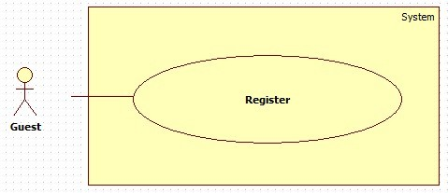

|  |  |  |  |  |
| --- | --- | --- | --- | --- |
| **USE CASE-n SPECIFICATION** | | | | |
| **Use-case No.** | <UC001> | **Use-case Version** | | <1.0> |
| **Use-case Name** | Register | | | |
| **Author** | KhánhNQ | | | |
| **Date** | 12/02/2014 | **Priority** | High | |
| **Actor:**  Guest  **Summary:**  Guest uses this use case to register account  **Goal:**  Allow guest to register account  **Triggers:**  On header page, click on Register link and Register page will be showed, then input information and then click Register button to finish.  **Preconditions:**  N/A  **Post-conditions:**  Guest can register an account successfully. System will transfer to Homepage  **Main Success Scenario:**   |  |  |  | | --- | --- | --- | | Step | Actor Action | System Response | | 1 | Click on Register link to request Register page | System will response Register page | | 2 | Enter information into text fields. Click on Register button to finish |  | | 3 |  | System will create new account in database, user will be login automatically and system will transfer to Homepage of User |   **Alternative Scenario:**     |  |  | | --- | --- | | Actor Action | System Response | | Click on Cancel button to cancel | System will transfer to “Homepage |   **Exceptions:**     |  |  |  | | --- | --- | --- | |  | Actor Action | System Response | | 1. | Email has existed in database. | Display error message: “Email has existed. Try another email.” | | 2. | Input not a valid information in Email’s textbox. | Display error message: “Email is invalid”. | | 3. | Password’s length is not in range: [6,20]. | Display error message: “Passwords must be at least 6 characters ”. | | 4. | Input confirm password information different with password. | Display error message: “Confirm password wrong . Please re-enter”. |   **Relationships:**  N/A  **Business Rules:**  N/A | | | | |

1. **Find Stadiums**

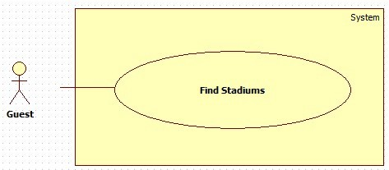

|  |  |  |  |  |
| --- | --- | --- | --- | --- |
| **USE CASE-n SPECIFICATION** | | | | |
| **Use-case No.** | <UC001> | **Use-case Version** | | <1.0> |
| **Use-case Name** | Find Stadiums | | | |
| **Author** | KhánhNQ | | | |
| **Date** | 12/02/2014 | **Priority** | High | |
| **Actor:**  Guest , Authorized Member  **Summary:**  This use case describe finding a stadium  **Goal:**  Find out expect stadiums  **Triggers:**  Actor use Find Stadium forms on any page which contain the form.  **Preconditions:**  N/A  **Post-conditions:**  Display found stadiums those satisfy actor  **Main Success Scenario:**   |  |  |  | | --- | --- | --- | | Step | Actor Action | System Response | | 1 | User select options of group:   * Province/City radio button * District checkbox * Field type checkbox   User specify date on Date picker  User specify time on Time dropdown list  User specify duration on Duration dropdown list |  | | 2 | User click Find Stadium button |  | | 3 |  | Display results that correspond with user’s expect |   **Alternative Scenario:**  N/A  **Exceptions:**  N/A  **Relationships:**  N/A  **Business Rules:**  N/A | | | | |

thật ra cái này không khác cái Find Available là mấy nên a cũng ko biết sửa cái gì

1. View Stadium’s Detail :

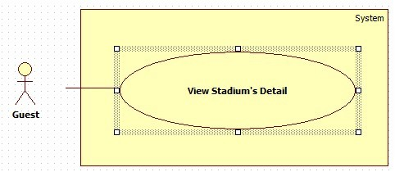

|  |  |  |  |  |
| --- | --- | --- | --- | --- |
| **USE CASE-n SPECIFICATION** | | | | |
| **Use-case No.** | <UC001> | **Use-case Version** | | <1.0> |
| **Use-case Name** | View Stadium’s Detail | | | |
| **Author** | KhánhNQ | | | |
| **Date** | 12/02/2014 | **Priority** | High | |
| **Actor:**  Guest  **Summary:**  Guest want to view information, detail of stadium  **Goal:**  See all of detail of stadium  **Triggers:**  Actor use View Stadium’s Detail when click in Detail link.  **Preconditions:**  N/A  **Post-conditions:**  Display detail of stadium those satisfy actor  **Main Success Scenario:**   |  |  |  | | --- | --- | --- | | Step | Actor Action | System Response | | 1 | User click Detail button |  | | 2 |  | System will response to Detail Form |   **Alternative Scenario:**  N/A  **Exceptions:**  N/A  **Relationships:**  N/A  **Business Rules:**  N/A | | | | |