1. Book Field

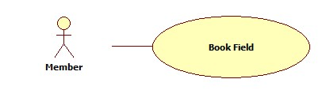

|  |  |  |  |  |
| --- | --- | --- | --- | --- |
| **USE CASE-n SPECIFICATION** | | | | |
| **Use-case No.** | <UC001> | **Use-case Version** | | <1.0> |
| **Use-case Name** | Book Field | | | |
| **Author** | ThinhND | | | |
| **Date** | 12/02/2014 | **Priority** | High | |
| **Actor:**  Member  **Summary:**  This use case describes how to book field  **Goal:**  Book a field of stadium  **Triggers:**  Actor click on Book button  **Preconditions:**  Login as user  **Post-conditions:**  Successful message is displayed.  **Main Success Scenario:**   |  |  |  | | --- | --- | --- | | Step | Actor Action | System Response | | 1 | Click on Book button | Display Book form | | 2 | Enter information of booking  Click on Check available button | Show Field is available message | | 3 | Click OK button | Show successful message and save this reservation |   **Alternative Scenario:**   |  |  | | --- | --- | | Actor Action | System Response | | Click on Check available button | Show Field is not available message | | Click on Cancel button | Back to previous page |   **Exceptions:**  This field is not available such as existing reservation, duplicate booking time, etc.  **Relationships:**  N/A  **Business Rules:**  N/A | | | | |

1. Rate Stadium

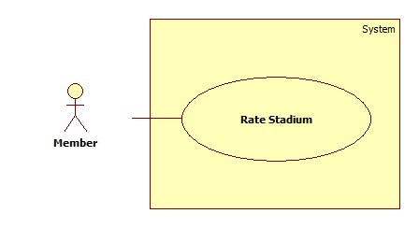

|  |  |  |  |  |
| --- | --- | --- | --- | --- |
| **USE CASE-n SPECIFICATION** | | | | |
| **Use-case No.** | <UC001> | **Use-case Version** | | <1.0> |
| **Use-case Name** | Rate Stadium | | | |
| **Author** | ThinhND | | | |
| **Date** | 12/02/2014 | **Priority** | High | |
| **Actor:**  Member  **Summary:**  This use case describe how to Rate stadium  **Goal:**  Rate a stadium  **Triggers:**  Actor click on Rate star to rate that stadium  **Preconditions:**  N/A  **Post-conditions:**    **Main Success Scenario:**   |  |  |  | | --- | --- | --- | | Step | Actor Action | System Response | | 1 | Click on Rate star to rate stadium | The system will save rate point into database |   **Alternative Scenario:**     |  |  | | --- | --- | | Actor Action | System Response | |  |  |   **Exceptions:**  N/A  **Relationships:**  N/A  **Business Rules:**  N/A | | | | |

1. Cancel Stadium Booking

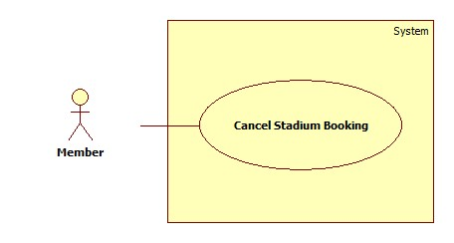

|  |  |  |  |  |
| --- | --- | --- | --- | --- |
| **USE CASE-n SPECIFICATION** | | | | |
| **Use-case No.** | <UC001> | **Use-case Version** | | <1.0> |
| **Use-case Name** | Cancel Stadium Booking | | | |
| **Author** | ThinhND | | | |
| **Date** | 12/02/2014 | **Priority** | High | |
| **Actor:**  Member  **Summary:**  This use case describe how to Cancel a stadium booking  **Goal:**  Cancel a stadium booking  **Triggers:**  Actor click on Cancel button to cancel a stadium booking  **Preconditions:**  N/A  **Post-conditions:**    **Main Success Scenario:**   |  |  |  | | --- | --- | --- | | Step | Actor Action | System Response | | 1 | Click on Cancel button to cancel stadium booking | The system will show a message to confirm | | 2 | Click OK button to confirm this action | The system will update status of this reservation to cancel. |   **Alternative Scenario:**     |  |  | | --- | --- | | Actor Action | System Response | | Click on Cancel button to cancel | The system will back to “Booking Details” page |   **Exceptions:**  N/A  **Relationships:**  N/A  **Business Rules:**  N/A | | | | |

1. Review Stadium

|  |  |  |  |  |
| --- | --- | --- | --- | --- |
| **USE CASE-n SPECIFICATION** | | | | |
| **Use-case No.** | <UC001> | **Use-case Version** | | <1.0> |
| **Use-case Name** | Review Stadium | | | |
| **Author** | ThinhND | | | |
| **Date** | 12/02/2014 | **Priority** | High | |
| **Actor:**  Member  **Summary:**  This use case describe how to write a Review stadium  **Goal:**  Review a stadium  **Triggers:**  Actor write a review in review message box in stadium details page  **Preconditions:**  N/A  **Post-conditions:**    **Main Success Scenario:**   |  |  |  | | --- | --- | --- | | Step | Actor Action | System Response | | 1 | Write a review stadium | The system will create a review in database |   **Alternative Scenario:**     |  |  | | --- | --- | | Actor Action | System Response | |  |  |   **Exceptions:**  N/A  **Relationships:**  N/A  **Business Rules:**  N/A | | | | |

1. Update Account Profiles

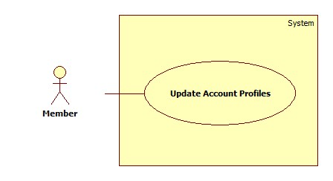

|  |  |  |  |  |
| --- | --- | --- | --- | --- |
| **USE CASE-n SPECIFICATION** | | | | |
| **Use-case No.** | <UC001> | **Use-case Version** | | <1.0> |
| **Use-case Name** | Update Account Profiles | | | |
| **Author** | ThinhND | | | |
| **Date** | 12/02/2014 | **Priority** | High | |
| **Actor:**  Member  **Summary:**  This use case describe how to Update user account profiles  **Goal:**  Update user account profiles  **Triggers:**  Actor click on Edit button to edit account profile  **Preconditions:**  N/A  **Post-conditions:**    **Main Success Scenario:**   |  |  |  | | --- | --- | --- | | Step | Actor Action | System Response | | 1 | Click on Edit button to edit user account profiles information | The system will respond to Edit user account profiles page with information was filled. | | 2 | Enter information into text fields. Click on Save button to finish | The system will update account profiles in database. |   **Alternative Scenario:**     |  |  | | --- | --- | | Actor Action | System Response | | Click on Cancel button to cancel | The system will back to previous page |   **Exceptions:**  N/A  **Relationships:**  N/A  **Business Rules:**  N/A | | | | |

1. Find Rival

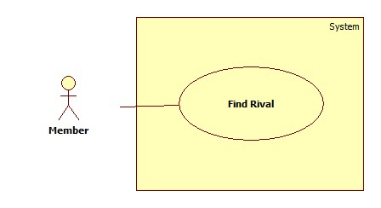

|  |  |  |  |  |
| --- | --- | --- | --- | --- |
| **USE CASE-n SPECIFICATION** | | | | |
| **Use-case No.** | <UC001> | **Use-case Version** | | <1.0> |
| **Use-case Name** | Find Rival | | | |
| **Author** | ThinhND | | | |
| **Date** | 12/02/2014 | **Priority** | High | |
| **Actor:**  Member  **Summary:**  This use case describe how to find rival  **Goal:**  Find rival  **Triggers:**  Actor click on Find Rival button to find  **Preconditions:**  N/A  **Post-conditions:**    **Main Success Scenario:**   |  |  |  | | --- | --- | --- | | Step | Actor Action | System Response | | 1 | Click on Find Rival to find | The system will return rivals list to select | | 2 | Select a rival team | The system will update rival information to reservation details and save in database |   **Alternative Scenario:**     |  |  | | --- | --- | | Actor Action | System Response | | Click on Cancel button to cancel | The system will back to previous page |   **Exceptions:**  N/A  **Relationships:**  N/A  **Business Rules:**  N/A | | | | |

1. Find Available Stadiums

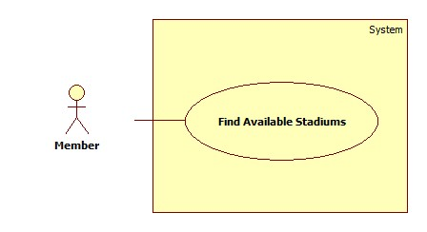

|  |  |  |  |  |
| --- | --- | --- | --- | --- |
| **USE CASE-n SPECIFICATION** | | | | |
| **Use-case No.** | <UC001> | **Use-case Version** | | <1.0> |
| **Use-case Name** | Find Available Stadiums | | | |
| **Author** | ThinhND | | | |
| **Date** | 12/02/2014 | **Priority** | High | |
| **Actor:**  Member  **Summary:**  This use case describe how to find available stadium with conditions of user  **Goal:**  Find all available stadium  **Triggers:**  Actor click on Find button to find available stadium  **Preconditions:**  N/A  **Post-conditions:**    **Main Success Scenario:**   |  |  |  | | --- | --- | --- | | Step | Actor Action | System Response | | 1 | Enter information into text fields conditions of users and click Find to find | The system will return list of all suitable available stadiums |   **Alternative Scenario:**     |  |  | | --- | --- | | Actor Action | System Response | |  |  |   **Exceptions:**  N/A  **Relationships:**  N/A  **Business Rules:**  N/A | | | | |

1. Feedback Website

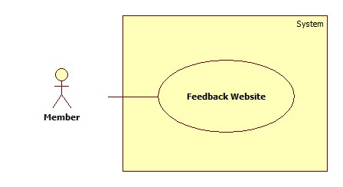

|  |  |  |  |  |
| --- | --- | --- | --- | --- |
| **USE CASE-n SPECIFICATION** | | | | |
| **Use-case No.** | <UC001> | **Use-case Version** | | <1.0> |
| **Use-case Name** | Feedback Website | | | |
| **Author** | ThinhND | | | |
| **Date** | 12/02/2014 | **Priority** | High | |
| **Actor:**  Member  **Summary:**  This use case describe how to feedback website  **Goal:**  Feedback website to webmaster  **Triggers:**  Actor click on Feedback button to write feedback to page  **Preconditions:**  N/A  **Post-conditions:**    **Main Success Scenario:**   |  |  |  | | --- | --- | --- | | Step | Actor Action | System Response | | 1 | Click on Feedback button to feedback about website problems | The system will respond to Feedback website page | | 2 | Enter information into text fields. Click on Send button to finish | The system will send an email to webmaster. |   **Alternative Scenario:**     |  |  | | --- | --- | | Actor Action | System Response | | Click on Cancel button to cancel | The system will respond to home page |   **Exceptions:**  N/A  **Relationships:**  N/A  **Business Rules:**  N/A | | | | |

1. Challenging

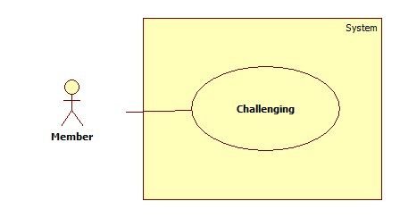

|  |  |  |  |  |
| --- | --- | --- | --- | --- |
| **USE CASE-n SPECIFICATION** | | | | |
| **Use-case No.** | <UC001> | **Use-case Version** | | <1.0> |
| **Use-case Name** | Challenging | | | |
| **Author** | ThinhND | | | |
| **Date** | 12/02/2014 | **Priority** | High | |
| **Actor:**  Member  **Summary:**  This use case describe how to Manager such as View, Create, Update, and Delete all promotion of stadium.  **Goal:**  Manager all promotion of stadium  **Triggers:**  Actor click on View, Create, Update, Delete button to do with all promotion of stadium  **Preconditions:**  N/A  **Post-conditions:**    **Main Success Scenario:**   |  |  |  | | --- | --- | --- | | Step | Actor Action | System Response | | 1 | Click on Create to create a promotion | The system will respond to Create promotion page | | 2 | Enter information into text fields. Click on Save button to finish | The system will create new promotion in database. | | 3 | Click on promotion to view | The system will show the promotion with the information | | 4 | Click on Edit button to change promotion information | The system will show the promotion with page of information was filled |   **Alternative Scenario:**     |  |  | | --- | --- | | Actor Action | System Response | | Click on Cancel button to cancel | The system will back to previous page |   **Exceptions:**  N/A  **Relationships:**  N/A  **Business Rules:**  N/A | | | | |

1. Find Stadium

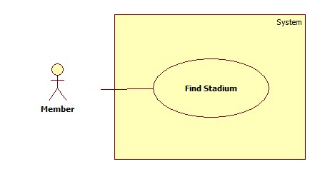

|  |  |  |  |  |
| --- | --- | --- | --- | --- |
| **USE CASE-n SPECIFICATION** | | | | |
| **Use-case No.** | <UC001> | **Use-case Version** | | <1.0> |
| **Use-case Name** | Stadium Promotion Management | | | |
| **Author** | ThinhND | | | |
| **Date** | 12/02/2014 | **Priority** | High | |
| **Actor:**  Member  **Summary:**  This use case describe how to Manager such as View, Create, Update, and Delete all promotion of stadium.  **Goal:**  Manager all promotion of stadium  **Triggers:**  Actor click on View, Create, Update, Delete button to do with all promotion of stadium  **Preconditions:**  N/A  **Post-conditions:**    **Main Success Scenario:**   |  |  |  | | --- | --- | --- | | Step | Actor Action | System Response | | 1 | Click on Create to create a promotion | The system will respond to Create promotion page | | 2 | Enter information into text fields. Click on Save button to finish | The system will create new promotion in database. | | 3 | Click on promotion to view | The system will show the promotion with the information | | 4 | Click on Edit button to change promotion information | The system will show the promotion with page of information was filled |   **Alternative Scenario:**     |  |  | | --- | --- | | Actor Action | System Response | | Click on Cancel button to cancel | The system will back to previous page |   **Exceptions:**  N/A  **Relationships:**  N/A  **Business Rules:**  N/A | | | | |

1. View Stadium Booking History

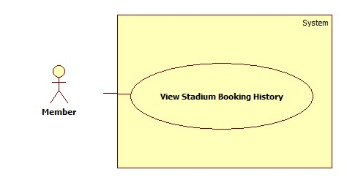

|  |  |  |  |  |
| --- | --- | --- | --- | --- |
| **USE CASE-n SPECIFICATION** | | | | |
| **Use-case No.** | <UC001> | **Use-case Version** | | <1.0> |
| **Use-case Name** | Stadium Promotion Management | | | |
| **Author** | ThinhND | | | |
| **Date** | 12/02/2014 | **Priority** | High | |
| **Actor:**  Member  **Summary:**  This use case describe how to Manager such as View, Create, Update, and Delete all promotion of stadium.  **Goal:**  Manager all promotion of stadium  **Triggers:**  Actor click on View, Create, Update, Delete button to do with all promotion of stadium  **Preconditions:**  N/A  **Post-conditions:**    **Main Success Scenario:**   |  |  |  | | --- | --- | --- | | Step | Actor Action | System Response | | 1 | Click on Create to create a promotion | The system will respond to Create promotion page | | 2 | Enter information into text fields. Click on Save button to finish | The system will create new promotion in database. | | 3 | Click on promotion to view | The system will show the promotion with the information | | 4 | Click on Edit button to change promotion information | The system will show the promotion with page of information was filled |   **Alternative Scenario:**     |  |  | | --- | --- | | Actor Action | System Response | | Click on Cancel button to cancel | The system will back to previous page |   **Exceptions:**  N/A  **Relationships:**  N/A  **Business Rules:**  N/A | | | | |

1. View Stadium's Details

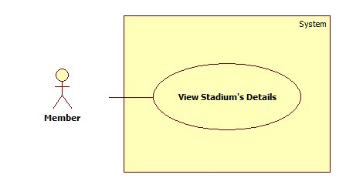

|  |  |  |  |  |
| --- | --- | --- | --- | --- |
| **USE CASE-n SPECIFICATION** | | | | |
| **Use-case No.** | <UC001> | **Use-case Version** | | <1.0> |
| **Use-case Name** | Stadium Promotion Management | | | |
| **Author** | ThinhND | | | |
| **Date** | 12/02/2014 | **Priority** | High | |
| **Actor:**  Member  **Summary:**  This use case describe how to Manager such as View, Create, Update, and Delete all promotion of stadium.  **Goal:**  Manager all promotion of stadium  **Triggers:**  Actor click on View, Create, Update, Delete button to do with all promotion of stadium  **Preconditions:**  N/A  **Post-conditions:**    **Main Success Scenario:**   |  |  |  | | --- | --- | --- | | Step | Actor Action | System Response | | 1 | Click on Create to create a promotion | The system will respond to Create promotion page | | 2 | Enter information into text fields. Click on Save button to finish | The system will create new promotion in database. | | 3 | Click on promotion to view | The system will show the promotion with the information | | 4 | Click on Edit button to change promotion information | The system will show the promotion with page of information was filled |   **Alternative Scenario:**     |  |  | | --- | --- | | Actor Action | System Response | | Click on Cancel button to cancel | The system will back to previous page |   **Exceptions:**  N/A  **Relationships:**  N/A  **Business Rules:**  N/A | | | | |

1. Request Join System

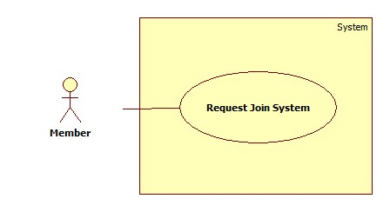

|  |  |  |  |  |
| --- | --- | --- | --- | --- |
| **USE CASE-n SPECIFICATION** | | | | |
| **Use-case No.** | <UC001> | **Use-case Version** | | <1.0> |
| **Use-case Name** | Stadium Promotion Management | | | |
| **Author** | ThinhND | | | |
| **Date** | 12/02/2014 | **Priority** | High | |
| **Actor:**  Member  **Summary:**  This use case describe how to Manager such as View, Create, Update, and Delete all promotion of stadium.  **Goal:**  Manager all promotion of stadium  **Triggers:**  Actor click on View, Create, Update, Delete button to do with all promotion of stadium  **Preconditions:**  N/A  **Post-conditions:**    **Main Success Scenario:**   |  |  |  | | --- | --- | --- | | Step | Actor Action | System Response | | 1 | Click on Create to create a promotion | The system will respond to Create promotion page | | 2 | Enter information into text fields. Click on Save button to finish | The system will create new promotion in database. | | 3 | Click on promotion to view | The system will show the promotion with the information | | 4 | Click on Edit button to change promotion information | The system will show the promotion with page of information was filled |   **Alternative Scenario:**     |  |  | | --- | --- | | Actor Action | System Response | | Click on Cancel button to cancel | The system will back to previous page |   **Exceptions:**  N/A  **Relationships:**  N/A  **Business Rules:**  N/A | | | | |