## Report No.6: System User’s Manual

##### 6.1. Installation Guide

##### 6.2. User’s Guide

6.2.1. Website Staff

6.2.1.1. Join Request Management

6.2.1.2. Stadium Management

6.2.1.3. User Management

6.2.1.4. Advertise Management

6.2.1.5. Member Rank Management

6.2.2. Stadium Staff

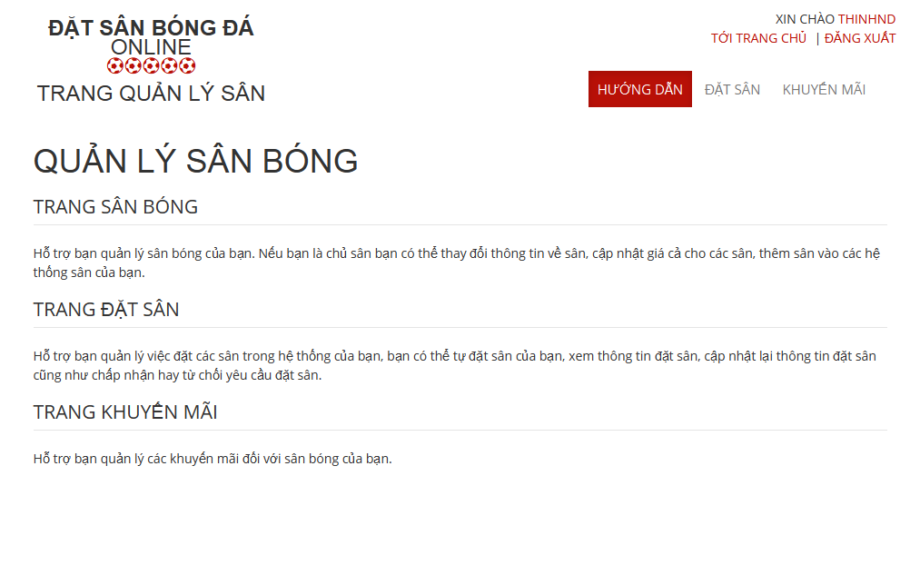

6.2.2.1 Stadium Management

6.2.2.2 Field Management

6.2.2.3 Promotion Management

6.2.2.3.1. View List Promotions

- Step 1: Click “Khuyến mãi” link in Stadium Management page

- Step 2: Choose Stadium to view promotions of that stadium

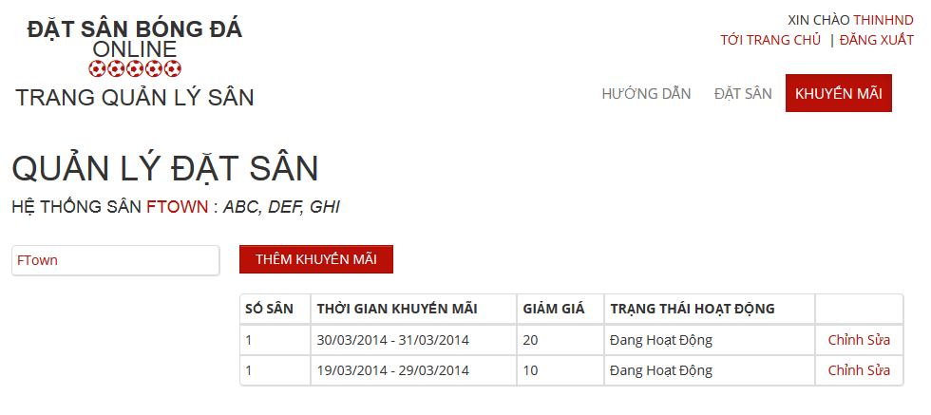

6.2.2.3.2. Add New Promotion

- Step 1: Click “Thêm khuyến mãi” button from Promotion Management page

- Step 2: Input information about promotion

- Step 3: Click “Lưu” button to save or click “Huỷ bỏ” to cancel

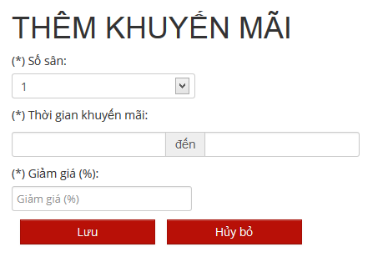

6.2.2.3.3. Edit Promotion

- Step 1: Click “Chỉnh sửa” link on what promotion you wanna edit

- Step 2: Change information about that promotion

- Step 3: Click “Lưu” button to save or click “Huỷ bỏ” to cancel

6.2.2.4 Reservation Management

6.2.3. User

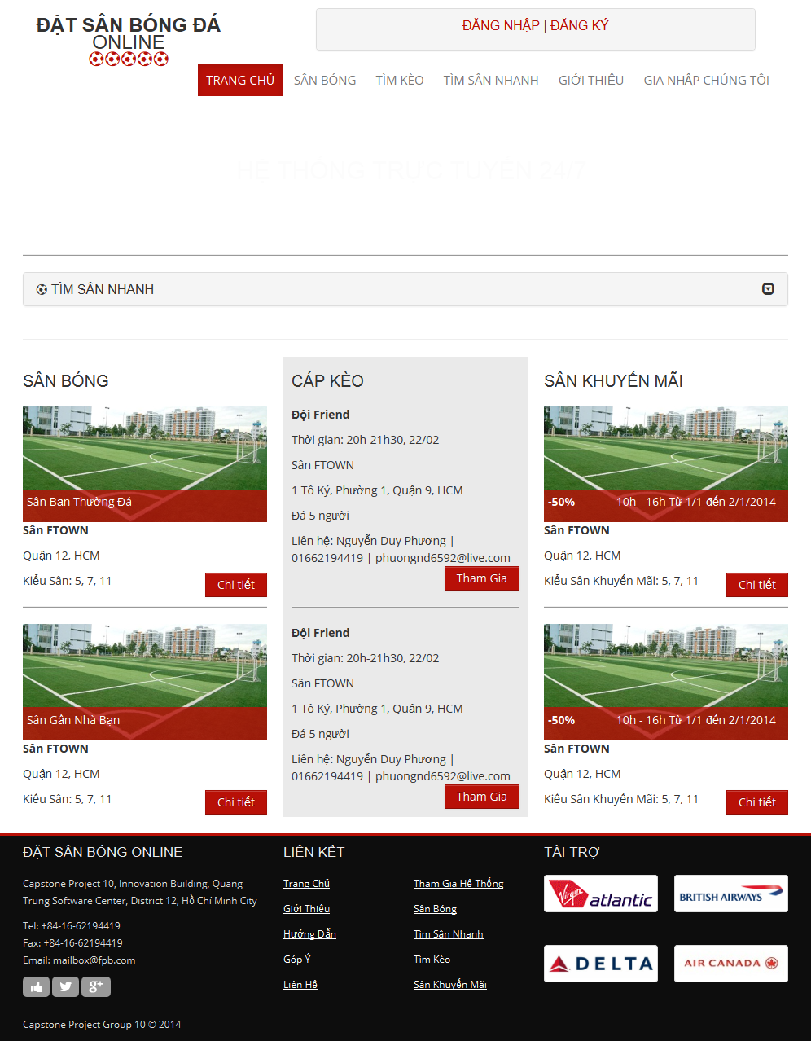

6.2.3.1. Register

- Step 1: Click “Đăng ký” link on home page.

- Step 2: Input all required field

- Step 3: Click “Đăng ký” button to register, or click “Huỷ bỏ” button to cancel

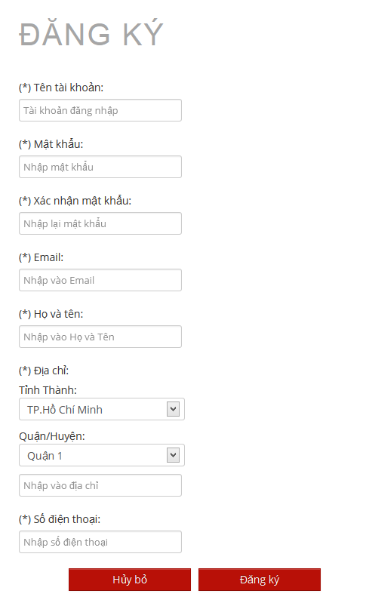

6.2.3.2. Login

- Step 1: Click “Đăng nhập” link on home page

- Step 2: Input username and password

- Step 3: Click “Đăng nhập” button

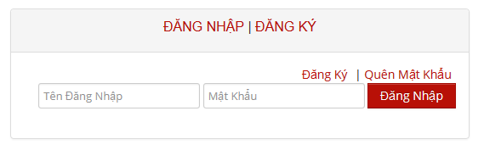

6.2.3.3. View Account Profiles

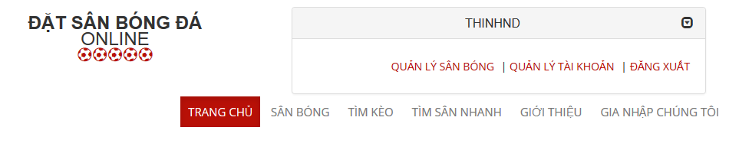

* Step 1: Click username link to open management window
* Step 2: Click “Quản lý tài khoản” link

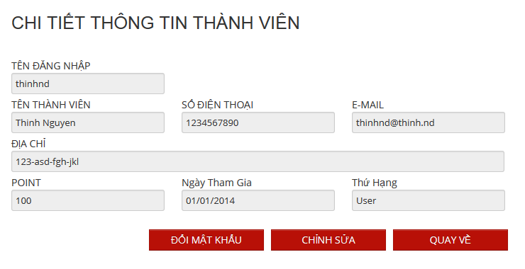

6.2.3.4. Edit Account Profiles

Edit Account Profiles

- Step 1: Click “Chỉnh sửa” button from view account profiles page

- Step 2: Change account profiles information

- Step 3: Click “Lưu” to save or click “Quay về” to cancel and back to view account profiles page

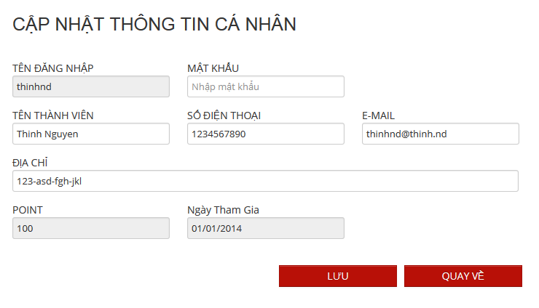

Change Password:

* Step 1: Click “Đổi mật khẩu” button from view account profiles page
* Step 2: Input old and new password, confirm password
* Step 3: Click button “Lưu” to save new password or click “Quay về” button to cancel and back to view account profiles page

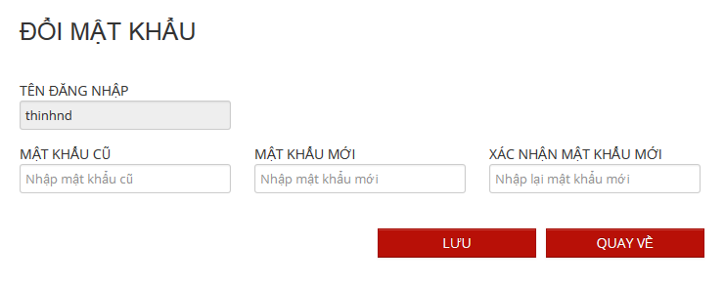

6.2.3.5. Find Available Stadium

- Step 1: Click “Tìm sân nhanh” link or open “Tìm sân nhanh” board at home page

- Step 2: Choose information

- Step 3: Click “Tìm kiếm” to find available stadium

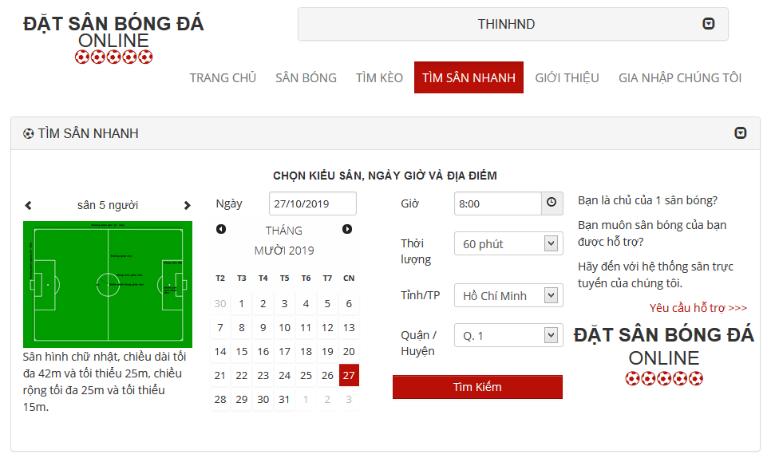

6.2.3.6. Find Stadium

6.2.3.7. View Stadium Details

6.2.3.8. Rating Stadium

6.2.3.9. Review Stadium

6.2.3.10. Booking Pitches

6.2.3.11. Cancel Reservation

6.2.3.12. Find Rival

6.2.3.13. Join Rival

6.2.3.14. View Booking History

6.2.3.15. Request Join System

- Step 1: Click “Gia nhập chúng tôi” link from home page

- Step 2: Input all require information

- Step 3: Click “Gửi yêu cầu” to send this request or click “Trang chủ” link to back to home page

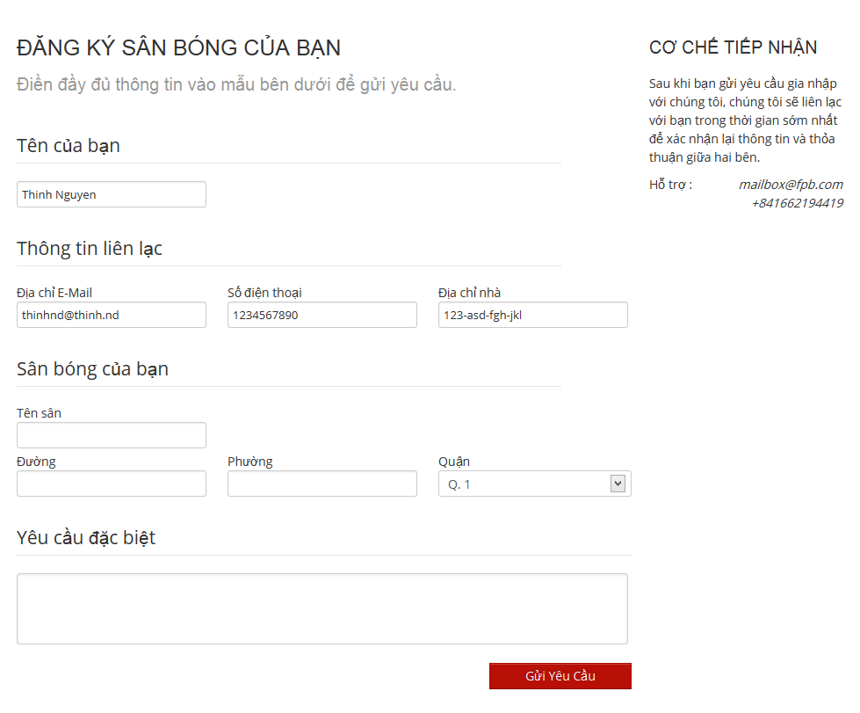

6.2.3.16. Feedback Website

##### 6.3. Other [Optional]