**MINISTRY OF EDUCATION AND TRAINING**

**FPT UNIVERSITY**

Capstone Project Document

Football Pitches Booking

|  |  |
| --- | --- |
| **Group 10** | |
| **Group Members** | Nguyễn Duy Phương – SE60761 – [phuongndse60761@fpt.edu.vn](mailto:phuongndse60761@fpt.edu.vn)  Nguyễn Hữu Hoàng Giang – SE60606 – [giangnhhse60606@fpt.edu.vn](mailto:giangnhhse60606@fpt.edu.vn)  Nguyễn Đức Thịnh – 60398 – [thinhnd60398@fpt.edu.vn](mailto:thinhnd60398@fpt.edu.vn)  Nguyễn Quốc Khánh – 60556 – [khanhnq60556@fpt.edu.vn](mailto:khanhnq60556@fpt.edu.vn) |
| **Supervisor** | Lại Đức Hùng |
| **Ext Supervisor** |  |
| **Capstone Project code** | FPB |

- Ho Chi Minh, 01/2014 –

Contents

Report No.1: Introduction 4

Report No.2: Project Management Plan (PMP) 4

Report No.3: System Requirements Specifications (SRS) 4

Report No.4: System Design Description (SDD) 6

Report No.5: System Implementation & Test (SIT) 7

Report No.6: System User’s Manual 8

## Report No.1: Introduction

This part is about the group of developers, the initial idea of the group’s Capstone project, overview of similar existing solutions, overview of existing methods, business outline, limitations of the existing system. From that point, you will advance your knowledge/skill levels in the topic you have chosen, and benefits of expected system.

*<Introduction to this document, how it is organized, and what it contains>*

## Report No.2: Project Management Plan (PMP)

##### 2.1. Problem Definition

2.1.1. Name of this CapStone Project

2.1.2. Problem Abstract

*<Write down the problem abstract. This can be paraphrased from the Customer’s Requirement>*

2.1.3. Project Overview

2.1.3.1. The Current System

*<Describe the current system/situation. This can be paraphrased from the Customer’s*

*Requirements>*

2.1.3.2. The Proposed System

*<Describe the system under development. This can be paraphrased from the Customer’s Requirements>*

2.1.3.3. Boundaries of the System

*<List the scope/boundaries of the system under development. This can be paraphrased from the Customer’s Requirements>*

2.1.3.4. Development Environment

*<Describe the environment for system under development. Include software and hardware requirements>*

##### 2.2. Project organization

2.2.1. System Process Model

2.2.2. Roles and Responsibilities

###### 2.2.3. Tools and Techniques

##### 2.3. Project management plan

2.3.1. Tasks:

2.3.1.n Task-n:

Description

Deliverables

Resources Needed

Dependencies and Constraints

Risks



2.3.2. Task Sheet: Assignments and Timetable

2.3.3. All Meeting Minutes

*<Put all your-team’s meeting minutes here as an appendix >*

##### 2.4. Convention Rules

##### 2.5. Other material (if any)

## Report No.3: System Requirements Specifications (SRS)

##### 3.1. User Requirement Specification

*<Summarize the customer requirements in a compact form>*

##### 3.2. System Requirement Specification (Specific Requirements)

*<Summarize the system requirements in a compact form>*

3.2.1. External Interface Requirements

3.2.1.1. User Interfaces

3.2.1.2. Hardware Interfaces (if any)

3.2.1.3. System Interfaces (if any)

3.2.1.4. Communications Protocol 3.2.2. Functional Requirements

3.2.2.n. Functional Requirement n

3.2.2.n.1. Use Case-n Diagram (otherwise use another model)

3.2.2.n.2 .Use Case-n Specification

*<Write down all non-trivial use cases. This should reflect what you get when your team does the system analysis. Use the template to write a detailed specification for use cases>*

|  |  |  |  |  |
| --- | --- | --- | --- | --- |
| **USE CASE-n SPECIFICATION** | | | | |
| **Use-case No.** | <UC001> | **Use-case Version** | | <1.0> |
| **Use-case Name** | <Name> | | | |
| **Author** | <Members> | | | |
| **Date** | Dd/mm/yyyy | **Priority** | <High/Normal/Low> | |
| **Actor:**  *<Lit all actors>*  **Summary:**  *<Briefly describe the used case >*  **Goal:**  *<Briefly describe the goal of used case >*  **Triggers**  *<What does lead in using this case?>*  **Preconditions:** | | | | |
| *<List the required pre-conditions for using this case>* **Post Conditions:**  *<List the required post-conditions for using this case>*  **Main Success Scenario:**  *<List the main steps for using this case to reach the goal successfully >*  **Alternative Scenario:**  *<List other steps for using this case to reach the goal in some alternative conditions >*  **Exceptions:**  *<List exceptions of this use case >*  **Relationships:**  *<List the relationships that use case relates to>*  **Business Rules:**  *<Any concern about the business>* | | | | |

3.2.3. Non-Functional Requirements

3.2.3.1 Reliability

3.2.3.2 Availability

3.2.3.3 Security

3.2.3.4 Maintainability

3.2.3.5 Portability

3.2.3.6 Performance

##### 3.3. Entity Relationship Diagram or Data Structures (if any)

*<Provide the ERD Diagram for the system here. If your team uses a file or in-memory storage facility instead of a database, replace this section by ‘Data Structures’. Note, use only ERD or Data Structures>*

##### 3.4. Other material (if any)

## Report No.4: System Design Description (SDD)

##### 4.1. Design Overview

##### 4.2. System Architectural Design

4.2.1 Choice of System Architecture

4.2.2 Discussion of Alternative Designs

4.2.3 Description of System Interface

##### 4.3. Component Diagram

##### 4.4. Detailed Description of Components

###### 4.4.1. CRC Cards (Class-Responsibility-Collaborators) (if any)

4.4.1.*n.* Component-*n*

4.4.1.n.1. Class Diagram

4.4.2.n.2. Class Diagram Explanation

*<Provide a brief explanation of the class diagram above. You do not need to explain*

*“obvious” parts of your class diagram>*

4.4.3.n.3. Algorithms of important methods in each class, specified in pseudo code or by Flow-Chart

##### 4.5. Sequence Diagram

##### 4.6. User Interface Design/ Hardware Interface Design (if any)

4.6.1 Description of the User Interface

4.12.1.1 Screen Images/ Hardware Description

4.12.1.2 Objects and Actions/ Component

##### 4.7. Database Design or Data Structures or algorithms

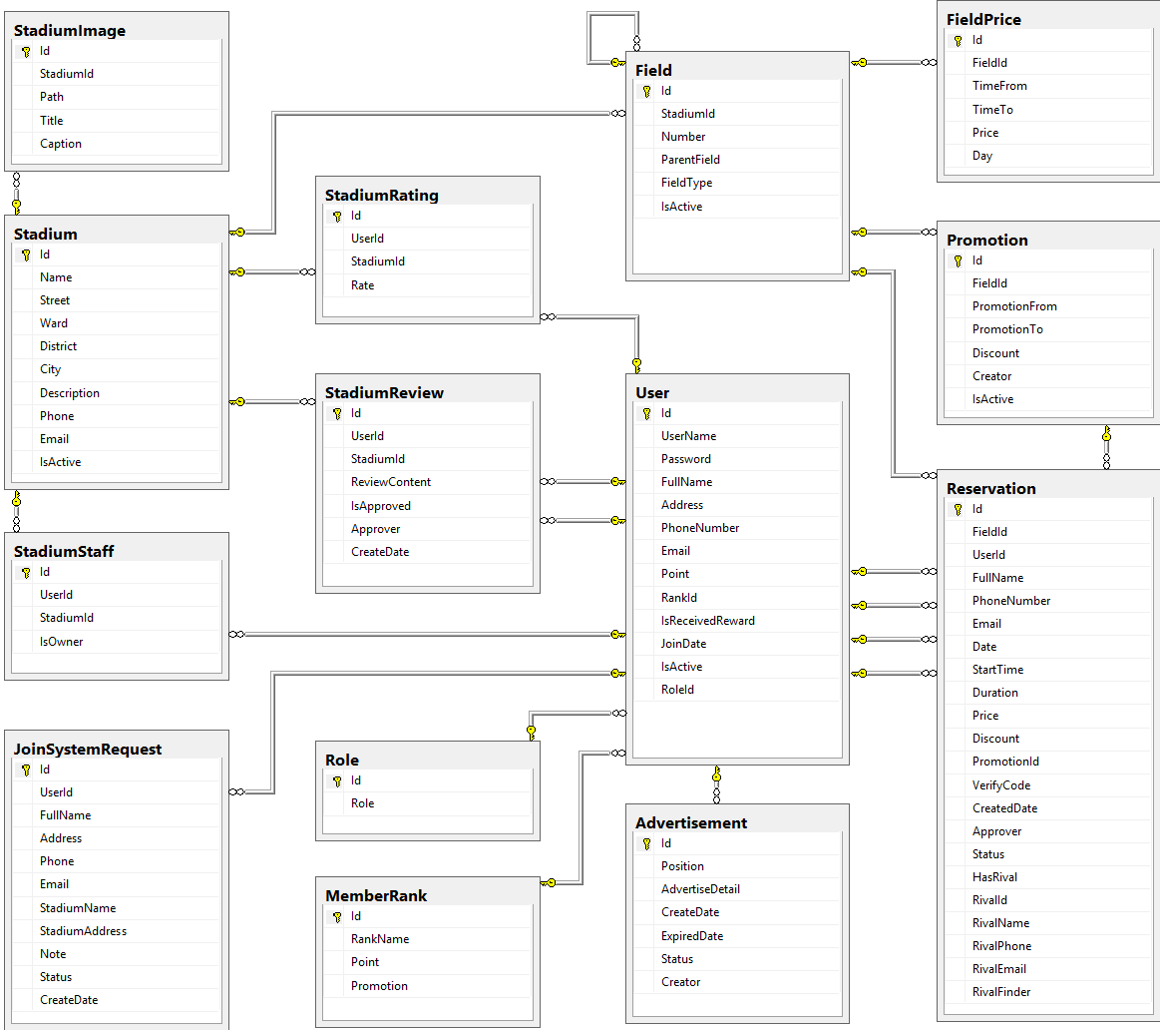

* + 1. Tables description

|  |  |  |
| --- | --- | --- |
| No. | Table name | Description |
| 1 | Advertisement | Store information about advertising of website |
| 2 | Field | Store information about fields in system |
| 3 | FieldPrice | Store information about price of fields in system |
| 4 | JoinSystemRequest | Store information about join system requests in system |
| 5 | MemberRank | Store information about rank of member in system |
| 6 | Promotion | Store information about promotions of stadiums in system |
| 7 | Reservation | Store information about reservations of stadiums in system |
| 8 | Stadium | Store information about stadiums in system |
| 9 | StadiumImage | Store information about images of stadiums in system |
| 10 | StadiumRating | Store information about rating of stadiums in system |
| 11 | StadiumReview | Store information about reviews of stadiums in system |
| 12 | StadiumStaff | Store information about staffs of stadiums in system |
| 13 | User | Store information about users in system |
| 14 | Role | Store information about roles of user in system |

* + 1. Advertisement

|  |  |  |  |  |  |  |
| --- | --- | --- | --- | --- | --- | --- |
| Field name | Type | Null | Unique | P/F key | Default | Description |
| Id | int |  |  | PK |  | The index of this advertising |
| Position | nvarchar(10) |  |  |  |  | The position to display of the advertising |
| AdvertiseDetail | ntext |  |  |  |  | The content of this advertising |
| CreateDate | date |  |  |  |  | The date when this advertising is created |
| ExpiredDate | date |  |  |  |  | The date when this advertising is expired |
| Status | nvarchar(50) |  |  |  |  | The status of this advertising |
| Creator | int | true |  | FK |  | The creator who is created this advertising |

* + 1. Field

|  |  |  |  |  |  |  |
| --- | --- | --- | --- | --- | --- | --- |
| Field name | Type | Null | Unique | P/F key | Default | Description |
| Id | int |  |  | PK |  | The index of this field |
| StadiumId | int |  |  | FK |  | The index of stadium which contain this field |
| Number | nvarchar(5) |  |  |  |  | The number of this field |
| ParentField | int | true |  | FK |  | The index of field which is parent of this field |
| FieldType | int |  |  |  |  | The type of this field |
| IsActive | bit | true |  |  |  | The status of this field |

* + 1. FieldPrice

|  |  |  |  |  |  |  |
| --- | --- | --- | --- | --- | --- | --- |
| Field name | Type | Null | Unique | P/F key | Default | Description |
| Id | int |  |  | PK |  | The index of price of field |
| FieldId | int |  |  | FK |  | The index of field |
| TimeFrom | float |  |  |  |  | The price of field begin from this time |
| TimeTo | float |  |  |  |  | The price of field end from this time |
| Price | float |  |  |  |  | The price of field |
| Day | int |  |  |  |  | The price of fiend in this day |

* + 1. JoinSystemRequest

|  |  |  |  |  |  |  |
| --- | --- | --- | --- | --- | --- | --- |
| Field name | Type | Null | Unique | P/F key | Default | Description |
| Id | int |  |  | PK |  | The index of this join system request |
| UserId | int |  |  | FK |  | The user who send this join system request |
| FullName | nvarchar(50) |  |  |  |  | The full name of user who send this join system request |
| Address | nvarchar(100) |  |  |  |  | The address of user who send this join system request |
| Phone | nvarchar(20) |  |  |  |  | The phone number of user who send this join system request |
| Email | nvarchar(50) |  |  |  |  | The email of user who send this join system request |
| StadiumName | nvarchar(100) |  |  |  |  | The name of stadium which is user want to join system |
| StadiumAddress | nvarchar(100) |  |  |  |  | The address of stadium which is user want to join system |
| Note | nvarchar(1000) | true |  |  |  | The note of this request |
| Status | nvarchar(50) |  |  |  |  | The status of this request |
| CreateDate | datetime |  |  |  |  | The date when this request is created |

* + 1. MemberRank

|  |  |  |  |  |  |  |
| --- | --- | --- | --- | --- | --- | --- |
| Field name | Type | Null | Unique | P/F key | Default | Description |
| Id | int |  |  | PK |  | The index of this rank |
| RankName | nvarchar(50) | true |  |  |  | The name of this rank |
| Point | int | true |  |  |  | This point is condition to have this user rank |
| Promotion | nvarchar(500) | true |  |  |  | The promotion for user who have this rank |

* + 1. Promotion

|  |  |  |  |  |  |  |
| --- | --- | --- | --- | --- | --- | --- |
| Field name | Type | Null | Unique | P/F key | Default | Description |
| Id | int |  |  | PK |  | The index of this promotion |
| FieldId | int |  |  | FK |  | The index of field which this promotion apply |
| PromotionFrom | date |  |  |  |  | The time when this promotion is started |
| PromotionTo | date |  |  |  |  | The time when this promotion is finished |
| Discount | float |  |  |  |  | The discount per cent of this promotion |
| Creator | int | true |  |  |  | The creator who is created this promotion |
| IsActive | bit | true |  |  |  | The status of this promotion |

* + 1. Reservation

|  |  |  |  |  |  |  |
| --- | --- | --- | --- | --- | --- | --- |
| Field name | Type | Null | Unique | P/F key | Default | Description |
| Id | int |  |  | PK |  | The index of this reservation |
| FieldId | int |  |  | FK |  | The index of field is booked |
| UserId | int | true |  | FK |  | The index of user who book the field |
| FullName | nvarchar(50) |  |  |  |  | The full name of user who book the field |
| PhoneNumber | nvarchar(20) |  |  |  |  | The phone number of user who book the field |
| Email | nvarchar(50) | true |  |  |  | The email of user who book the field |
| Date | date |  |  |  |  | The date that is booked the field |
| StartTime | float |  |  |  |  | The start time when user need the field |
| Duration | float |  |  |  |  | The duration time that user need the field |
| Price | float |  |  |  |  | The price of field |
| Discount | float | true |  |  |  | The discount per cent of the promotion is applied to this reservation |
| PromotionId | int | true |  |  |  | The index of the promotion is applied to this reservation |
| VerifyCode | nvarchar(50) |  |  |  |  | The code which use for verifying this reservation |
| CreatedDate | datetime |  |  |  |  | The date when this reservation is created |
| Approver | int | true |  | FK |  | The index of stadium staff who approve this reservation |
| Status | nvarchar(20) |  |  |  |  | The status about approving of this reservation |
| HasRival | bit |  |  |  |  | The status about having rival of this reservation |
| RivalId | int | true |  | FK |  | The index of rival who join this request rival of this reservation |
| RivalName | nvarchar(50) | true |  |  |  | The name of rival who join this request rival of this reservation |
| RivalPhone | nvarchar(20) | true |  |  |  | The phone number of rival who join this request rival of this reservation |
| RivalEmail | nvarchar(50) | true |  |  |  | The email of rival who join this request rival of this reservation |
| RivalFinder | int | true |  |  |  | The index of user who find rival for this request rival of this reservation |

* + 1. Stadium

|  |  |  |  |  |  |  |
| --- | --- | --- | --- | --- | --- | --- |
| Field name | Type | Null | Unique | P/F key | Default | Description |
| Id | int |  |  | PK |  | The index of this stadium |
| Name | nvarchar(100) |  |  |  |  | The name of this stadium |
| Street | nvarchar(50) |  |  |  |  | The street address of this stadium |
| Ward | nvarchar(50) |  |  |  |  | The ward address of this stadium |
| District | nvarchar(50) |  |  |  |  | The district address of this stadium |
| City | nvarchar(50) |  |  |  |  | The city address of this stadium |
| Description | nvarchar(500) |  |  |  |  | The description about this stadium |
| Phone | nvarchar(20) |  |  |  |  | The phone number to contact with this stadium staff |
| Email | nvarchar(50) |  |  |  |  | The email to contact with this stadium staff |
| IsActive | bit | true |  |  |  | The status of this stadium |

* + 1. StadiumImage

|  |  |  |  |  |  |  |
| --- | --- | --- | --- | --- | --- | --- |
| Field name | Type | Null | Unique | P/F key | Default | Description |
| Id | int |  |  | PK |  | The index of this image |
| StadiumId | int |  |  | FK |  | The index of stadium which the image about |
| Path | nvarchar(100) |  |  |  |  | The path of this image store in server |
| Title | nvarchar(100) | true |  |  |  | The title of this image |
| Caption | nvarchar(200) | true |  |  |  | The caption of this image |

* + 1. StadiumRating

|  |  |  |  |  |  |  |
| --- | --- | --- | --- | --- | --- | --- |
| Field name | Type | Null | Unique | P/F key | Default | Description |
| Id | int |  |  | PK |  | The index of this rating |
| UserId | int |  |  | FK |  | The index of user who rate the stadium |
| StadiumId | int |  |  | FK |  | The index of stadium which is rated |
| Rate | float |  |  |  |  | The point of this rating |

* + 1. StadiumReview

|  |  |  |  |  |  |  |  |  |  |  |  |  |
| --- | --- | --- | --- | --- | --- | --- | --- | --- | --- | --- | --- | --- |
| Field name | Type | | | Null | | Unique | | P/F key | | Default | | Description |
| Id | | int |  | |  | | PK | |  | | The index of this review | |
| UserId | | int |  | |  | | FK | |  | | The index of user who review the stadium | |
| StadiumId | | int |  | |  | | FK | |  | | The index of stadium which is reviewed | |
| ReviewContent | | nvarchar(500) |  | |  | |  | |  | | The content of this review | |
| IsApproved | | bit |  | |  | |  | |  | | The status about approving of this review | |
| Approver | | int | true | |  | | FK | |  | | The index of stadium staff who approve this review | |
| CreateDate | | datetime |  | |  | |  | |  | | The date when this review is created | |

* + 1. StadiumStaff

|  |  |  |  |  |  |  |  |  |  |  |  |  |
| --- | --- | --- | --- | --- | --- | --- | --- | --- | --- | --- | --- | --- |
| Field name | Type | | Null | | Unique | | P/F key | | Default | | Description | |
| Id | | int | |  | |  | | PK | |  | | The index of this stadium staff |
| UserId | | int | |  | |  | | FK | |  | | The index of user who is staff of stadium |
| StadiumId | | int | |  | |  | | FK | |  | | The index of stadium |
| IsOwner | | bit | |  | |  | |  | |  | | The role of this staff |

* + 1. User

|  |  |  |  |  |  |  |
| --- | --- | --- | --- | --- | --- | --- |
| Field name | Type | Null | Unique | P/F key | Default | Description |
| Id | int |  |  | PK |  | The index of this user |
| UserName | nvarchar(50) |  |  |  |  | The user name of this user |
| Password | nvarchar(50) |  |  |  |  | The password of this user |
| FullName | nvarchar(50) | true |  |  |  | The full name of this user |
| Address | nvarchar(100) | true |  |  |  | The address of this user |
| PhoneNumber | nvarchar(20) | true |  |  |  | The phone number of this user |
| Email | nvarchar(50) |  |  |  |  | The email of this user |
| Point | int |  |  |  |  | The point of this user |
| RankId | int |  |  | FK |  | The index of rank of this user |
| IsReceivedReward | bit |  |  |  |  | The status about receiving reward of this user |
| JoinDate | date |  |  |  |  | The date when user register at website |
| IsActive | bit |  |  |  |  | The status of this user |
| RoleId | int |  |  |  |  | The index of role of this user |

* + 1. Role

|  |  |  |  |  |  |  |  |  |  |  |  |  |
| --- | --- | --- | --- | --- | --- | --- | --- | --- | --- | --- | --- | --- |
| Field name | Type | | Null | | Unique | | P/F key | | Default | | Description | |
| Id | | int | |  | |  | | PK, FK | |  | | The index of this role |
| Role | | nvarchar(50) | |  | |  | |  | |  | | The name of this role |

##### 4.8. Other material (if any)

## Report No.5: System Implementation & Test (SIT)

##### 5.1. Introduction

5.1.1 System Overview

5.1.2 Test Approach

##### 5.2. Database Relationship Diagrams/Hardware Charts (if any)

##### 5.3. Screen shots/ Performance measures/…

##### 5.4. Test Plan

5.4.1 Features to be tested

5.4.2 Features not to be tested

5.4.3 Testing Tools and Environment

##### 5.5. Test Cases

5.5.*n* Case-*n*

5.5.*n*.1 Purpose

5.5.*n*.2 Inputs

5.5.*n*.3 Expected Outputs & Pass/Fail criteria

5.5.*n*.4 Test Procedure

##### 5.6. Checklists

5.6.1. Checklist of Validation

*<Put the checklist here. Describe how it is used and the resulted checklist>*

5.6.2. Submission Checklist

*<Put the checklist here. Describe how it is used and the resulted checklist>*

##### 5.7. Other material (if any) (including appendix A)

APPENDIX A. TEST LOGS

A.n Log for test *n*

A.n.1 Test Results

A.n.2 Incident Report

## Report No.6: System User’s Manual

##### 6.1. Installation Guide 6.2. User’s Guide

##### 6.3. Other [Optional]