|  |  |
| --- | --- |
| **Logo_FPT_University_doc** | **MINISTRY OF EDUCATION AND TRAINING** |

|  |
| --- |
| **FPT UNIVERSITY** |
| Software User’s Manual |
| SMDH |
|  |
| |  |  | | --- | --- | | **Group 5** | | | **Group Members** | Nguyen Hoang Viet Khanh – Team leader –  Nguyen Do Vuong – Team member – 60075  Nguyen Thi Yen Thinh – Team member – 60269  An Ngoc Anh – Team member – 60168 | | **Supervisor** | Mr. Lam Huu Khanh Phuong | | **Ext Supervisor** |  | | **Capstone Project code** | SMDH | |
|  |

Ho Chi Minh City, 04/2013

**Record of Changes**

|  |  |  |  |  |
| --- | --- | --- | --- | --- |
| **Date** | **Changed Item** | **Description** | **By** | **Version** |
| 16/04/2013 | All | Create Document | ThinhNTY | 0.1 |
| 05/12/2012 | User Guild | Add | HienPTT | 0.1 |
| 05/12/2012 | Review & fix content | Modify | HuyTQ | 1.0 |
|  |  |  |  |  |
|  |  |  |  |  |
|  |  |  |  |  |
|  |  |  |  |  |
|  |  |  |  |  |
|  |  |  |  |  |
|  |  |  |  |  |

Table of Contents

[**1.** **Installation Guide** 6](#_Toc342479030)

[**1.1** **Setting up the environment at server side** 6](#_Toc342479031)

[**1.2** **Deployment at server side** 6](#_Toc342479032)

[**1.3** **Setting up the environment at client side** 14](#_Toc342479033)

[**2** **User‘s Guide** 14](#_Toc342479034)

[**2.1** **User’s Guide** 14](#_Toc342479035)

[**2.1.1** **Login** 14](#_Toc342479036)

[**2.1.2** **Logout** 15](#_Toc342479037)

[**2.1.3** **Edit Account Information** 16](#_Toc342479038)

[**2.2** **Boss’s Guide** 17](#_Toc342479039)

[**2.2.1** **Add Admin** 17](#_Toc342479052)

[**2.2.2** **Withdraw Admin** 19](#_Toc342479053)

[**2.2.3** **De-active/active Admin** 19](#_Toc342479054)

[**2.2.4** **View feedback** 19](#_Toc342479055)

[**2.2.5** **View Report** 20](#_Toc342479056)

[**2.3** **Staff’s Guide** 20](#_Toc342479057)

[**2.3.1** **Send Private Message** 20](#_Toc342479058)

[**2.3.2** **Read Private Message** 20](#_Toc342479059)

[**2.3.3** **Reply Private Message** 21](#_Toc342479060)

[**2.3.4** **Delete Private Message** 21](#_Toc342479061)

[**2.4** **Addmin’s Guide** 23](#_Toc342479062)

[**2.4.1** **Manage Product** 23](#_Toc342479063)

[**2.4.2** **Manage Order** 24](#_Toc342479064)

[**2.4.3** **Manage Delivering Process** 24](#_Toc342479065)

[**2.4.4** **Manage Feedback** 24](#_Toc342479066)

[**2.4.5** **Manage Sales** 24](#_Toc342479075)

[**2.4.6** **Manage Account** 25](#_Toc342479085)

[**2.4.7** **Add Product** 25](#_Toc342479096)

[**2.4.8** **Edit Product** 25](#_Toc342479108)

[**2.4.9** **Search Product By Name** 26](#_Toc342479121)

[**2.4.10** **Add Category** 26](#_Toc342479135)

[**2.4.11** **Edit Category** 27](#_Toc342479150)

[**2.4.12** **Add manufacture** 27](#_Toc342479166)

[**2.4.13** **Edit manufacture** 28](#_Toc342479183)

[**2.4.14** **Search Product By IsSelling** 28](#_Toc342479201)

[**2.4.15** **Assign Order** 28](#_Toc342479202)

[**2.4.16** **Change Order Status** 29](#_Toc342479203)

[**2.4.17** **Set Schedule For Delivering** 30](#_Toc342479224)

[**2.4.18** **View FeedBack** 30](#_Toc342479225)

[**2.4.19** **Reply FeedBack** 30](#_Toc342479248)

[2.4.20 **Set Role To Customer** 30](#_Toc342479272)

[**2.4.21** **Set Role To Deliverer** 30](#_Toc342479273)

[**2.4.22** **Change Account Status** 30](#_Toc342479274)

[**2.4.23** **Add New Sale** 31](#_Toc342479275)

[**2.4.24** **Edit Sale** 32](#_Toc342479276)

[**2.4.25** **Remove Sale** 33](#_Toc342479277)

[**2.4.26** **Search Sale** 33](#_Toc342479278)

[**2.5** **Deliverer’s Guide** 33](#_Toc342479279)

[**2.5.1** **Check Order to delivery** 33](#_Toc342479280)

[**2.5.2** **Search Order Delivery** 34](#_Toc342479281)

[**2.5.3** **Change Order Delivery Status** 34](#_Toc342479282)

[**2.6** **Guest’s Guide** 35](#_Toc342479283)

[**2.6.1** **Register** 35](#_Toc342479284)

[**2.6.2** **Forget Password** 36](#_Toc342479285)

[**2.6.3** **View Product List** 36](#_Toc342479286)

[**2.6.4** **View Product Detail** 37](#_Toc342479287)

[**2.6.5** **View Price History** 39](#_Toc342479288)

[**2.6.6** **View Comments** 39](#_Toc342479289)

[**2.6.7** **Add To Cart** 40](#_Toc342479302)

[**2.6.8** **View Current Order** 41](#_Toc342479316)

[**2.6.9** **Remove Product from Cart** 42](#_Toc342479317)

[**2.6.10** **Edit Product Quantity** 42](#_Toc342479318)

[**2.6.11** **View Feedback List** 43](#_Toc342479336)

[**2.6.12** **View Feedback** 43](#_Toc342479354)

[**2.6.13** **Search by Title** 44](#_Toc342479374)

[**2.6.14** **Search by Categories** 44](#_Toc342479395)

[**2.6.15** **Search by Color** 45](#_Toc342479396)

[**2.6.16** **Sort Product** 45](#_Toc342479397)

[**2.6.17** **Search by Price Range** 46](#_Toc342479398)

[**2.7** **Customer’s Guide** 46](#_Toc342479399)

[**2.7.1** **Comment Product** 46](#_Toc342479400)

[**2.7.2** **Rating Product** 47](#_Toc342479401)

[**2.7.3** **Flag Comment** 48](#_Toc342479411)

[**2.7.4** **Add Product to Collection** 49](#_Toc342479422)

[**2.7.5** **Submit Order** 50](#_Toc342479434)

[**2.7.6** **View User Detail** 51](#_Toc342479435)

[**2.7.7** **Update User Detail** 51](#_Toc342479436)

[**2.7.8** **View Collection** 52](#_Toc342479451)

[**2.7.9** **Remove Item from Collection** 52](#_Toc342479452)

[**2.7.10** **View Histories Order** 53](#_Toc342479469)

[**2.7.11** **Create Feedback** 53](#_Toc342479487)

# **Installation Guide**

## **Setting up the environment at server side**

The following software must be installed into the server machine:

#### **Hardware requirements:**

* Personal computers for developing with the minimum configuration: CPU Core 2 Duo 2.0GHz, 2GB of RAM, 120GB of hard disk, and internet.

#### **Software requirements**:

* + Operating system: Windows 7
  + Web Server: TomCat 7.0
  + Microsoft Windows 7: operating system and platform for development
  + Microsoft SQL Server 2008: used to create and manage the database for web application

## **Deployment at server side**

#### **Prepare deployment package**

* Extract the deployment package toa folder on the server.
* *For exmaple: E:\Capstone Project\SVN*

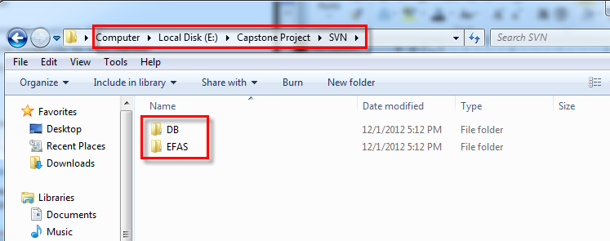

#### **Deploy database**

* Open Microsoft SQL Server Management Studio
* Create a database named **EFDB**

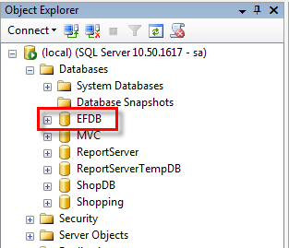

* Right click on the EFAM database and choose **Tasks -> Restore -> Database…**

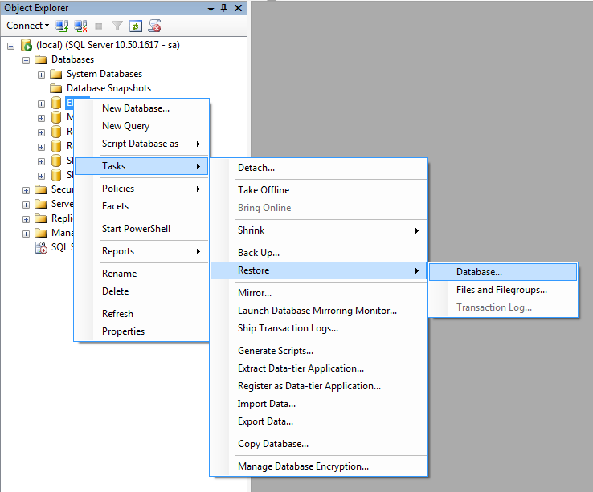

* Choose From **device** and clicks … (**3** **dots**) button

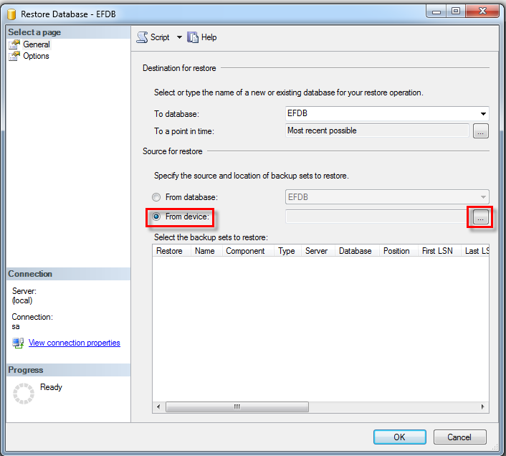

* Click **Add** button

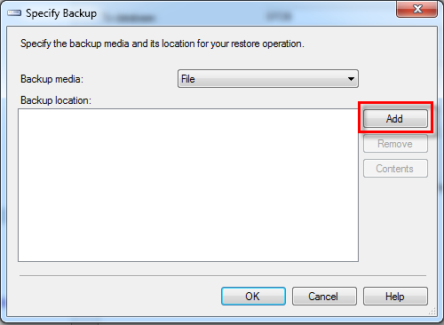

* Browse to **EFDB.bak** file in **<deployment package>\DB** folder and click

**OK** button **two** times for backing to the Restore Database - EFDB dialog

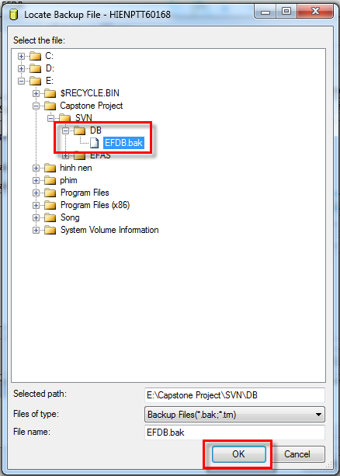

* Check the checkbox in **Restore** column, and then click **Options**

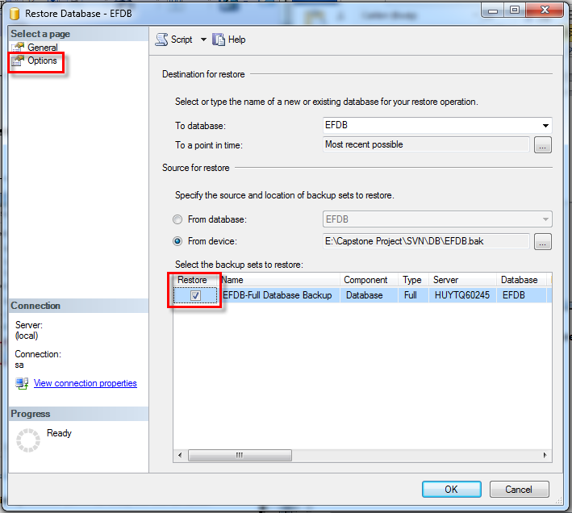

* Check **Overwrite the existing database (WITH REPLACE)** and click **OK** button

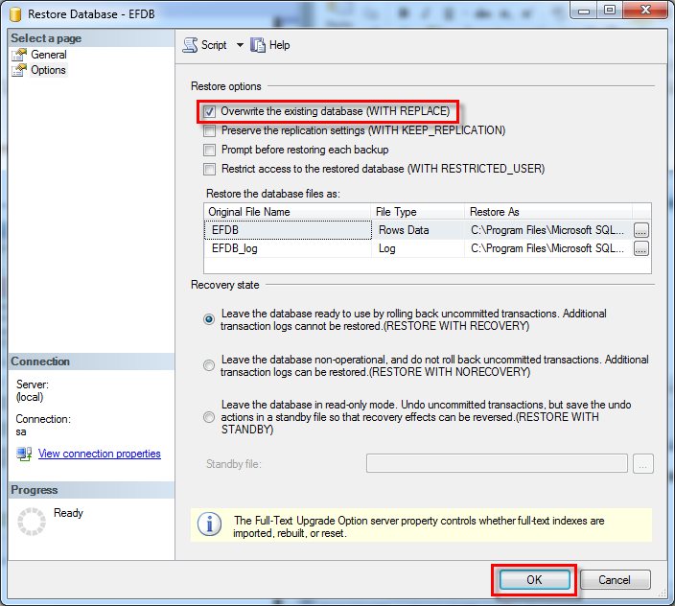

\*IMPORTANT:

Run this script in DBMS to enable cross storeprocedure call

USE [EFDB]

GO

sp\_configure 'Show Advanced Options', 1

GO

RECONFIGURE

GO

sp\_configure 'Ad Hoc Distributed Queries', 1

GO

RECONFIGURE

#### **Deploy web application**

* Copy WAR file in distribute folder in CD



* Copy it to webapps folder of TomCat 7.0

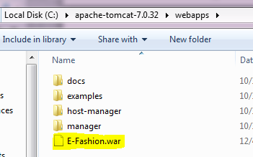

* Run tomcat and it will auto deploy the E-Fashion application

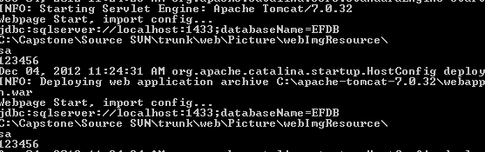

* After automatic deploy, stop Tomcat
* Change web configurations (**ref. steps below**)
* Start tomcat again for final start up

#### **Change web configurations**

* After automatic deploy you will have new application folder name E-Fashion in webapps folder of TomCat

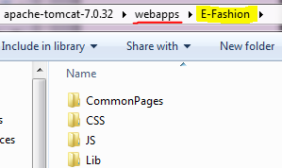

* Open Lib folder in E-Fashion folder and double click on Config.ini to view config file

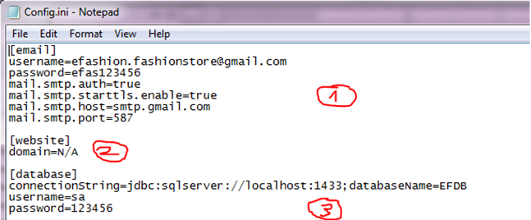

1: email gmail of system web use to send to customer

2: website domain if website

3: database Configs

* Edit and save

## **Setting up the environment at client side**

* N/A

# **User‘s Guide**

## **Buyer’s Guide**



### **Make an Order**

* This function is used by Boss. Boss click “Thêm Admin” link at header website
* 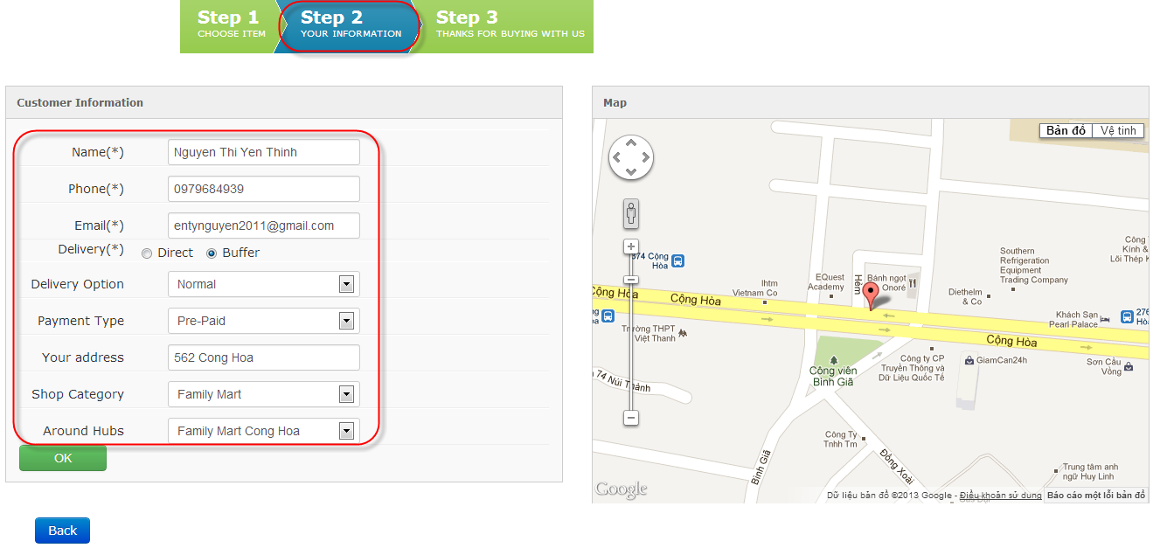Move to step 2. User must fill in information and click OK button to finish order.

User can click Back button to redirect to step 1.

* 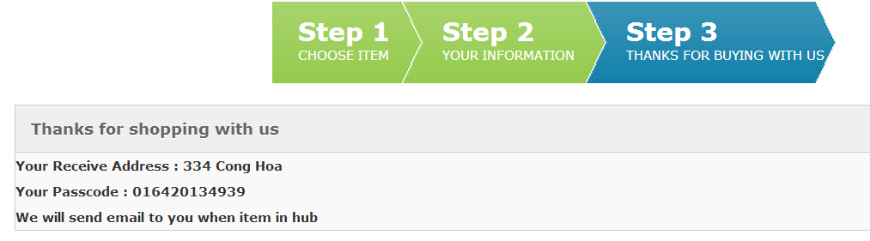Move to step 3: confirm message and receive passcode

### **Check Order**

* Input phone number

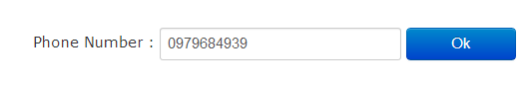Click “OK” button

* 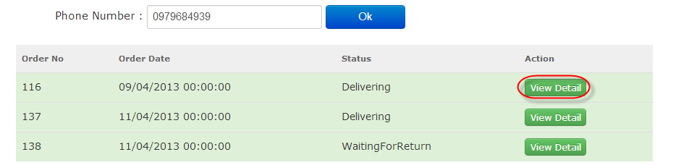Click “Detail”
* 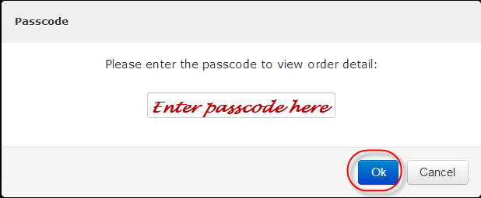Enter passcode and click “OK” button
* 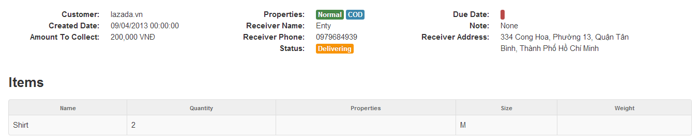Order detail is displayed

## **Customer’s Guide**

* This function is used by Customer of system

### **Log in**

* Input username & password
* Click “Login” button

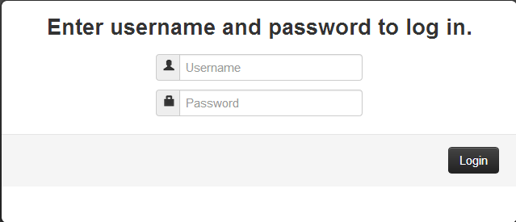

### **Log out**

* Click “Customer1” dropdown list
* Click “Log out” action

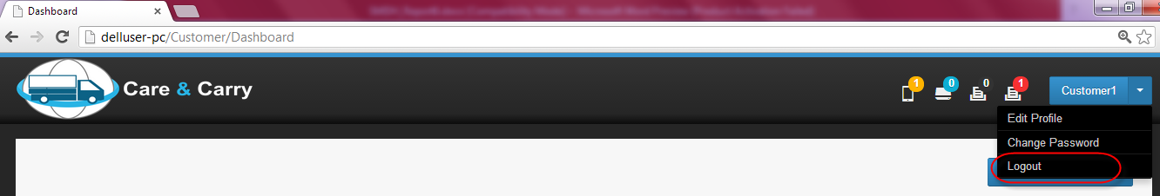

### **Manage Product**

* 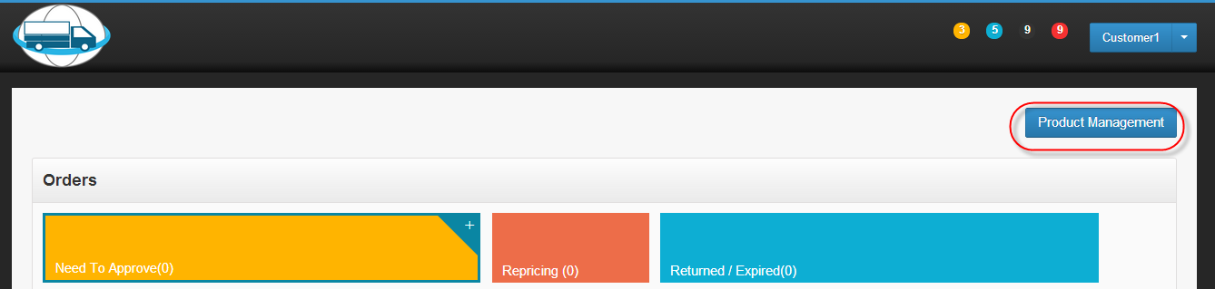Click “Product Management” button at right corn on the top website.

#### **Add product**

* Click “Add New” button

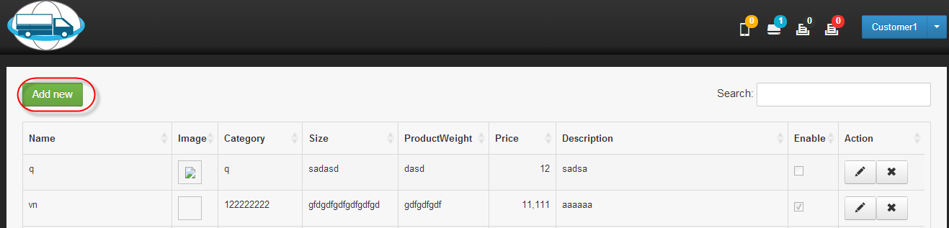

* “Create new Product” pop up is displayed.

Input information to create new product and click Create button

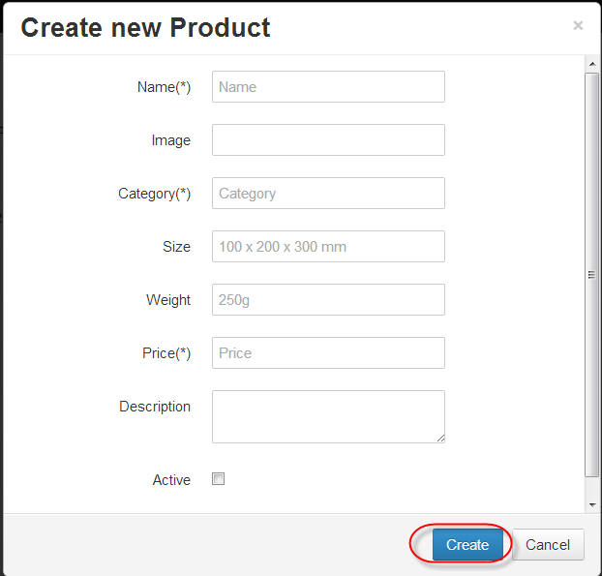

* + Created product is displayed on the first record of product table

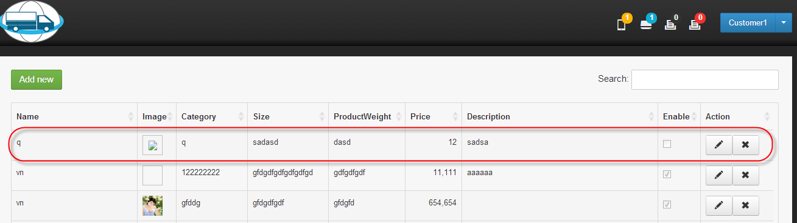

#### **Edit Product**

* + Click “Edit” button

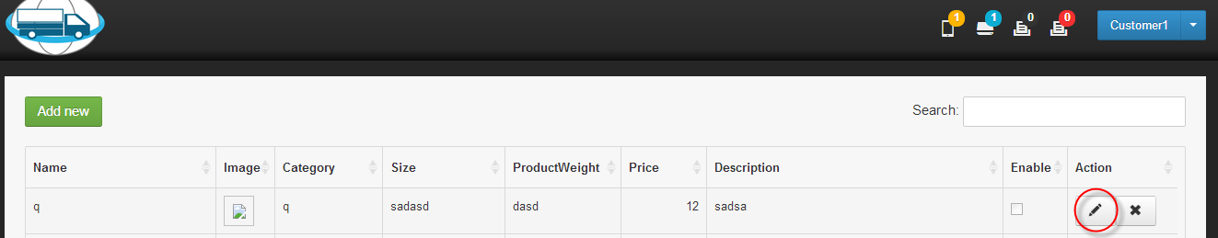

* + 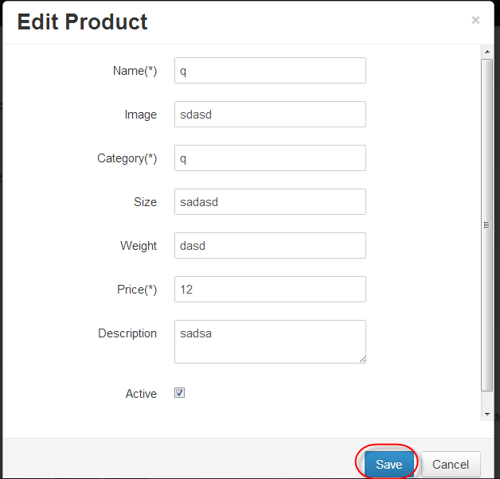Modify some information and click “Save” button

#### **Delete Product**

* Click “Delete” button

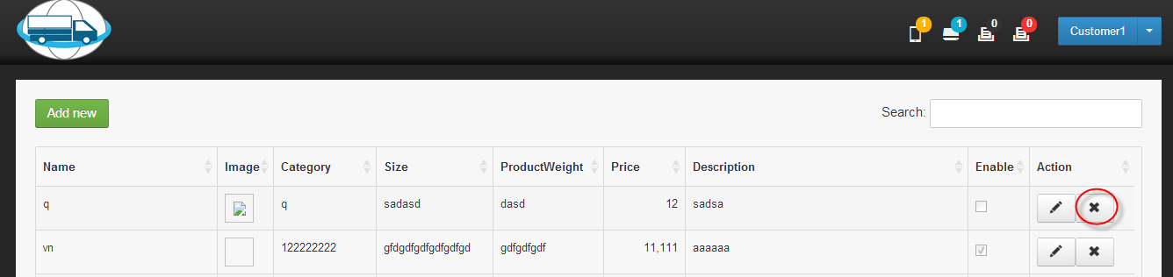

* 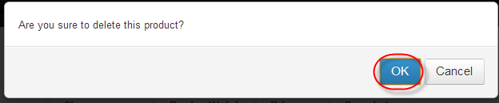Click “OK” button
* Product is removed from table

### **Approve Order**

* 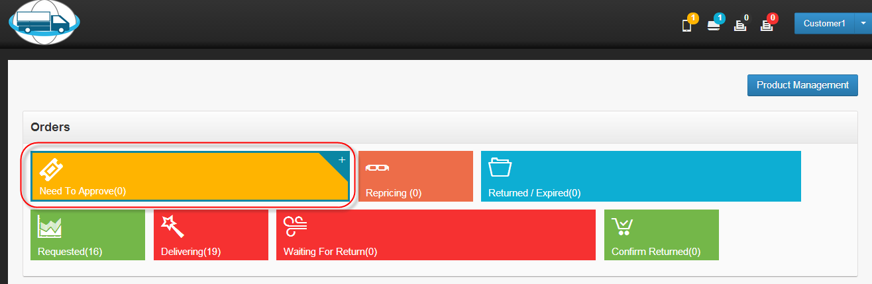Click “Need to Approve”
* 1. Click “Aprrove” for each order

1. Click “Approve All” for all orders in table

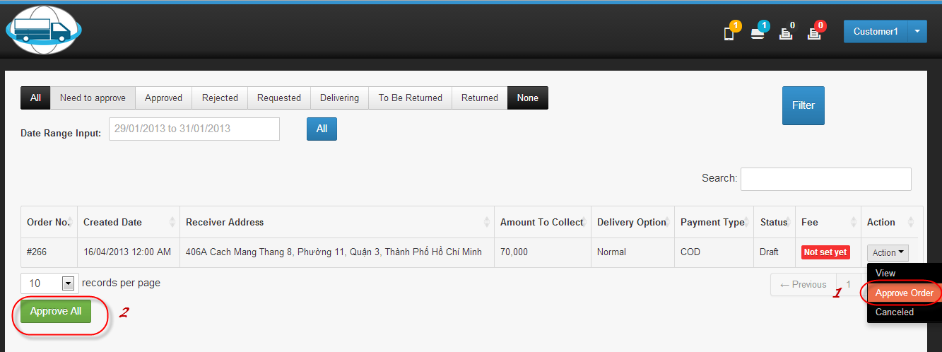

### **Add Order to Request**

* Click “Waiting For Price”

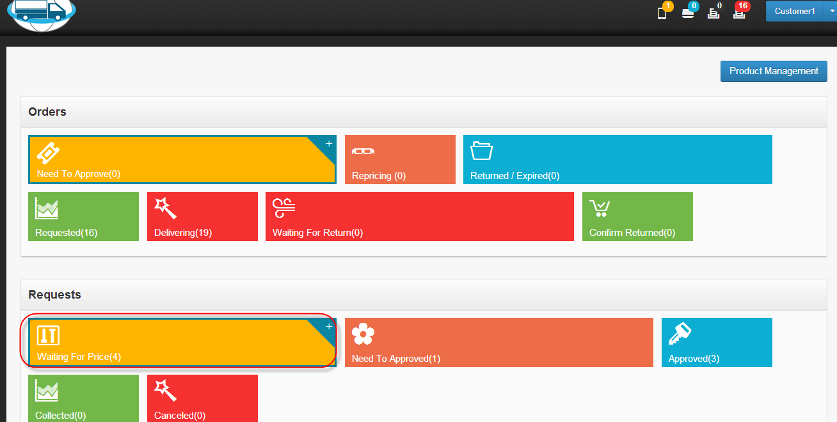

* Click “Add” button

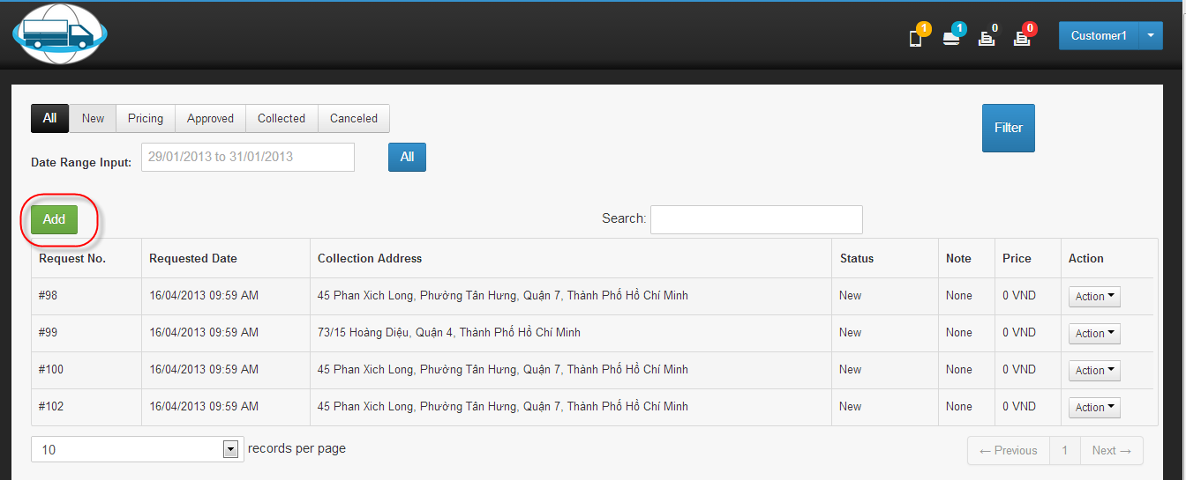

* Choose collection address.

[Input orders by importing excel file.]

Click “Create” button

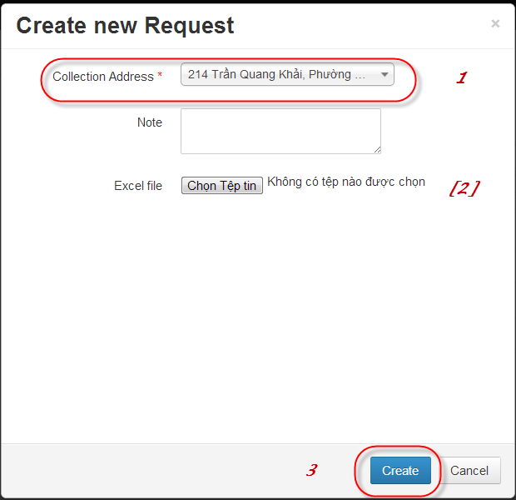

* 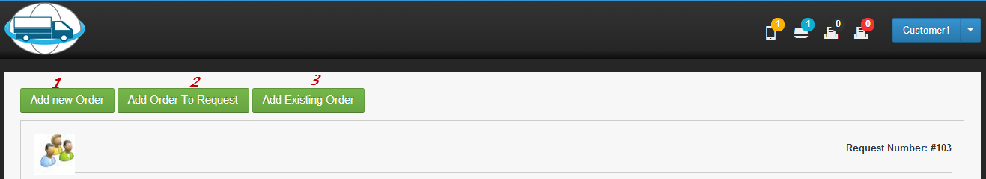Add order to request by:

1. Click “Add new Order” button:

Input valid value and click “Create” button

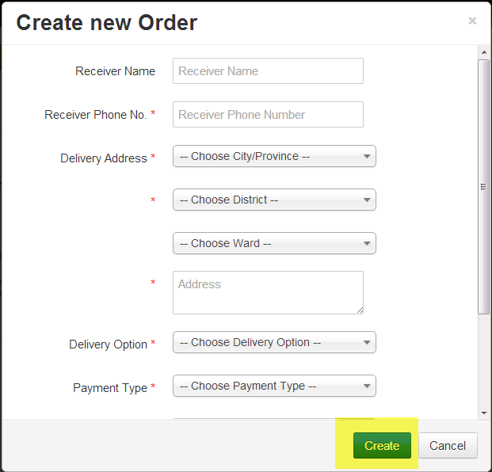

1. Click “Add Order to Request” button: (refer to 2.4.1.1)
2. Click “Add existing order” button. Check order to request and click “Add to Request” button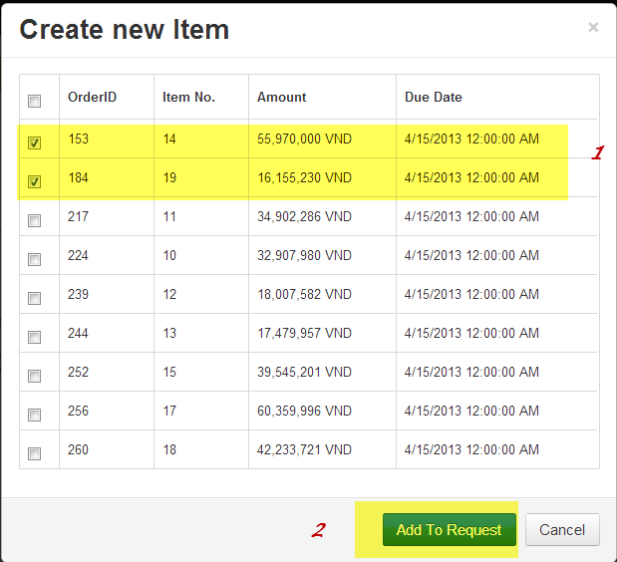

### **Submit request to Tiktak**

* Click “Submit Request” (send request to tiktak)

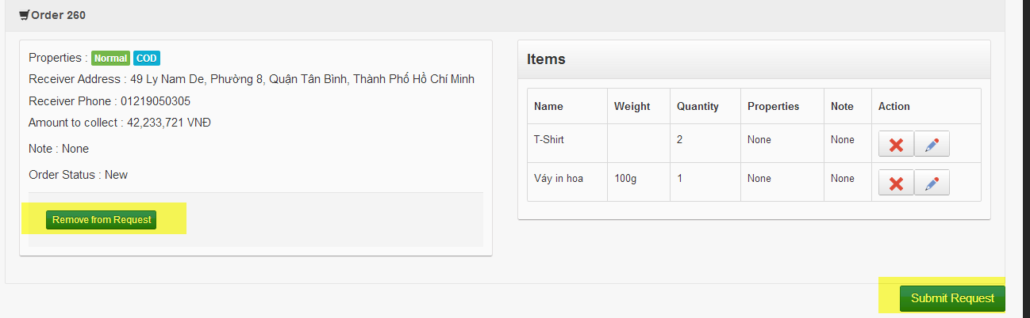Click “Remove from Request” (delete request from db)



### **Approve Pricing**

* 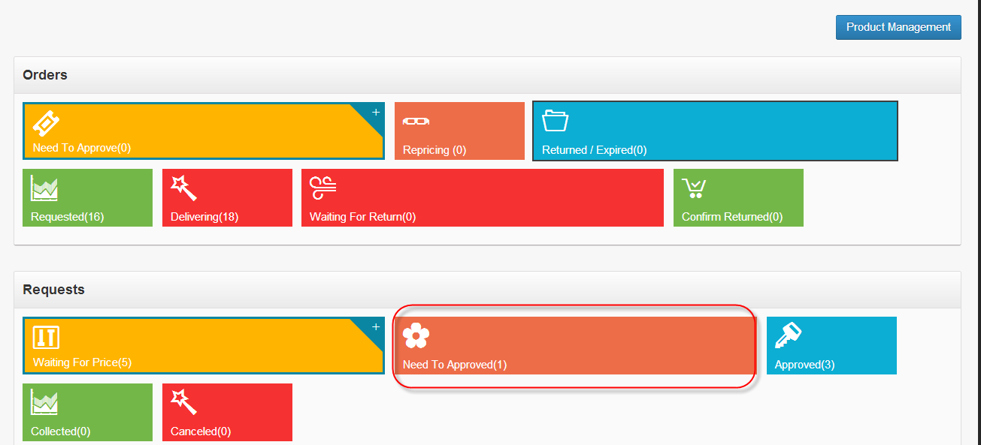Click “Need to Approved” in Requests area
* Click “Approve” action in dropdown list

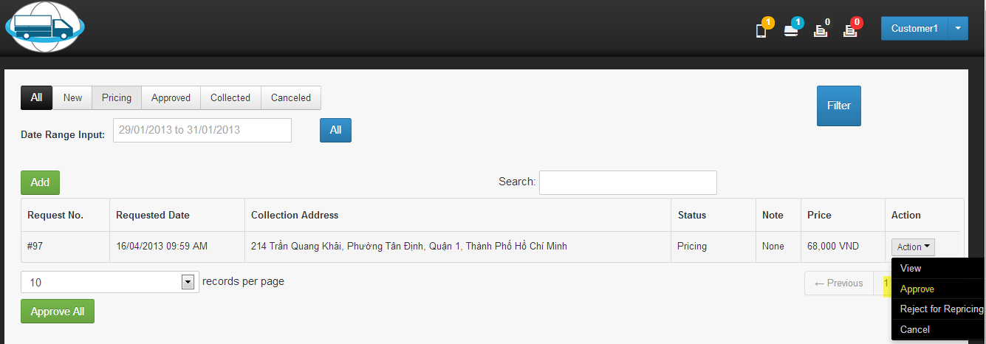

### **Reject Pricing**

* 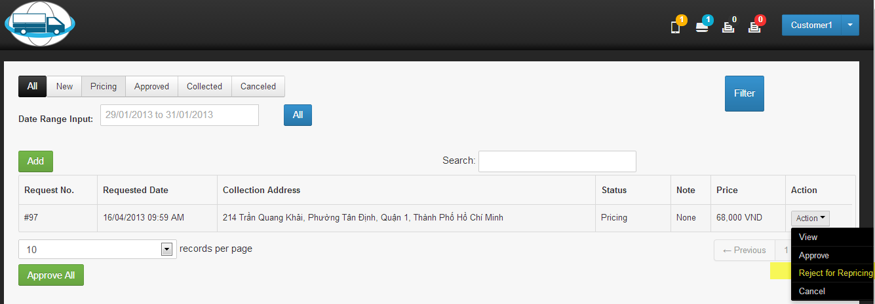Click “Reject for Repricing”

### **Cancel Request after Pricing**

* 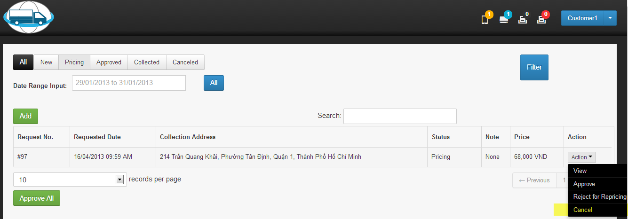Click “Cancel” in dropdown list

## **Tiktak Staff’s Guide**

### **Log in**

* Input username & password
* 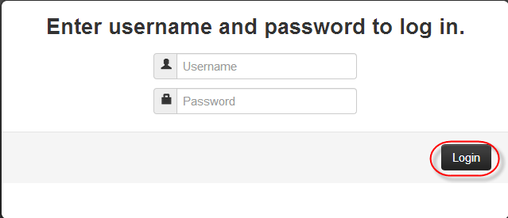Click “Login” button

### **Log out**

* Click dropdown list on the top right corn of website
* 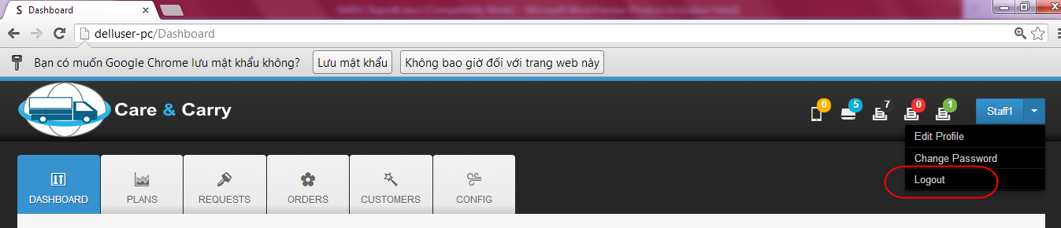Click “Log out”

### **Set Pricing**

* Click “REQUESTS” tab

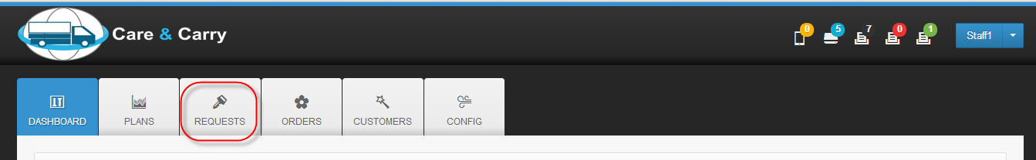

* Click “Action” and then, click “Approve Orders”

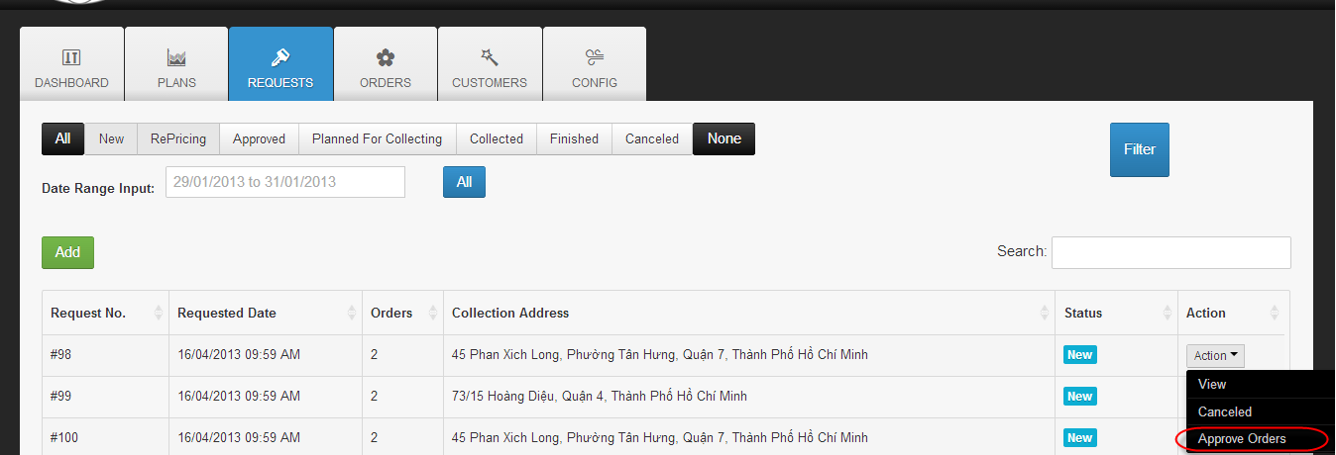

* 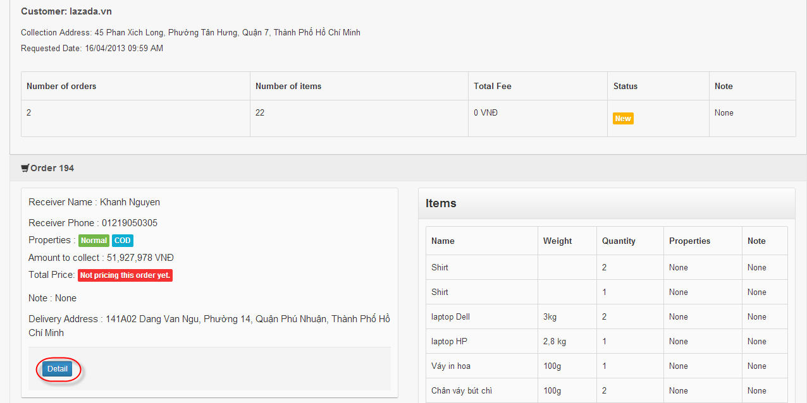Click “Detail” button to set price
* Choose price type from dropdown list

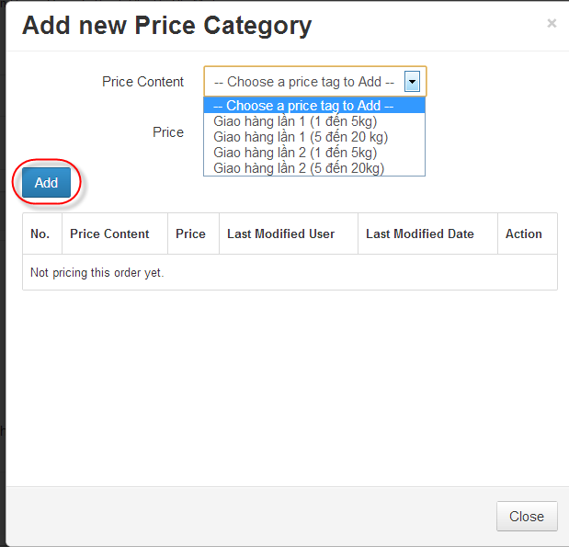Click “Add” button

* Click “Close” button

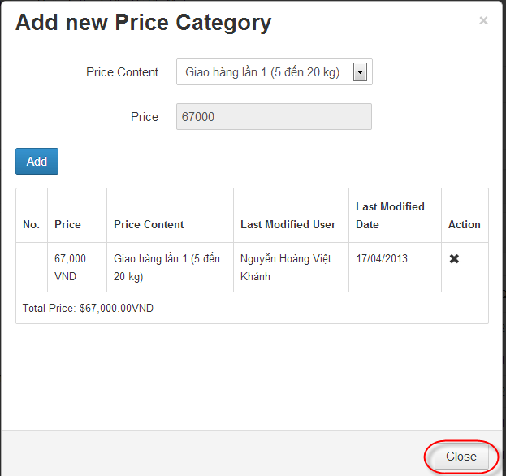

* Order has amount to collect now

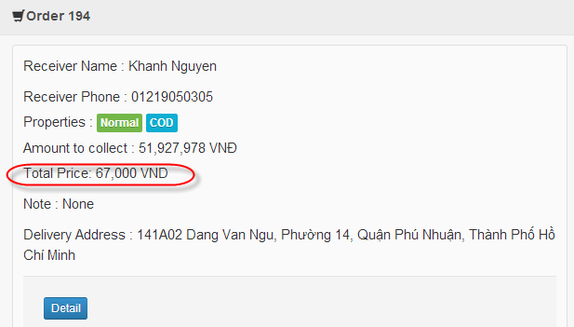

* Click “Approve Request”

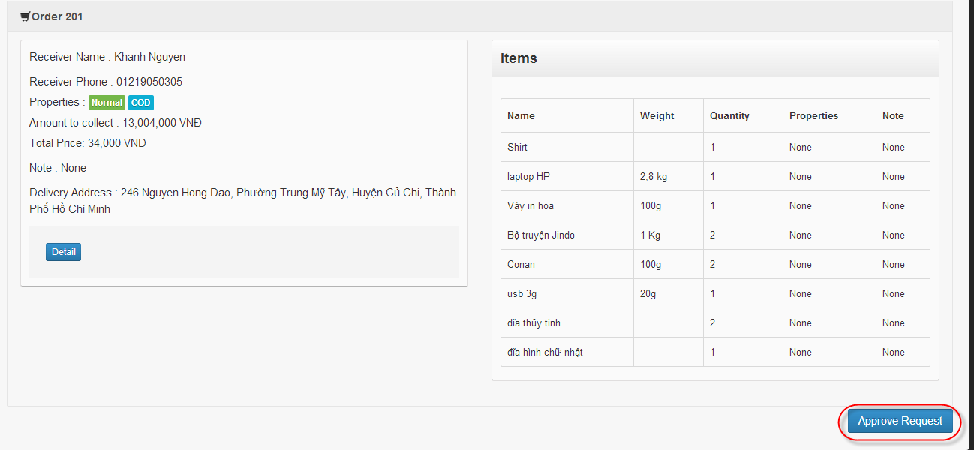

### **Manage Plan**

* 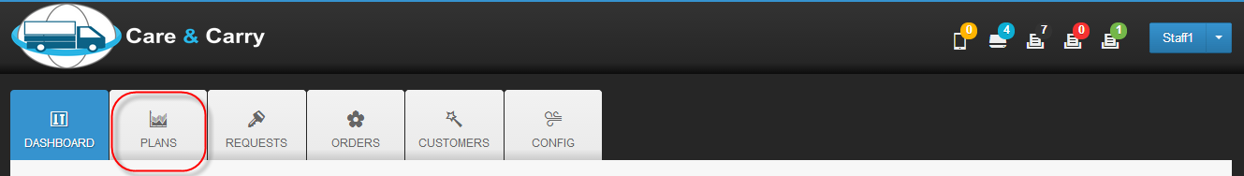Click “PLANS” tab

#### **Manage Collection Plan**

* Click “Collection Plan”

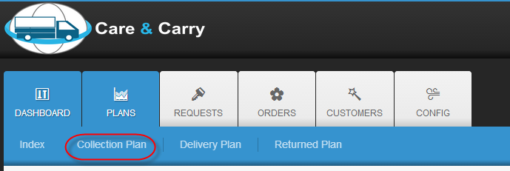

* 1. Enter number of plan

2. Choose group type

3. Click right arrowhead or “Select all”

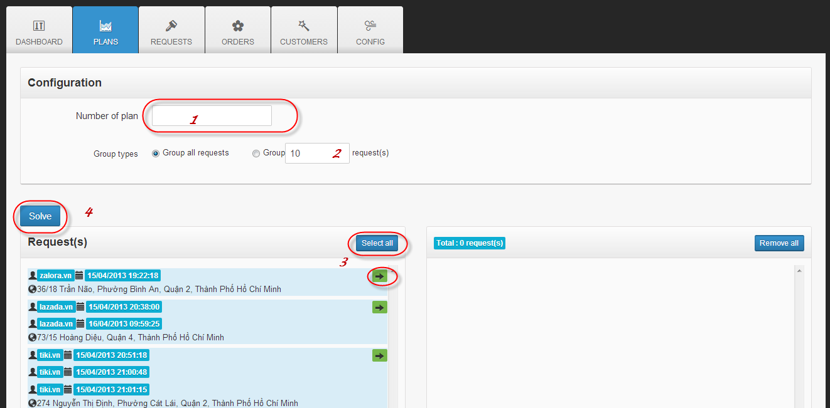4. Click “Solve” button

[Optional]

* Click left arrowhead or “Remove All” button to remove request from Cart Add

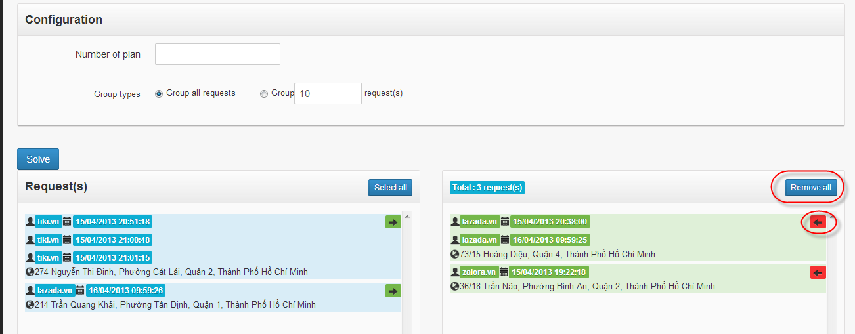

* 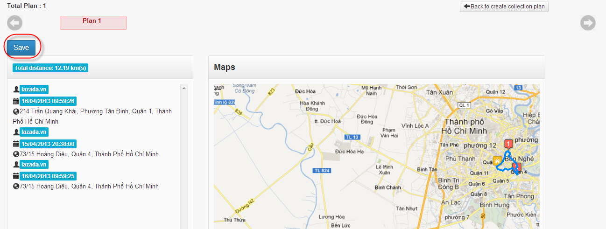Click “Save” button

[Optional]

* Click “Back to create collection plan” button to make another collection plan

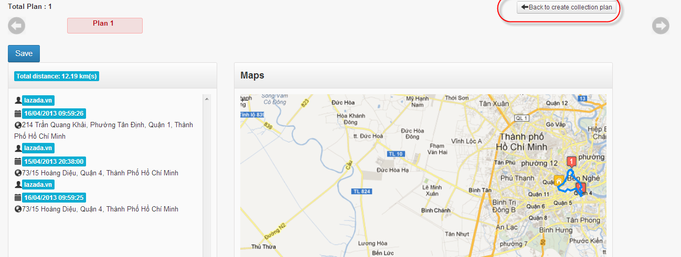

* Click “View & Assign” to assign plan to Delivery men

Click “Cancel” to cancel plan [optional]

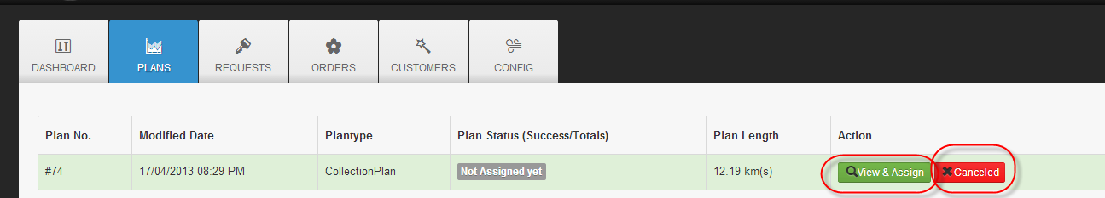

* Check DM to assign

Click “Assign” button

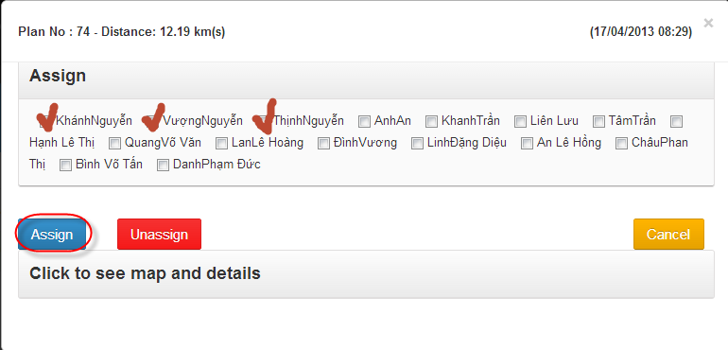

* Plan is changed to “Assigned”



* Click “Mark as Finished” button

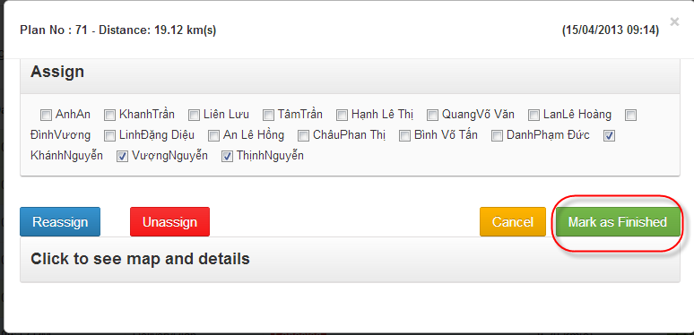

* Plan is changed to “Finished”



#### **Manage Delivery Plan**

* 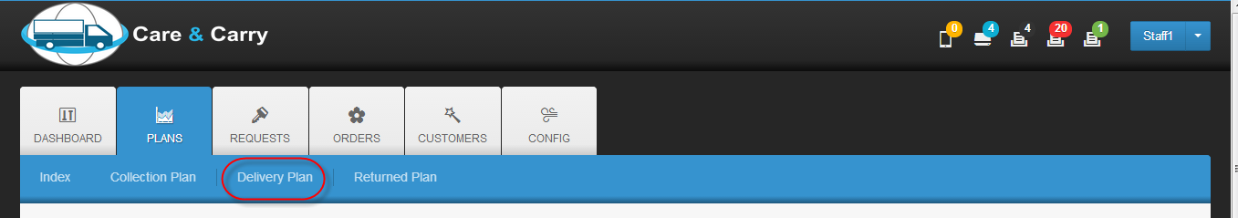Click “Delivery Plan”
* 1. Enter number of plan

2. Choose group order type

3. Click right arrow or “Select all” button

4. Click “Solve” button

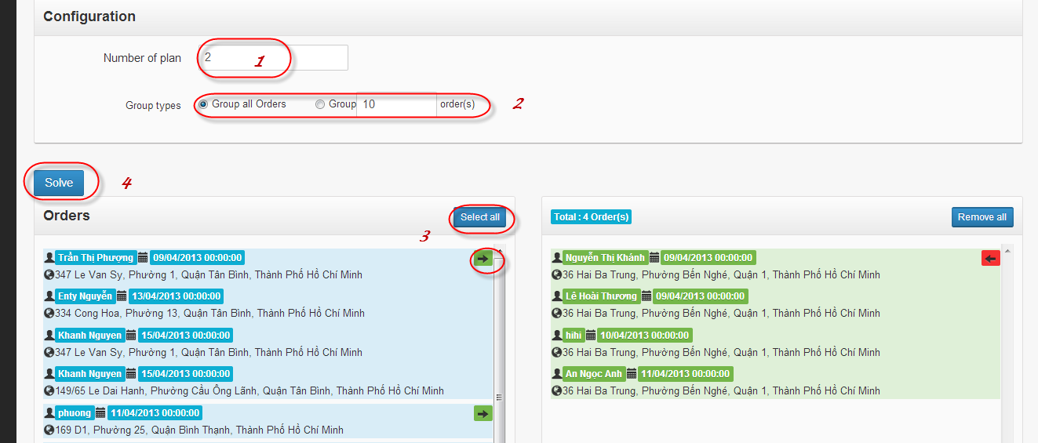

* 1. Click “Save” button to continue

2. Click “Back to create delivery plan” [optional]

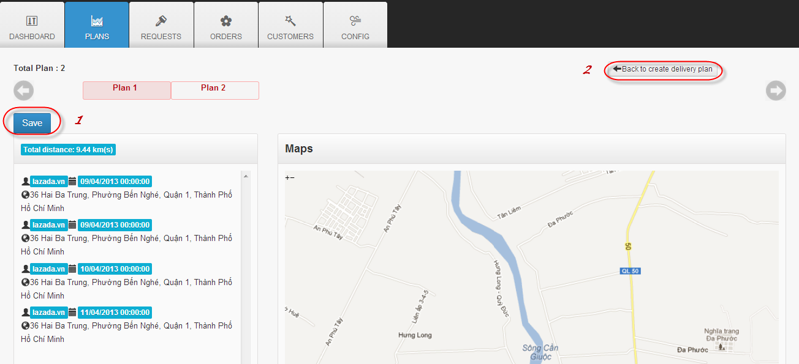

* Click “View & Assign” to assign plan to delivery men

Click “Cancel” to cancel plan [optional]

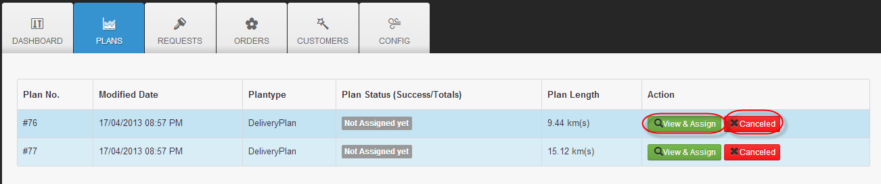

* Check Delivery Men to assign

Click “Assign” button

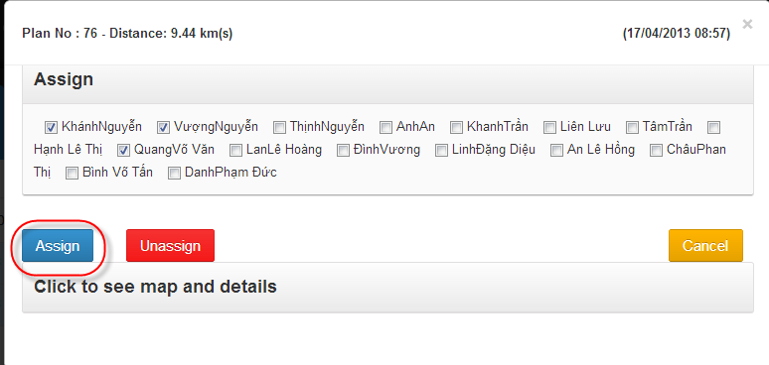

* Plan is changed to “Assigned”

[Optional] Reassign

* + Click “View & Assign”



* + Check another Delivery men

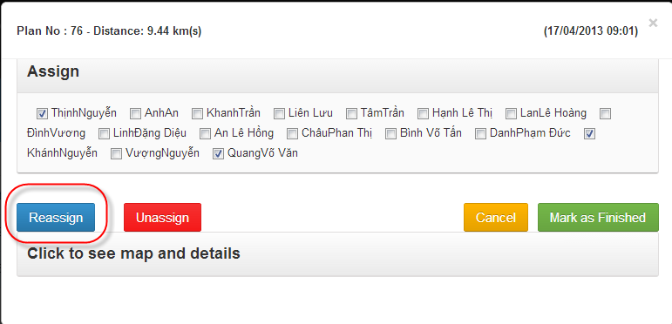Click “Reassign” button

* Click “View & Assign”



* 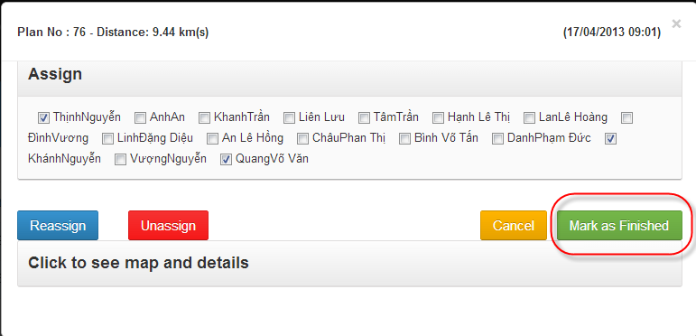Click “Mark as Finished”
* Edit Order status



* Click “Finished” or “Mark all as Finished” : make order to finish

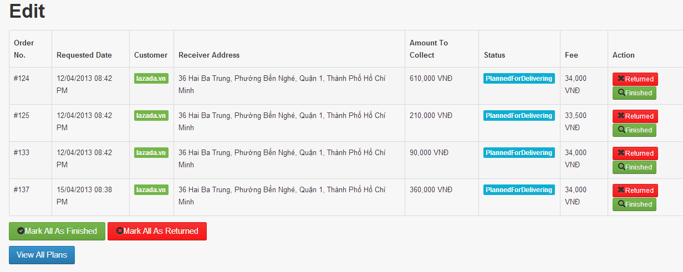Click “Returned” or “Mark all as Returned”: make order to return

* Click “Mark as Finished”

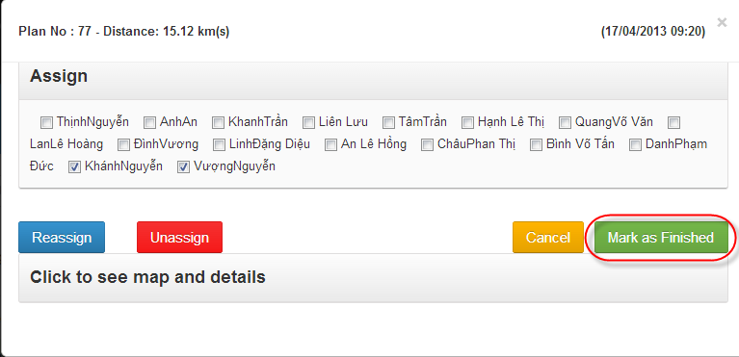

* Plan is changed to “Finished”



#### **Manage Return Plan**

* 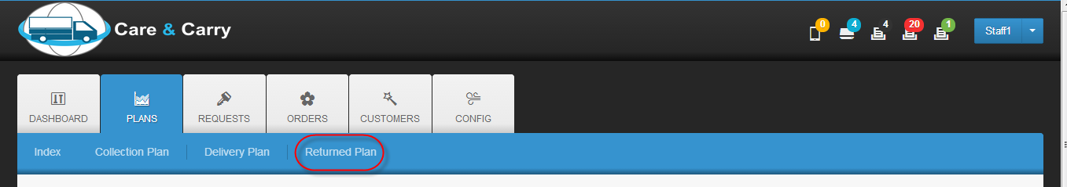Click “Return plan”
* 1. Enter number of return plan

2. Choose group order type

3. Click right arrow or “Select all”

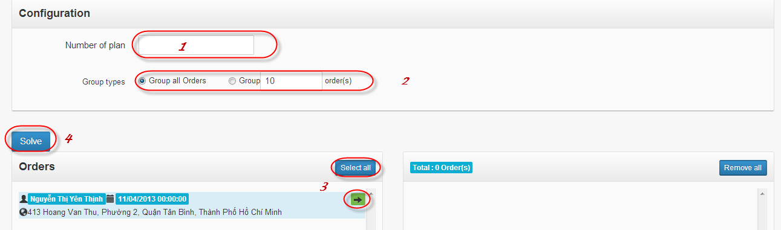4. Click “Solve” button

* 1. Click “Save” button to continue

2. Click “Back to create return plan” [optional]



* Click “View & Assign” to assign plan to delivery men

Click “Cancel” to cancel plan [optional]



* Check Delivery Men to assign

Click “Assign” button



* Plan is changed to “Assigned”

[Optional] Reassign

* + Click “View & Assign”



* + Check another Delivery men

Click “Reassign” button

* Click “View & Assign”



* Click “Mark as Finished”
* Edit Order status



* Click “Finished” or “Mark all as Finished” : make order to finish

Click “Returned” or “Mark all as Returned”: make order to return

* Click “Mark as Finished”



* Plan is changed to “Finished”



## **Hub staff’s Guide**

### **Log in**

* Input username & password

Click “Login” button





### **Log out**

* Click dropdown list on the top right corn of website

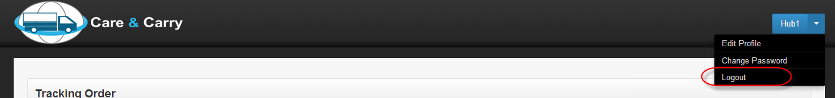Click “Logout” action

### **Delivery order to Buyer**

* Enter passcode

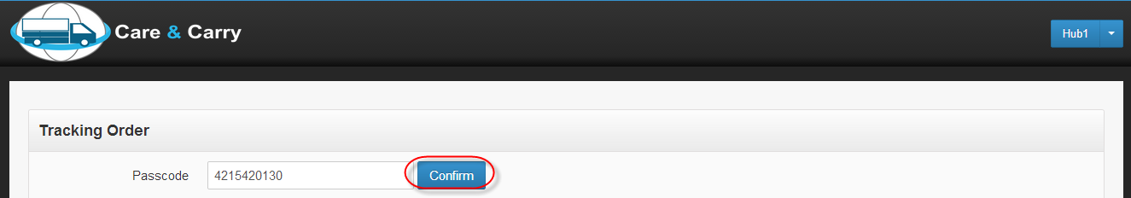Click “Confirm” button

* All orders belong to this passcode are displayed

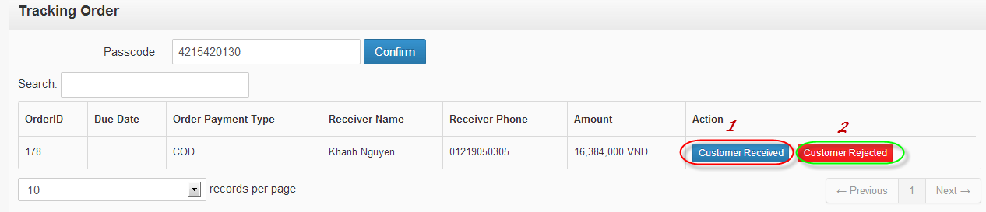

* Case 1:
* Click “Customer Received”, confirm message is displayed

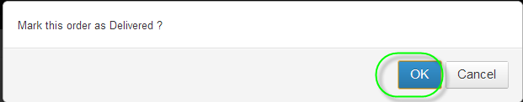Click “OK” button

* 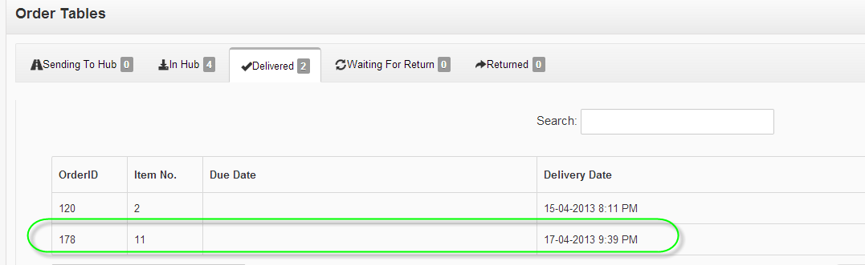Order is changed to “Delivered” status
* Case 2:
* Click “Customer Rejected”, confirm message is displayed

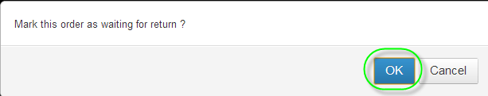Click “OK” button

* Order is changed to “Waiting for Return” status

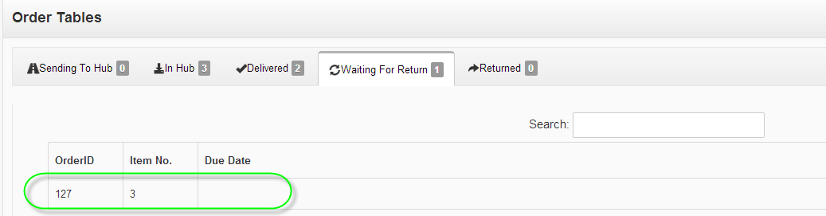

### View Order by Status

#### **View In Hub Order**

* Click “In Hub” tab

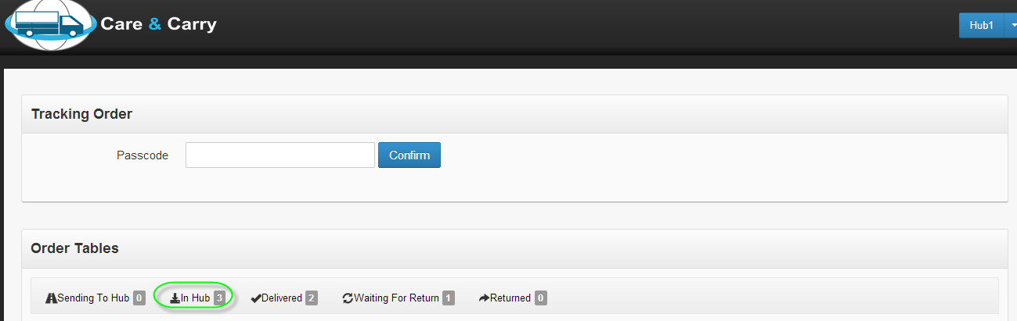

* 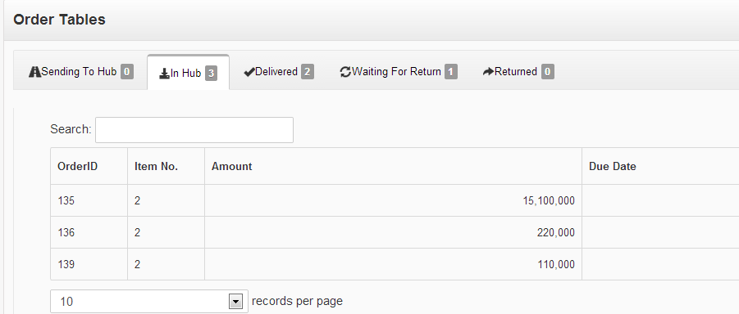Orders are displayed

#### **View Delivered Order**

* 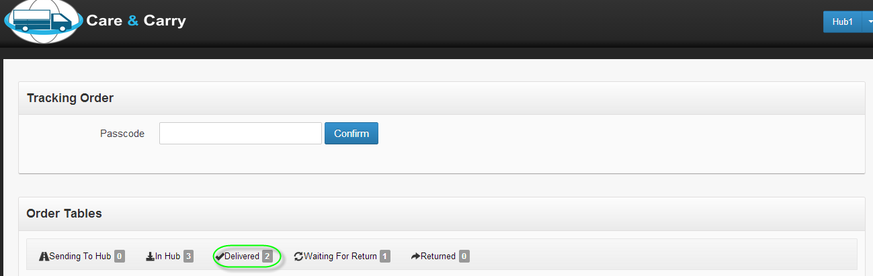Click “Delivered” tab
* Orders are displayed

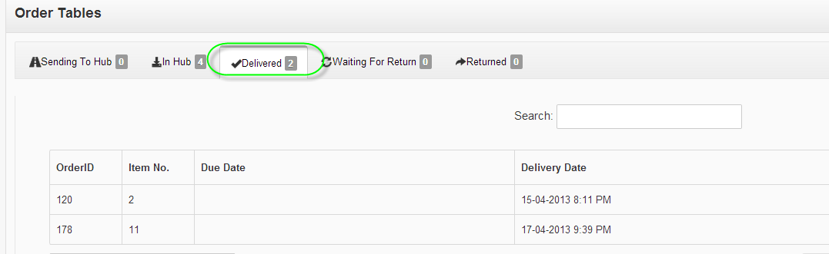

#### **View Waiting for Return order**

* 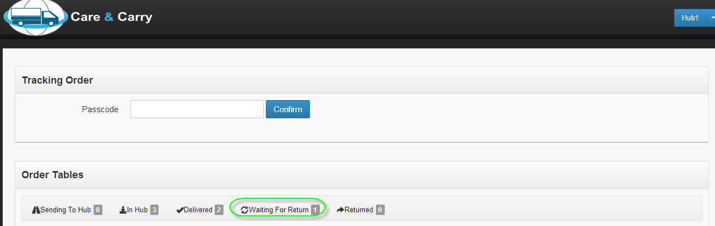Click “Waiting for Return” tab
* 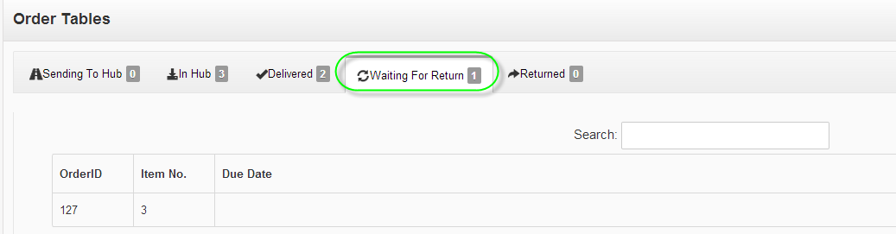Orders are displayed

#### **View Return Order**

* Click “Returned” tab

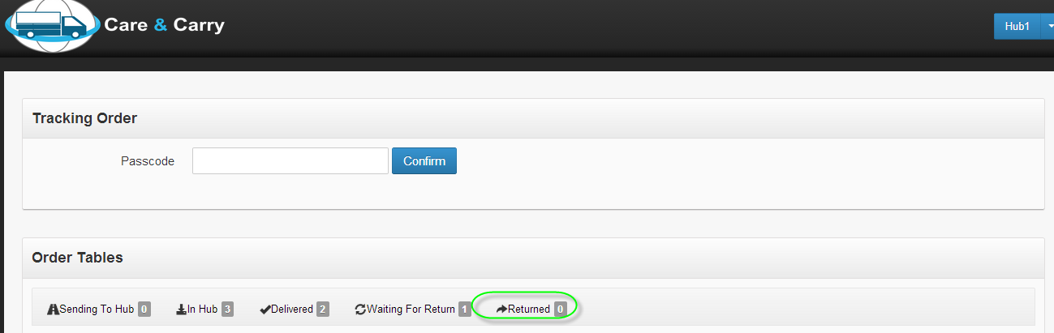

* Orders are displayed

