1. Book Field

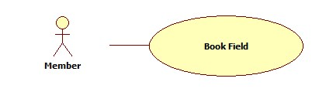

|  |  |  |  |  |
| --- | --- | --- | --- | --- |
| **USE CASE-n SPECIFICATION** | | | | |
| **Use-case No.** | <UC001> | **Use-case Version** | | <1.0> |
| **Use-case Name** | Book Field | | | |
| **Author** | ThinhND | | | |
| **Date** | 12/02/2014 | **Priority** | High | |
| **Actor:**  Member  **Summary:**  This use case describes how to book field  **Goal:**  Book a field of stadium  **Triggers:**  Actor click on Book button  **Preconditions:**  Login as user  **Post-conditions:**  Successful message is displayed.  **Main Success Scenario:**   |  |  |  | | --- | --- | --- | | Step | Actor Action | System Response | | 1 | Click on Book button | Display Book form | | 2 | Enter information of booking  Click on Check available button | Show Field is available message | | 3 | Click OK button | Show successful message and save this reservation |   **Alternative Scenario:**   |  |  | | --- | --- | | Actor Action | System Response | | Click on Check available button | Show Field is not available message | | Click on Cancel button | Back to previous page |   **Exceptions:**  This field is not available such as existing reservation, duplicate booking time, etc.  **Relationships:**  N/A  **Business Rules:**  N/A | | | | |

1. Rate Stadium

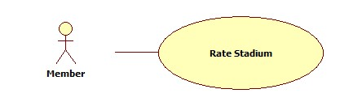

|  |  |  |  |  |
| --- | --- | --- | --- | --- |
| **USE CASE-n SPECIFICATION** | | | | |
| **Use-case No.** | <UC001> | **Use-case Version** | | <1.0> |
| **Use-case Name** | Rate Stadium | | | |
| **Author** | ThinhND | | | |
| **Date** | 12/02/2014 | **Priority** | High | |
| **Actor:**  Member  **Summary:**  This use case describes how to rate stadium  **Goal:**  Rate a stadium  **Triggers:**  Actor click on Rate stars of stadium  **Preconditions:**  Login as user  **Post-conditions:**  N/A  **Main Success Scenario:**   |  |  |  | | --- | --- | --- | | Step | Actor Action | System Response | | 1 | Click on Rate stars | Save this rate |   **Alternative Scenario:**     |  |  | | --- | --- | | Actor Action | System Response | |  |  |   **Exceptions:**  N/A  **Relationships:**  N/A  **Business Rules:**  N/A | | | | |

1. Cancel Reservation

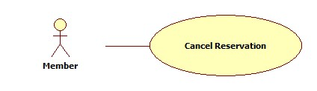

|  |  |  |  |  |
| --- | --- | --- | --- | --- |
| **USE CASE-n SPECIFICATION** | | | | |
| **Use-case No.** | <UC001> | **Use-case Version** | | <1.0> |
| **Use-case Name** | Cancel Reservation | | | |
| **Author** | ThinhND | | | |
| **Date** | 12/02/2014 | **Priority** | High | |
| **Actor:**  Member  **Summary:**  This use case describes how to cancel reservation  **Goal:**  Cancel a reservation  **Triggers:**  Actor click on Cancel button  **Preconditions:**  Login as user. Reservation is not approved.  **Post-conditions:**  Successful message is displayed  **Main Success Scenario:**   |  |  |  | | --- | --- | --- | | Step | Actor Action | System Response | | 1 | Click on Cancel button | Show message to request user’s confirmation | | 2 | Click OK button to confirm this action | Show successful message and cancel reservation |   **Alternative Scenario:**   |  |  | | --- | --- | | Actor Action | System Response | | Click on Cancel button | Close the message |   **Exceptions:**  N/A  **Relationships:**  N/A  **Business Rules:**  N/A | | | | |
|  | | | | |

1. Review Stadium

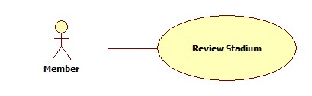

|  |  |  |  |  |
| --- | --- | --- | --- | --- |
| **USE CASE-n SPECIFICATION** | | | | |
| **Use-case No.** | <UC001> | **Use-case Version** | | <1.0> |
| **Use-case Name** | Review Stadium | | | |
| **Author** | ThinhND | | | |
| **Date** | 12/02/2014 | **Priority** | High | |
| **Actor:**  Member  **Summary:**  This use case describes how to review stadium  **Goal:**  Review a stadium  **Triggers:**  Actor write a review in review message box in stadium details page  **Preconditions:**  Login as user  **Post-conditions:**  N/A  **Main Success Scenario:**   |  |  |  | | --- | --- | --- | | Step | Actor Action | System Response | | 1 | Write a review stadium | Save this review |   **Alternative Scenario:**   |  |  | | --- | --- | | Actor Action | System Response | |  |  |   **Exceptions:**  Blank content  **Relationships:**  N/A  **Business Rules:**  N/A | | | | |

1. Edit Account Profiles

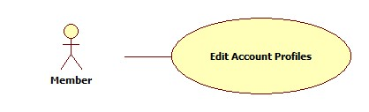

|  |  |  |  |  |
| --- | --- | --- | --- | --- |
| **USE CASE-n SPECIFICATION** | | | | |
| **Use-case No.** | <UC001> | **Use-case Version** | | <1.0> |
| **Use-case Name** | Edit Account Profiles | | | |
| **Author** | ThinhND | | | |
| **Date** | 12/02/2014 | **Priority** | High | |
| **Actor:**  Member  **Summary:**  This use case describes how to edit user’s account profiles  **Goal:**  Update user’s account profiles  **Triggers:**  Actor click on Edit button  **Preconditions:**  Login as user  **Post-conditions:**  Successful message is displayed  **Main Success Scenario:**   |  |  |  | | --- | --- | --- | | Step | Actor Action | System Response | | 1 | Click on Edit button | Display Edit form with filled information | | 2 | Enter new profiles information of user’s account  Click Save button | Update new profiles information |   **Alternative Scenario:**   |  |  | | --- | --- | | Actor Action | System Response | | Click on Cancel button | Back to previous page |   **Exceptions:**  N/A  **Relationships:**  N/A  **Business Rules:**  N/A | | | | |

1. Find Rival

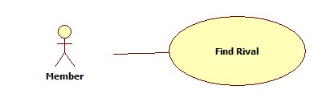

|  |  |  |  |  |
| --- | --- | --- | --- | --- |
| **USE CASE-n SPECIFICATION** | | | | |
| **Use-case No.** | <UC001> | **Use-case Version** | | <1.0> |
| **Use-case Name** | Find Rival | | | |
| **Author** | ThinhND | | | |
| **Date** | 12/02/2014 | **Priority** | High | |
| **Actor:**  Member  **Summary:**  This use case describes how to find rival  **Goal:**  Find rival  **Triggers:**  Actor click on Find Rival button  **Preconditions:**  Login as user  **Post-conditions:**  N/A  **Main Success Scenario:**   |  |  |  | | --- | --- | --- | | Step | Actor Action | System Response | | 1 | Enter conditions information  Click on Find Rival button | Show list of rivals |   **Alternative Scenario:**   |  |  | | --- | --- | | Actor Action | System Response | | Click on Cancel button | Back to previous page |   **Exceptions:**  N/A  **Relationships:**  N/A  **Business Rules:**  N/A | | | | |

1. Find Available Stadiums

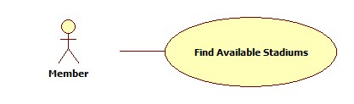

|  |  |  |  |  |
| --- | --- | --- | --- | --- |
| **USE CASE-n SPECIFICATION** | | | | |
| **Use-case No.** | <UC001> | **Use-case Version** | | <1.0> |
| **Use-case Name** | Find Available Stadiums | | | |
| **Author** | ThinhND | | | |
| **Date** | 12/02/2014 | **Priority** | High | |
| **Actor:**  Member  **Summary:**  This use case describes how to find available stadium with conditions  **Goal:**  Find available stadium  **Triggers:**  Actor click on Find button  **Preconditions:**  N/A  **Post-conditions:**    **Main Success Scenario:**   |  |  |  | | --- | --- | --- | | Step | Actor Action | System Response | | 1 | Enter conditions information  Click on Find button | Show list of stadiums |   **Alternative Scenario:**     |  |  | | --- | --- | | Actor Action | System Response | |  |  |   **Exceptions:**  N/A  **Relationships:**  N/A  **Business Rules:**  N/A | | | | |

1. Feedback Website

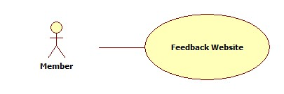

|  |  |  |  |  |
| --- | --- | --- | --- | --- |
| **USE CASE-n SPECIFICATION** | | | | |
| **Use-case No.** | <UC001> | **Use-case Version** | | <1.0> |
| **Use-case Name** | Feedback Website | | | |
| **Author** | ThinhND | | | |
| **Date** | 12/02/2014 | **Priority** | High | |
| **Actor:**  Member  **Summary:**  This use case describes how to feedback website  **Goal:**  Feedback website  **Triggers:**  Actor click on Feedback button  **Preconditions:**  Login as user  **Post-conditions:**  Successful message is displayed  **Main Success Scenario:**   |  |  |  | | --- | --- | --- | | Step | Actor Action | System Response | | 1 | Click on Feedback button | Display Feedback form | | 2 | Enter feedback information  Click on Send button | Send an email to webmaster. |   **Alternative Scenario:**     |  |  | | --- | --- | | Actor Action | System Response | | Click on Cancel button | Respond to home page |   **Exceptions:**  Required Fields are blank  **Relationships:**  N/A  **Business Rules:**  N/A | | | | |

1. Find Stadium

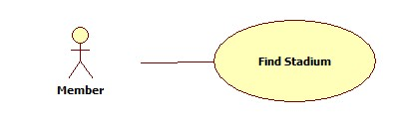

|  |  |  |  |  |
| --- | --- | --- | --- | --- |
| **USE CASE-n SPECIFICATION** | | | | |
| **Use-case No.** | <UC001> | **Use-case Version** | | <1.0> |
| **Use-case Name** | Find Stadium | | | |
| **Author** | ThinhND | | | |
| **Date** | 12/02/2014 | **Priority** | High | |
| **Actor:**  Member  **Summary:**  This use case describes how to find stadium  **Goal:**  Find stadium  **Triggers:**  Actor click on Find button  **Preconditions:**  N/A  **Post-conditions:**  N/A  **Main Success Scenario:**   |  |  |  | | --- | --- | --- | | Step | Actor Action | System Response | | 1 | Enter conditions information  Click on Find button | Show list of stadiums |   **Alternative Scenario:**     |  |  | | --- | --- | | Actor Action | System Response | |  |  |   **Exceptions:**  N/A  **Relationships:**  N/A  **Business Rules:**  N/A | | | | |

1. View Stadium Booking History

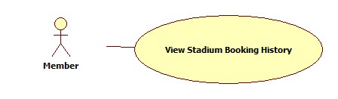

|  |  |  |  |  |
| --- | --- | --- | --- | --- |
| **USE CASE-n SPECIFICATION** | | | | |
| **Use-case No.** | <UC001> | **Use-case Version** | | <1.0> |
| **Use-case Name** | View Stadium Booking History | | | |
| **Author** | ThinhND | | | |
| **Date** | 12/02/2014 | **Priority** | High | |
| **Actor:**  Member  **Summary:**  This use case describes how to view stadium booking history  **Goal:**  View stadium booking history  **Triggers:**  Actor click on History button  **Preconditions:**  Login as user  **Post-conditions:**  N/A  **Main Success Scenario:**   |  |  |  | | --- | --- | --- | | Step | Actor Action | System Response | | 1 | Click on History button | Show list of stadium booking histories |   **Alternative Scenario:**     |  |  | | --- | --- | | Actor Action | System Response | |  |  |   **Exceptions:**  N/A  **Relationships:**  N/A  **Business Rules:**  N/A | | | | |

1. View Stadium's Details

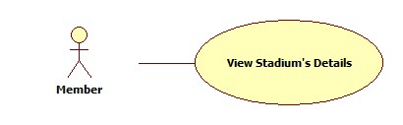

|  |  |  |  |  |
| --- | --- | --- | --- | --- |
| **USE CASE-n SPECIFICATION** | | | | |
| **Use-case No.** | <UC001> | **Use-case Version** | | <1.0> |
| **Use-case Name** | View Stadium's Details | | | |
| **Author** | ThinhND | | | |
| **Date** | 12/02/2014 | **Priority** | High | |
| **Actor:**  Member  **Summary:**  This use case describes how to view stadium’s details  **Goal:**  View stadium's details  **Triggers:**  Actor click on Details button  **Preconditions:**  N/A  **Post-conditions:**  N/A  **Main Success Scenario:**   |  |  |  | | --- | --- | --- | | Step | Actor Action | System Response | | 1 | Click on Details button | Display details of stadium |   **Alternative Scenario:**     |  |  | | --- | --- | | Actor Action | System Response | |  |  |   **Exceptions:**  N/A  **Relationships:**  N/A  **Business Rules:**  N/A | | | | |

1. Request Join System

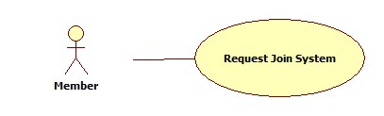

|  |  |  |  |  |
| --- | --- | --- | --- | --- |
| **USE CASE-n SPECIFICATION** | | | | |
| **Use-case No.** | <UC001> | **Use-case Version** | | <1.0> |
| **Use-case Name** | Request Join System | | | |
| **Author** | ThinhND | | | |
| **Date** | 12/02/2014 | **Priority** | High | |
| **Actor:**  Member  **Summary:**  This use case describes how to request join system  **Goal:**  Request join system  **Triggers:**  Actor click on Join System button  **Preconditions:**  Login as user  **Post-conditions:**  N/A  **Main Success Scenario:**   |  |  |  | | --- | --- | --- | | Step | Actor Action | System Response | | 1 | Click on Join System button | Display Stadium Create form | | 2 | Enter information of stadium  Click on Join button | Show message request success and save stadium information |   **Alternative Scenario:**     |  |  | | --- | --- | | Actor Action | System Response | | Click on Cancel button | Back to previous page |   **Exceptions:**  N/A  **Relationships:**  N/A  **Business Rules:**  N/A | | | | |